Hybrid Optimization Assisted Deep Convolutional Neural Network for Hardening Prediction in Steel

Nomenclature

|  |  |
| --- | --- |
| Abbreviation | Description |
| DCNN | Deep Convolutional Neural Network |
| SL-DU | Sea Lion insisted Dragon Fly Update |
| SLnO | Sea Lion Optimization |
| DA | Dragon Fly Algorithm |
| GA | Genetic Algorithms |
| ANN | Artificial Neural Network |
| ASSs | Austenitic Stainless Steels |
| ECT | Effective Cooling Time |
| ECDT | Effective Carbon Diffusion Time |
| RPV | Reactor Pressure Vessel |
| CSMs | Cyclically Stable Materials |
| FEM | Finite Element Method |
| ODF | Orientation Distribution Function |
| MVR | Multi Variant Regression |
| MAE | Mean Absolute Error |
| MAPE | Mean Absolute Percentage Error |
| RMSRE | Root Mean Square Relative Error |

|  |  |
| --- | --- |
| dist-1  (a) | dist-2  (b) |
| dist-3  (c) | dist-4  (d) |
| dist-5  (e) |  |

Fig. S1: Analysis on prediction over actual values of proposed and existing schemes for varied distances: (a) 1.5 (b) 3 (c) 5 (d) 7 (e) 9

|  |  |
| --- | --- |
| dist-1  (a) | dist-2  (b) |
| dist-3  (c) | dist-4  (d) |
| dist-5  (e) | dist-6  (f) |
| dist-7  (g) | dist-8  (h) |
| dist-9  (i) | dist-10  (j) |

Fig. S2 Analysis on prediction over actual values of proposed and existing schemes for varied distances: (a) 11 (b) 13 (c) 15 (d) 20 (e) 25

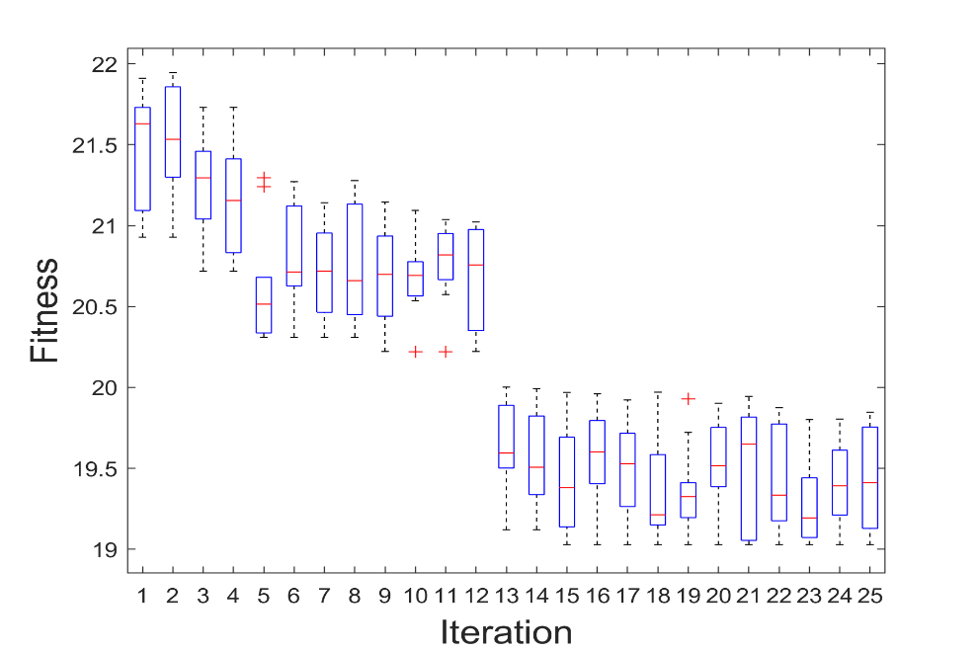

Fig.S3 Analysis of Proposed model: SL-DU

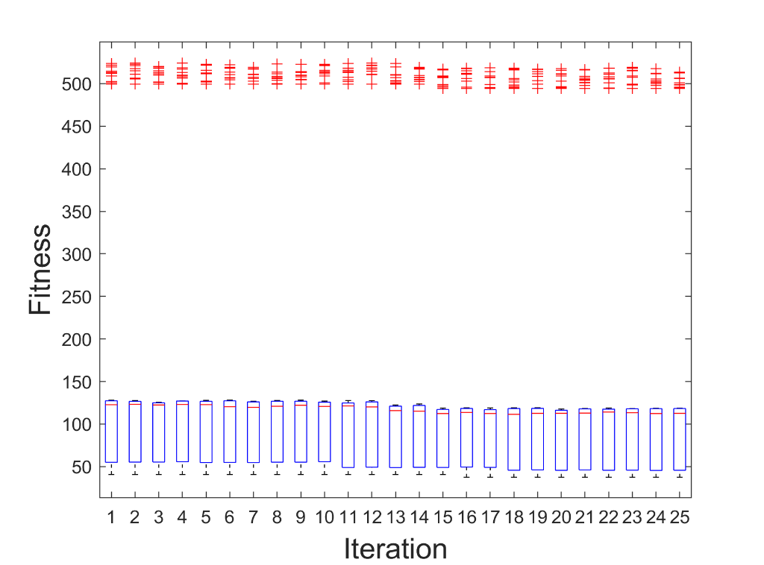

Fig. S4 Analysis of the optimal performance of the proposed model

|  |  |
| --- | --- |
| MAE | MAPE |
| (a) | (b) |
| RMSRE | R_value |
| (c) | (d) |

Fig. S5 Error analysis for proposed over existing schemes (a) MAE (b) MAPE (c) RMSRE (d) R-value

Table S1 MAE analysis: proposed over traditional schemes for varied distance

|  |  |  |  |  |  |
| --- | --- | --- | --- | --- | --- |
| **Distance** | **Regression [27]** | **MVR [28]** | **ANN [29]** | **CNN [30]** | **SL-DU** |
| 1.5 | 0.13141 | 0.033286 | 0.034381 | 0.039156 | 0.03001 |
| 3 | 0.13012 | 0.043716 | 0.029822 | 0.018964 | 0.02287 |
| 5 | 0.12783 | 0.069311 | 0.033357 | 0.022087 | 0.022066 |
| 7 | 0.1291 | 0.092367 | 0.029952 | 0.058985 | 0.013583 |
| 9 | 0.14042 | 0.10757 | 0.031501 | 0.092154 | 0.02012 |
| 11 | 0.12859 | 0.053181 | 0.034305 | 0.066823 | 0.031298 |
| 13 | 0.13116 | 0.0574 | 0.02864 | 0.035721 | 0.013695 |
| 15 | 0.15057 | 0.12662 | 0.026715 | 0.062338 | 0.015205 |
| 20 | 0.1316 | 0.067353 | 0.031212 | 0.017265 | 0.015022 |
| 25 | 0.12632 | 0.024674 | 0.029487 | 0.009288 | 0.014338 |

Table S2 MAPE analysis: proposed over traditional schemes for varied distance

|  |  |  |  |  |  |
| --- | --- | --- | --- | --- | --- |
| Distance | Regression [27] | MVR [28] | ANN [29] | CNN [30] | SL-DU |
| 1.5 | 13.548 | 3.4083 | 3.5298 | 4.0552 | 3.0638 |
| 3 | 13.815 | 4.6251 | 3.1538 | 2.0279 | 2.4095 |
| 5 | 13.961 | 7.5339 | 3.6252 | 2.3859 | 2.3836 |
| 7 | 14.519 | 10.371 | 3.3555 | 6.6154 | 1.5166 |
| 9 | 16.391 | 12.516 | 3.653 | 10.72 | 2.3339 |
| 11 | 16.851 | 6.8458 | 4.4063 | 8.5934 | 4.0295 |
| 13 | 21.847 | 9.6386 | 4.6844 | 5.9959 | 2.2154 |
| 15 | 29.891 | 25.128 | 5.2514 | 12.394 | 2.9866 |
| 20 | 31.64 | 16.306 | 7.3549 | 3.9818 | 3.4645 |
| 25 | 34.858 | 6.7915 | 8.0903 | 2.5381 | 3.893 |

Table S3 RMSRE analysis: proposed over traditional schemes for varied distance

|  |  |  |  |  |  |
| --- | --- | --- | --- | --- | --- |
| **Distance** | **Regression [27]** | **MVR [28]** | **ANN [29]** | **CNN [30]** | **SL-DU** |
| 1.5 | 0.18423 | 0.041167 | 0.041997 | 0.04398 | 0.033863 |
| 3 | 0.18761 | 0.051963 | 0.039327 | 0.024212 | 0.027007 |
| 5 | 0.19127 | 0.080009 | 0.042641 | 0.027763 | 0.027716 |
| 7 | 0.19886 | 0.10606 | 0.040828 | 0.067328 | 0.018356 |
| 9 | 0.21893 | 0.12948 | 0.043738 | 0.10872 | 0.025658 |
| 11 | 0.22785 | 0.077375 | 0.054673 | 0.09284 | 0.047988 |
| 13 | 0.2982 | 0.10589 | 0.059966 | 0.063743 | 0.032769 |
| 15 | 0.39228 | 0.25468 | 0.065497 | 0.12616 | 0.033421 |
| 20 | 0.43111 | 0.17832 | 0.091698 | 0.053297 | 0.04764 |
| 25 | 0.47372 | 0.080142 | 0.10703 | 0.030826 | 0.04596 |

Table S4 R-value analysis: proposed over traditional schemes for varied distance

|  |  |  |  |  |  |
| --- | --- | --- | --- | --- | --- |
| **Distance** | **Regression [27]** | **MVR [28]** | **ANN [29]** | **CNN [30]** | **SL-DU** |
| 1.5 | 0.96619 | 0.99828 | 0.99823 | 0.99812 | 0.99883 |
| 3 | 0.96502 | 0.99728 | 0.99844 | 0.99943 | 0.99926 |
| 5 | 0.96389 | 0.99353 | 0.99817 | 0.99921 | 0.99921 |
| 7 | 0.96056 | 0.98869 | 0.99831 | 0.99542 | 0.99965 |
| 9 | 0.95222 | 0.98306 | 0.99804 | 0.98803 | 0.99933 |
| 11 | 0.94829 | 0.99371 | 0.99682 | 0.99094 | 0.99755 |
| 13 | 0.91109 | 0.98912 | 0.99614 | 0.99605 | 0.99879 |
| 15 | 0.84721 | 0.93566 | 0.9956 | 0.98433 | 0.99885 |
| 20 | 0.81931 | 0.96962 | 0.99129 | 0.99686 | 0.99749 |
| 25 | 0.77596 | 0.99352 | 0.9884 | 0.99902 | 0.99778 |

Table S5 Statistical analysis: time property and traditional model; mean and Standard Deviation for varied distance

|  |  |  |  |  |  |  |  |  |  |  |
| --- | --- | --- | --- | --- | --- | --- | --- | --- | --- | --- |
|  | **Mean** | | | | | **Standard deviation** | | | | |
| **Distance** | **Regression [27]** | **MVR [28]** | **ANN [29]** | **CNN [30]** | **SL-DU** | **Regression [27]** | **MVR [28]** | **ANN [29]** | **CNN [30]** | **SL-DU** |
| 1.5 | 0.13141 | 0.033286 | 0.034381 | 0.039156 | 0.03001 | 0.12186 | 0.022911 | 0.022295 | 0.015853 | 0.014507 |
| 3 | 0.13012 | 0.043716 | 0.029822 | 0.018964 | 0.02287 | 0.11972 | 0.022663 | 0.022412 | 0.012241 | 0.011822 |
| 5 | 0.12783 | 0.069311 | 0.033357 | 0.022087 | 0.022066 | 0.1192 | 0.025449 | 0.02087 | 0.013454 | 0.01341 |
| 7 | 0.1291 | 0.092367 | 0.029952 | 0.058985 | 0.013583 | 0.12122 | 0.020513 | 0.021035 | 0.01194 | 0.009458 |
| 9 | 0.14042 | 0.10757 | 0.031501 | 0.092154 | 0.02012 | 0.12464 | 0.029705 | 0.021171 | 0.017264 | 0.009524 |
| 11 | 0.12859 | 0.053181 | 0.034305 | 0.066823 | 0.031298 | 0.11819 | 0.029588 | 0.026403 | 0.029328 | 0.021486 |
| 13 | 0.13116 | 0.0574 | 0.02864 | 0.035721 | 0.013695 | 0.12295 | 0.02548 | 0.024129 | 0.012363 | 0.015872 |
| 15 | 0.15057 | 0.12662 | 0.026715 | 0.062338 | 0.015205 | 0.12836 | 0.019594 | 0.020345 | 0.010545 | 0.007967 |
| 20 | 0.1316 | 0.067353 | 0.031212 | 0.017265 | 0.015022 | 0.12072 | 0.028444 | 0.023683 | 0.016006 | 0.014747 |
| 25 | 0.12632 | 0.024674 | 0.029487 | 0.009288 | 0.014338 | 0.1168 | 0.01569 | 0.025742 | 0.006509 | 0.009314 |

Table S6 Statistical analysis time property and traditional model; median and worst for varied distance

|  |  |  |  |  |  |  |  |  |  |  |
| --- | --- | --- | --- | --- | --- | --- | --- | --- | --- | --- |
|  | **Median** | | | | | **Worst** | | | | |
| **Distance** | **Regression [27]** | **MVR [28]** | **ANN [29]** | **CNN [30]** | **SL-DU** | **Regression [27]** | **MVR [28]** | **ANN [29]** | **CNN [30]** | **SL-DU** |
| 1.5 | 0.001575 | 0.000664 | 0.000679 | 0.011854 | 0.001562 | 0.72897 | 0.10696 | 0.10458 | 0.076241 | 0.056917 |
| 3 | 0.003149 | 0.000648 | 0.000325 | 0.001965 | 0.001181 | 0.72939 | 0.097336 | 0.11153 | 0.044591 | 0.03956 |
| 5 | 5.17E-05 | 0.0113 | 0.002104 | 0.000124 | 4.28E-06 | 0.71544 | 0.12909 | 0.10605 | 0.04428 | 0.043982 |
| 7 | 0.00215 | 0.040468 | 9.03E-05 | 0.028601 | 0.000618 | 0.65254 | 0.13513 | 0.11409 | 0.089724 | 0.042476 |
| 9 | 0.00212 | 0.02815 | 0.003487 | 0.057988 | 0.000872 | 0.62078 | 0.16428 | 0.11573 | 0.12089 | 0.04423 |
| 11 | 0.001537 | 0.003763 | 0.000967 | 0.001743 | 0.002456 | 0.63015 | 0.12971 | 0.11329 | 0.1303 | 0.088294 |
| 13 | 8.11E-05 | 0.000774 | 5.93E-05 | 0.00394 | 0.000177 | 0.71251 | 0.12948 | 0.11136 | 0.069946 | 0.071149 |
| 15 | 0.000178 | 0.071377 | 3.40E-05 | 0.039715 | 0.003133 | 0.77685 | 0.17677 | 0.11563 | 0.091223 | 0.03612 |
| 20 | 0.001438 | 0.002077 | 0.000548 | 8.62E-05 | 0.000112 | 0.71461 | 0.13288 | 0.10879 | 0.047972 | 0.043172 |
| 25 | 0.00108 | 0.00043 | 0.000358 | 3.81E-05 | 0.001258 | 0.62648 | 0.066587 | 0.11637 | 0.024219 | 0.031807 |