**Supporting information**

**Investigation of structural and optical properties of pure and metal ion-doped TiO2 mesoporous prepared by evaporation induced self-assembly method**

**Bedor S.Alyahya**

Department of Physics, Al Badayea College of Sciences and Arts, Qassim University, P.O. 64, Buraidah, 51452, Saudi Arabia

Email: bedoryeha2021@gmail.com

**Table S1** Expemintal details for synthesis of transition metals doped OMP

|  |  |  |
| --- | --- | --- |
| Samples | precursor | Amount (g) |
| OMT | Ti(OBu)4 | 3.4 |
| Fe-OMT | Fe(Nt)3 | 0.1 |
| Mn-OMT | Mn(Nt)2 | 0.062 |
| Ni-OMT | Ni(Nt)2 | 0.073 |

|  |  |  |
| --- | --- | --- |
| Element | Weight% | Atomic% |
| O K | 21.39 | 44.89 |
| Ti K | 78.61 | 55.11 |
| Total | 100 |  |

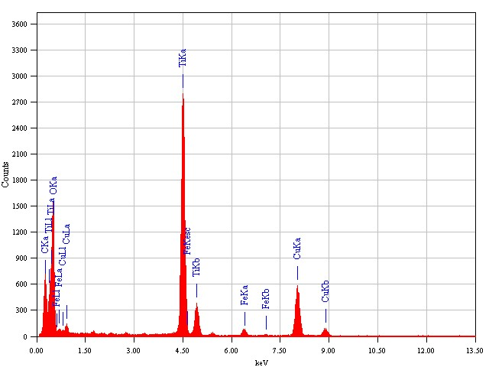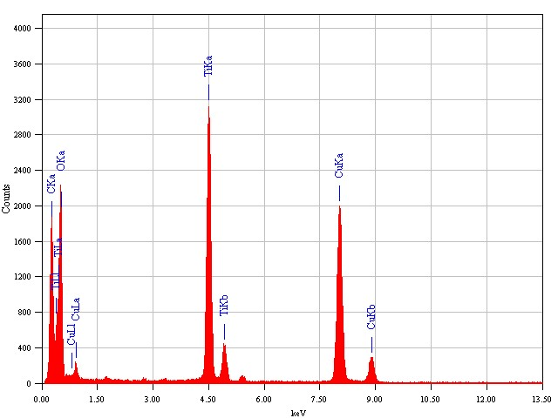

**a**

|  |  |  |
| --- | --- | --- |
| Element | Weight% | Atomic% |
| O K | 35.54 | 60.33 |
| Ti K | 62.67 | 35.76 |
| Fe K | 3.79 | 3.91 |
| Total | 100 |  |

**b**

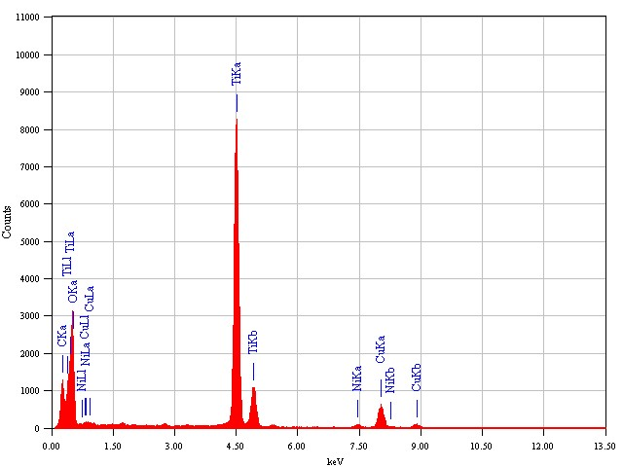

**d**

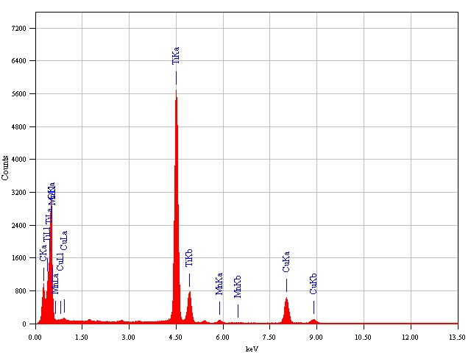

**c**

|  |  |  |
| --- | --- | --- |
| Element | Weight% | Atomic% |
| O K | 40.44 | 66.97 |
| Ti K | 55.87 | 29.70 |
| Mn K | 3.68 | 3.33 |
| Total | 100 |  |

|  |  |  |
| --- | --- | --- |
| Element | Weight% | Atomic% |
| O K | 39.51 | 61.15 |
| Ti K | 56.68 | 30.49 |
| Ni K | 3.81 | 3.36 |
| Total | 100 |  |

**Figure S1.** EDX images of pure OMT (a), Fe/OMT (b), Mn/OMT (c), and Ni/OMT (d) materials prepared from EISA route.



**Figure S2.** Comparative XPS surface spectra of pure and TM-OMT fabricated by EISA approaches.

**Table S2.** The loading weight (g) of TM in TM-TiO2 mesoporous samples.

|  |  |  |  |
| --- | --- | --- | --- |
| Sample | Fe | Mn | Ni |
| Theory values | 0.068 | 0.062 | 0.0621 |
| ICP values | 0.058 | 0.0544 | 0.0413 |