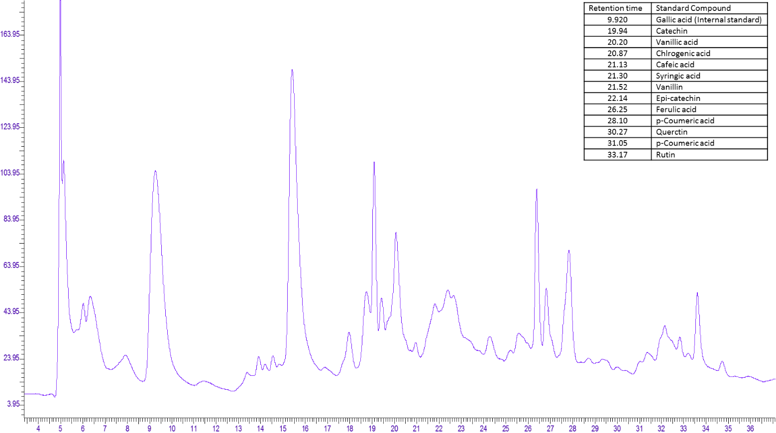

Fig. S1. Chromatogram showing retention time and peaks of various phenolic and flavonoid compounds