**Supplementary data**

**Unravelling the beehive air volatiles profile as analysed *via* solid-phase microextraction (SPME) and chemometrics**

**Aida A. Abd El-Waheda, Mohamed A. Farag b,c,*, Walaa A. Eraqid, Gaber A. M. Mersale, Chao Zhaof, Shaden A.M. Khalifag, Hesham R. El-Seedi h,i,j,\***

a Department of Bee Research, Plant Protection Research Institute, Agricultural Research Centre, 12627 Giza, Egypt

b Pharmacognosy Department, College of Pharmacy, Cairo University, Kasr el Aini St., P.B. 11562, Cairo, Egypt

c Department of Chemistry, School of Sciences and Engineering, The American University in Cairo, New Cairo 11835, Egypt

d Department of Microbiology and Immunology, Faculty of Pharmacy, Cairo University, Cairo 11562, Egypt

e Chemistry Department, College of Science, Taif University, Taif 21944, Saudi Arabia

f College of Food Science, Fujian Agriculture and Forestry University, Fuzhou 350002, China

g Department of Molecular Biosciences, The Wenner-Gren Institute, Stockholm University, S-10691, Stockholm, Sweden

h Pharmacognosy Group, Department of Pharmaceutical Biosciences, Uppsala University, Biomedical Centre, Box 574, 751 23 Uppsala, Sweden

i Department of Chemistry, Faculty of Science, Menouﬁa University, 32512 Shebin El-Kom, Egypt

j International Research Center for Food Nutrition and Safety, Jiangsu University, Zhenjiang 212013, China

*Corresponding author: [Mohamed.farag@pharma.cu.edu.eg](mailto:Mohamed.farag@pharma.cu.edu.eg) & [Mohamed.alifarag@aucegypt.edu](mailto:Mohamed.alifarag@aucegypt.edu); Tel.: +011-202-2362245 **(M.F.A**); [hesham.el-seedi@farmbio.uu.se](mailto:hesham.el-seedi@farmbio.uu.se) ; Tel.: +46 700 43 43 43 (H.R.E.-S.)

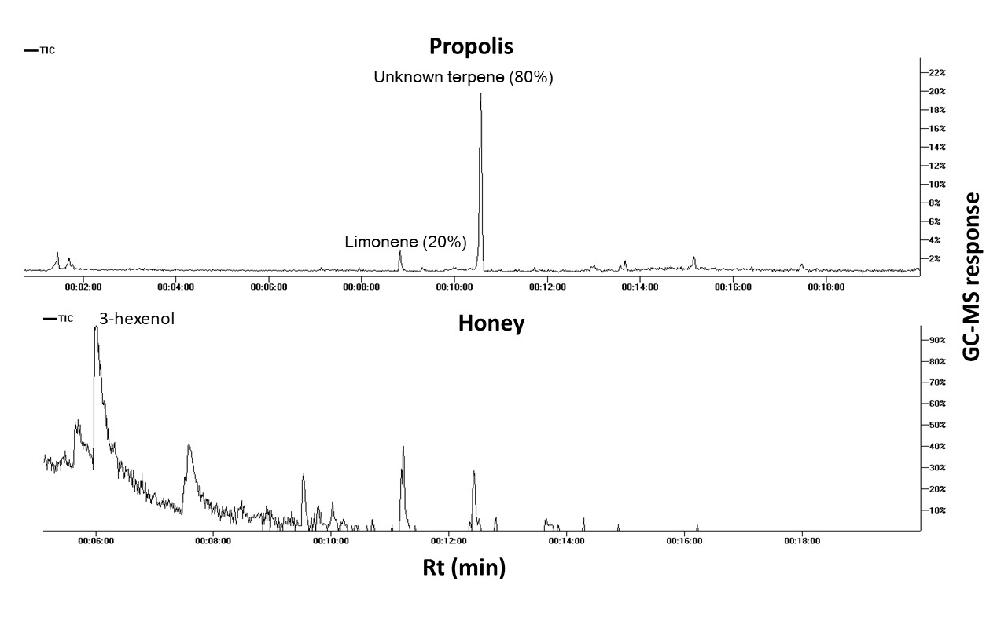

**Fig. S1**. Representative SPME GC-MS chromatograms of propolis and honey headspace.

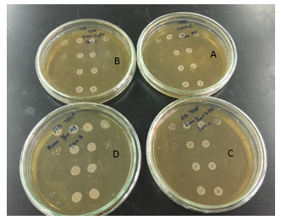

**Fig. S2**. Viability titre assay at different dilutions of S. aureus solution spotted from varient wells onto a microplate post exposure to bee venom. (A) Negative control, (B) Bacterial solution from 2nd well, (C) Bacterial solution from 3rd well, (D) Bacterial solution from 4th well.