**Supplementary information**

**Manuscript Title:**

*Biochar/Polypropylene Composites: A Study on the Effect of Pyrolysis Temperature on Crystallization Kinetics, Crystalline Structure, and Thermal Stability*

**Authors:**

Abdulaziz A. Alghyamah1, Ahmed Yagoub Elnour1,2, Hamid Shaikh2*, Sajjad Haider1, Anesh Manjaly Poulose2, S. M. Al-Zahrani1,2, Waheed A. Almasry1, Soo Young Park3

**Institutional affiliations:**

1) Chemical Engineering Department, College of Engineering, King Saud University, Riyadh 11421, Saudi Arabia

2) SABIC Polymer Research Centre (SPRC), Chemical Engineering Department, King Saud University, P. O. Box 800, Riyadh, 11421, Saudi Arabia

3) Department of Polymer Science & Engineering, Polymeric Nanomaterials Laboratory, School of Applied Chemical Engineering, Kyungpook National University, 80 Daehak-ro, Buk-gu, 41566 Daegu, Korea.

* **Corresponding author.**

E-mail addresses: [aalghyamah@ksu.edu.sa](mailto:aalghyamah@ksu.edu.sa) (A. A. Alghyamah), [aelnour@ksu.edu.sa](mailto:aelnour@ksu.edu.sa) (A. Y. Elnour), [shaider@ksu.edu.sa](mailto:shaider@ksu.edu.sa) (S. Haider), [hamshaikh@ksu.edu.sa](mailto:hamshaikh@ksu.edu.sa) (H. Shaikh), [apoulose@ksu.edu.sa](mailto:apoulose@ksu.edu.sa) (A. M. Poulose), [szahrani@ksu.edu.sa](mailto:szahrani@ksu.edu.sa) (S. M. Al-Zahrani), [walmasry@ksu.edu.sa](mailto:walmasry@ksu.edu.sa) (W. A. Almasry), [psy@knu.ac.kr](mailto:psy@knu.ac.kr) (S. Y. Park).

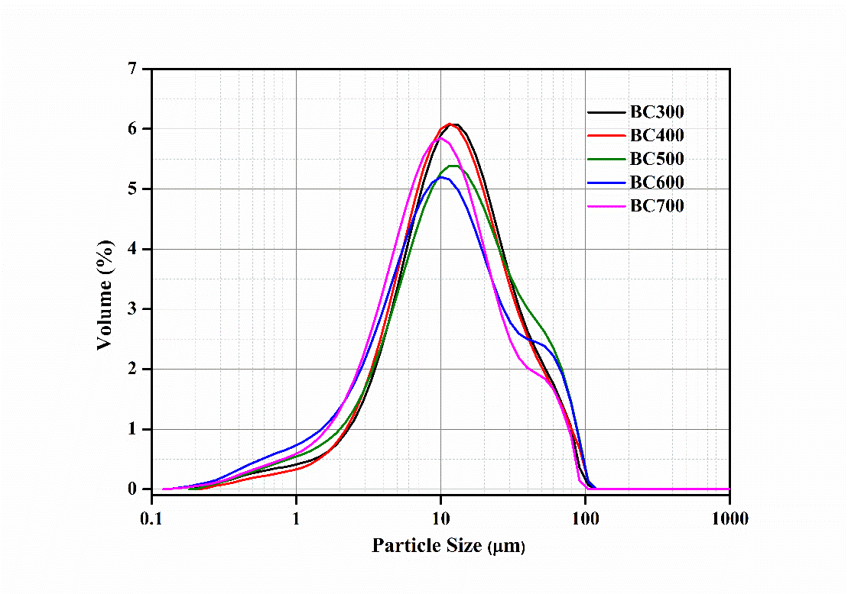

Figure S1. Particle size distribution of biochar samples

The characteristic particle size of biochar samples is reported in **Table S.1**. As it can be seen, the differences in particle size distribution between biochar samples are not significant (BC samples have almost the same size distribution). Therefore, any potential alteration (differences) in the properties of the BC/PP composites that is reinforced with different type of BC will not be attributed to the variance of BC samples particle size.

Table S.1. Summary of particle size of biochar samples.

|  |  |  |  |  |  |  |  |
| --- | --- | --- | --- | --- | --- | --- | --- |
| Sample type | Particle size in µm | | | | | | |
| D10 | D50 | | D90 | | Daverage | |
| BC300 | 3.57 | | 13.04 | | 43.19 | | 18.89 |
| BC400 | 3.71 | | 12.66 | | 43.29 | | 18.87 |
| BC500 | 3.08 | | 13.35 | | 50.85 | | 20.65 |
| BC600 | 2.26 | | 11.11 | | 49.29 | | 18.75 |
| BC700 | 2.61 | | 10.40 | | 39.37 | | 16.25 |

D10 (10% of total particles lies below this diameter), D50 (50% of total particles lies below this diameter), D90 (90% of total particles lies below this diameter) and Daverage (the volume weighted average particle size)

Table S.2. Physicochemical characteristics of biochar samples.

| **Sample** | **Ultimate Analysis** | | | | **Proximate Analysis** | | **Physical Analysis** | |
| --- | --- | --- | --- | --- | --- | --- | --- | --- |
| **C %** | **H %** | **N %** | **O%(a)** | **Moisture %** | **Ash %** | **SA(b) (m2/g)** | **VP (c) (m3/g)** |
| **BC300** | 63.72 (4.12) | 3.91 (0.27) | 1.17 (0.05) | 19.66 (4.83) | 4.63 (0.26) | 11.54 (0.13) | 2.04  (1.03) | 0.0057  (0.0001) |
| **BC400** | 65.23 (1.21) | 3.13 (0.13) | 0.92 (0.03) | 16.95 (0.80) | 3.92 (0.12) | 13.77 (0.21) | 5.54  (2.30) | 0.0055  (0.0001) |
| **BC500** | 71.16 (1.37) | 2.37 (0.15) | 0.85 (0.02) | 9.71 (1.29) | 3.31 (0.09) | 15.91 (0.17) | 123.63  (15.33) | 0.0209  (0.0002) |
| **BC600** | 72.63 (0.79) | 1.62 (0.03) | 0.74 (0.01) | 7.13 (1.94) | 2.64 (0.10) | 17.88 (0.21) | 221.23  (22.57) | 0.0317  (0.0005) |
| **BC700** | 75.17 (2.05) | 0.93 (0.01) | 0.63 (0.01) | 4.70 (0.91) | 2.79 (0.05) | 18.57 (0.21) | 249.13  (34.12) | 0.0308  (0.0005) |

1. Oxygen determined by difference (100% − (C + H +N + ash %)). All analyses were conducted in triplicate (n = 3), values between brackets represent the standard deviation; (b) BET surface area; (c) Pore volume.

Table S. 3: Formulations of BC/PP composites

|  |  |  |
| --- | --- | --- |
| **Composite** | **PP wt. %** | **BC wt. %** |
| Neat PP | 100 | 0 |
| 5BC (α)*/PP | 95 | 5 |
| 10BC (α)*/PP | 90 | 10 |
| 15BC (α)*/PP | 85 | 15 |
| 20BC (α)*/PP | 80 | 20 |

*: (α) represents the type of biochar used (BC300, BC400, BC500, BC600 or BC700)

|  |  |
| --- | --- |
| **(A)** | **(B)** |
| **(C)** | **(D)** |
| **Figure S2.** DTG curves of BC/PP composites, (A) 5%, (B) 10%, (C) 15% and (D) 20% loading | |

|  |  |
| --- | --- |
| **(A)** | **(B)** |
| Figure S3. TGA residual percentage of BC/PP composites (A) and maximum decomposition temperature (B) | |