**Ecological stoichiometric characteristicsof soil SOC, TN, and TP under different restoration methods in QiXing River wetland**

**Table S1**

Average temperature, precipitation, and relative humidity of QiXingRiver wetland from 2016 to 2018

|  |  |  |  |  |  |  |  |  |  |
| --- | --- | --- | --- | --- | --- | --- | --- | --- | --- |
| Seasons | AT(℃) | | | P(mm) | | | RH (%) | | |
| 2016 | 2017 | 2018 | 2016 | 2017 | 2018 | 2016 | 2017 | 2018 |
| F1Q | -16.7 | -15.67 | -9.47 | 38.00 | 40.00 | 9.00 | 95.00 | 91.67 | 64.33 |
| SQ | 6.0 | 6.67 | 13.00 | 167.0 | 150.0 | 114.3 | 69.67 | 62.33 | 75.00 |
| TQ | 23.0 | 24.33 | 24.33 | 774.0 | 302.0 | 302.0 | 73.67 | 73.00 | 73.00 |
| F2Q | 2.67 | 4.33 | 7.67 | 133.0 | 113.0 | 27.67 | 72.00 | 65.00 | 66.67 |
| Mean | 3.74 | 4.92 | 8.88 | 278.0 | 151.3 | 113.2 | 77.60 | 73.00 | 69.80 |

F1Q (First Quarter)；SQ (Second Quarter)； TQ (Third Quarter)； F2Q (Fourth Quarter)；AT (Average Temperature)；P (Precipitation)；RH (Relative Humidity)

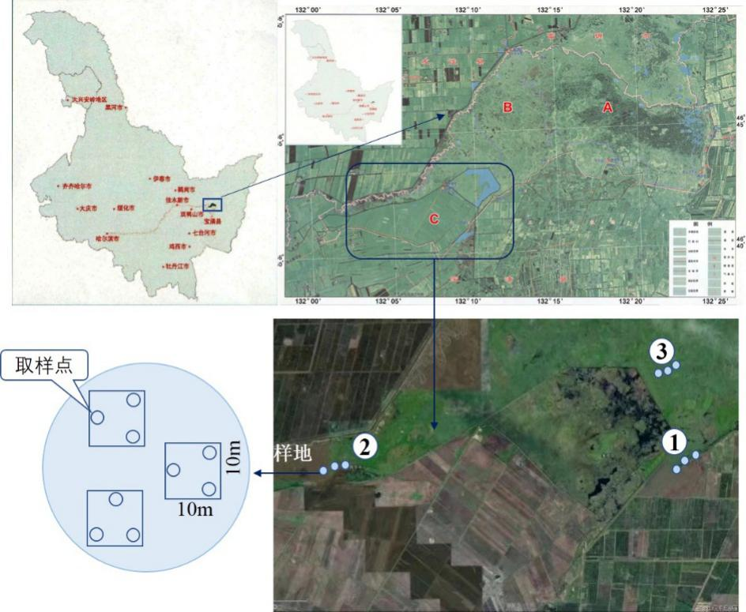

**Fig. S1.** Location of QiXing River National Wetland Reserve and distribution of research areas.

A: Core area; B: Buffer area; C: Experimental area; ①②③ present research area respectively.

**Table S2**

Location of the sample site in QiXing River wetland research area

|  |  |  |  |
| --- | --- | --- | --- |
| Sample site | Research area | | |
| ① | ② | ③ |
| Sample site 1 | 132°05′44.7＂E 46°42′15.6＂N | 132°11′32.6＂E 46°43′09.9＂N | 132°11′35.7＂E 46°43′12.5＂N |
| Sample site 2 | 132°05′43.7＂E 46°42′15.8＂N | 132°11′28.7＂E  46°43′09.5＂N | 132°11′35.9＂E 46°43′11.9＂N |
| Sample site 3 | 132°05′34.8＂E 46°42′11.1＂N | 132°11′28.7＂E  46°42′06.6＂N | 132°11′45.5＂E 46°42′15.5＂N |

①RFW，②RFF，③NW

**Table S3**

Soil carbon, nitrogen, and phosphorus content of classification standard in China.

|  |  |  |  |  |
| --- | --- | --- | --- | --- |
| 级别 | SOC(g/kg) | TN(g/kg) | TP(g/kg) | Rate |
| Level rating | SOC | TN | TP |
| Ⅰ  Ⅱ  Ⅲ  Ⅳ  Ⅵ  Ⅴ | >23.20  17.40~23.20  11.60~17.40  5.80~11.60  3.48~5.80  <3.48 | >2.00  1.50~2.00  1.00~1.50  0.75~1.00  0.50~0.75  <0.50 | >1.00  0.80~1.00  0.60~0.80  0.40~0.60  0.20~0.40  <0.20 | Excellent  Well  Above the average  Below the average  Imperfect  Scarcity |