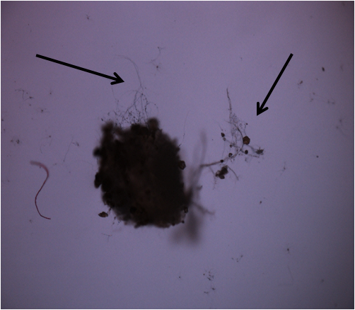

Bright field microscopic image showing emergence of hyphae of *P. lilacinum* 6029 from the egg mass of *M. incognita* (40X magnification)

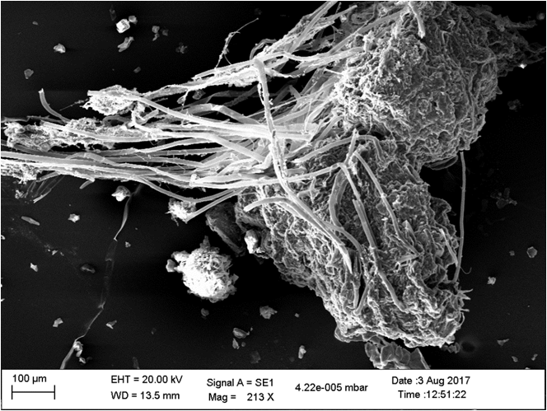

SEM image of egg mass colonized by *P. lilacinum* 6029 mycelium

**Supplementary S1.** Bright field microscopic (40X) and SEM image of egg mass colonized by *P. lilacinum* 6029 mycelium

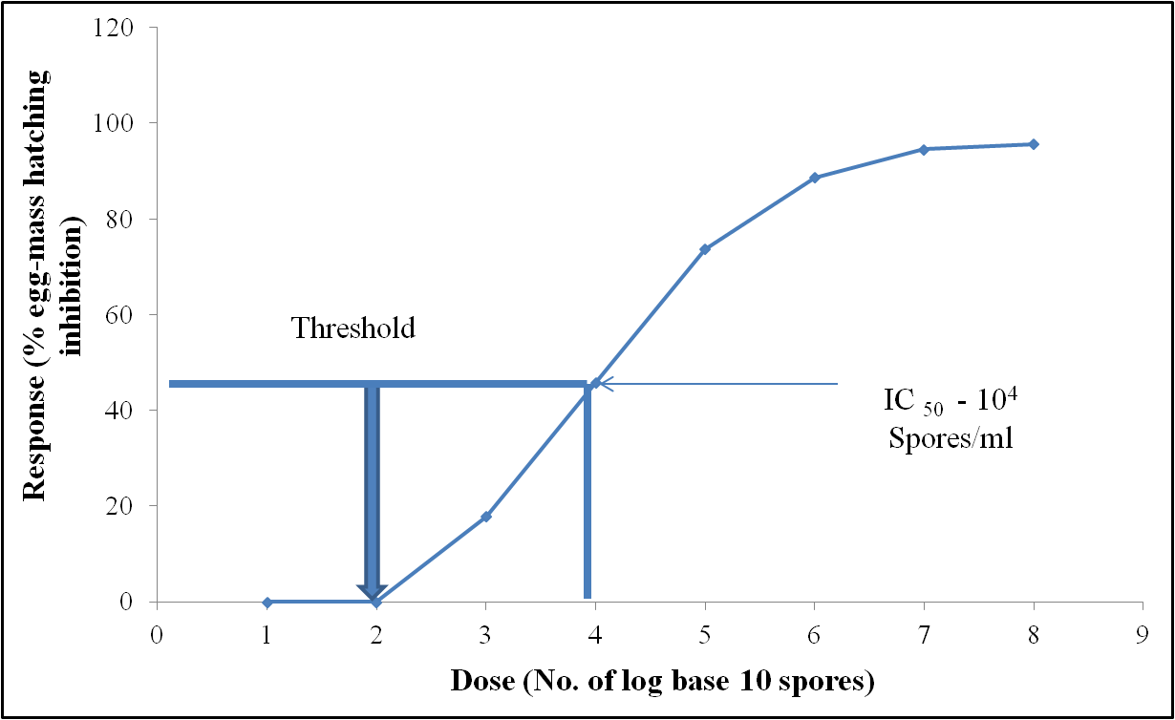

**Supplementary S2.** A log dose-response (*in-vitro*) of *P. lilacinum* 6029 spores from the formulation on egg mass hatching inhibition of *M. incognita*