**Fabrication of ZnO nanorods based gas sensor pattern by photolithography and lift off techniques**

Daejeong Yang1**,** Adam Gopal Ramu 1, Youngjin Lee2, Sungjin Kim2, Heungwoo Jeon3* Sathishkumar V E4,Amal M. Al-Mohaimeed5, Wedad A. Al-onazi5 and Tahani saad Algarni5, Dongjin Choi1*

*1School of Materials Science and Engineering, Hongik University 2639, Sejong-ro, Jochiwon-eup Sejong city, 30016 S Korea.*

*2School of Advanced Materials & Engineering, Kumoh National Institute of Technology, 61 Daehak-Ro, Gumi 39177, S Korea.*

*3School of electronic & Engineering, Kumoh National Institute of Technology, 61 Daehak-Ro, Gumi 39177, S Korea.*

*4Department of Computer Science and Engineering Kongu Engineering College Perundurai, Tamilnadu, India*

*5Department of Chemistry, College of Science, King Saud University, P.O. Box 22452, Riyadh 11495, Saudi Arabia.*

***\*corresponding e-mail:*** [*djchoi@hongik.ac.kr*](mailto:djchoi@hongik.ac.kr) *(Dongjin Choi)*

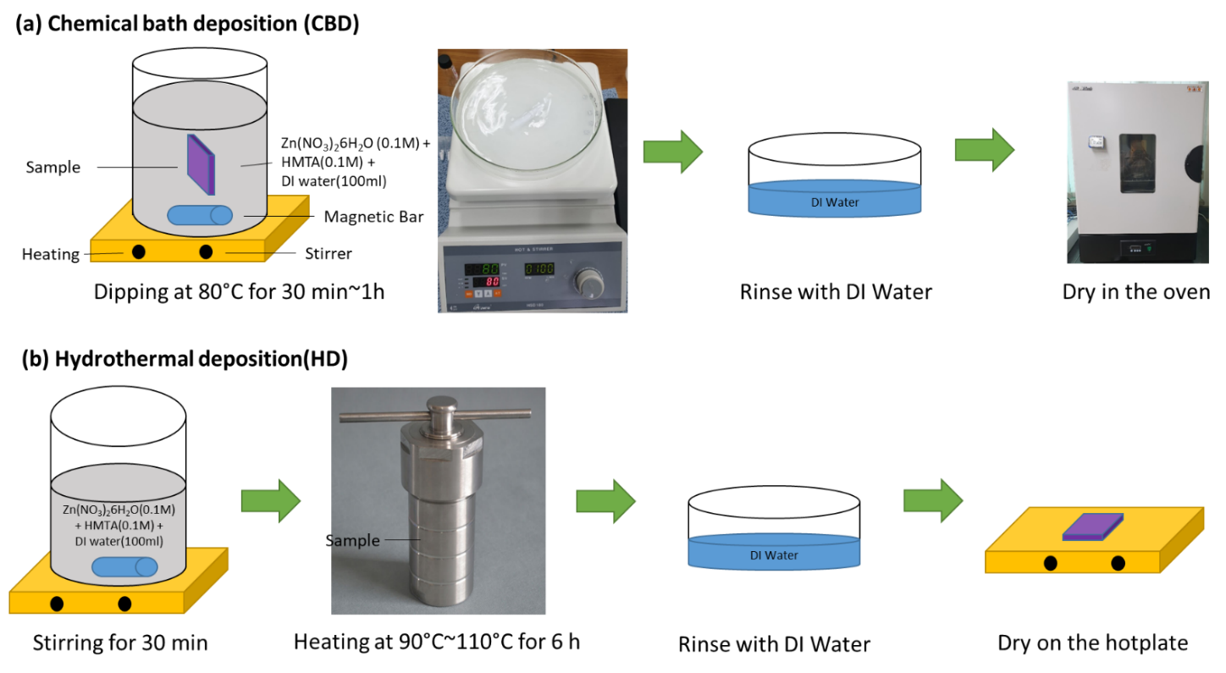

**Fig. SI.1** Schematic diagram for synthesis of ZnO nanorods films using (a) chemical bath deposition, (b) hydrothermal deposition.

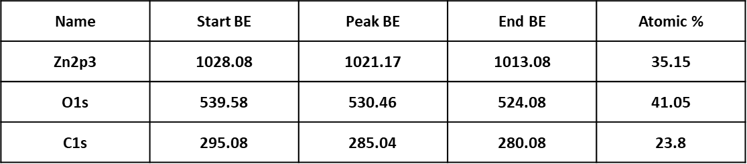

**Fig. SI.2** XPS atomic percentage of the ZnO nanrods.