**Supporting Information**

for

Synthesis of nanocomposite films based on conjugated oligomer-2D layered MoS2 as a potential candidate for optoelectronic devices

F. Barakat 1,2,5, M.S. AlSalhi 1,2,*, S. Prasad 1,2, S. Alterary 3,4, S. Faraji 5 and A. Laref 1

1 Department of Physics and Astronomy, College of Science, King Saud University, P.O. Box. 2455, Riyadh, Saudi Arabia (F.Barakat); fbarakat@ksu.edu.sa; (S. Prasad)1; [srajendra@ksu.edu.sa](mailto:srajendra@ksu.edu.sa); (A. Laref) alaref@ksu.edu.sa

2 Research Chair in Laser Diagnosis of Cancers, Department of Physics and Astronomy College of Science, King Saud University, P.O. Box. 2455, Riyadh, 11451, Saudi Arabia.

3 Department Chemistry, College of Science, King Saud University, P.O. Box. 2455, Riyadh,11451, Saudi Arabia (S. Alterary) salterary@ksu.edu.sa

4 King Abdullah Institute of Nanotechnology, King Saud University, P.O. Box. 2455, Riyadh,11451, Saudi Arabia

5 Zernike Institute for Advanced Materials, University of Groningen, P.O. Box. 729700, AB Groningen, Netherland ; (S. Faraji ) s.s.faraji@rug.nl

**\*** Correspondance: AlSalhi:malsalhy@gmail.com; malsalhi@ksu.edu.sa ,Tel.: +966-50-510-4815

***S1. Surface Morphology (Transmission Electron Microscope (TEM))***

TEM represents a practical tool to inspect small details in the different materials down to near atomic levels. The TEM images are grasped to reveal more the characteristics of structures for MoS2 films. The structural morphologies of MoS2 films are altered with the addition of oligomer, as displayed in TEM images (Figure S1). The successful loading of the pure MoS2 films are further described within TEM as established by our measurements. The lateral dimension of MoS2 films lies between a few hundreds of nanometers having an average of 200 nm. The reduced contrast in TEM images implied a relative transparency of MoS2 films to the electron beam. TEM measures the morphology, crystallinity and the order of MoS2 sample. It was illustrated that the crystallinity shape of the pure MoS2 nanoparticles has a hexagonal order for MoS2 nanoparticles. The hexagonal structure of MoS2 is noticeable in the images, of high-resolution TEM (Figure S1). Thus, the MoS2 films can be grown by varying the thickness, as thick or thin layers, owing to the hexagonality of the structure.

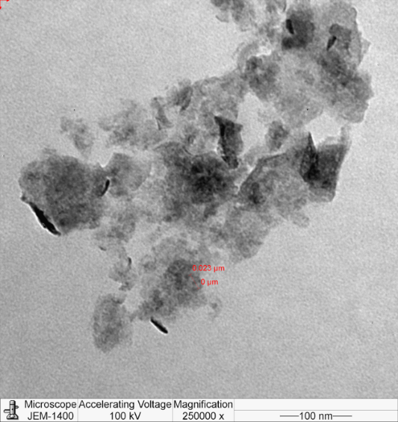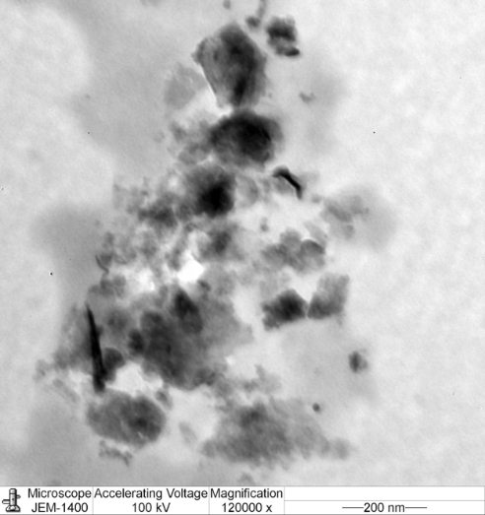



**FigS1**. Transmission electron microscope (TEM) image of pure MoS2 solution.

***S2. Profilometer Thickness Measurement***



**a)**



**b)**



**c)**

**Fig.S2.** thickness profile of (a) pure MoS2 spin coated at 1000 and 3000 rpm,(b)pure oligomer spin coated at 1000 and 3000 rpm, and (c) mix solution spin coated at 1000 and 3000 rpm.