**Metal organic framework- derived Ni-Cu bimetallic electrocatalyst for efficient oxygen evolution reaction**

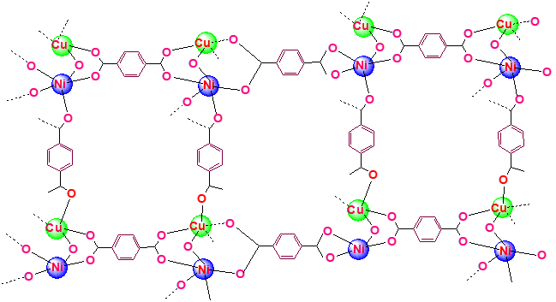

**Scheme 1.** Hypothetical structure of synthesized NiCu-MOF.

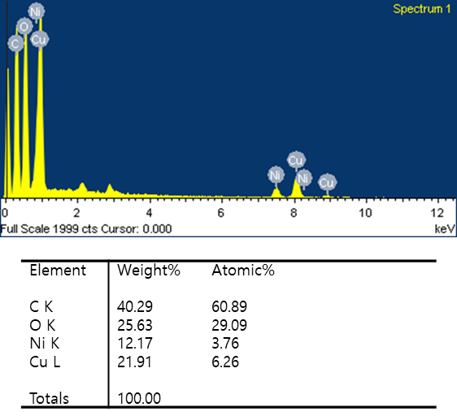

**Fig 1.** EDX spectrum of NiCu-MOF catalyst.

**Table 1.** EDX analysis of NiCu-MOF catalyst.



**Table 2.** EDX analysis of Cu-MOF catalyst.

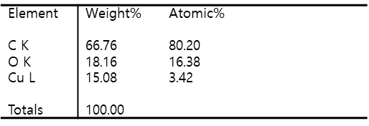

**Table 3.** EDX analysis of Ni-MOF catalyst.

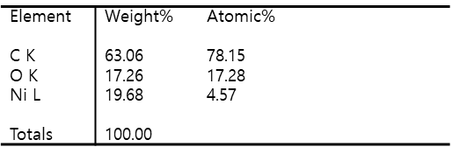

**Table 4.** Elemental composition obtained from XPS.

|  |  |  |  |  |  |  |
| --- | --- | --- | --- | --- | --- | --- |
| Name | Peak BE | Height Counts | FWHM eV | Area (P) CPS.eV | Area (N) | At. % |
| C1s | 285.02 | 66438.48 | 3.47 | 279357.2 | 39727.52 | 35.91 |
| O1s | 532.65 | 76525.16 | 3.13 | 269951.4 | 13494.98 | 12.2 |
| Ni2p | 858.21 | 9121.45 | 4.33 | 107939 | 1149.13 | 1.04 |
| Cu2p | 935.38 | 30044.59 | 4.33 | 290910.3 | 2763.98 | 2.5 |



**Fig S2.** XPS survey spectrum of NiCu-MOF.

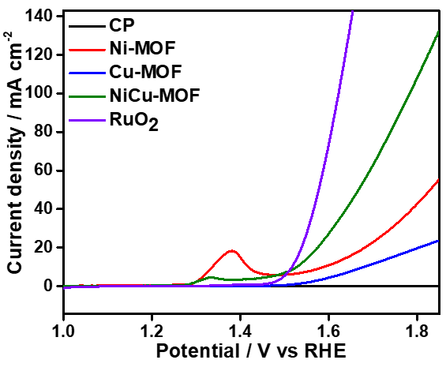

**Fig S3.** Comparison LSV study RuO2 with other catalyst.



**Fig S4.** Electrochemical impedance spectrum of Ni-MOF, Cu-MOF and NiCu-MOF catalyst.

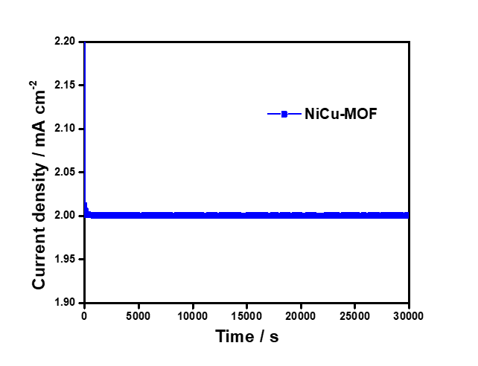

**Fig S5.** Chronoamprometry study of NiCu-MOF catalyst.

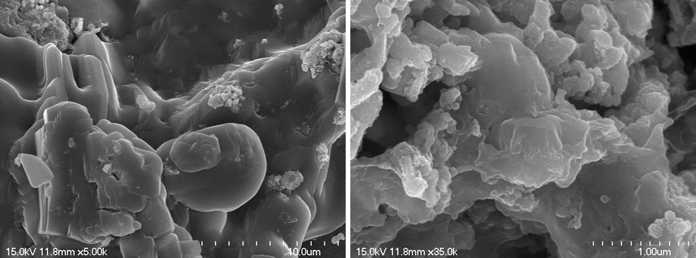

**Fig S6**. FE-SEM images of NiCu-MOF after OER study.

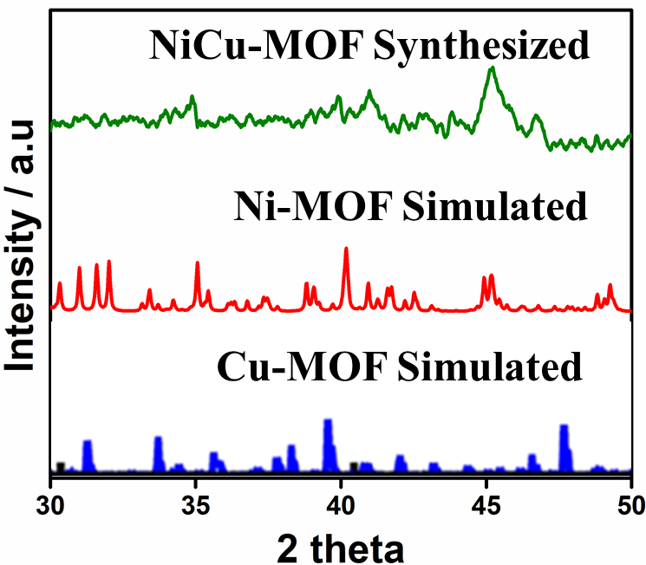

**Fig S7.** Simulated XRD pattern of Ni-MOF (Yang et al., 2014) and Cu-MOF (Zhang et al., 2018) and synthesized NiCu-MOF.

**Table 5**. Comparison of OER onset potential, tafel slope and overpotential of different Ni and Cu based materials.

|  |  |  |  |  |  |
| --- | --- | --- | --- | --- | --- |
| S.No | Catalyst | Onset potential (V) | Tafel  (mV/dec) | Overpotential   (mV) | Ref. |
| 1. | Ni/Co-P-1/0 | 1.65 | 113 | 423 | Zheng et al., 2019 |
| 2. | Co-Ni/HA-MWCNTs | 1.50 | 41.8 | 270 | Safavi et al., 2020 |
| 3. | NiO/Ni/C | 1.54 | - | 310 | Zhang et al., 2017 |
| 4. | Ni0.78WO2.72 | 1.50 | - | 270 | Xi et al., 2017 |
| 5. | Ni-Bi/RGO | 1.58 | 85 | 359 | Cao et al., 2018 |
| 6. | NiCo-LDH | 1.56 | 41 | 335 | Kanan et al., 2008 |
| 7. | MWCNTs/CuO | 1.58 | 53 | 350 | Qian et al., 2018 |
| 8. | Ni2.85Cu0.15S2 | 1.489 | 54.9 | 259 | Liu et al., 2021 |
| 9. | CoNi-CuHP/NF | 1.6 | 88 | 370 | Zhang et al., 2018 |
| 10 | NiCu-MOF | 1.48 | 169 | 250 | This work |

Cao, X., Cui, L., Wang, X., Yang, W. and Liu, J., 2018. Nickel‐Borate/Reduced Graphene Oxide Nanohybrid: A Robust and Efficient Electrocatalyst for Oxygen Evolution Reaction in Alkaline and Near Neutral Media. *ChemCatChem*. *10*, 2826-2832.

Kanan, M.W. and Nocera, D.G., 2008. In situ formation of an oxygen-evolving catalyst in neutral water containing phosphate and Co2+. *Science* *321*, 1072-1075.

Liu, H., Guo, Z. and Lian, J., 2021 Cu-doped Ni3S2 nanosheet arrays on Ni foam as an efficient electrocatalyst for oxygen evolution reaction. *J. Solid State Chem*. *293*,121776.

Qian, M., Liu, X., Cui, S., Jia, H. and Du, P., 2018. Copper oxide nanosheets prepared by molten salt method for efficient electrocatalytic oxygen evolution reaction with low catalyst loading. *Electrochim. Acta 263*, 318-327.

Safavi, A., Mohammadi, A. and Sorouri, M., 2020. Cobalt-Nickel Wrapped Hydroxyapatite Carbon Nanotubes as a New Catalyst in Oxygen Evolution Reaction in Alkaline Media. Electrocatalysis. 11, 226-233.

Xi, Z., Mendoza-Garcia, A., Zhu, H., Chi, M., Su, D., Erdosy, D.P., Li, J. and Sun, S., 2017. NixWO2. 72 nanorods as an efficient electrocatalyst for oxygen evolution reaction. *Green Energy Environ.* *2*, 119-123.

Yang, J., Xiong, P., Zheng, C., Qiu, H. and Wei, M., 2014. Metal–organic frameworks: a new promising class of materials for a high performance supercapacitor electrode. J. Mater. Chem. A. 2, 16640-16644.

Zhang, Q., Chen, M., Zhong, L., Ye, Q., Jiang, S. and Huang, Z., 2018. Highly effective removal of metal cyanide complexes and recovery of palladium using quaternary-ammonium-functionalized MOFs. *Molecules* *23*, 2086.

Zhang, R., Wei, H., Si, W., Ou, G., Zhao, C., Song, M., Zhang, C. and Wu, H., 2017. Enhanced electrocatalytic activity for water splitting on NiO/Ni/carbon fiber paper. *Materials.* 10, 15.

Zhang, Y., Qu, T., Bi, F., Hao, P., Li, M., Chen, S., Guo, X., Xie, M. and Guo, X., 2018. Trimetallic (Co/Ni/Cu) hydroxyphosphate nanosheet array as efficient and durable electrocatalyst for oxygen evolution reaction. *ACS Sustain. Chem. Eng*. *6*, 16859-16866.

Zheng, H., Huang, X., Gao, H., Lu, G., Li, A., Dong, W. and Wang, G., 2019. Cobalt-tuned nickel phosphide nanoparticles for highly efficient electrocatalysis. *Appl. Surf. Sci.* *479*, 1254-1261.