**Supplementary Material**

**Combined Docking methods and Molecular Dynamics to Identify Effective Antiviral 2, 5-diaminoBenzophenone derivatives against SARS-CoV-2**

**Table S1.** Toxicity prediction of identified Mpro SARS-Cov-2 inhibitors.

|  |  |  |  |  |
| --- | --- | --- | --- | --- |
| Compound Number | Total Clearance | AMES toxicity | hERG I inhibitor | Oral Rat Acute Toxicity (LD50) |
| 20c | 0.402 | No | No | 4.109 |
| 24c | 0.428 | No | No | 3.882 |
| 30c | 0.438 | Yes | No | 2.482 |
| 34c | 0.446 | No | No | 3.129 |
| 35c | 0.462 | No | No | 3.242 |
| 36c | 0.329 | No | No | 4.055 |

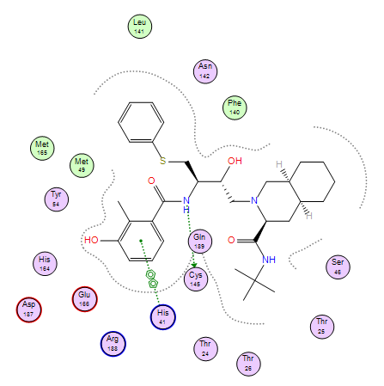

**Figure s1.** Interactions between compound Nelfinavir and the SARS-CoV-2 main protease