List of figures
Figure S1: Electron localization function (ELF) maps of hydroxychloroquine (a) on the plane of C₂₃, C₈, N₃ atoms and of hydroxychloroquine sulfate (b) on the plane of N₁₁, N₁₃, N₉.
Figure S2: Plots of the frontier molecular orbitals of hydroxychloroquine sulfate in gas phase (a) and in water (b) by using TD-DFT calculations.
Figure S3: The density of states (DOS) plots of chloroquine derivatives in gas phase (a) and in water (b) via Gauss-Sum program.
Figure S4: Molecular electrostatic potential (MEP) maps of hydroxychloroquine sulfate in gas phase (a) and in water (b).
Figure S5: Structures of docked hydroxychloroquine and hydroxychloroquine sulfate in the active sites of 5R7Y, 6M03 and 6LU7 proteins.
Figure S6: Different interactions between ligand-protein.

a)  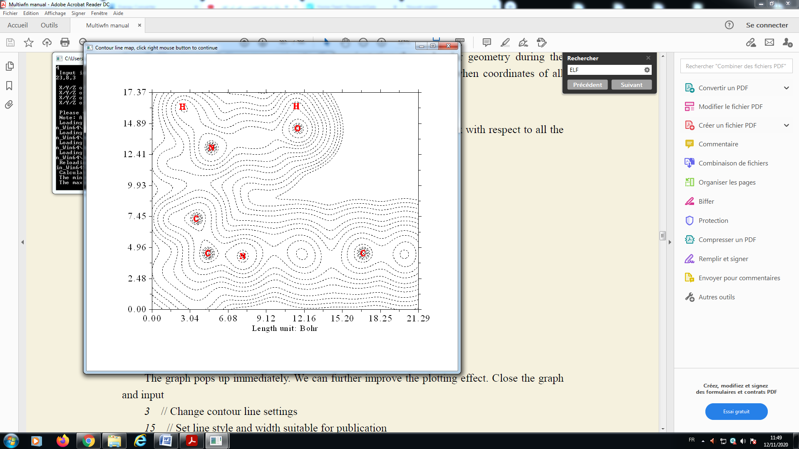 | 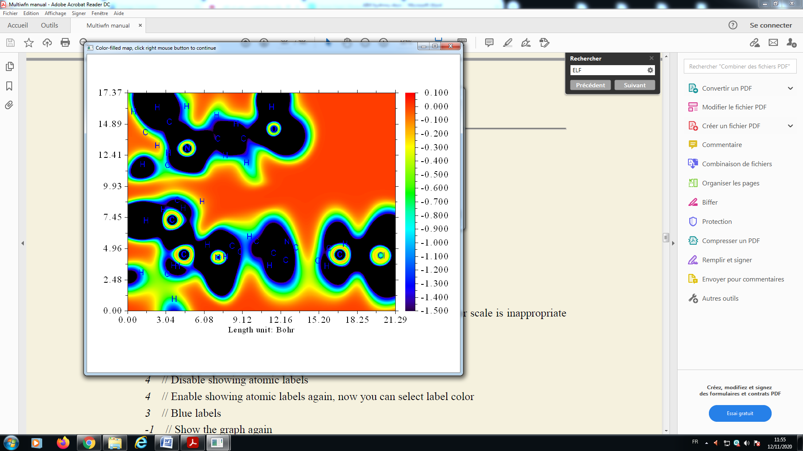
b)  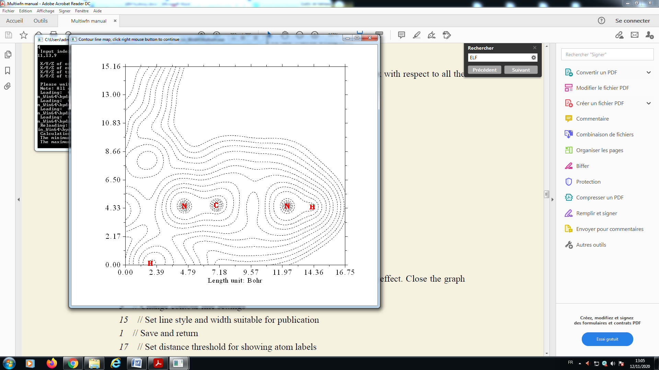 | 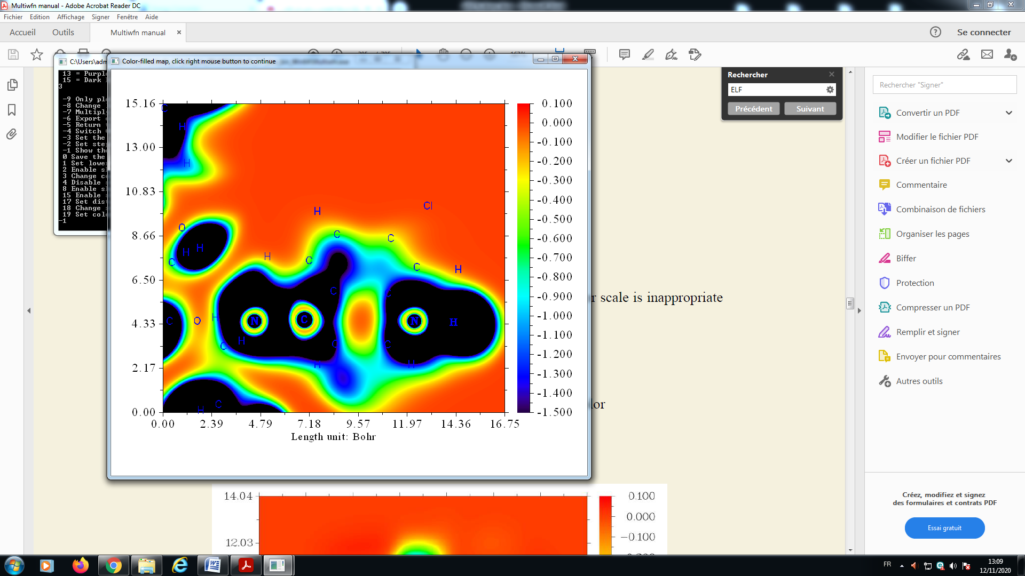
Figure S1: Electron localization function (ELF) maps of hydroxychloroquine (a) on the plane of C₂₃, C₈, N₃ atoms and of hydroxychloroquine sulfate (b) on the plane of N₁₁, N₁₃, N₉.

E(eV)  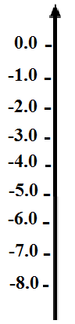 | (a)  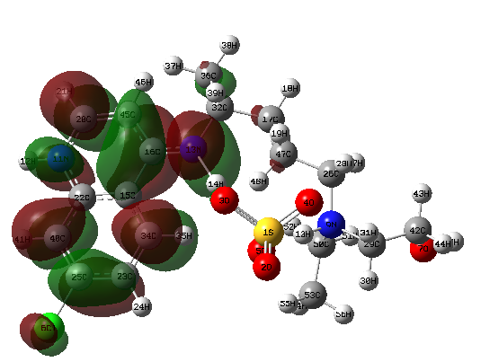 | (b)  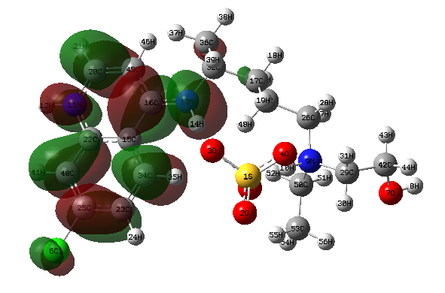
 |  | 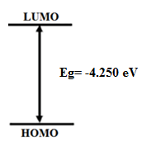
 | 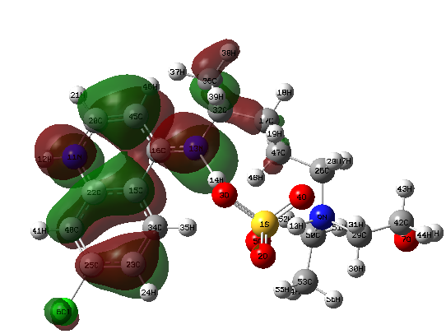 | 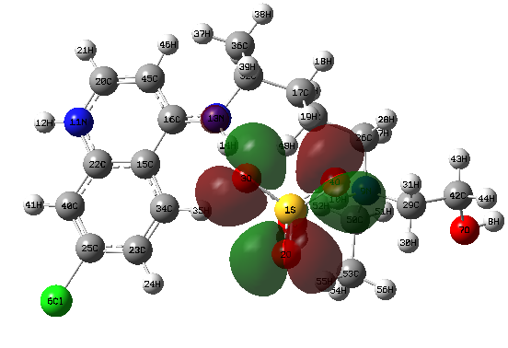
Figure S2: Plots of the frontier molecular orbitals of hydroxychloroquine sulfate in gas phase (a) and in water (b) by using TD-DFT calculations.

a) In gas phase

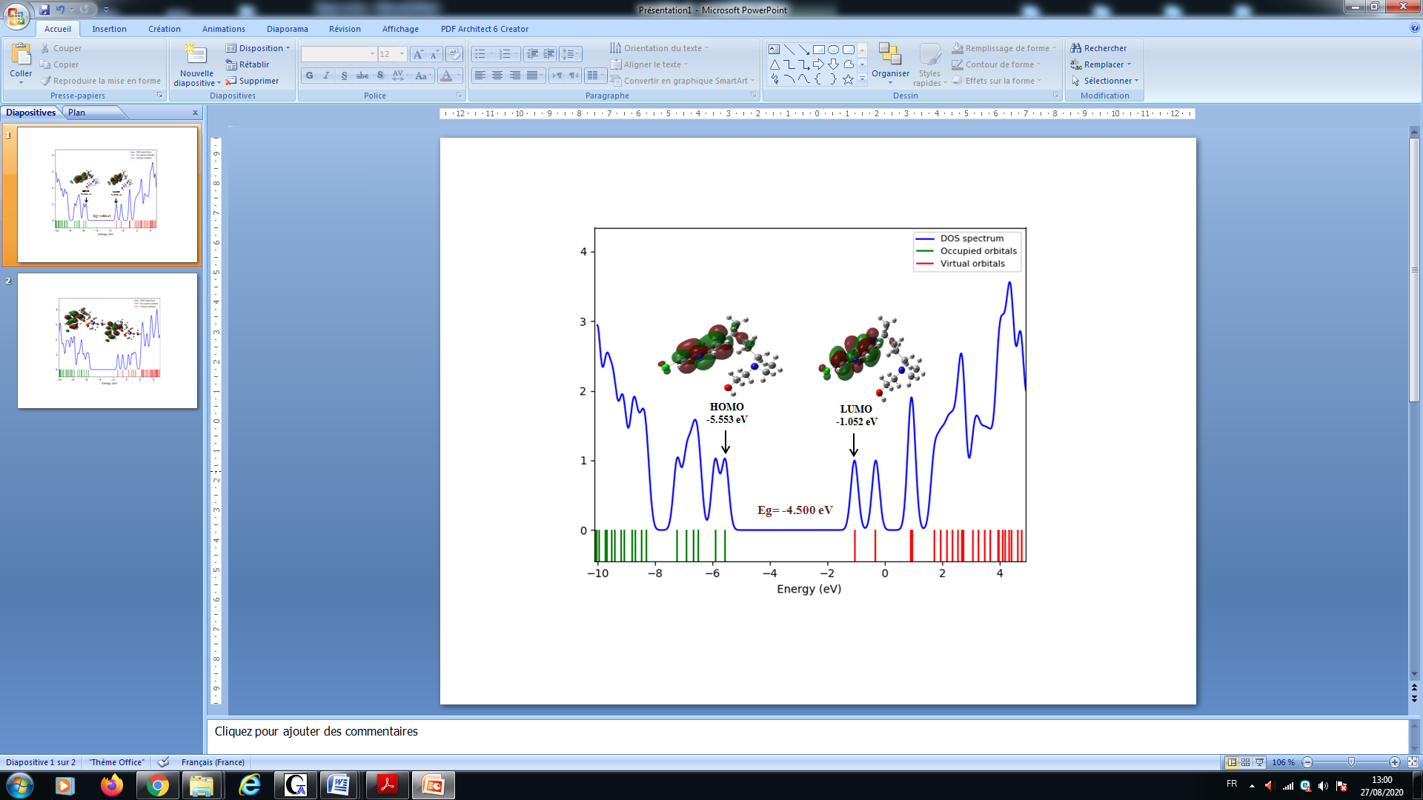 | 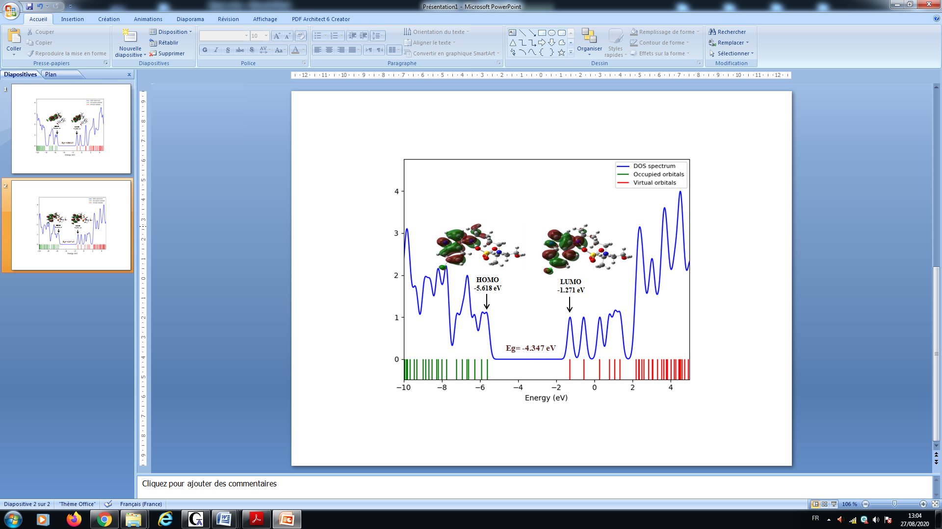
b) In water

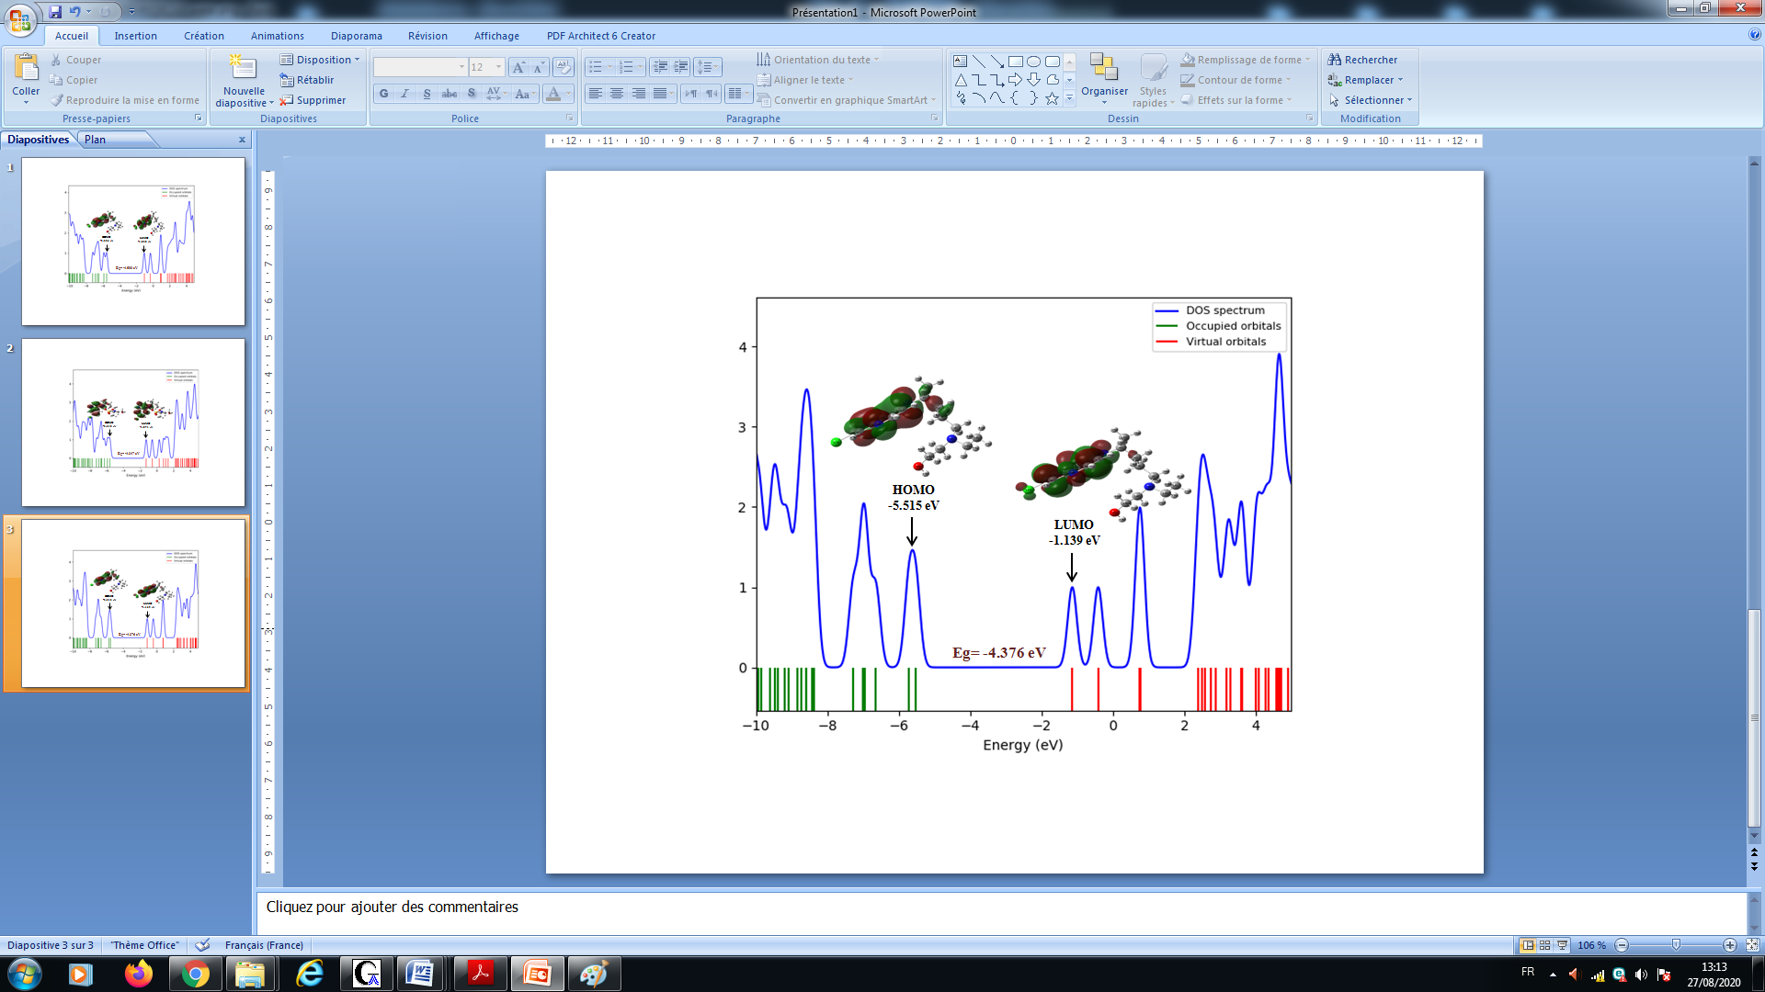 | 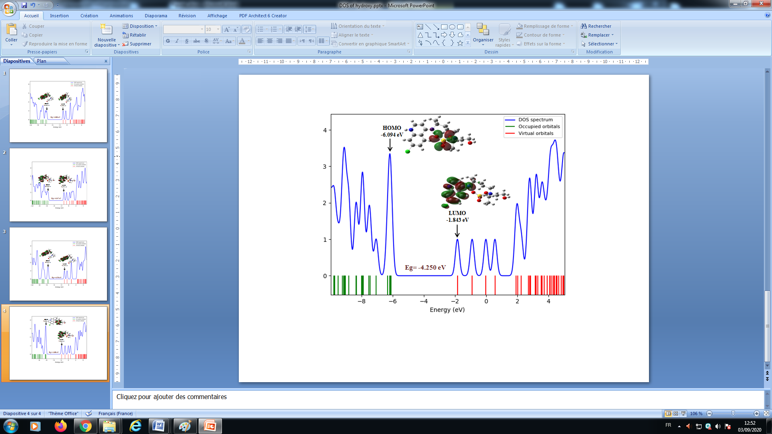
Figure S3: The density of states (DOS) plots of chloroquine derivatives in gas phase (a) and in water (b)
via Gauss-Sum program.

(a)
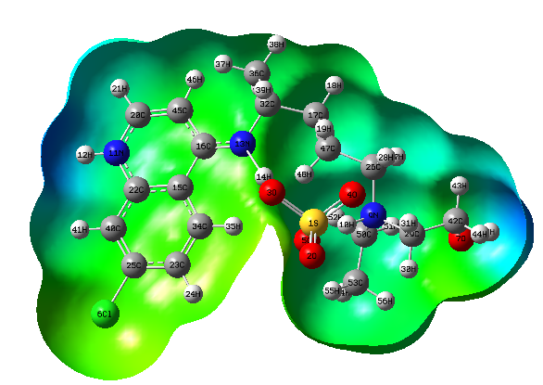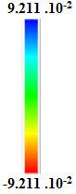

(b)
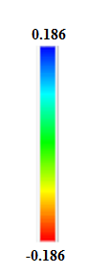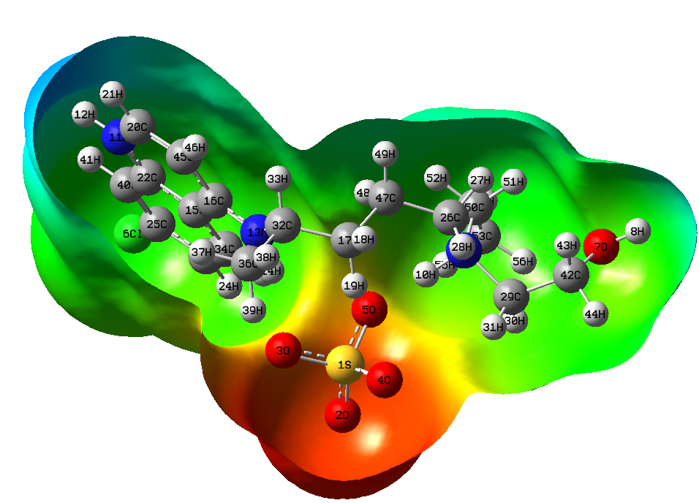
Figure S4: Molecular electrostatic potential (MEP) maps of hydroxychloroquine sulfate in gas phase (a) and in water (b).

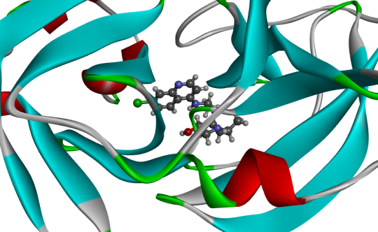 | 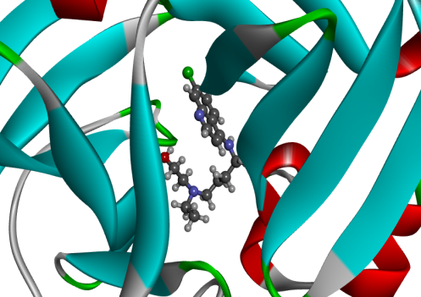 | 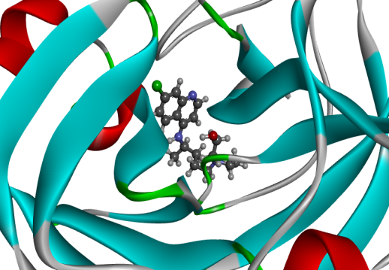
5R7Y-Hydroxychloroquine | 6M03- Hydroxychloroquine | 6LU7- Hydroxychloroquine
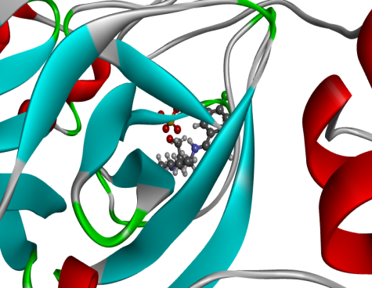 | 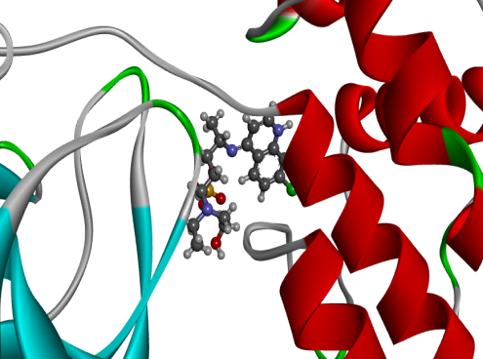 | 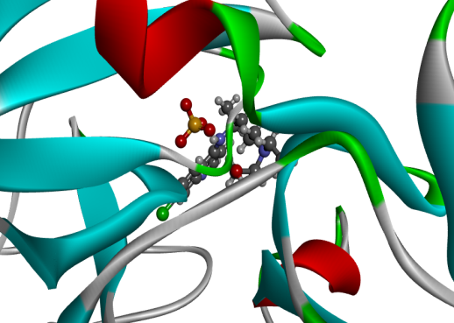
5R7Y-Hydroxychloroquine sulfate | 6M03- Hydroxychloroquine sulfate | 6LU7- Hydroxychloroquine sulfate
Figure S5: Structures of docked hydroxychloroquine and hydroxychloroquine sulfate in the active sites of 5R7Y, 6M03 and 6LU7 proteins.

(A)  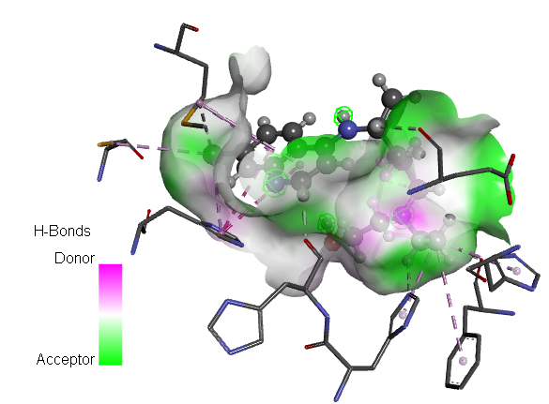 | 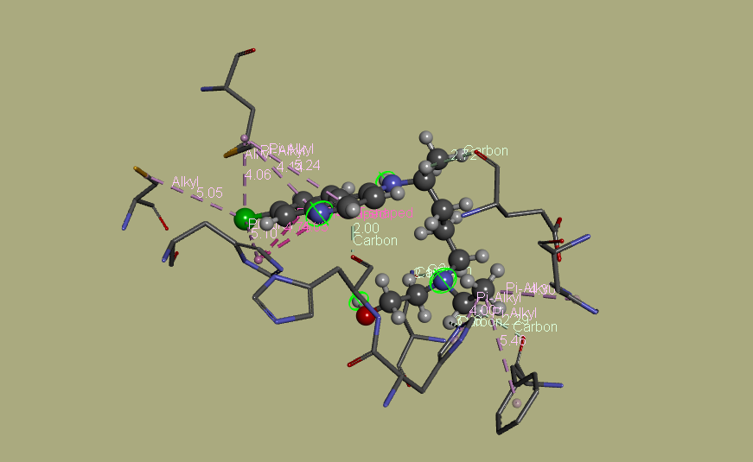
5R7Y-Hydroxychloroquine

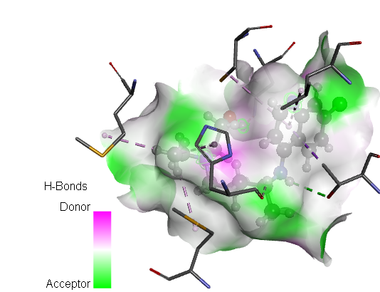 | 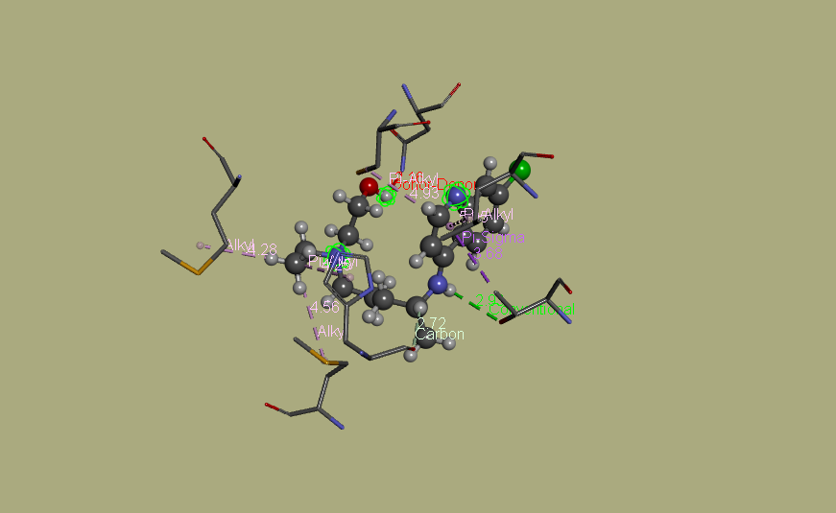
6M03- Hydroxychloroquine

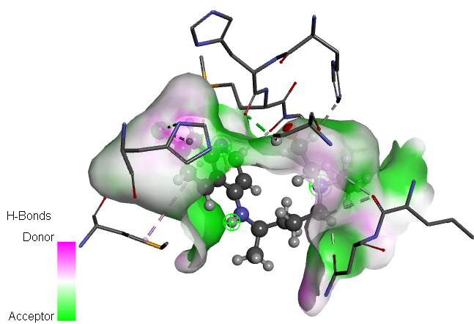 | 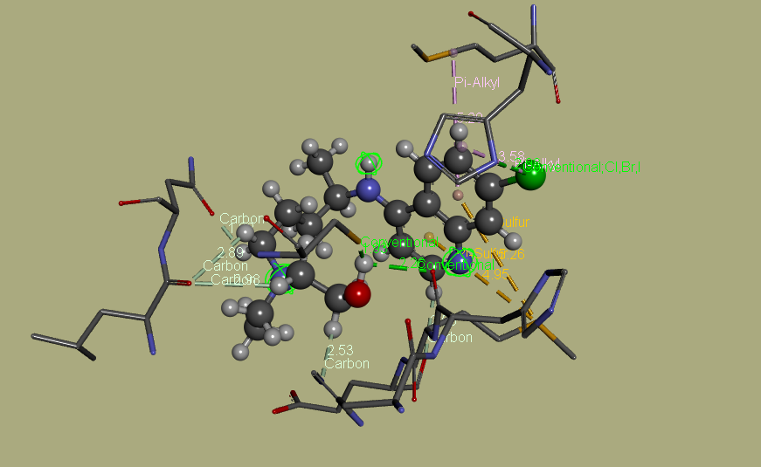
6LU7- Hydroxychloroquine

(B)  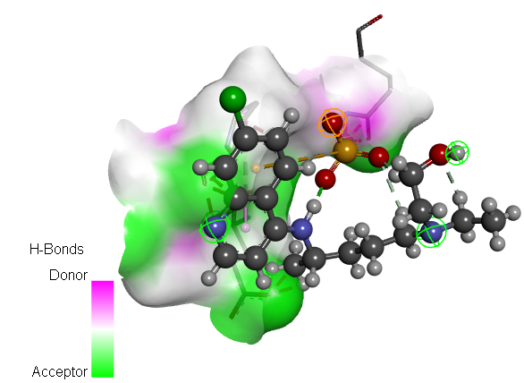 | 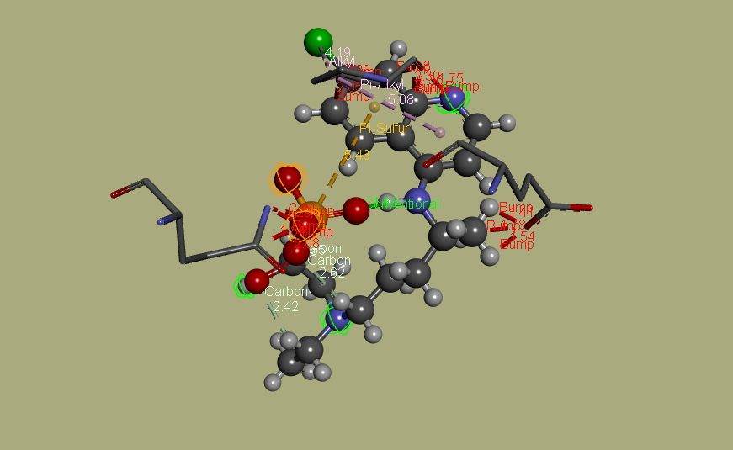
5R7Y-Hydroxychloroquine sulfate

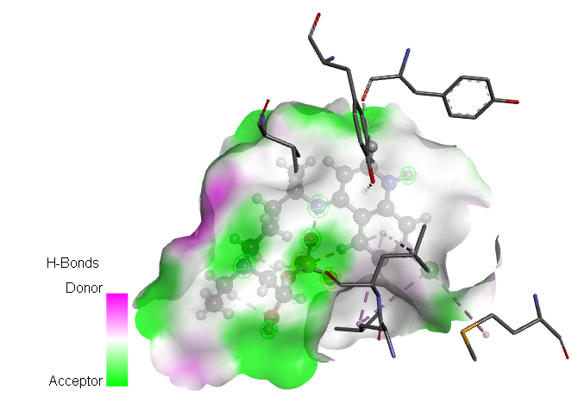 | 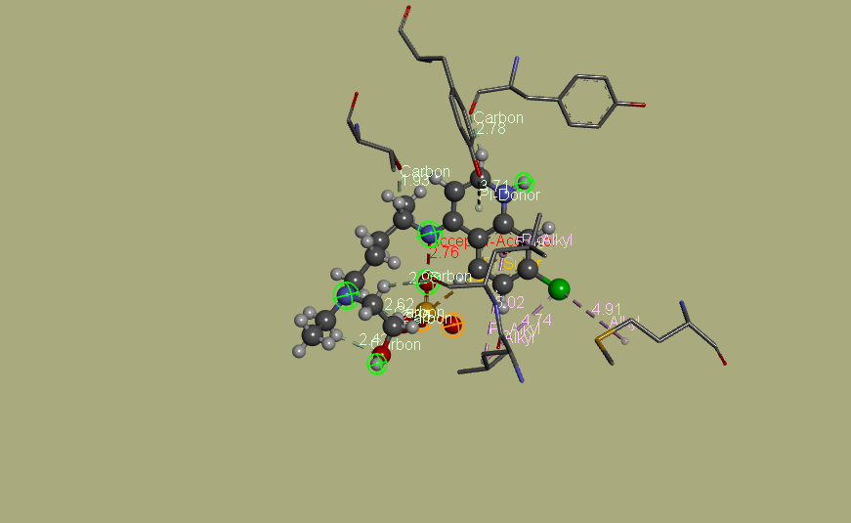
6M03- Hydroxychloroquine sulfate

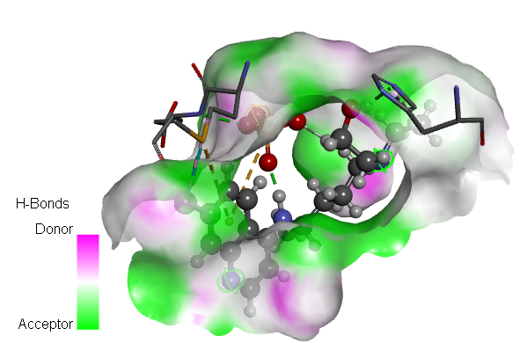 | 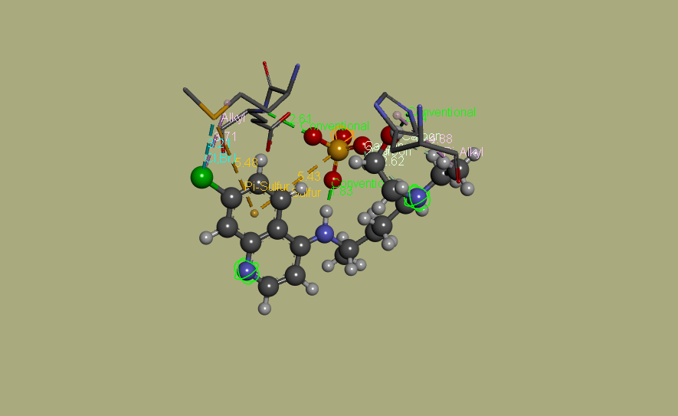
6LU7- Hydroxychloroquine sulfate

Figure S6: Different interactions between ligand-protein.

List of tables
Table S1: Calculated geometrical parameters for the hydroxychloroquine compound in the gas phase and in water compared with the experimental ones by using B3LYP/6-31G* basis set.
Table S2: Optimized parameters for the hydroxychloroquine sulfate in the gas phase and water compared with the experimental ones by using B3LYP/6-31G* basis set.
Table S3: Calculated total energies (E), RMS Cartesian force, dipole moments (µ) and Maximum Cartesian force of chloroquine derivatives by using B3LYP/6-31G* level of theory.
Table S4: Amino acid residues-hydroxychloroquine interactions.
Table S5: Amino acid residues-hydroxychloroquine sulfate interactions.

Table S1: Calculated geometrical parameters for the hydroxychloroquine compound in the gas phase and in water compared with the experimental ones by using B3LYP/6-31G* basis set.
Hydroxychloroquine
Parameters | Experimental | Theoretical |  | Parameters | Experimental | Theoretical
 |  | In the Gas | In Water |  |  | In the Gas | In Water
Bond lengths (Å)
Cl-C₂₃ | 1.760 | 1.721 | 1.767 | C₁₁-H₃₄ | 1.097 | 1.095 | 1.096
O₂-C₁₄ | 1.422 | 1.422 | 1.432 | C₁₁-H₃₅ | 1.095 | 1.096 | 1.095
O₂-H₄₉ | 0.970 | 0.973 | 0.971 | C₁₁-H₃₆ | 1.095 | 1.095 | 1.095
N₃-C₉ | 1.468 | 1.458 | 1.476 | C₁₂-C₁₅ | 1.529 | 1.519 | 1.526
N₃-C₁₀ | 1.465 | 1.464 | 1.471 | C₁₂-H₃₇ | 1.108 | 1.097 | 1.106
N₃-C₁₂ | 1.470 | 1.464 | 1.477 | C₁₂-H₃₈ | 1.095 | 1.093 | 1.094
N₄-C₈ | 1.464 | 1.448 | 1.470 | C₁₃-C₁₆ | 1.445 | 1.418 | 1.449
N₄-C₁₃ | 1.371 | 1.383 | 1.361 | C₁₂- C₁₇ | 1.394 | 1.403 | 1.399
N₄-H₃₁ | 1.009 | 1.012 | 1.011 | C₁₄-H₃₉ | 1.102 | 1.091 | 1.098
N₅-C₁₈ | 1.366 | 1.347 | 1.369 | C₁₄-H₄₀ | 1.094 | 1.095 | 1.094
N₅-C₂₀ | 1.319 | 1.353 | 1.327 | C₁₅-H₄₁ | 1.096 | 1.094 | 1.095
C₆-C₇ | 1.534 | 1.534 | 1.534 | C₁₅-H₄₂ | 1.095 | 1.096 | 1.095
C₆-C₈ | 1.547 | 1.535 | 1.544 | C₁₅-H₄₃ | 1.096 | 1.096 | 1.096
C₆-H₂₄ | 1.095 | 1.094 | 1.094 | C₁₆-C₁₈ | 1.432 | 1.411 | 1.431
C₆-H₂₅ | 1.100 | 1.098 | 1.098 | C₁₆- C₁₉ | 1.418 | 1.405 | 1.417
C₇-C₉ | 1.537 | 1.528 | 1.534 | C₁₇-C₂₀ | 1.407 | 1.380 | 1.400
C₇-H₂₆ | 1.098 | 1.093 | 1.097 | C₁₇-H₄₄ | 1.083 | 1.084 | 1.082
C₇-H₂₇ | 1.098 | 1.097 | 1.097 | C₁₈-C₂₁ | 1.420 | 1.392 | 1.420
C₈-C₁₁ | 1.533 | 1.525 | 1.530 | C₁₉-C₂₂ | 1.378 | 1.392 | 1.379
C₈, H₂₈ | 1.097 | 1.096 | 1.095 | C₁₉-H₄₅ | 1.087 | 1.086 | 1.085
C₉- H₂₉ | 1.107 | 1.098 | 1.106 | C₂₀-H₄₆ | 1.090 | 1.085 | 1.089
C₉- H₃₀ | 1.096 | 1.095 | 1.094 | C₂₁-C₂₃ | 1.374 | 1.397 | 1.373
C₁₀-C₁₄ | 1.533 | 1.520 | 1.529 | C₂₁-H₄₇ | 1.084 | 1.089 | 1.084
C₁₀-H₃₂ | 1.110 | 1.098 | 1.106 | C₂₂-C₂₃ | 1.411 | 1.389 | 1.409
C₁₀-H₃₃ | 1.094 | 1.092 | 1.093 | C₂₂-H₄₈ | 1.084 | 1.087 | 1.084
RMSD _{Gas}= 0.009 Å; RMSD _{Water}= 0.002 Å
Bond angles (°)
C₁₄-O₂-H₄₉ | 107.662 | 107.688 | 106.956 | N₃-C₁₂-H₃₇ | 111.097 | 112.002 | 110.496
C₉-N₃-C₁₀ | 112.423 | 110.608 | 110.778 | N₃-C₁₂-H₃₈ | 107.709 | 111.309 | 107.839
C₉-N₃-C₁₀ | 112.438 | 110.610 | 110.555 | C₁₅-C₁₂-H₃₇ | 110.105 | 109.833 | 109.800
C₁₀-N₃-C₁₂ | 112.024 | 110.291 | 110.235 | C₁₅-C₁₂. H₃₈ | 108.259 | 104.599 | 108.244
C₈-N₄-C₁₃ | 125.563 | 123.568 | 125.358 | H₃₇-C₁₂-H₃₈ | 106.090 | 107.604 | 106.139
C₈-N₄-H₃₁ | 115.105 | 116.792 | 114.192 | N₄-C₁₃-C₁₆ | 120.126 | 122.856 | 120.497
C₁₃-N₄-H₃₁ | 116.578 | 118.254 | 116.939 | N₄-C₁₃-C₁₇ | 123.034 | 119.183 | 122.997
C₁₈-N₅-C₂₀ | 116.103 | 118.216 | 115.707 | C₁₆-C₁₃-C₁₇ | 116.814 | 117.961 | 116.475
C₇- C₆-C₈ | 115.584 | 112.558 | 115.428 | O₂-C₁₄-C₁₀ | 111.626 | 108.744 | 111.550
C₇-C₆-H₂₄ | 108.083 | 110.806 | 109.303 | O₂-C₁₄-H₃₉ | 111.322 | 105.561 | 110.474
C₇-C₆-H₂₅ | 109.415 | 108.807 | 109.450 | O₂-C₁₄-H₄₀ | 106.260 | 108.018 | 106.051
C₈-C₆-H₂₄ | 109.118 | 110.229 | 108.273 | C₁₀-C₁₄-H₃₉ | 110.910 | 114.171 | 111.212
C₈-C₆- H₂₅ | 107.774 | 108.405 | 107.602 | C₁₀-C₁₄-H₄₀ | 109.354 | 111.369 | 109.723
H₂₄-C₆-H₂₅ | 106.503 | 105.767 | 106.398 | H₃₉-C₁₄-H₄₀ | 107.145 | 108.659 | 107.620
C₆-C₇-C₉ | 112.713 | 111.079 | 113.661 | C₁₂-C₁₅-H₄₁ | 112.229 | 112.488 | 112.490
C₆-C₇-H₂₆ | 109.647 | 112.882 | 109.956 | C₁₂-C₁₅-H₄₂ | 110.306 | 111.764 | 110.897
C₆-C₇-H₂₇ | 110.788 | 109.112 | 109.954 | C₁₂-C₁₅-H₄₃ | 110.256 | 109.583 | 109.766
C₉-C₇-H₂₆ | 109.531 | 112.943 | 109.934 | H₄₁-C₁₅-H₄₂ | 107.905 | 108.974 | 107.985
C₉-C₇-H₂₇ | 107.614 | 105.628 | 106.925 | H₄₁-C₁₅-H₄₃ | 107.431 | 106.470 | 107.420
H₂₆-C₇-H₂₇ | 106.330 | 104.667 | 106.095 | H₄₂-C₁₅-H₄₃ | 108.588 | 107.296 | 108.121
N₄-C₈-C₆ | 113.451 | 110.262 | 112.812 | C₁₃-C₁₆-C₁₈ | 117.788 | 119.173 | 117.997
N₄-C₈-C₁₁ | 108.386 | 108.603 | 108.384 | C₁₃-C₁₆-C₁₉ | 123.822 | 120.489 | 123.404
N₄-C₈-H₂₈ | 106.593 | 110.682 | 106.917 | C₁₈-C₁₆-C₁₉ | 118.388 | 120.338 | 118.596
C₆-C₈-C₁₁ | 113.258 | 110.948 | 113.285 | C₁₃-C₁₇-C₂₀ | 119.730 | 118.684 | 119.882
C₆-C₈-H₂₈ | 107.483 | 109.288 | 107.510 | C₁₃-C₁₇-H₄₄ | 121.342 | 122.776 | 121.217
C₁₁-C₈-H₂₈ | 107.282 | 107.012 | 107.612 | C₂₀-C₁₇-H₄₄ | 118.925 | 118.532 | 118.899
N₃-C₉-C₇ | 113.471 | 110.343 | 114.827 | N₅-C₁₈-C₁₆ | 123.899 | 121.852 | 123.966
N₃-C₉-H₂₉ | 111.192 | 111.531 | 110.261 | N₅-C₁₈-C₂₁ | 116.936 | 120.090 | 117.043
N₃-C₉-H₃₀ | 107.973 | 111.549 | 107.834 | C₁₆-C₁₈-C₂₁ | 119.164 | 118.058 | 118.989
C₇-C₉-H₂₉ | 109.522 | 109.210 | 109.145 | C₁₆-C₁₉-C₂₂ | 121.708 | 120.395 | 121.757
C₇-C₉-H₃₀ | 108.185 | 106.685 | 108.161 | C₁₆-C₁₉-H₄₅ | 120.722 | 122.788 | 120.687
H₂₉-C₉-H₃₀ | 106.182 | 107.350 | 106.234 | C₂₂-C₁₉-H₄₅ | 117.556 | 116.815 | 117.554
N₃-C₁₀-C₁₄ | 112.642 | 110.672 | 112.716 | N₅-C₂₀-C₁₇ | 125.648 | 124.114 | 125.967
N₃-C₁₀-H₃₂ | 111.503 | 111.680 | 111.329 | N₅-C₂₀- H₄₆ | 115.992 | 115.027 | 115.928
N₃-C₁₀-H₃₃ | 109.439 | 112.960 | 109.256 | C₁₇-C₂₀-H₄₆ | 118.356 | 120.859 | 118.102
C₁₄-C₁₀-H₃₂ | 109.576 | 110.157 | 109.285 | C₁₈-C₂₁-C₂₃ | 120.189 | 121.619 | 120.041
C₁₄-C₁₀-H₃₃ | 107.286 | 104.952 | 107.501 | C₁₈-C₂₁-H₄₇ | 117.814 | 118.959 | 118.291
H₃₂-C₁₀-H₃₃ | 106.098 | 106.126 | 106.490 | C₂₃-C₂₁-H₄₇ | 121.997 | 119.422 | 121.667
C₈-C₁₁-H₃₄ | 111.648 | 112.951 | 111.637 | C₁₉-C₂₂-C₂₃ | 119.097 | 119.579 | 118.714
C₈-C₁₁-H₃₅ | 110.685 | 109.931 | 110.823 | C₁₉-C₂₂-H₄₈ | 120.974 | 119.414 | 120.773
C₈-C₁₁-H₃₆ | 110.440 | 111.222 | 110.075 | C₂₃-C₂₂-H₄₈ | 119.928 | 121.007 | 120.511
H₃₄-C₁₁-H₃₅ | 107.997 | 106.322 | 108.009 | Cl-C₂₃-C₂₁ | 120.006 | 119.974 | 119.521
H₃₄-C₁₁-H₃₆ | 107.464 | 108.638 | 107.955 | Cl-C₂₃C₂₂ | 118.551 | 120.015 | 118.581
H₃₅-C₁₁-H₃₆ | 108.481 | 107.521 | 108.221 | C₂₁-C₂₃-C₂₂ | 121.441 | 120.012 | 121.896
N₃-C₁₂-C₁₅ | 113.257 | 111.181 | 113.977
RMSD _{Gas}= 1.700 °; RMSD _{Water}=0.367 °

Table S2: Optimized parameters for the hydroxychloroquine sulfate in the gas phase and water compared with the experimental ones by using B3LYP/6-31G* basis set.
Hydroxychloroquine sulfate
Parameters | Experimental |  | Theoretical |  |  |  | Parameters | Experimental |  |  | Theoretical
 |  |  | In the Gas |  | In Water |  |  |  |  |  | In the Gas |  | In Water
Bond lengths (Å)
S-O₂ | 1.457(3) | 1.459 |  | 1.503 |  | C₂₂-C₄₀ |  |  | 1.410(4) | 1.404 |  | 1.084
S-O₃ | 1.438(3) | 1.630 |  | 1.522 |  | C₂₃-H₂₄ |  |  | 0.970 | 1.084 |  | 1.405
S-O₄ | 1.497(4) | 1.491 |  | 1.510 |  | C₂₃-C₂₅ |  |  | 1.361(5) | 1.399 |  | 1.381
S-O₅ | 1.430(8) | 1.528 |  | 1.534 |  | C₂₃-C₃₄ |  |  | 1.375 | 1.387 |  | 1.379
O₄-H₁₄ | 1.9922 | 1.002 |  | 1.862 |  | C₂₅-C₄₀ |  |  | 1.368(5) | 1.385 |  | 1.091
Cl-C₂₅ | 1.742(3) | 1.757 |  | 1.757 |  | C₂₆-H₂₇ |  |  | 0.930 | 1.094 |  | 1.092
O₇-H₈ | 0.82(3) | 0.969 |  | 0.971 |  | C₂₆-H₂₈ |  |  | 0.970 | 1.090 |  | 1.537
O₇-C₄₂ | 1.325(4) | 1.425 |  | 1.429 |  | C₂₆-C₄₇ |  |  | 1.516(5) | 1.543 |  | 1.091
N₉-H₁₀ | 0.89(4) | 1.078 |  | 1.058 |  | C₂₉-H₃₀ |  |  | 0.970 | 1.091 |  | 1.091
N₉-C₂₆ | 1.499(4) | 1.510 |  | 1.517 |  | C₂₉-H₃₁ |  |  | 0.980 | 1.094 |  | 1.517
N₉-C₂₉ | 1.495(4) | 1.507 |  | 1.511 |  | C₂₉-C₄₂ |  |  | 1.504(5) | 1.517 |  | 1.093
N₉-C₅₀ | 1.504(4) | 1.509 |  | 1.516 |  | C₃₂-H₃₃ |  |  | 1.001 | 1.103 |  | 1.533
N₁₁-H₁₂ | 0.821 | 1.009 |  | 1.015 |  | C₃₂-C₃₆ |  |  | 1.530(4) | 1.538 |  | 1.083
N₁₁-C₂₀ | 1.333(4) | 1.365 |  | 1.346 |  | C₃₄-H₃₅ |  |  | 0.950 | 1.083 |  | 1.095
N₁₁-C₂₂ | 1.368(3) | 1.389 |  | 1.377 |  | C₃₆-H₃₇ |  |  | 0.980 | 1.095 |  | 1.095
N₁₃-H₁₄ | 0.81(4) | 1.840 |  | 1.033 |  | C₃₆-H₃₈ |  |  | 0.980 | 1.097 |  | 1.095
N₁₃-C₁₆ | 1.3307 | 1.302 |  | 1.334 |  | C₃₆-H₃₉ |  |  | 0.980 | 1.095 |  | 1.084
N₁₃-C₃₂ | 1.475(4) | 1.465 |  | 1.475 |  | C₄₀-H₄₁ |  |  | 0.960 | 1.086 |  | 1.097
C₁₅-C₁₆ | 1.406(4) | 1.485 |  | 1.459 |  | C₄₂-H₄₃ |  |  | 0.991 | 1.100 |  | 1.099
C₁₅-C₂₂ | 1.406(4) | 1.415 |  | 1.418 |  | C₄₂-H₄₄ |  |  | 0.991 | 1.101 |  | 1.080
C₁₅-C₃₄ | 1.454(4) | 1.408 |  | 1.4141 |  | C₄₅-H₄₆ |  |  | 0.950 | 1.081 |  | 1.095
C₁₆-C₄₅ | 1.410(4) | 1.457 |  | 1.4219 |  | C₄₇-H₄₈ |  |  | 0.991 | 1.094 |  | 1.095
C₁₇-H₁₈ | 0.970 | 1.099 |  | 1.096 |  | C₄₇-H₄₉ |  |  | 0.989 | 1.097 |  | 1.090
C₁₇-H₁₉ | 0.980 | 1.096 |  | 1.095 |  | C₅₀-H₅₁ |  |  | 0.989 | 1.091 |  | 1.092
C₁₇-C₃₂ | 1.526(4) | 1.542 |  | 1.536 |  | C₅₀-H₅₂ |  |  | 0.990 | 1.093 |  | 1.521
C₁₇-C₄₇ | 1.527(4) | 1.537 |  | 1.536 |  | C₅₀-C₅₃ |  |  | 1.403(4) | 1.526 |  | 1.095
C₂₀-H₂₁ | 0.970 | 1.085 |  | 1.083 |  | C₅₃-H₅₄ |  |  | 0.979 | 1.095 |  | 1.093
C₂₀-C₄₅ | 1.361(5) | 1.357 |  | 1.370 |  | C₅₃-H₅₅ |  |  | 0.980 | 1.095 |  | 1.093
C₅₃-H₅₆ | 0.970 | 1.093 |  | 1.407
RMSD _{Gas}= 0.111 Å; RMSD _{Water}= 0.155 Å
 | Bond lengths (°)
O₂-S-O₃ | 111.0(2) | 105.252 |  | 109.979 |  | H₃₁-C₂₉-C₄₂ |  |  | 108.9 | 110.447 |  | 105.310
O₂-S-O₄ | 104.2(2) | 116.274 |  | 110.904 |  | N₁₃-C₃₂-C₁₇ |  |  | 108.9 | 108.723 |  | 108.134
O₂-S-O₅ | 111.1(4) | 114.268 |  | 109.524 |  | N₁₃-C₃₂-H₃₃ |  |  | 108.8 | 110.701 |  | 107.730
O₃-S-O₄ | 106.3(2) | 107.085 |  | 109.710 |  | N₁₃-C₃₂-C₃₆ |  |  | 110.8(4) | 110.620 |  | 110.400
O₃-S-O₅ | 102.0(4) | 103.986 |  | 107.798 |  | C₁₇-C₃₂-H₃₃ |  |  | 108.8 | 107.657 |  | 109.167
O₄-S-O₅ | 122.0(4) | 108.918 |  | 108.860 |  | C₁₇-C₃₂-C₃₆ |  |  | 111.43 | 110.185 |  | 109.195
S-O₃-H₁₄ | 118(2) | 110.240 |  | 113.728 |  | H₃₃-C₃₂-C₃₆ |  |  | 108.83 | 108.909 |  | 107.577
H₈-O₇-C₄₂ | 117(2) | 108.249 |  | 107.157 |  | C₁₅-C₃₄-C₂₃ |  |  | 121.04 | 121.743 |  | 121.474
H₁₀-N₉-C₂₆ | 124.6(2) | 105.974 |  | 108.658 |  | C₁₅-C₃₄-H₃₅ |  |  | 119.4 | 119.734 |  | 116.517
H₁₀-N₉-C₂₉ | 121(2) | 103.756 |  | 104.530 |  | C₂₃-C₃₄-H₃₅ |  |  | 119.4 | 118.520 |  | 118.305
H₁₀-N₉-C₅₀ | 119(2) | 106.085 |  | 105.701 |  | C₃₂-C₃₆-H₃₇ |  |  | 109.4 | 111.336 |  | 109.514
C₂₆-N₉-C₂₉ | 120.7(3) | 112.513 |  | 112.251 |  | C₃₂-C₃₆-H₃₈ |  |  | 109.5 | 110.889 |  | 109.346
C₂₆-N₉-C₅₀ | 111(3) | 111.976 |  | 110.214 |  | C₃₂-C₃₆-H₃₉ |  |  | 109.5 | 109.845 |  | 110.281
C₂₉-N₉-C₅₀ | 113.6(2) | 115.492 |  | 114.943 |  | H₃₇-C₃₆-H₃₈ |  |  | 109.5 | 108.297 |  | 108.250
H₁₂-N₁₁-C₂₀ | 122.7(3) | 119.849 |  | 119.481 |  | H₃₇-C₃₆-H₃₉ |  |  | 109.4 | 107.945 |  | 111.016
H₁₂-N₁₁-C₂₂ | 117.9(2) | 118.746 |  | 118.685 |  | H₃₈-C₃₆-H₃₉ |  |  | 109.4 | 108.431 |  | 110.320
C₂₀-N₁₁-C₂₂ | 120.5(2) | 121.371 |  | 121.826 |  | C₂₂-C₄₀-C₂₅ |  |  | 118.35 | 118.899 |  | 117.363
H₁₄-O₃-C₁₆ | 123.2(2) | 125.649 |  | 119.418 |  | C₂₂-C₄₀-H₄₁ |  |  | 120.4 | 120.493 |  | 121.401
H₁₄-N₁₃-C₃₂ | 116.8(2) | 109.438 |  | 113.637 |  | C₂₅-C₄₀-H₄₁ |  |  | 120.5 | 120.607 |  | 120.540
C₁₆-N₁₃-C₃₂ | 124.220 | 120.621 |  | 125.627 |  | O₇-C₄₂-C₂₉ |  |  | 113.5(2) | 109.628 |  | 108.453
O₃-H₁₄-N₁₃ | 158.274 | 170.474 |  | 119.046 |  | O₇-C₄₂-H₄₃ |  |  | 108.8 | 111.329 |  | 111.226
C₁₆-C₁₅-C₂₂ | 118.5(3) | 120.331 |  | 123.312 |  | O₇-C₄₂-H₄₄ |  |  | 108.8 | 111.264 |  | 108.254
C₁₆-C₁₅-C₃₄ | 122.3(3) | 122.186 |  | 117.621 |  | C₂₉-C₄₂-H₄₃ |  |  | 108.8 | 110.914 |  | 110.557
C₂₂-C₁₅-C₃₄ | 119.0(3) | 117.473 |  | 120.493 |  | C₂₉-C₄₂-H₄₄ |  |  | 108.8 | 106.467 |  | 106.304
N₁₃-C₁₆-C₁₅ | 120.9(3) | 119.613 |  | 122.373 |  | H₄₃-C₄₂-H₄₄ |  |  | 107.7 | 107.113 |  | 110.998
N₁₃-C₁₆-C₄₅ | 122.292 | 125.735 |  | 117.130 |  | C₁₆-C₄₅-C₂₀ |  |  | 119.2(2) | 121.579 |  | 119.729
C₁₅-C₁₆-C₄₅ | 117.313 | 114.652 |  | 118.1982 |  | C₁₆-C₄₅-H₄₆ |  |  | 120.8 | 120.359 |  | 121.804
H₁₈-C₁₇-H₁₉ | 107.5 | 107.128 |  | 107.352 |  | C₂₀-C₄₅-H₄₆ |  |  | 120.8 | 117.986 |  | 118.463
H₁₈-C₁₇-C₃₂ | 109.062 | 108.721 |  | 108.775 |  | C₁₇-C₄₇-C₂₆ |  |  | 109.5 | 112.437 |  | 107.219
H₁₈-C₁₇-C₄₇ | 108.6 | 110.546 |  | 109.395 |  | C₁₇-C₄₇-H₄₈ |  |  | 109.5 | 106.821 |  | 109.803
H₁₉-C₁₇-C₃₂ | 109.8 | 108.761 |  | 110.374 |  | C₁₇-C₄₇-H₄₉ |  |  | 109.5 | 110.628 |  | 110.387
H₁₉-C₁₇-C₄₇ | 109.7 | 108.373 |  | 114.139 |  | C₂₆-C₄₇-H₄₈ |  |  | 109.4 | 109.395 |  | 110.530
C₃₂-C₁₇-C₄₇ | 112.826 | 113.124 |  | 115.883 |  | C₂₆-C₄₇-H₄₉ |  |  | 109.7 | 110.448 |  | 112.710
N₁₁-C₂₀-H₂₁ | 118.5 | 115.417 |  | 121.878 |  | H₄₈-C₄₇-H₄₉ |  |  | 108.181 | 106.889 |  | 110.336
N₁₁-C₂₀-C₄₅ | 122.875 | 122.255 |  | 122.231 |  | N₉-C₅₀-H₅₁ |  |  | 109.047 | 107.522 |  | 109.269
H₂₁-C₂₀-C₄₅ | 118.5(3) | 122.324 |  | 119.480 |  | N₉-C₅₀-H₅₂ |  |  | 109.031 | 105.386 |  | 109.915
N₁₁-C₂₂-C₁₅ | 120.149 | 119.487 |  | 119.104 |  | N₉-C₅₀-C₅₃ |  |  | 113.6(3) | 112.905 |  | 108.169
N₁₁-C₂₂-C₄₀ | 118.8 | 119.163 |  | 121.412 |  | H₅₁-C₅₀-H₅₂ |  |  | 107.8 | 109.100 |  | 106.205
C₁₅-C₂₂-C₄₀ | 121.3(3) | 121.346 |  | 120.366 |  | H₅₁-C₅₀-C₅₃ |  |  | 109.1 | 111.750 |  | 106.802
H₂₄-C₂₃-C₂₅ | 120.3(2) | 120.489 |  | 120.446 |  | H₅₂-C₅₀-C₅₃ |  |  | 109.0 | 109.920 |  | 105.412
H₂₄-C₂₃-C₃₄ | 120.1(2) | 120.359 |  | 119.186 |  | C₅₀-C₅₃-H₅₄ |  |  | 109.5 | 108.667 |  | 114.161
C₂₅-C₂₃-C₃₄ | 119.1(3) | 119.152 |  | 118.912 |  | C₅₀-C₅₃-H₅₅ |  |  | 109.5 | 111.092 |  | 108.452
Cl-C₂₅-C₂₃ | 118.47 | 119.635 |  | 119.197 |  | C₅₀-C₅₃-H₅₆ |  |  | 109.4 | 111.965 |  | 111.486
Cl-C₂₅-C₄₀ | 119.01(3) | 119.011 |  | 121.886 |  | H₅₄-C₅₃-H₅₅ |  |  | 109.5 | 108.252 |  | 110.197
C₂₃-C₂₅-C₄₀ | 122.9(3) | 121.349 |  | 106.428 |  | H₅₄-C₅₃-H₅₆ |  |  | 109.5 | 107.414 |  | 107.923
N₉-C₂₆-H₂₇ | 108.7 | 107.423 |  | 107.002 |  | H₅₅-C₅₃-H₅₆ |  |  | 109.4 | 109.311 |  | 111.601
N₉-C₂₆-H₂₈ | 108.7 | 105.347 |  | 113.158 |  | N₉-C₂₉-H₃₁ |  |  | 108.9 | 104.656 |  | 112.358
N₉-C₂₆-C₄₇ | 113.3(3) | 111.985 |  | 107.787 |  | N₉-C₂₉-C₄₂ |  |  | 114.0(2) | 116.279 |  | 108.132
H₂₇-C₂₆-H₂₈ | 107.7 | 109.224 |  | 111.672 |  | H₃₀-C₂₉-H₃₁ |  |  | 107.8 | 107.963 |  | 107.665
H₂₇-C₂₆-C₄₇ | 108.8 | 112.563 |  | 110.502 |  | H₃₀-C₂₉-C₄₂ |  |  | 108.9 | 110.012 |  | 108.993
H₂₈-C₂₆-C₄₇ | 108.5 | 110.002 |  | 107.294 |  | N₉-C₂₉-H₃₀ |  |  | 108.9 | 107.071 |  | 108.364
RMSD _{Gas}= 2.523 °; RMSD _{Water}= 3.125 °

Table S3: Calculated total energies (E), RMS Cartesian force, dipole moments (µ) and Maximum Cartesian force of chloroquine derivatives by using B3LYP/6-31G* level of theory.
B3LYP/6-31G* method
Molecules | E (Hartree) | RMS Cartesian force | µ (D) | Maximum Cartesian force
In gas phase
Hydroxychloroquine | -1401.2376 | 0.0090 | 7.33 | 0.0325
Hydroxychloroquine sulfate | -2101.4778 | 0.0721 | 12.65 | 0.2606
In water
Hydroxychloroquine | -1401.2620 | 0.0020 | 11.04 | 0.0079
Hydroxychloroquine sulfate | -2101.5608 | 0.0015 | 29.85 | 0.0112

Table S4: Amino acid residues-hydroxychloroquine interactions.
Ligand | Target protein | Binding residue | Type | Atoms | Bond length | Interactions
Hydroxychloroquine | 5R7Y | A:MET49  A:CYS44  A:HIS41  A:HIS164  A:GLU166  A:ASN142  A:HIS142  A:HIS163  A:PHE140 | Methionine  Cysteine  Histidine  Histidine  GlutamicAcid  Asparagine  Histidine  Histidine  Phenylalanine | Cl  Cl  Cl  H₄₆  H₂₇  H₃₂, H₃₈  C₁₄  C₁₄,  C₁₄, H₃₃ | 4.06  5.05  4.75  2.65  2.72  3.02  2.15  3.06  3.25 | Alkyl  Pi- Alkyl  Pi-Pi T-shaped  Carbon-H bond  Carbon-H bond  Carbon-H bond  Carbon-H bond  Carbon-H bond  Carbon-H bond
 | 6M03 | A:ASN142  A:THR25  A:THR25  A:CYS145  A:LEU27 | Asparagine  Threonine  Threonine  Cysteine  Leucine | O₂  N₄  Pyridine  Pyridine  Pyridine | 2.75  3.27  3.68  4.93  5.05 | Conventional H-bond  Conventional H-bond  Pi-Sigma  Pi-Alkyl  Pi-Alkyl
 | 6LU7 | A:MET165  A:MET49  A:HIS163  A:GLU166  A:LEU141  A:ASN142  A:CYS145  A:HIS164  A:HIS41 | Methionine  Methionine  Histidine GlutamicAcid  Leucine  Asparagine  Cysteine  Histidine  Histidine | Benzene  Benzene  H₃₉  H₄₆  H₃₃, H₃₈  H₃₇  H₄₉  H₄₉  Cl | 5.26  5.20  2.53  2.56  2.98  1.92  1.93  2.26  2.98 | Pi-Sulfur  Pi-Alkyl  Carbon H-bond Carbon H-bond  Carbon H-bond  Carbon H-bond  Conventional H-bond  Conventional H-bond  Conventional H-bond

Table S5: Amino acid residues-hydroxychloroquine sulfate interactions.
Ligand | Target protein | Binding residue | Type | Atoms | Bond length | Interactions
Hydroxychloroquine sulfate | 5R7Y | A:HIS41  A:CYS145  A:CYS145  A:LEU141  A:THR25  A:SER46 | Histidine  Cysteine  Cysteine  Leucine  Threonine  Serine | S₁  Benzene  Pyridine  H₂₁  O₄  H₁₉ | 4.10  5.28  3.26  2.83  3.32  1.89 | Pi-Sulfur  Pi-Alkyl  Pi Donor H-bond  Carbon H-bond  Conventional H-bond  Conventional H-bond
 | 6M03 | A:LEU286  A:MET276  A:LEU287  A:TYR239  A:LEU287  A:THR199 | Leucine  Methionine  Leucine  Threonine  Leucine  Threonine | Cl  Cl  Benzene  Pyridine  H15  H23 | 4.74  4.91  5.09  3.71  2.95  1.93 | Alkyl  Alkyl  Pi-Alkyl  Pi Donor H-bond  Carbon H-bond  Carbon H-bond
 | 6LU7 | A:MET165  A:MET165  A:MET165  A:HIS41  A:HIS41  A:HIS164  A:CYS145 | Methionine  Methionine  Methionine  Histidine  Histidine  Histidine  Cysteine | Cl  Benzene  Cl  C18  O1  O1  O1 | 3.71  5.48  3.21  4.88  3.16  3.31  2.62 | Alkyl  Pi-Sulfur  Halogen  Pi-Alkyl  Conventional H-bond  Conventional H-bond  Conventional H-bond

