**Supplementary Information**

**Computational investigations of three main drugs and its comparison with synthesized compounds as potent inhibitors of SARS-CoV-2 main protease (Mpro): DFT, QSAR, Molecular docking, and *in silico* toxicity analysis**

Ranjan K. Mohapatra1,*, Lina Perekhoda2,*, Mohammad Azam3,*, Marharyta Suleiman2, Ashish K. Sarangi4,*, Anton Semenets2, Lucia Pintilie5, Saud I. Al-Resayes3

*1Department of Chemistry, Government College of Engineering, Keonjhar, Odisha-758002, India*

*2Department of Medicinal Chemistry, National University of Pharmacy, Pushkinska Str. 53, Kharkiv 61002, Ukraine*

*3Department of Chemistry, College of Science, King Saud University, PO Box 2455, Riyadh 11451, Saudi Arabia*

*4Department of Chemistry, School of Applied Sciences, Centurion University of Technology and Management, Odisha, India*

*5Department of Synthesis of Bioactive Substances and Pharmaceutical Technologies, National Institute for Chemical & Pharmaceutical Research and Development, Bucharest, Romania*

**Correspondence:**

Ranjan K. Mohapatra, Email: ranjank_mohapatra@yahoo.com

Mohammad Azam, Email: azam_res@yahoo.com

Lina Perekhoda, Email: linaperekhoda@ukr.net

Ashish K. Sarangi, Email: [ashishsbp_2008@yahoo.com](mailto:ashishsbp_2008@yahoo.com)

**DFT Investigations**

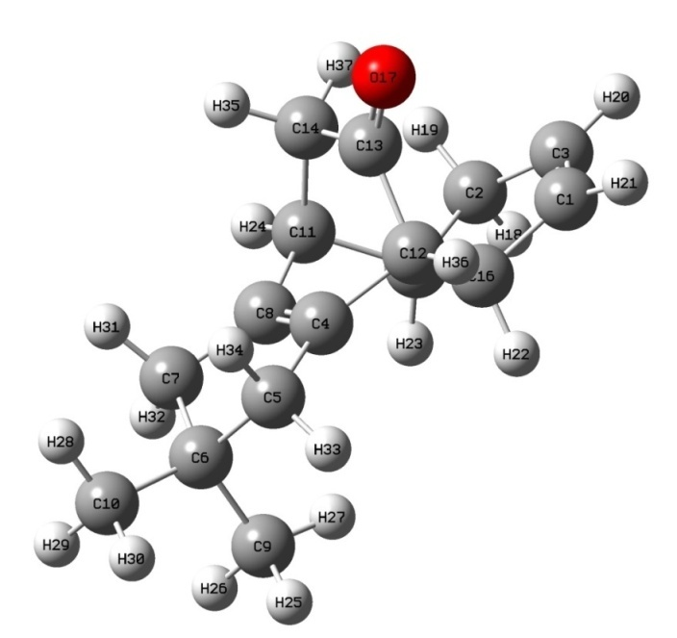

**Fig. S1**: Optimized geometry of the compound-1

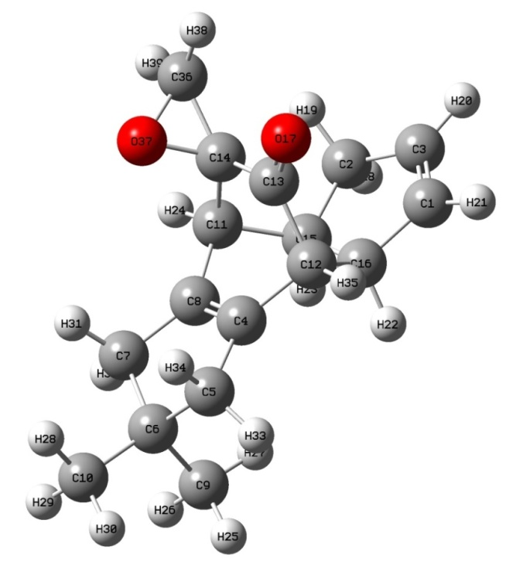

**Fig. S2**: Optimized geometry of the compound-2

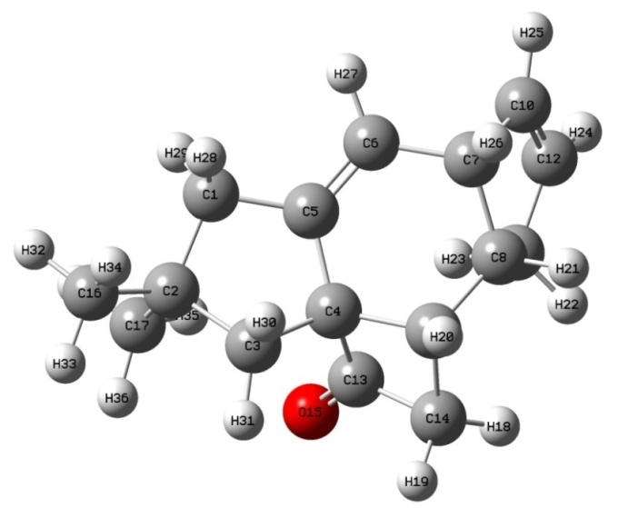

**Fig. S3**: Optimized geometry of the compound-3

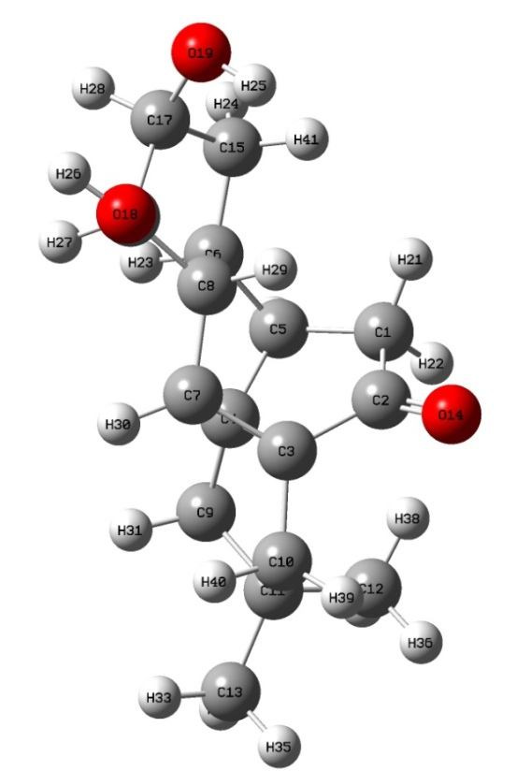

**Fig. S4**: Optimized geometry of the compound-4

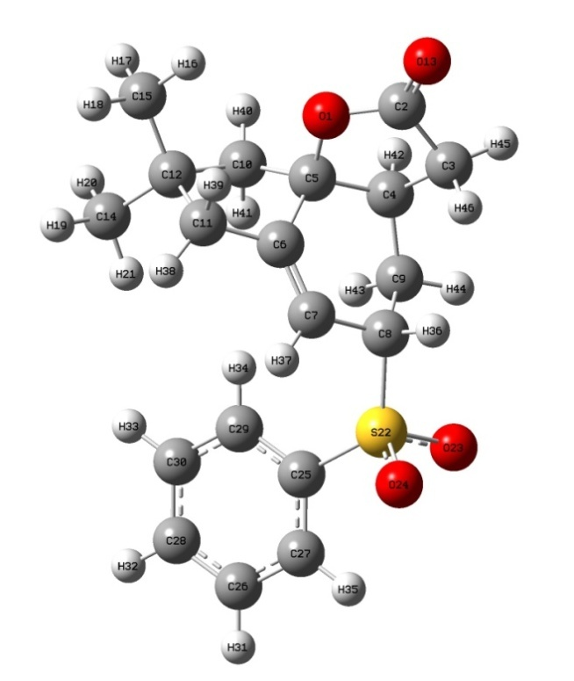

**Fig. S5**: Optimized geometry of the compound-5

**Molecular Docking Study**

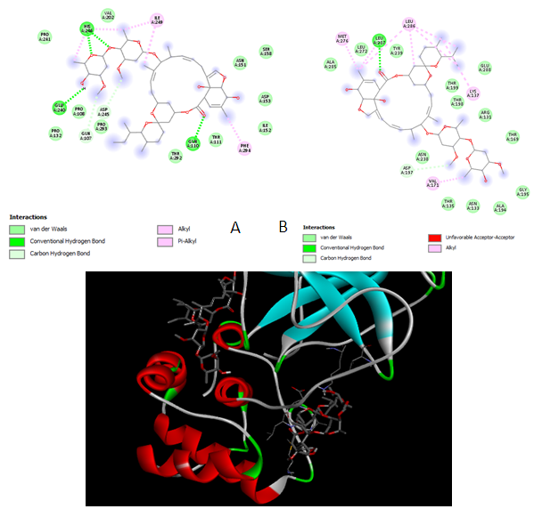

**Fig. S6.** The superposition of the Ivermectin molecule and the diagram ofintermolecular interactions (22,23-dihydroavermectin B1a (a) and 22,23-dihydroavermectin B1b (b)) in the complex with the COVID-19 virus (Mpro) protease(PDBID: 6LU7)

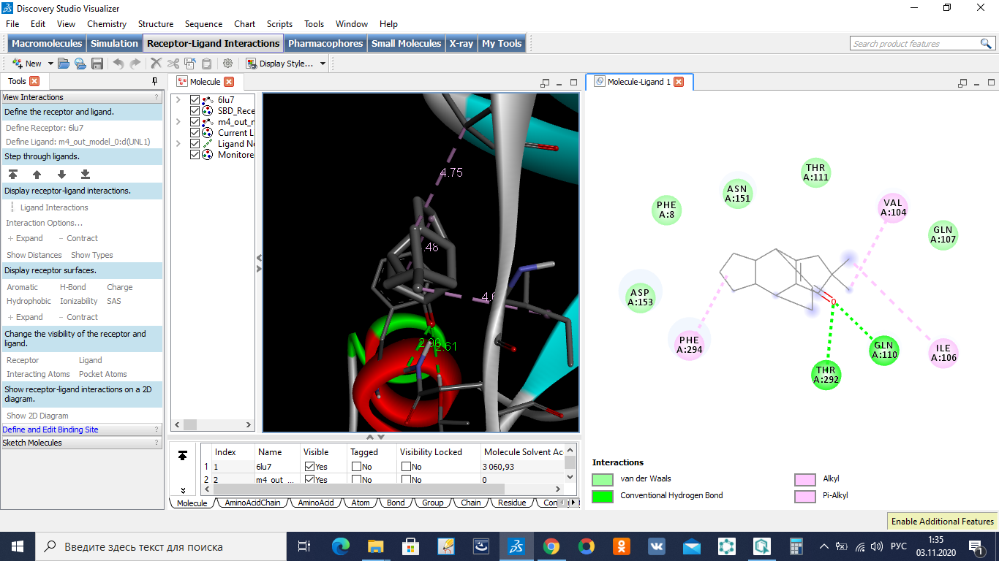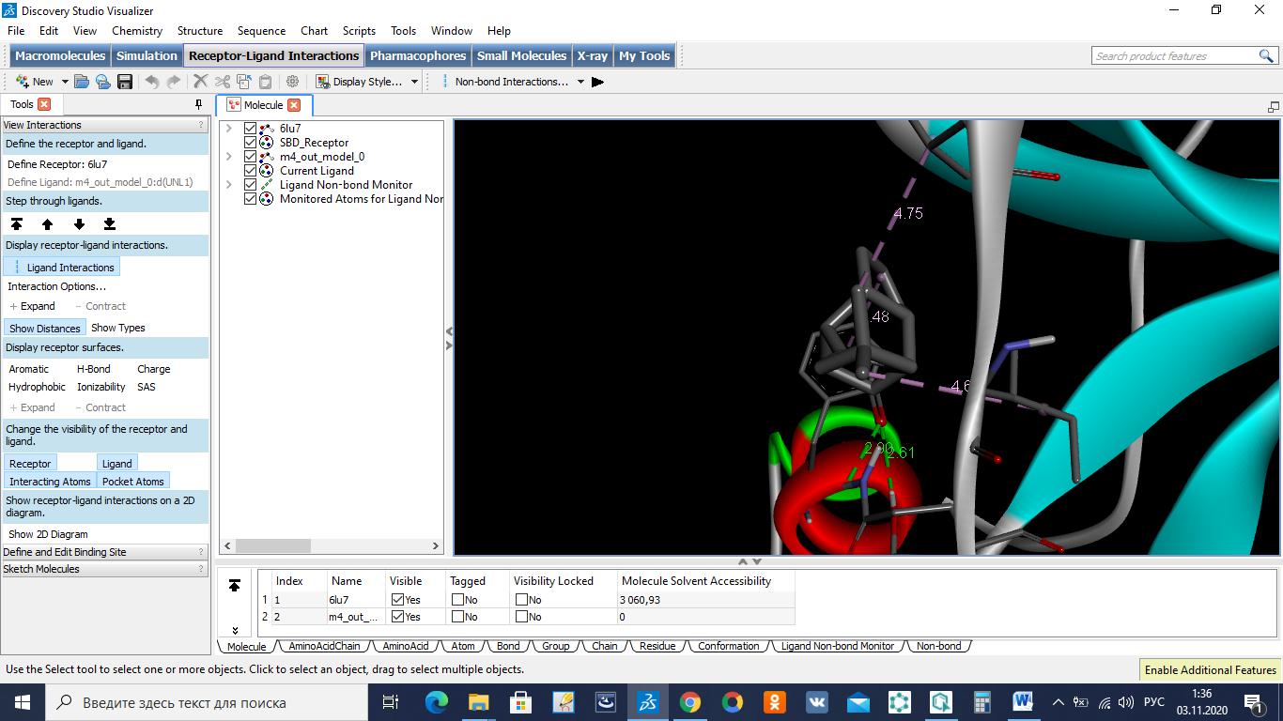

**Fig. S7.** The superposition of 4 and the diagram of intermolecular interactions in the complex with the COVID-19 virus (Mpro) protease(PDB ID: 6LU7)

**TableS1.**The values of inter atomic distances, categories and types of intermolecular interactions of the reference drugs in the active site of the COVID-19 virus (Mpro) protease (PDB ID: 6LU7)

|  |  |  |  |  |  |  |  |  |  |  |  |
| --- | --- | --- | --- | --- | --- | --- | --- | --- | --- | --- | --- |
| **Remdesivir** | | | **Ivermectin b1a** | | | **Ivermectin b1b** | | | **Hydroxychlorochine** | | |
| Distance, À | Category | Types | Distance, À | Category | Types | Distance, À | Category | Types | Distance, À | Category | Types |
| 3.90 | Electrostatic | Attractive Charge | 2.25 | Hydrogen Bond | Conventional Hydrogen Bond | 2.67 | Hydrogen Bond | Conventional Hydrogen Bond | 2.64 | Hydrogen Bond | Conventional Hydrogen Bond |
| 2.24 | Hydrogen Bond | Conventional Hydrogen Bond | 2.37 | Hydrogen Bond | Conventional Hydrogen Bond | 2.95 | Unfavorable | Unfavorable Acceptor-Acceptor | 2.20 | Hydrogen Bond | Conventional Hydrogen Bond |
| 2.86 | Hydrogen Bond | Conventional Hydrogen Bond | 2.36 | Hydrogen Bond | Conventional Hydrogen Bond | 3.34 | Hydrogen Bond | Carbon Hydrogen Bond | 3.48 | Hydrogen Bond | Carbon Hydrogen Bond |
| 2.15 | Hydrogen Bond | Conventional Hydrogen Bond | 2.32 | Hydrogen Bond | Conventional Hydrogen Bond | 3.92 | Hydrophobic | Alkyl | 2.77 | Hydrogen Bond | Pi-Donor Hydrogen Bond |
| 2.61 | Hydrogen Bond | Pi-Donor Hydrogen Bond | 2.44 | Hydrogen Bond | Conventional Hydrogen Bond | 3.96 | Hydrophobic | Alkyl | 4.73 | Hydrophobic | Pi-Pi T-shaped |
| 5.43 | Other | Pi-Sulfur | 3.41 | Hydrogen Bond | Carbon Hydrogen Bond | 5.35 | Hydrophobic | Alkyl | 4.73 | Hydrophobic | Alkyl |
| 4.78 | Other | Pi-Sulfur | 3.48 | Hydrogen Bond | Carbon Hydrogen Bond | 4.56 | Hydrophobic | Alkyl | 4.99 | Hydrophobic | Pi-Alkyl |
| 4.13 | Hydrophobic | Alkyl | 5.23 | Hydrophobic | Alkyl | 4.68 | Hydrophobic | Alkyl | 4.38 | Hydrophobic | Pi-Alkyl |
| 5.32 | Hydrophobic | Pi-Alkyl | 5.00 | Hydrophobic | Alkyl | 4.45 | Hydrophobic | Alkyl |
| 4.38 | Hydrophobic | Pi-Alkyl | 4.46 | Hydrophobic | Alkyl |
| 4.87 | Hydrophobic | Pi-Alkyl | 4.10 | Hydrophobic | Alkyl |
| 4.50 | Hydrophobic | Pi-Alkyl |

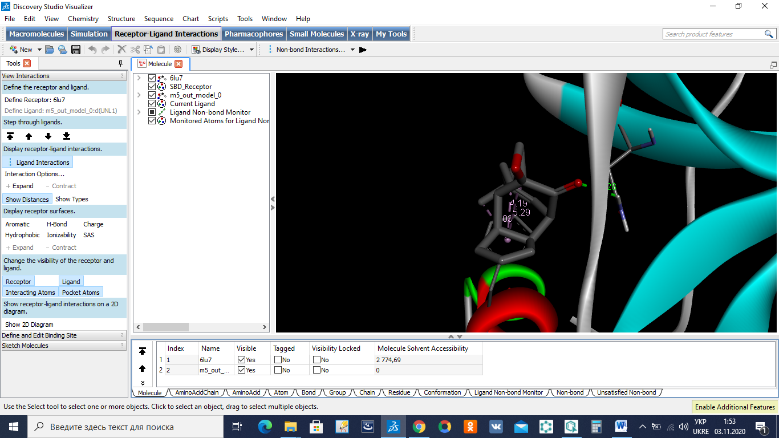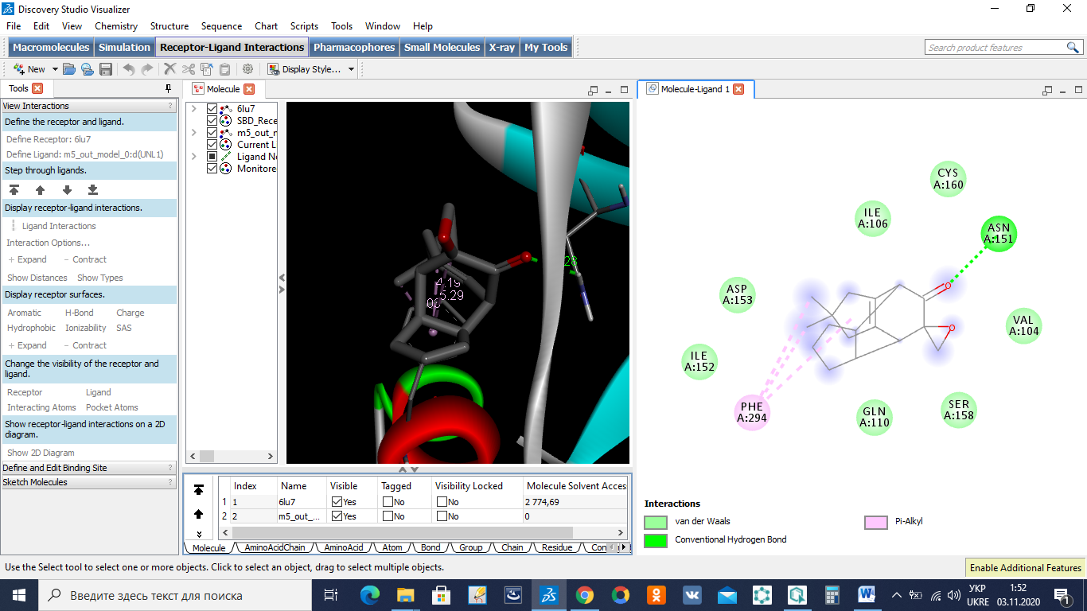

**Fig. S8.** The superposition of 5 and the diagram of intermolecular interactions in the complex with the COVID-19 virus (Mpro) protease(PDB ID: 6LU7)

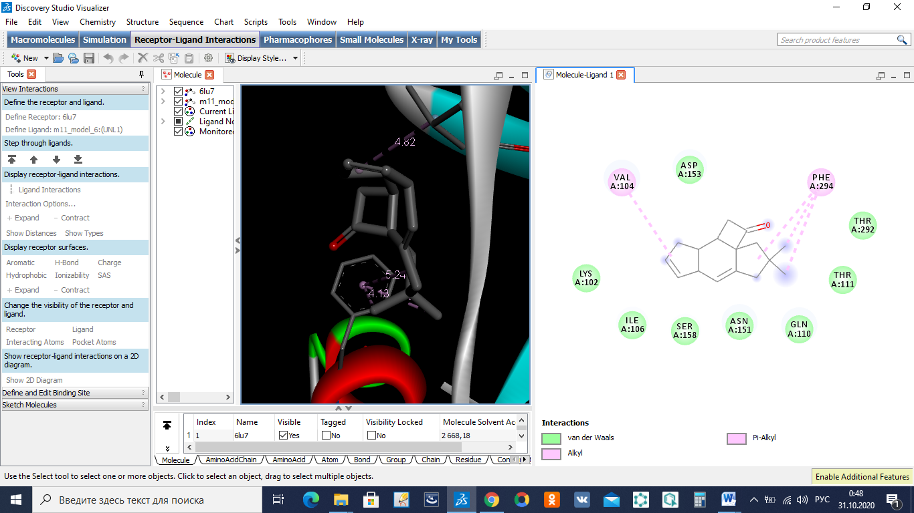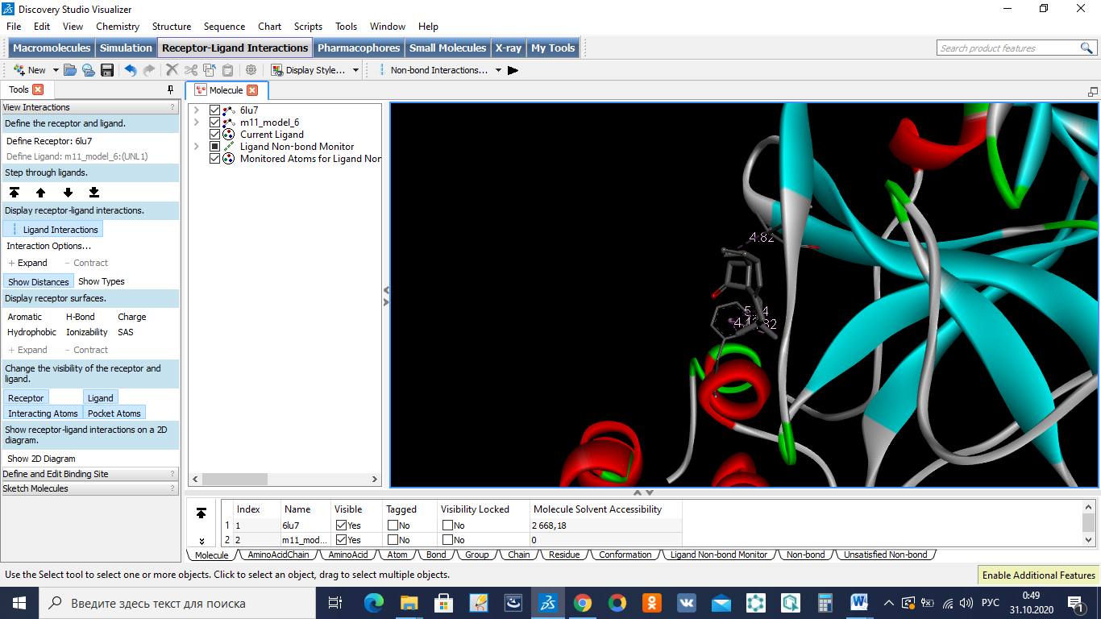

**Fig. S9.** The superposition of 11 and the diagram of intermolecular interactions in the complex with the COVID-19 virus (Mpro) protease(PDB ID: 6LU7)

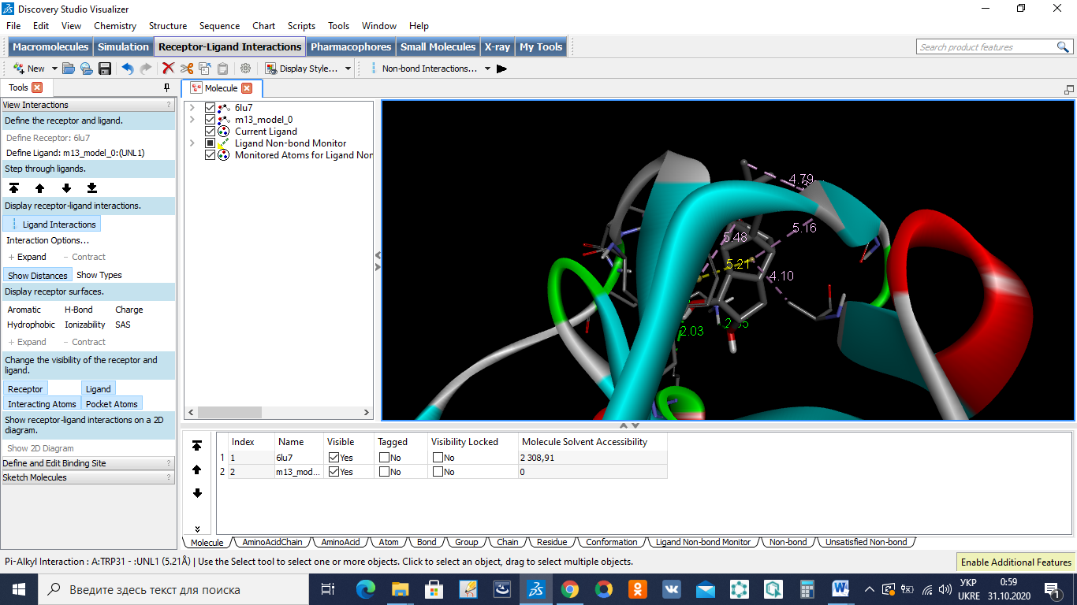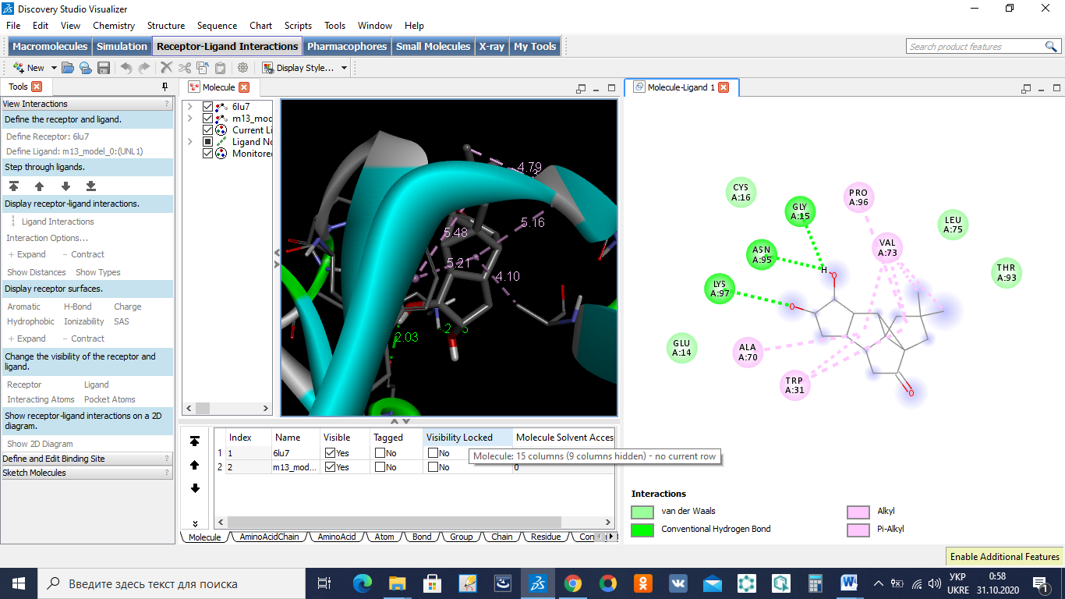

**Fig. S10.** The superposition of 13 and the diagram of intermolecular interactions in the complex with the COVID-19 virus (Mpro) protease(PDB ID: 6LU7)

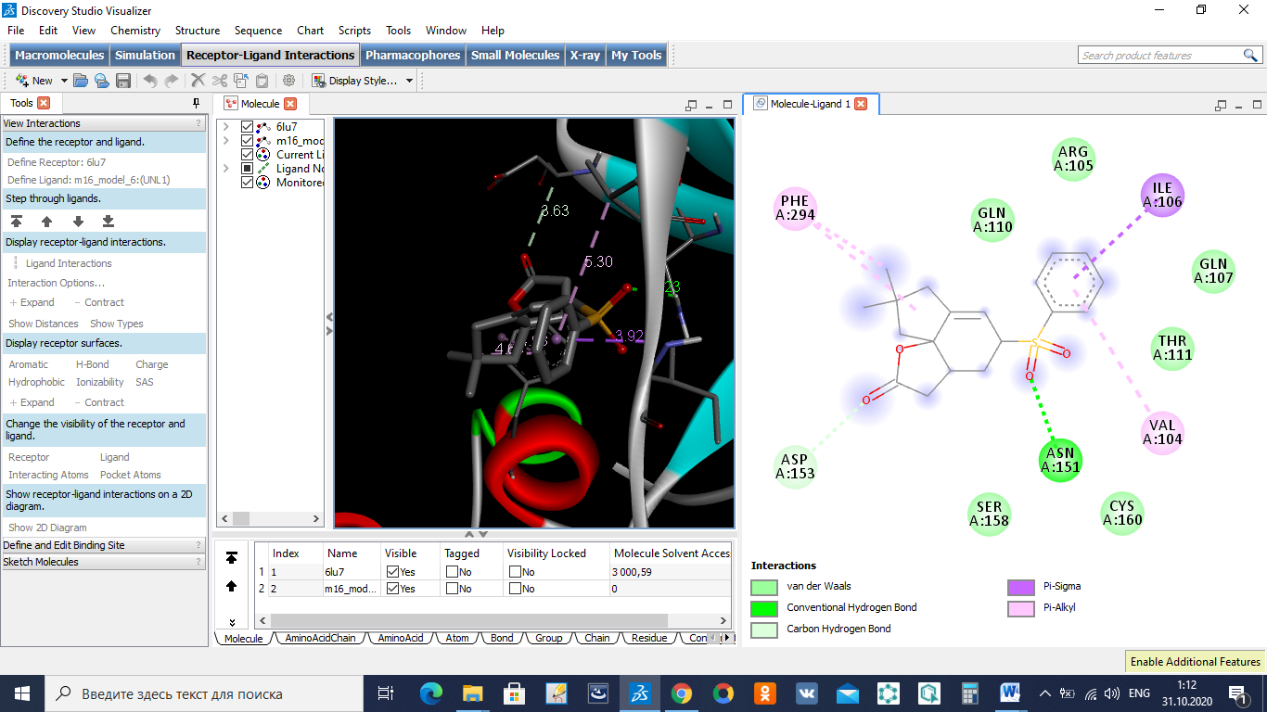

**Fig. S11.** The superposition of 16 and the diagram of intermolecular interactions in the complex with the COVID-19 virus (Mpro) protease(PDB ID: 6LU7)

***IN SILICO* TOXICITY ANALYSIS**

**Figure 1.tif**

**Fig. S12.** Radar plot of the compounds suggesting the drug-likeness [the pink area represents the optimal range of each properties. SIZE = Molecular weight (between 150 and 500 g/mol),LIPO = Lipophilicity (between −0.7 and +5.0), POLAR = Polarity (between 20 and 130Å2), INSOLU = Solubility (not higher than 6), FLEX = Flexibility (no more than 9 rotatable bonds), INSATU = Saturation (fraction of carbons in the sp3 hybridization not less than 0.25)]

**Figure 2.tif**

**Fig. S13.** Radar plot of the compounds suggesting the drug-likeness [the pink area represents the optimal range of each properties. SIZE = Molecular weight (between 150 and 500 g/mol),LIPO = Lipophilicity (between −0.7 and +5.0), POLAR = Polarity (between 20 and 130Å2), INSOLU = Solubility (not higher than 6), FLEX = Flexibility (no more than 9 rotatable bonds), INSATU = Saturation (fraction of carbons in the sp3 hybridization not less than 0.25)]

**Electrostatic potential studies**

The electrostatic potential surfaces of the developedcompounds were execute by applyingArgusLab 4.0.1 software and shown in (Fig. S14–S18). The structure of the compounds is optimized by applying molecular mechanics force field (MM+) followed by semiempirical PM3 methods.This model is feasible to interpret the sensory behavior of all compounds,it is found thatfrom the molecular surfaceplot the negative part of the electron cloud designates as nucleophilic centers and the positive part of the electron cloud shows the potential electrophile sites.The ESP plot helps to predict the molecular size, molecular shape and electrostatic potential activity of the compounds.From the electrostatic potential plots of all the compounds were predominance of green region and doner atoms such as O and S are predominant over red region, which clearly explain all the compounds possesses almost halfway potential electron distribution among two extreme color red and blue [1, 2].

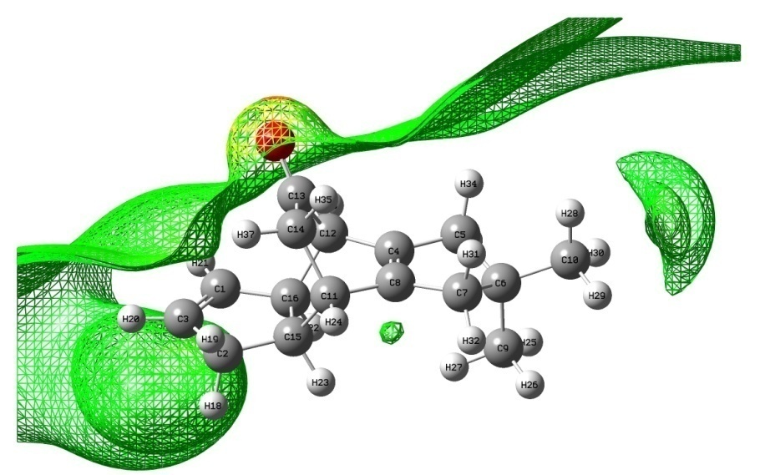

**Fig. S14:** ESP of the compound-1

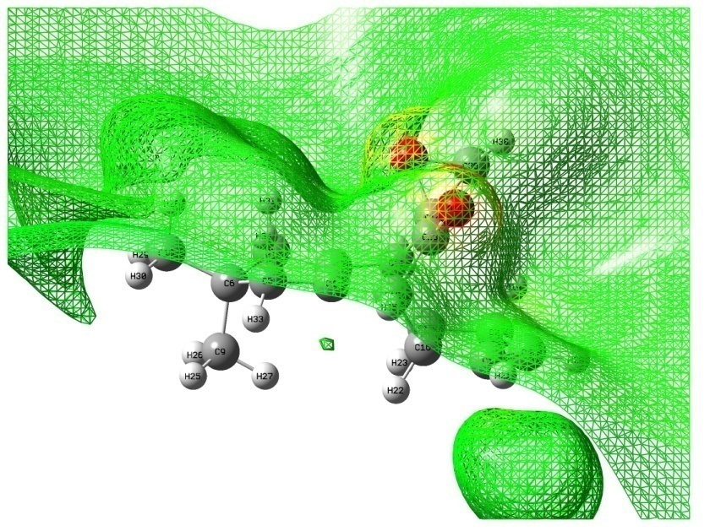

**Fig. S15:** ESP of the compound-2

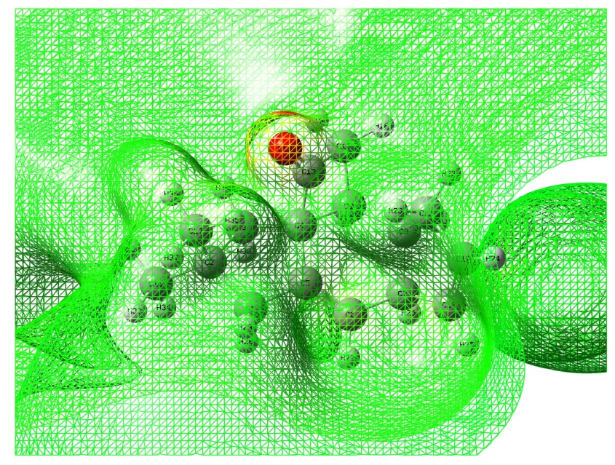

**Fig. S16:** ESP of the compound-3

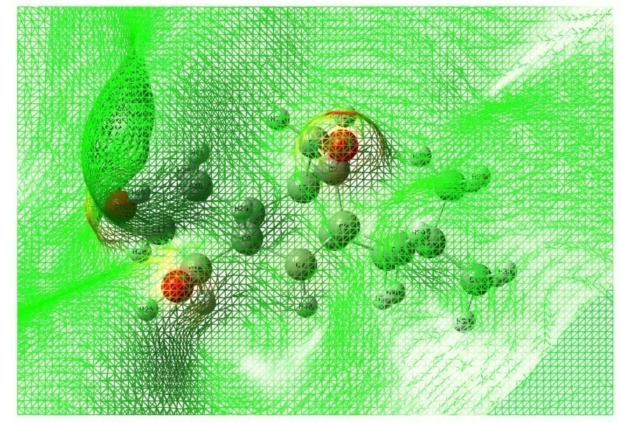

**Fig. S17:** ESP of the compound-4

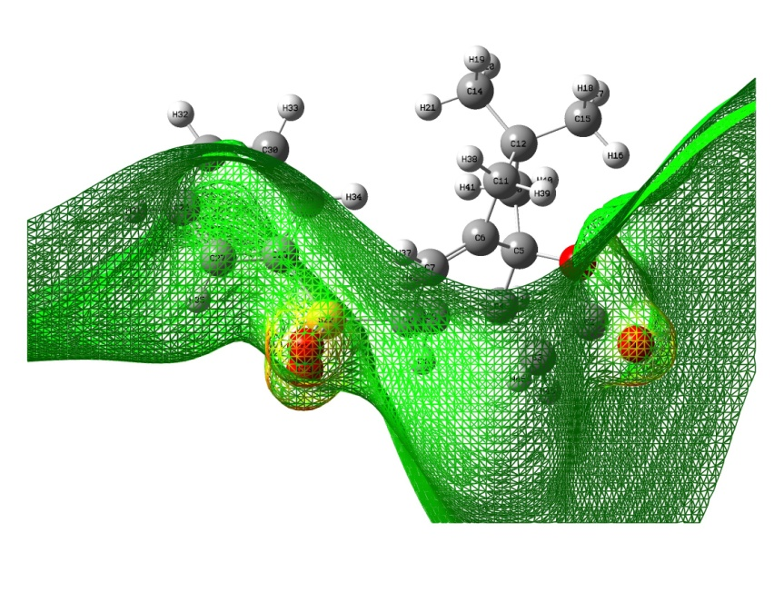

**Fig. S18:** ESP of the compound-5

**References**

[1] R.C. Maurya, B.A. Malik, J. M. Mir, A. K. Sharma, Synthesis, characterization, thermal behavior, and DFT aspects of some oxovanadium(IV) complexes involving ONO-donor sugar Schiff bases, Journal of Coordination Chemistry, 2014, 67:18, 3084-3106.

[2] P. Khanna, L. Khanna, S. Singhal, S. C. Jain, Spiro-Indole-Coumarin Hybrids: Synthesis, ADME, DFT, NBO Studies and In Silico Screening through Molecular Docking on DNA G-Quadruplex, Chemistryselect, 2020, 5, 3420-3433.