

1 = Butan-2-one

2 = Hydrazinecarbothioamide

3= (*E*)-2-(butan-2-ylidene)hydrazinecarbothioamide)

4= Metal-ligand complex, where, M=Cu, Co, Fe, Zn

**Fig. 1** Synthesis of 2-butanone thiosemicarbazone and its complexes.

E:\Tahmeena\Ligand-DFT\opt-freq\without-solvent\Ligand-opti.tif

**Fig. 2.** Optimized 3D structure of ligand.

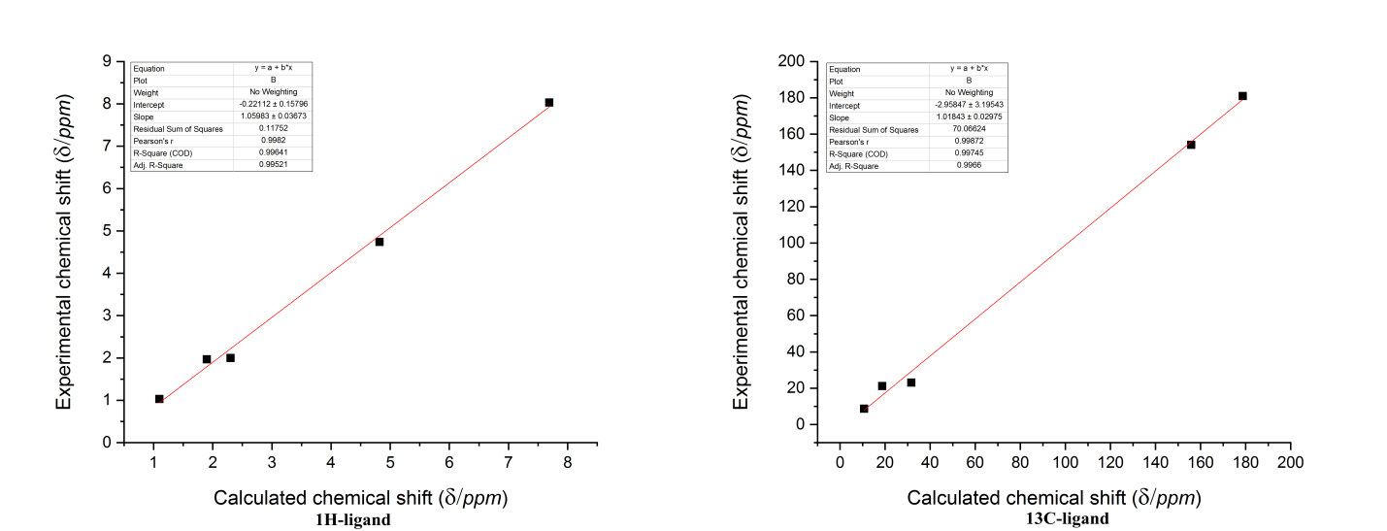

**Fig. 3** Correlation between the experimental and calculated 1H and 13C chemical shifts.

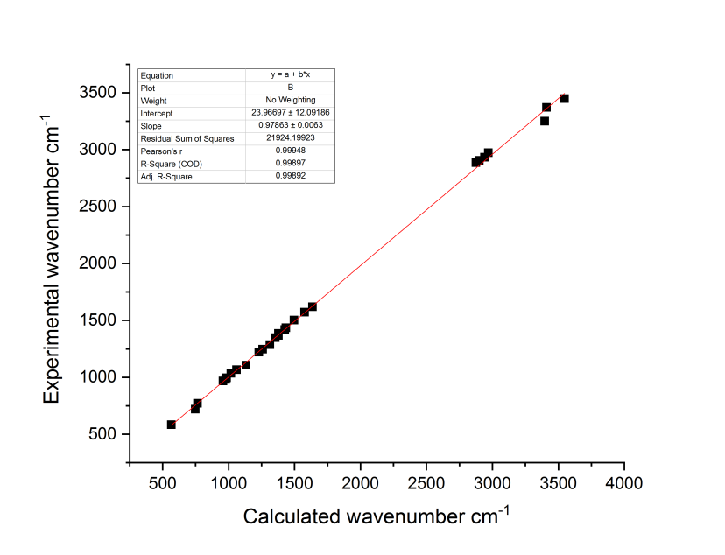

**Fig. 4** Correlation between the experimental and calculated vibrational wave numbers (cm-1).

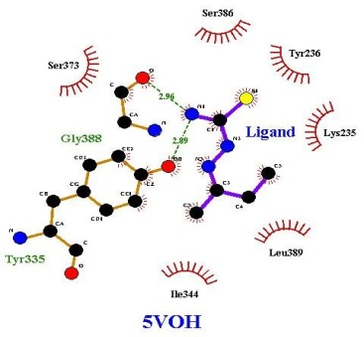 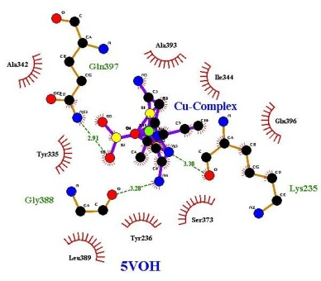 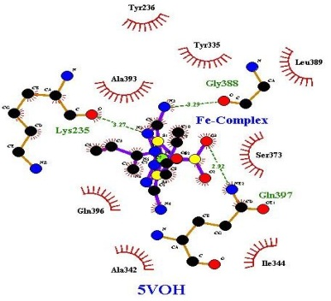

(a) (b) (c)

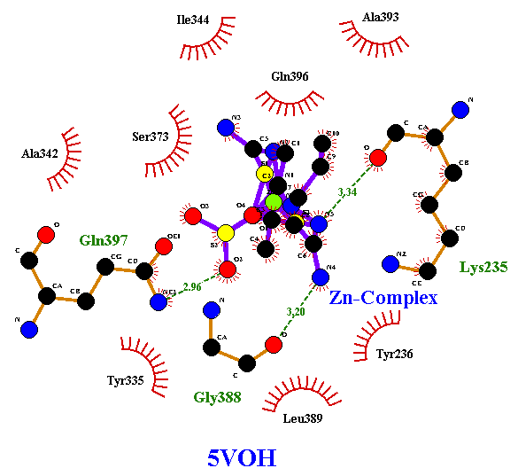 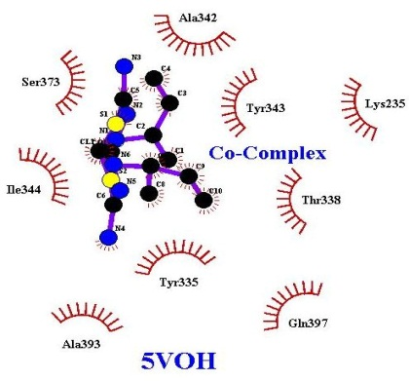

(d) (e)

**Fig. 5** Docking poses of (a) 2-butanone thiosemicarbazone and its (b) Cu, (c) Fe, (d) Zn and (e) Co complexes with NADPH.

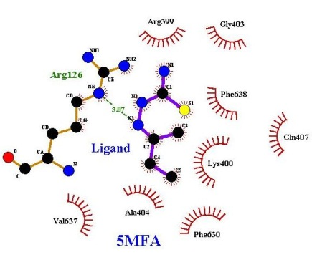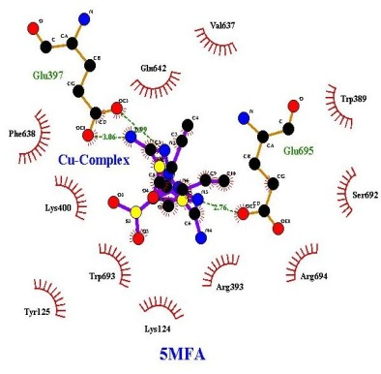 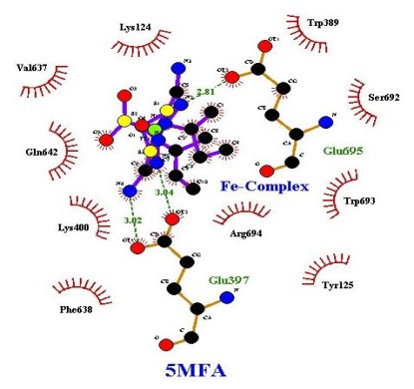

(a) (b) (c)

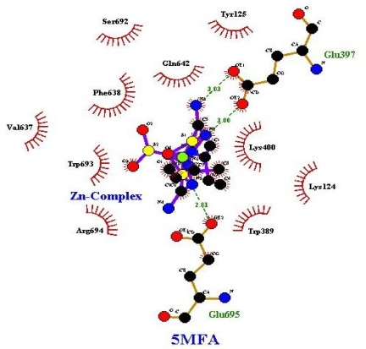 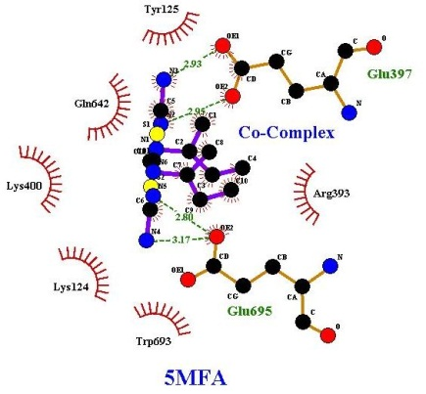

(d) (e)

**Fig. 6** Docking poses of (a) 2-buatnone thiosemicarbazone and its’ (b) Cu, (c) Fe, (d) Zn and (e) Co complexes with MPO.

**Table 1.** Characterization data of complexes

|  |  |  |  |  |  |
| --- | --- | --- | --- | --- | --- |
| **Complex** | **MW** | **MP (0C)** | **FTIR (KBr) cm-1** | **1H-NMR (DMSO) (ppm)** | **Elemental Analysis** |
| [Cu(C5H11N3S)2SO4] | 450 | 195 | 1562 (C=N), 705, 1058 (C=S) | 0.31 (t, 3H), 2.3 (s, 3H), 2.5 (q, 2H), 6.6 (br s, 1H,NH), 7.8 (br s, 2H,NH2) | Cal % C, 26.69;H, 4.93; N, 18.67, S, 21.37, Exp % C, 25.98; H, 5.01; N, 18.21; S 20.87 |
| [Fe(C5H11N3S)2SO4] | 442 | 190 | 1562 (C=N), 705, 1050 (C=S) | - | Cal % C, 27.15; H, 5.01;N, 19.00; S,21.74, Exp % C, 27. 03; H, 4.98; N,18.98; S, 21.54 |
| [Zn(C5H11N3S)2SO4] | 452 | 250 | 1570 (C=N), 705, 1050 (C=S) | 1.1 (t, 3H), 1.9 (s, 3H), 2.5 (q, 2H), 7.3 (br s, 1H,NH), 7.5 (br s, 2H,NH2) | Cal % C,26.58; H, 4.91;N,18.60; S,21.28, Exp % C, 26.25; H, 4.83; N, 18.23; S, 21.00 |
| [Co(C5H11N3S)2Cl2]+ | 420 | 210 | 1570 (C=N), 700, 1050 (C=S) | 1.1 (t-3H), 2.2 (s,3H), 2.5 (q, 2H), 7.6 (br s, 1H,NH), 8.3 (br s,2H,NH2); | Cal % C,28.58; H, 5.28; N,20.00; S,15.26, Exp % C, 28.15; H, 5.01; N, 19.97; S, 14.99 |

**Table 2.** Calculated Global descriptors for the ligand

|  |  |  |  |  |  |  |  |  |  |
| --- | --- | --- | --- | --- | --- | --- | --- | --- | --- |
|  | **EHOMOa** | **ELUMOb** | **EH-ELa** | **b** | **c** | **d** | **Se** | **f** | **∆Nmaxg** |
|  | -5.3015 | -0.6642 | -4.6373 | 2.9828 | -2.9828 | 2.3186 | 0.2156 | 1.9185 | 1.2868 |

a EHOMO-ELUMO

bElectronegativity

c Chemical potential

dGlobal hardness

eGlobal softness

fGlobal electrophilicity index (eV) at 298.15 K for ligand at B3LYP/6-31++G (d, p) method

g∆Nmax= Electrophilic charge transfer

**Table 3.** NBO intermolecular interactions for ligand

|  |  |  |  |  |  |  |
| --- | --- | --- | --- | --- | --- | --- |
| **Donor NBO (i)** | **Occupancy** | **Acceptor NBO (j)** | **Occupancy** | **(E2)a (kcal/mol)** | **E(j)-E(i)b (a.u.)** | **F (i,j)c (a.u.)** |
| Within unit 1 | | | | | | |
| *π*S1-C2 | 1.97741 | *σ\**N9-H20 | 0.00755 | 2.37 | 0.75 | 0.038 |
| *σ*C2-N3 | 1.98959 | *σ\**N4-C5 | 0.01987 | 2.02 | 1.37 | 0.047 |
| σN3-N4 | 1.97627 | *σ\**C5-C6 | 0.02121 | 3.76 | 1.17 | 0.059 |
| σN3-H10 | 1.96676 | *σ\**S1-C2 | 0.02644 | 3.12 | 1.04 | 0.051 |
| *π*N4-C5 | 1.99063 | *σ\**N3-H10 | 0.02355 | 3.61 | 0.73 | 0.046 |
| *σ*C5-C6 | 1.97845 | *σ\**N3-N4 | 0.02385 | 5.99 | 0.95 | 0.067 |
| *σ*C6-H11 | 1.98306 | *σ\**N4-C5 | 0.01987 | 3.89 | 1.13 | 0.059 |
| *σ*C6-H12 | 1.98474 | *σ\**C5-C7 | 0.04186 | 3.47 | 0.90 | 0.050 |
| *σ*C6-H13 | 1.97204 | *π\**N4-C5 | 0.11650 | 5.57 | 0.55 | 0.050 |
| *σ*C7-C8 | 1.98483 | *σ\**N4-C5 | 0.01987 | 2.83 | 1.20 | 0.052 |
| *σ*C7-H14 | 1.97548 | *σ\**C5-C6 | 0.02121 | 3.59 | 0.88 | 0.050 |
|  |  | *σ\**C8-H17 | 0.00774 | 2.18 | 0.94 | 0.041 |
| *σ*C7-H15 | 1.96629 | *σ\**N4-C5 | 0.04186 | 4.83 | 0.54 | 0.047 |
|  |  | *σ\**C8-H18 | 0.00707 | 2.19 | 0.95 | 0.041 |
| *σ*C8-H16 | 1.98917 | *σ\**C5-C7 | 0.04186 | 2.42 | 0.89 | 0.042 |
| *σ*C8-H17 | 1.98950 | *σ\**C7-H14 | 0.01406 | 2.18 | 0.96 | 0.041 |
| *σ*C8-H18 | 1.99020 | *σ\**C7-H15 | 0.01482 | 2.35 | 0.94 | 0.042 |
| *σ*N9-H19 | 1.98323 | *σ\**S1-C2 | 0.02644 | 4.35 | 1.03 | 0.060 |
| *σ*N9-H20 | 1.97135 | *π\**S1-C2 | 0.24094 | 5.29 | 0.61 | 0.054 |
| *n*(1)N4 | 1.99920 | *σ\**C5-C7 | 0.04186 | 10.10 | 0.75 | 0.078 |
| *n*(1)N3 | 1.99929 | *σ\**N4-C5 | 0.01987 | 2.97 | 0.38 | 0.031 |
| *n*(2)S1 | 1.99907 | *σ\**C2-N3 | 0.10280 | 19.08 | 0.49 | 0.087 |
| *n*(2)S1 |  | *σ\**C2-N9 | 0.06695 | 16.63 | 0.50 | 0.083 |
| *n*(1)S1 | 2.00000 | *σ\**C2-N3 | 0.10280 | 3.28 | 1.01 | 0.052 |
| *n*(1)S1 |  | *σ\**C2-N9 | 0.06695 | 3.73 | 1.02 | 0.056 |

aEenergy of hyperconjugative interaction (stabilization energy)

bEnergy difference between donor (i) and acceptor (j) NBO orbitals

cFock matrix element between i and j NBO orbitals

**Table 4.** Calculated thermodynamic values of the ligand

|  |  |  |
| --- | --- | --- |
| **Thermodynamic parameters** | **Hartree/Particle** | **kcal/mol** |
| ΔSReaction | -759.425661 | -476546.8988624838 |
| ΔHReaction | -759.413667 | -476539.3725122451 |
| ΔGReaction | -759.463604 | -476570.7084595413 |

**Table 5.** Calculated NLOs of ligand

|  |  |  |  |  |  |
| --- | --- | --- | --- | --- | --- |
| **μ0a** | | **α0b** | | **β0c** | |
| *μx* | 4.4681 | αxx | 162.910 | *βxxx* | -527.375 |
| *μy* | -4.6394 | αyy | -3.57807 | *βxyy* | 69.7466 |
| *μz* | -0.6550 | αzz | 114.608 | *βxzz* | -36.1889 |
| *μ0* | 6.4744 | α0 | 91.3157 | *βyyy* | -51.9917 |
|  |  | (∆α) | 411.9700 | *βyzz* | -190.966 |
|  |  |  |  | *βyxx* | -13.3456 |
|  |  |  |  | *βzzz* | 24.0536 |
|  |  |  |  | *βzxx* | -38.0351 |
|  |  | | | *βzyy* | -6.67877 |
|  |  | | | *β0* | -556.7528716 |

a Dipole moment (a.u.)

bPolarizability (a.u.)

cHyperpolarizability (a.u.)

μ0 in Debye (D); α0 and ∆α in10-24 esu. (1 a.u. = 0.1482x10-24 esu.); β0 in10-33 esu. (1 a.u. = 8.639x10-33 esu.)

**Table 6.** Docking energies with NADPH

|  |  |  |  |  |  |
| --- | --- | --- | --- | --- | --- |
| **Compound** | **iGEMDOCK** | | | | **AutoDock** |
| **TEa** | **VDWb** | **HBondc** | **Elecd** | **BEe** |
| C5H11N3S | -64.431 | -40.841 | -23.589 | 0 | -4.7 |
| [Cu(C5H11N3S)2SO4] | -75.709 | -65.123 | -10.586 | 0 | -6.7 |
| [Fe(C5H11N3S)2SO4] | -105.60 | -71.144 | -34.456 | 0 | -6.9 |
| [Zn(C5H11N3S)2SO4] | -87.504 | -54.387 | -33.116 | 0 | -6.8 |
| [Co(C5H11N3S)2Cl2]+ | -96.845 | -64.654 | -32.191 | 0 | -6.8 |

aTotal energy (kcal/mol)

bvan der Waal’s energy

cHydrogen bonding

dElectrostatic interaction

eBinding Energy (kcal/mol)

**Table 7.** Docking energies with MPO

|  |  |  |  |  |  |
| --- | --- | --- | --- | --- | --- |
| **Compound** | **iGEMDOCK** | | | | **AutoDock** |
| **TEa** | **VDWb** | **HBondc** | **Elecd** | **BEe** |
| C5H11N3S | -76.2143 | -8.78364 | 0 | 43.8889 | -5.8 |
| [Cu(C5H11N3S)2SO4] | -115.833 | -80.7451 | -36.087 | 0 | -7.2 |
| [Fe(C5H11N3S)2SO4] | -116.782 | -79.2942 | -36.487 | 0 | -7.3 |
| [Zn(C5H11N3S)2SO4] | -88.2011 | -69.9675 | -14.233 | 0 | -7.2 |
| [Co(C5H11N3S)2Cl2]+ | -84.5787 | -61.9218 | ---2.6568 | 0 | -7.0 |  |

aTotal energy (kcal/mol)

bvan der Waal’s energy

cHydrogen bonding

dElectrostatic interaction

eBinding Energy (kcal/mol)