**Quantum chemical calculations, spectroscopic properties and molecular docking studies of a novel piperazine derivative**

**List of figures**

**Figure S1:** Schematic representation of the compound [(NO3)2.H2O].

**Figure S2:** Molecular graph of critical points according to AIM analysis of (C10H16N2)(NO3)2.H2O molecule.

**Figure S3:** Electron localization function (ELF) maps of 1PPNO3 compound on the plane of O31, N16, O36 atoms.

**Figure S4:** Shaded surface map with projection effect of electron localization function (ELF) of 1PPNO3 compound.

**Figure S5:** molecular electrostatic potential of 1PPNO3.

**Figure S6:** Orbital Density Spectrum (DOS) of (C10H16N2)(NO3)2.H2O.

**Figure S7:** Representation of different types of interaction between protein-ligands.

**Figure S8:** 2D diagrams of GDP/JGA in Kalirin-7 and of 2BK3/2BK5 in MAOB proteins.

**Figure S9:** Variation of thermodynamic parameters as a function of temperature of 1PPNO3.

**Figure S10:** Theoretical Raman spectrum.

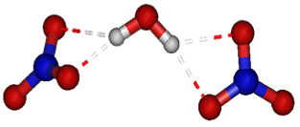

**Figure S1:** Schematic representation of the compound [(NO3)2.H2O].

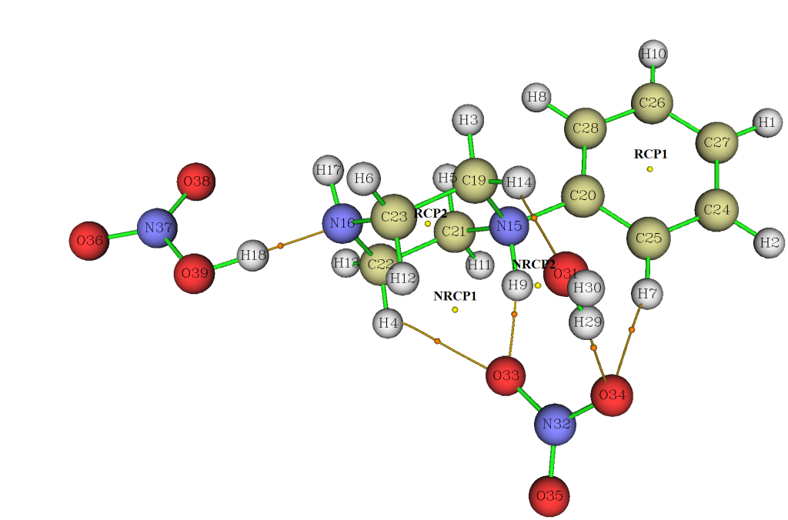

**Figure S2:** Molecular graph of critical points according to AIM analysis of (C10H16N2)(NO3)2.H2O molecule using Multiwfn program.

|  |  |
| --- | --- |
| **(a)** | **(b)** |
| **Figure S3:** Electron localization function (ELF) maps of 1PPNO3 compound on the plane of O31, N16, O36 atoms. | |

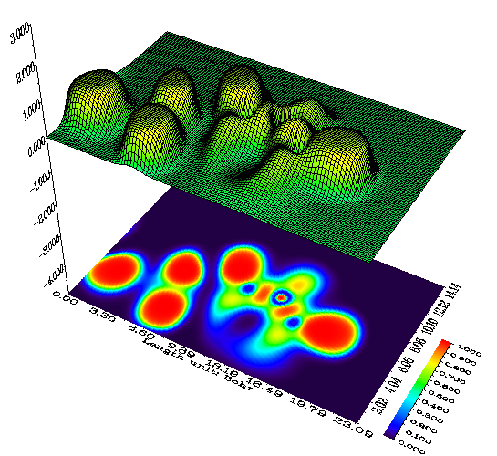

**Figure S4:** Shaded surface map with projection effect of electron localization function (ELF) of 1PPNO3 compound.

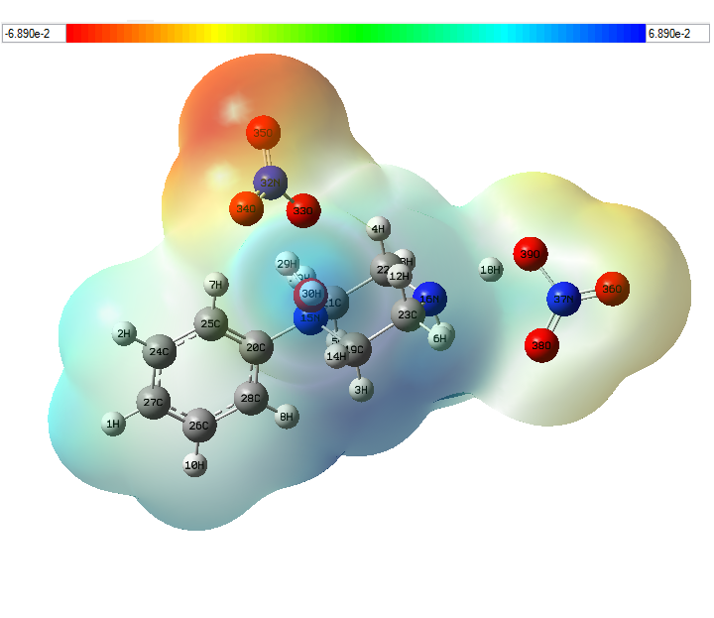

**Figure S5:** molecular electrostatic potential of 1PPNO3.

|  |  |
| --- | --- |
| 1. **In gas phase** | |
| 1. **In water** | |
| 1. **In methanol** | |
| **Figure S6:** Orbital Density Spectrum (DOS) of (C10H16N2)(NO3)2.H2O  using GaussSum software. | |
| **A)** |  | |
| **(Kalirin-7)- GDP** | | |
|  |  | |
| **(Kalirin-7)- 1PPNO3** | | |
|  |  | |
| **(Kalirin-7)- JGA** | | |
|  |  | |
| **(Kalirin-7)- 1-PPHS** | | |
|  |  | |
| **(Kalirin-7)- 4PPHP** | | |
| **B)** |  | |
| **MAOB-1-PPHS** | | |
|  |  | |
| **MAOB- 2BK3** | | |
|  |  | |
| **MAOB-1PPNO3** | | |
|  |  | |
| **MAOB- 4PPHP** | | |
|  |  | |
| **MAOB- 2BK5** | | |
| **Figure S7:** Representation of different types of interaction between protein-ligands. | | |

|  |  |
| --- | --- |
| **a)** | |
|  |  |
| **GDP-Kalirin-7** | **JGA- Kalirin-7** |
| **b)** | |
|  |  |
| **2BK3-MAOB** | **2BK5-MAOB** |

**Figure S8:** 2D diagrams of GDP/JGA in Kalirin-7 and of 2BK3/2BK5 in MAOB proteins.

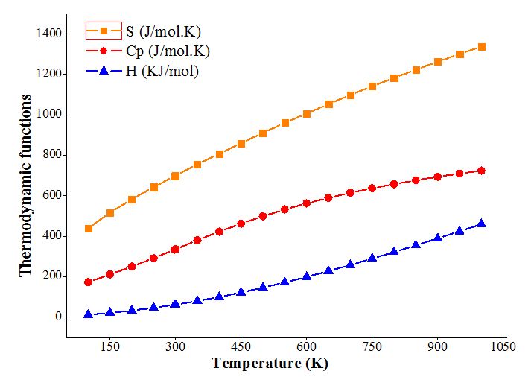

**Figure S9:** Variation of thermodynamic parameters as a function of temperature of 1PPNO3.

|  |
| --- |
|  |
| **Figure S10:** Theoretical Raman spectrum. |

**List of tables**

**Table S1:** Energy, dipole moment, maximum Cartesian force, RMS Cartesian force, RMS Gradient Norm and point group determined in gas and in water.

**Table S2:** Comparison of theoretical parameters (bond angles) of (C10H16N2)(NO3)2.H2O molecule with experimental results.

**Table S3:** Mulliken charge distribution in 1PPNO3 compound.

**Table S4:** Ligand-amino acids interactions.

**Table S5:** Entropy S, heat capacity Cp and the enthalpy H determined from the theoretical frequencies.

**Table S1:** Energy, dipole moment, maximum Cartesian force, RMS Cartesian force, RMS Gradient Norm and point group determined in gas and in water.

|  |  |  |  |  |
| --- | --- | --- | --- | --- |
|  | **B3LYP-D/ 6-311++G\*\*** | | **WB97XD/6-311++G\*\*** | |
| **Gas** | **Water** | **Gas** | **Water** |
| Energy (a.u) | -1137.580 | -1137.649 | -1137.216 | -1137.287 |
| Dipole moment (Debye) | 10.222 | 32.112 | 10.257 | 23.140 |
| Maximum Cartesian force | 0.415 | 9.09 .10-5 | 0.408 | 0.0639 |
| RMS Cartesian force | 0.114 | 2.54 .10-5 | 0.115 | 0.0266 |
| RMS Gradient Norm (a.u) | 7.79 .10-6 | 9.15 .10-6 | 8.87 .10-6 | 7.97 .10-6 |
| Point groupe | C1 | C1 | C1 | C1 |

**Table S2:** Comparison of theoretical parameters (bond angles) of (C10H16N2)(NO3)2.H2O molecule with experimental results.

|  |  |  |  |  |  |  |  |  |
| --- | --- | --- | --- | --- | --- | --- | --- | --- |
| **Theoretically calculated** | | | | | | | | **Experimental** |
| **B3LYP-D/6-311++G\*\*** | | | | **WB97XD/6-311++G\*\*** | | | |
| **Gas** | | **Water** | | **Gas** | | **Water** | |
| **Bond angles (°)** | | | | | | | | |
| N15-H9-O31 | 107.102 | | 106.814 | | 107.424 | | 173.714 | 163.78 |
| H9-N15-C19 | 108.077 | | 107.478 | | 108.144 | | 107.174 | 114 (2) |
| H9-N15-C20 | 107.832 | | 106.320 | | 107.696 | | 107.396 | 102 (2) |
| H9-N15-C21 | 103.513 | | 112.865 | | 103.710 | | 106.049 | 105(2) |
| C19-N15- C20 | 112.476 | | 110.358 | | 112.425 | | 111.658 | 113.8 (2) |
| C19-N15-C21 | 111.087 | | 112.577 | | 111.227 | | 110.342 | 109.5 (3) |
| C20-N15-C21 | 113.279 | | 107.224 | | 113.084 | | 113.802 | 111.8 (2) |
| H17-N16-H18 | 98.473 | | 110.011 | | 98.907 | | 108.386 | 108.0 |
| H17- N16-C22 | 110.626 | | 109.148 | | 110.516 | | 109.735 | 109.3 |
| H17- N16-C23 | 108.89 | | 109.625 | | 108.879 | | 109.521 | 109.2 |
| H18-N16- C22 | 118.678 | | 109.245 | | 119.177 | | 108.450 | 109.3 |
| H18-N16- C23 | 107.785 | | 111.487 | | 107.154 | | 109.086 | 109.2 |
| C22-N16- C23 | 111.420 | | 109.994 | | 111.269 | | 111.598 | 111.8 (3) |
| H3-C19-H14 | 110.551 | | 107.473 | | 110.736 | | 109.554 | 115 (3) |
| H3-C19-N15 | 107.352 | | 111.506 | | 107.482 | | 107.414 | 112 (2) |
| H3-C19- C23 | 111.652 | | 107.538 | | 111.550 | | 111.797 | 104 (2) |
| H14-C19-N15 | 107.005 | | 110.050 | | 106.804 | | 107.805 | 107 (2) |
| H14-C19-C23 | 110.517 | | 110.168 | | 110.582 | | 109.763 | 109 (2) |
| N15-C19-C23 | 109.6 | | 118.077 | | 109.517 | | 110.399 | 110.0 (3) |
| N15-C20- C25 | 118.244 | | 120.092 | | 118.316 | | 117.897 | 117.5 (3) |
| N15-C20-C28 | 120.240 | | 121.830 | | 120.080 | | 120.438 | 121.0 (3) |
| C25-C20-C28 | 121.507 | | 109.647 | | 121.599 | | 121.641 | 121.5 (3) |
| H5-C21-H11 | 109.257 | | 107.476 | | 109.247 | | 109.866 | 119 (3) |
| H5-C21-N15 | 107.892 | | 111.189 | | 107.947 | | 108.231 | 105 (2) |
| H5-C21- C22 | 111.165 | | 107.621 | | 111.148 | | 110.765 | 113 (2) |
| H11- C21-N15 | 106.913 | | 110.068 | | 107.011 | | 107.752 | 105 (2) |
| H11- C21-C22 | 111.071 | | 110.74 | | 111.039 | | 109.983 | 104 (2) |
| N15- C21-C22 | 110.399 | | 109.187 | | 110.312 | | 110.177 | 111.0 (3) |
| H4-C22-H13 | 108.069 | | 107.135 | | 108.107 | | 109.27 | 114 (3) |
| H4-C22 -N16 | 108.359 | | 111.824 | | 108.498 | | 107.103 | 102 (2) |
| H4-C22 -C21 | 109.518 | | 108.550 | | 109.276 | | 111.811 | 110 (2) |
| H13-C22 N16 | 109.266 | | 109.373 | | 109.376 | | 108.351 | 109 (2) |
| H13-C22 -C21 | 108.818 | | 110.692 | | 108.899 | | 109.516 | 110 (2) |
| N16-C22 -C21 | 112.707 | | 109.331 | | 112.586 | | 110.700 | 110.3 (3) |
| H6-C23-H12 | 108.09 | | 108.277 | | 108.085 | | 109.342 | 114 (3) |
| H6-C23-N16 | 108.598 | | 109.806 | | 108.683 | | 108.477 | 104 (2) |
| H6-C23-C19 | 109.378 | | 107.202 | | 109.377 | | 109.668 | 108 (2) |
| H12-C23-N16 | 108.739 | | 111.681 | | 108.665 | | 107.12 | 103 (2) |
| H12-C23-C19 | 109.317 | | 110.45 | | 109.217 | | 111.535 | 117 (2) |
| N16-C23-C19 | 112.616 | | 119.433 | | 112.707 | | 110.618 | 110.9 (3) |
| H2-C24- C25 | 119.189 | | 120.395 | | 119.155 | | 119.509 | 125 (2) |
| H2- C24-C27 | 120.332 | | 120.172 | | 120.364 | | 120.355 | 114 (2) |
| C25- C24- C27 | 120.478 | | 120.350 | | 120.482 | | 120.136 | 120.6 (4) |
| H7-C25- C20 | 120.611 | | 120.732 | | 120.695 | | 120.396 | 123 (3) |
| H7-C25- C24 | 120.602 | | 118.916 | | 120.594 | | 120.543 | 118 (3) |
| C20-C25-C24 | 118.779 | | 120.222 | | 118.704 | | 119.060 | 118.8 (3) |
| H10-C26-C27 | 120.276 | | 119.404 | | 120.294 | | 120.235 | 121 (3) |
| H10-C26-C28 | 119.603 | | 120.374 | | 119.617 | | 119.346 | 118 (3) |
| C27- C26-C28 | 120.121 | | 120.017 | | 120.09 | | 120.419 | 120.3 (4) |
| H1-C27-C24 | 120.086 | | 119.953 | | 120.103 | | 120.017 | 124 (2) |
| H1-C27- C26 | 119.925 | | 120.03 | | 119.868 | | 119.997 | 116 (2) |
| C24-C27-C26 | 119.988 | | 121.036 | | 120.029 | | 119.985 | 119.9 (4) |
| H8-C28-C20 | 121.093 | | 120.286 | | 121.200 | | 121.228 | 124 (2) |
| H8-C28-C26 | 119.782 | | 118.678 | | 119.705 | | 120.024 | 115 (2) |
| C20-C28-C26 | 119.124 | | 104.266 | | 119.095 | | 118.748 | 118.9 (3) |
| O31-H29-O33 | 122.141 | | 119.547 | | 121.993 | | 124.980 | 130.39 |
| O33-H29- O34 | 51.638 | | 120.056 | | 52.148 | | 52.878 | 54.85 |
| H9-O31- H29 | 62.515 | | 120.397 | | 64.505 | | 101.822 | 102.19 |
| H9-O31-H30 | 165.91 | | 122.15 | | 168.563 | | 107.228 | 100.26 |
| H29-O31-H30 | 105.539 | | 116.721 | | 105.641 | | 105.015 | 111 (3) |
| O33-N32-O34 | 117.605 | | 121.174 | | 117.76 | | 119.677 | 112.5 (4) |
| O33- N32-O35 | 119.947 | | 119.52 | | 119.933 | | 120.662 | 121.9 (8) |
| O34-N32- O35 | 122.447 | | 119.306 | | 122.306 | | 119.659 | 122.0 (8) |
| H29-O33- N32 | 66.799 | | 108.711 | | 68.103 | | 70.853 | 91.86 |
| H29-O34-N32 | 114.254 | | 106.814 | | 114.365 | | 112.479 | 98.19 |
| O36-N37-O38 | 127.294 | | 107.478 | | 127.128 | | 120.976 | 121.4 (3) |
| O36-N37-O39 | 115.643 | | 106.32 | | 115.752 | | 119.442 | 119.0 (3) |
| O38- N37-O39 | 117.063 | | 112.865 | | 117.119 | | 119.582 | 119.7 (3) |
| H18-O39-N37 | 106.119 | | 110.358 | | 106.379 | | 112.067 | 106.41 |
| **RMSD** | **5.833** | | **6.848** | | **5.818** | | **3.164** | **-** |

**Table S3:** Mulliken charge distribution in 1PPNO3 compound.

|  |  |  |
| --- | --- | --- |
| **Atoms** | **Mulliken charges** | |
| **B3LYP-D** | **WB97XD** |
| 1 H | 0.168 | 0.213 |
| 2 H | 0.215 | 0.270 |
| 3 H | 0.183 | 0.205 |
| 4 H | 0.289 | 0.315 |
| 5 H | 0.159 | 0.175 |
| 6 H | 0.251 | 0.274 |
| 7 H | 0.189 | 0.169 |
| 8 H | 0.156 | 0.204 |
| 9 H | 0.151 | 0.108 |
| 10 H | 0.195 | 0.245 |
| 11 H | 0.242 | 0.287 |
| 12 H | 0.260 | 0.295 |
| 13 H | 0.216 | 0.255 |
| 14 H | 0.327 | 0.347 |
| 15 N | 0.099 | 0.127 |
| 16 N | -0.501 | -0.515 |
| 17 H | 0.280 | 0.308 |
| 18 H | 0.562 | 0.541 |
| 19 C | -0.534 | -0.572 |
| 20 C | 0.296 | 0.415 |
| 21 C | -0.135 | -0.174 |
| 22 C | -0.494 | -0.601 |
| 23 C | -0.319 | -0.377 |
| 24 C | -0.517 | -0.648 |
| 25 C | 0.047 | 0.116 |
| 26 C | -0.259 | -0.285 |
| 27 C | -0.323 | -0.449 |
| 28 C | -0.131 | -0.184 |
| 29 H | 0.309 | 0.293 |
| 30 H | 0.298 | 0.314 |
| 31 O | -0.597 | -0.609 |
| 32 N | -0.385 | -0.348 |
| 33 O | -0.124 | -0.148 |
| 34 O | -0.139 | -0.144 |
| 35 O | 0.000 | 0.002 |
| 36 O | 0.029 | 0.036 |
| 37 N | -0.380 | -0.370 |
| 38 O | -0.030 | -0.040 |
| 39 O | -0.058 | -0.048 |

**Table S4:** Ligand-amino acids interactions.

|  |  |  |  |  |  |  |
| --- | --- | --- | --- | --- | --- | --- |
| **Target protein** | **Ligands** | **Binding residue** | **Type** | **Atoms** | **Distances (Å)** | **Interactions** |
| **Kalirin-7** | **GDP** | A:LYS13  A:LYS12  A:LYS13  A:GLU14  A:GLU83  A:GLU84  A:LYS12 | Lysine  Lysine  Lysine  GlutamicAcid  GlutamicAcid  GlutamicAcid  Lysine | Pyrimidine  O6, O9, O10  Imidazole  N2  O2  N4  O11 | 3.19  2.53; 2.47; 4.44  4.36  2.88  2.60  2.40  2.96 | Pi-Cation  Pi-Cation  Pi-Alkyl  Conventional H-bond  Conventional H-bond  Conventional H-bond  Conventional H-bond |
| **1PPNO3** | A:ILE117  A:ILE138  A:GLY122  A:THR123  A:THR123  A:GLN129 | Isoleucine  Isoleucine  GlutamicAcid  Threonine  Threonine  Glutamine | Benzene  Benzene  C19  C23  N16  O34 | 5.50  4.91  3.63  3.21  2.60  2.67 | Pi-Alkyl  Pi-Alkyl  Carbon-H bond  Carbon-H bond  Conventional H-bond  Conventional H-bond |
| **JGA** | A:LEU159  A:PRO86  A:PHE15  A:ILE16  A:ILE16  A:MET17  A:GLU14  A:LYS13 | Leucine  Proline  Phenylalanine  Isoleucine  Isoleucine  Methionine  GlutamicAcid  Lysine | C1  Oxazolidine  Oxazolidine  Oxazolidine  O1  O1  H4  H6 | 4.69  4.80  2.94  3.32  4.84  1.68  2.60  2.60 | Alkyl  Pi-Alkyl  Pi-Sigma  Pi-Donor  Conventional H-bond  Conventional H-bond  Conventional H-bond  Conventional H-bond |
| **1-PPHS** | A:PRO181  A:GLN153  A:THR150  A:ASN185 | Proline  Glutamine  Threonine  Asparagine | Benzene  O4  O1  O7 | 4.50  2.39  2.56  2.70 | Pi-Alkyl  Conventional H-bond  Carbon-H bond  Acceptor-Acceptor |
| **4PPHP** | A:CYS107  A:PRO181  A:VAL180  A:GLN153 | Cysteine  Proline  Valine  Glutamine | Benzene  Benzene  Benzene  O | 4.74  3.58  4.71  2.14 | Pi-Sulfur  Pi-Alkyl  Amide Pi-Stacked  Conventional H-bond |
| **MAOB** | **1PPNO3** | B:ASP124  B:ARG127  B:THR195  B:THR196 | AsparticAcid  Arginine  Threonine  Threonine | O3  O3  O5  O6 | 4.28  2.86  2.65  2.54 | Attractive charge  Salt bridge  Conventional H-bond  Conventional H-bond |
| **1-PPHS** | A:ARG42  A:CYS397  A:TYR398  A:TYR398  A:TYR60  A:LYS296  A:GLY57  A:MET436 | Arginine  Cysteine  Tyrosine  Tyrosine  Tyrosine  Lysine  GlutamicAcid  Methionine | O1  Benzene  C2  O7  S2  N1  C, O  O3 | 4.67  4.88  3.58  3.77  5.42  4.91  3.74  3.06 | Attractive charge  Pi-Alkyl  Pi-Sigma  Pi-Anion  Pi-Sulfur  Pi-Cation  Amide-Pi Stacked  Conventional H-bond |
| **Farnesol** | B:VAL10  B:VAL235  B:PRO234  B:ALA35  B:TYR393  A:HIS273  B:GLY40  B:ILE14 | Valine  Valine  Proline  Alanine  Tyrosine  Histidine  GlutamicAcid  Isoleucine | C1  C1  C3  C1  C3  C3  O  O | 4.52  4.45  4.83  4.12  4.76  5.48  2.66  3.28 | Alkyl  Alkyl  Alkyl  Alkyl  Alkyl  Alkyl  Conventional H-bond  Conventional H-bond |
| **4PPHP** | A: ILE14  A:ARG42  A:ALA439  A:TYR435  A:TYR398  A:MET436 | Isoleucine  Arginine  Alanine  Tyrosine  Tyrosine  Methionine | Benzene  Benzene  Benzene  Benzene  C1  O31 | 4.77  5.20  3.71  4.96  3.25  2.68 | Pi-Alkyl  Pi-Alkyl  Pi-Sigma  Amide-Pi Stacked  Carbon-H bond  Carbon-H bond |
| **Isatin** | A:ALA439  A:TYR435  A:ARG42  A:ARG42  A:THR426  A:SER15  A:ILE14 | Alanine  Tyrosine  Arginine  Arginine  Threonine  Serine  Isoleucine | Imidazole  Benzene  Benzene  O1  O1  O2  O2 | 4.80  5.27  3.10  3.10  3.10  2.67  3.00 | Pi-Sigma  Amide-Pi Stacked  Pi-Alkyl  Conventional H-bond  Conventional H-bond  Conventional H-bond  Conventional H-bond |

**Table S5:** Entropy S, heat capacity Cp and the enthalpy H determined

from the theoretical frequencies.

|  |  |  |  |
| --- | --- | --- | --- |
| **T (K)** | **S (J/mol.K)** | **Cp (J/mol.K)** | **H (kJ/mol)** |
| 100 | 439.168 | 172.713 | 11.205 |
| 150 | 516.591 | 211.112 | 20.817 |
| 200 | 582.531 | 249.623 | 32.323 |
| 250 | 642.659 | 291.373 | 45.835 |
| 298 | 697.585 | 333.749 | 60.880 |
| 300 | 699.654 | 335.394 | 61.499 |
| 350 | 754.687 | 379.623 | 79.378 |
| 400 | 808.187 | 422.251 | 99.434 |
| 450 | 860.254 | 462.140 | 121.557 |
| 500 | 910.872 | 498.787 | 145.594 |
| 550 | 960.000 | 532.122 | 171.380 |
| 600 | 1007.618 | 562.320 | 198.754 |
| 650 | 1053.725 | 589.667 | 227.565 |
| 700 | 1098.347 | 614.473 | 257.678 |
| 750 | 1141.522 | 637.034 | 288.975 |
| 800 | 1183.302 | 657.615 | 321.349 |
| 850 | 1223.743 | 676.444 | 354.707 |
| 900 | 1262.904 | 693.717 | 388.967 |
| 950 | 1300.843 | 709.600 | 424.056 |
| 1000 | 1337.617 | 724.233 | 459.906 |