**Synthesis of 2-mercaptopropionic acid/hydrous zirconium oxide composite and its application for removal of Pb(II) from water samples: Central composite design for optimization**

**Supplementary information**

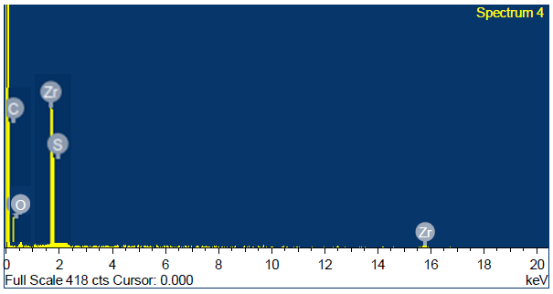

**Fig. S1:** EDX spectrum of MPA/HZO

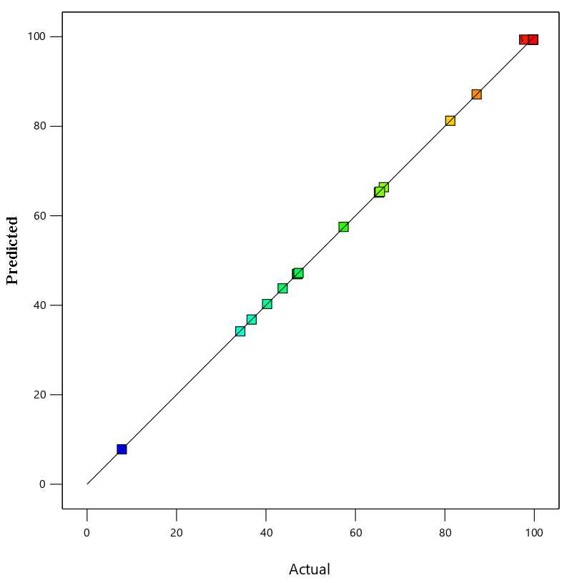

**Fig. S2**: Predicted vs actual plot for the removal of Pb (II) by MPA/HZO composite material.

**Fig.S3**: Effect of contact time on the removal of Pb(II) by MPA/HZO

**Table S1:** Independent variables and their levels used for central composite design.

|  |  |  |  |  |  |  |  |
| --- | --- | --- | --- | --- | --- | --- | --- |
| **Variables** | **Unit** | **Factor** | **Range and level** | | | | |
|  |  |  | **- α** | **-1** | **0** | **+1** | **+α** |
| **pH (-)** | (-) | **X1** | 0.745 | 3.200 | 6.800 | 10.400 | 12.854 |
| **Dosage** | (g) | **X2** | 0.009 | 0.012 | 0.016 | 0.020 | 0.023 |
| **Initial Concentration** | (mg/L) | **X3** | 9.546 | 30.000 | 60.000 | 90.000 | 110.454 |