**Mode of application of acaricides against the ectoparasitic mite (*Varroa destructor*) infesting honeybee colonies, determines their efficiencies and residues** **in honey and beeswax**

Tarek E. Abd El- Wahab1, Shehata EM Shalaby1, Saad N. Al-Kahtani2, Yahya Al Naggar3,4**\***, Saad H.D. Masry5,6

**1** Pests & Plant Protection Dept., National Research Centre, 33 El Buhouth St., Dokki, Giza, Egypt.

2Arid Land Agriculture Department, College of Agricultural Sciences & Foods, King Faisal University, P.O. Box 400, Al-Ahsa 31982, Saudi Arabia.

3Zoology Department, Faculty of Science, Tanta University, Tanta 31527, Egypt.

4General Zoology, Institute for Biology, Martin Luther University Halle-Wittenberg, Hoher weg 8, 06120 Halle (Saale), Germany.

5Department of Plant Protection and Molecular Diagnosis, Arid Lands Cultivation Research Institute, City of Scientific Research and Technological Applications (SRTA-City), Alexandria 21934, Egypt.

6Abu Dhabi Agriculture and Food Safety Authority, Al Ain, United Arab Emirates.

**\***Correspondence: [yehia.elnagar@science.tanta,edu.eg](mailto:yehia.elnagar@science.tanta,edu.eg) ; Tel.:+49 15226763431

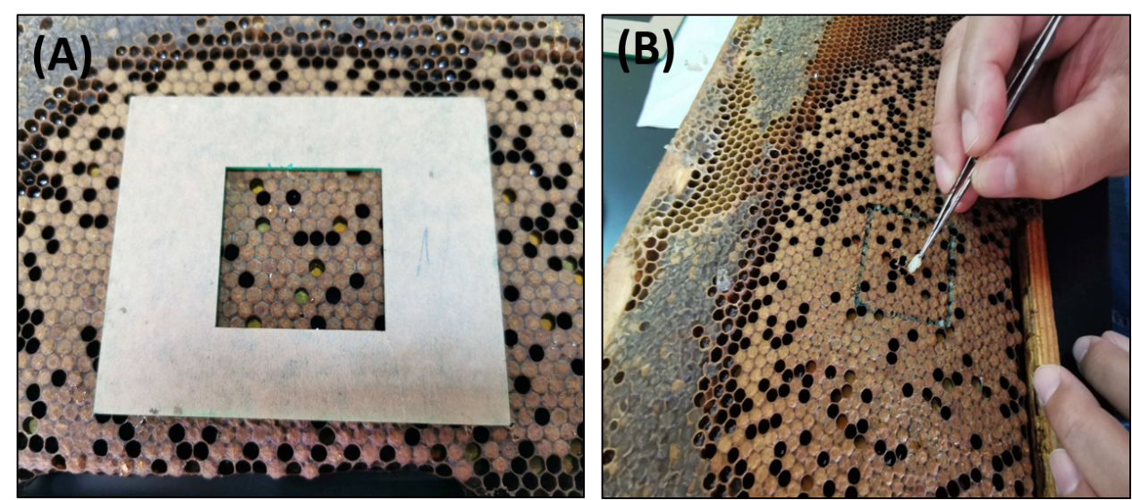

Fig.S1 Selection (a) and inspection (b)of *Varroa* mitein workers with sealed brood (Pigmented Eye Pupae) (Mites per Fifty Pupae, MPFP).