**Electronic Supplementary Information**

**Tables**

**Table S:** Independent variables and their levels used for Box-Behnken design.

|  |  |  |  |  |  |
| --- | --- | --- | --- | --- | --- |
| **Variables** | **Unit** | **Factor** | **Range and level** | | |
|  |  |  | **-1** | **0** | **+1** | |
| **pH** | mL | **X** | 2 | 6 | 10 | |
| **Adsorbent dose** | g | **Y** | 0.10 | 0.20 | 0.30 | |
| **Initial concentration** | mg/L | **Z** | 20 | 50 | 80 | |

**Table S2:** Statistical parameters of the polynomial models.

|  |  |  |  |  |  |  |  |  |
| --- | --- | --- | --- | --- | --- | --- | --- | --- |
| **Model** | **Std. Dev.** | **F** | **P values** | **R2** | **Adjusted R2** | **Predicted R2** | **PRESS** |  |
| Linear | 42.30 | 0.3080 | 0.8192 | 0.0664 | -0.1491 | -0.5114 | 37656.46 |  |
| 2-factor interaction | 48.07 | 0.0217 | 0.9954 | 0.0724 | -0.4842 | -1.9247 | 72866.46 |  |
| **Quadratic** | **0.4095** | **45929.05** | **< 0.0001** | **1.0000** | **0.9999** | **0.9992** | **18.78** | **Suggested** |

**Figures**

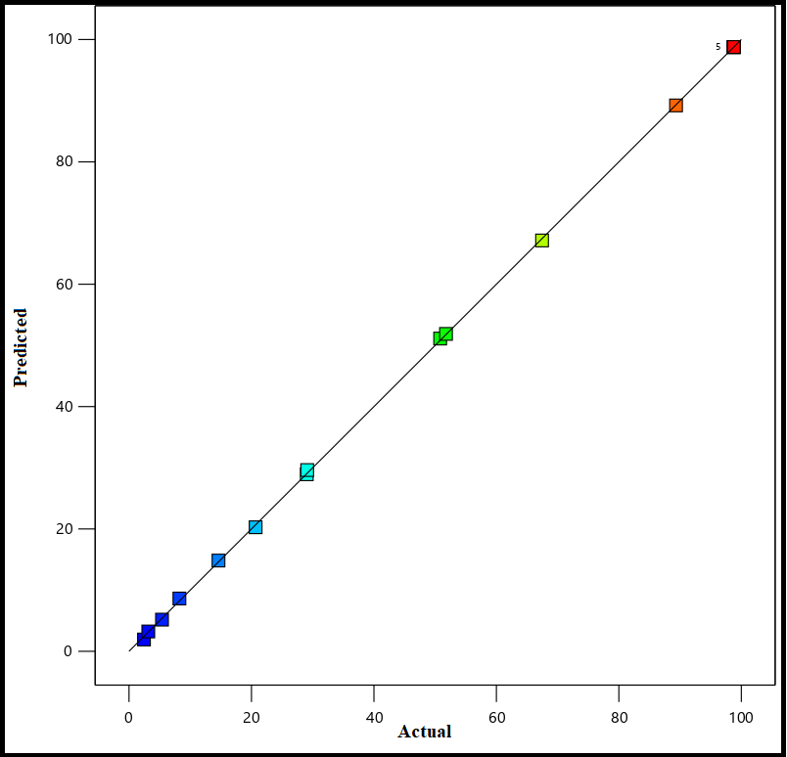

**Fig. S1:** predicted versus actual plots

**Fig. S2:** Vant’ Hoff plot for the adsorption ofPb(II) ontoTSA@amine modified SiO2