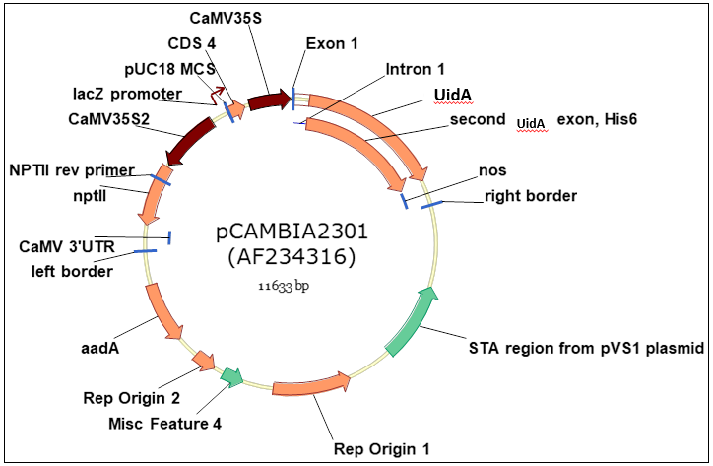

Supporting Figure 1. Map of pCAMBIA2301

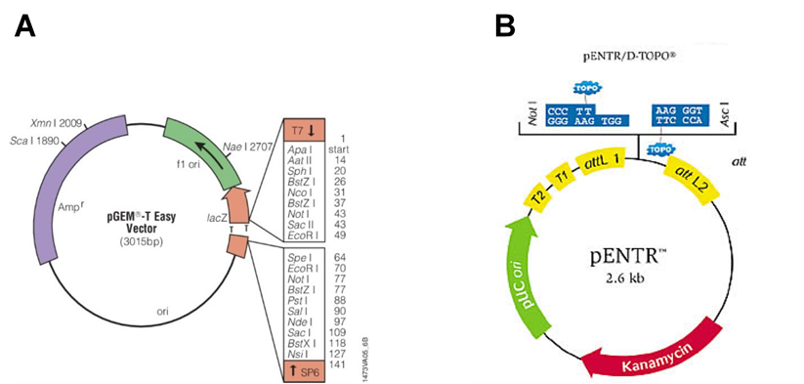

Supporting Figure 2. Map of pENTR/D-TOPO® entry vector

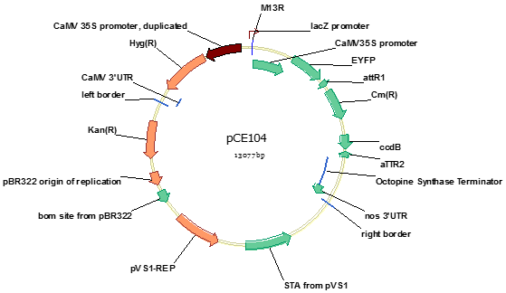

Supporting Figure 3. Map of pCE104-EYFP plant expression vector

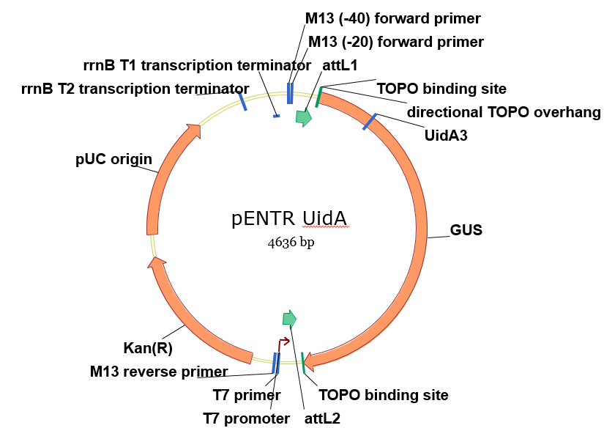

Supporting Figure 4. Map of pENTR-UidA

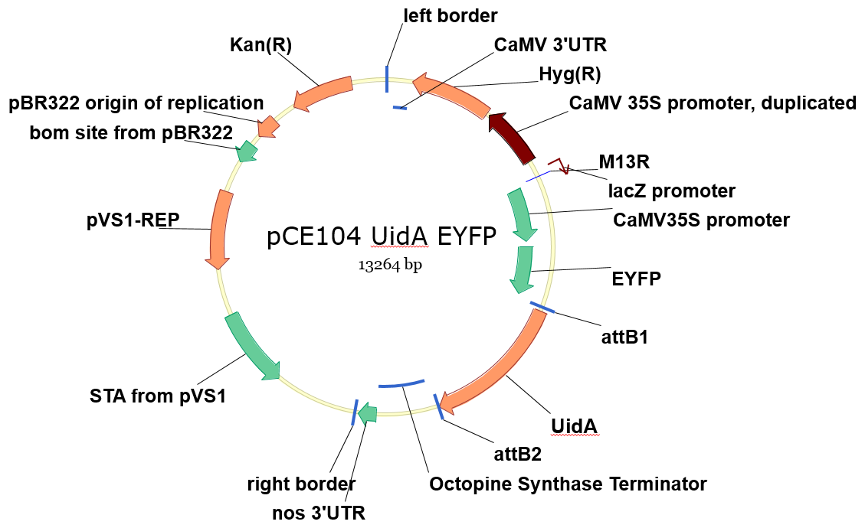

Supporting Figure 5. Map of pCE104-UidA-EYFP

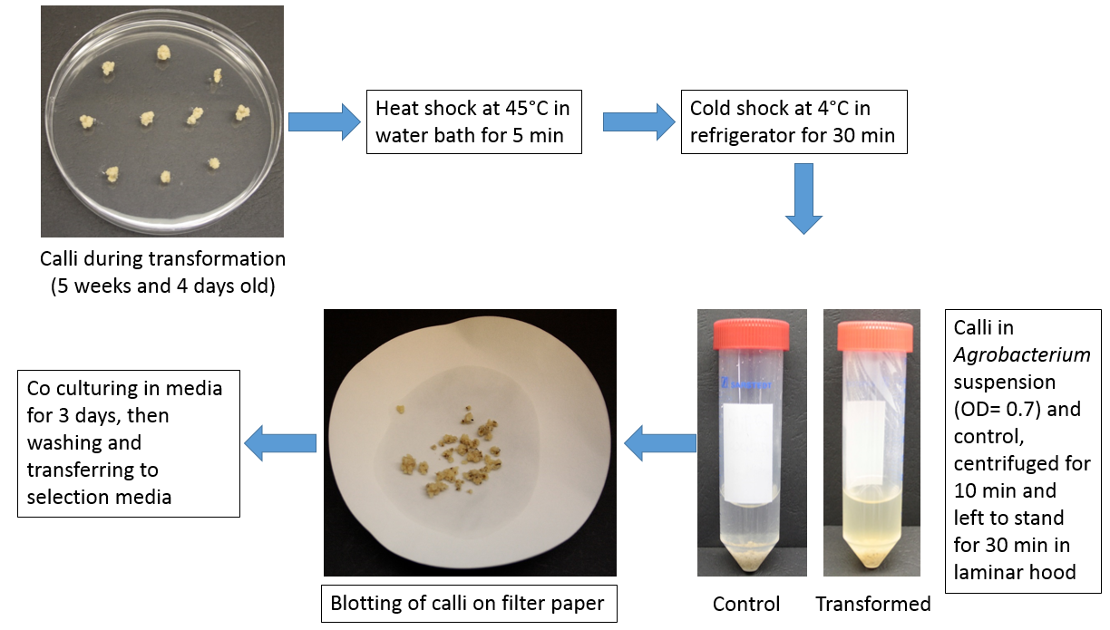

**Supporting Figure 6. *Tripogon loliiformis* calli transformation following rice transformation protocol**

**(****Hoang, 2014****)**

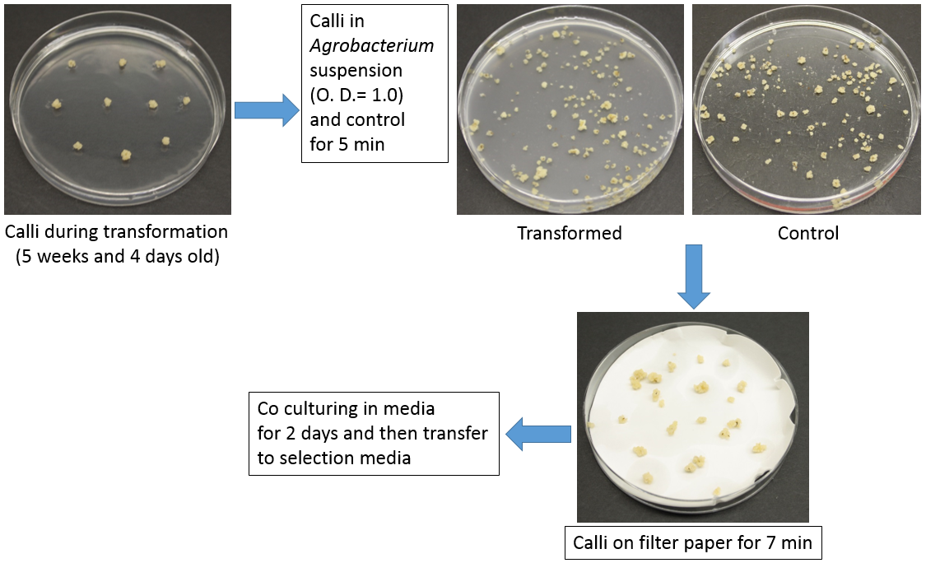

**Supporting Figure 7. *Tripogon loliiformis* calli transformation following the *Brachypodium distachyon* transformation protocol**

**(****Alves et al., 2009****)**

**Supporting Table 1: Chemicals used during regeneration and transformation of *Tripogon lolliformis***

|  |  |
| --- | --- |
| **Chemicals** | **Composition** |
| **Acetosyringone** | 100 mM acetosyringone; dissolved in DMSO |
| **Agarose gel loading dye (6X)** | 0.25% (w/v) bromophenol blue, 50% TE (w/v), 50% (v/v) glycerol |
| **BAP (1 mg mL-1)** | Dissolved 6-Benzylaminopurine in 1 M NaOH |
| **CHCl3: IAA** | Chloroform isoamyl alcohol in a ratio of 24:1 (v/v) |
| **EDTA** | 0.5 M Ethylene diamine tetra-acetic acid, pH 8.0 |
| **Gus stain solution** | 100 mM phosphate buffer pH 7.0, 10 mM EDTA, 1 mM potassium ferricyanide, 0.1% Triton X-100, 2 mM 5-bromo-4-chloro- 3-indolyl-β-D-glucuronide. |
| **Kanamycin (50 mg mL-1)** | Dissolved kanamycin in deionised water, filter sterilised |
| **NAA (1 mg mL-1)** | Dissolved 1-naphthaleneacetic acid in ethanol |
| **Rifampicin (25 mg mL-1)** | Dissolved rifampicin in DMF (dimethylformanmide) |
| **TAE buffer** | 10 mM Tris-HCl, 0.5 mM EDTA pH 7.8 |
| **MS Macronutrients stock solution 1 (10X concentrated)** | NH4N03 16.5 gL-1, KNO3 19 gL-1, MgSO4.7H2O 3.76 gL-1, KH2PO4 1.7 gL-1 |
| **MS Macronutrients stock solution 2 (10X concentrated)** | CaCl2.2H2O 4.398 mgL-1 |
| **MS Micronutrients stock solution (1000X concentrated)** | KI 830 mgL-1, H3BO3 620 mgL-1, MnSO4.4H2O 13,200 mgL-1, ZnSO4.7H2O 860 mgL-1, Na2MoO4.2H2O 250 mgL-1, CuSO4.5H2O 25 mgL-1, CoCl2.2H2O 25 mgL-1 |
| **N6 Macronutrients Stock solution (20X concentrated)** | KNO3 56.6 gL-1, (NH4)2SO4 9.26 gL-1, MgSO4.7H2O 3.7 gL-1, KH2PO4 8 gL-1, CaCl2.2H2O 3.32 gL-1 |
| **N6 Micronutrients Stock solution (100X concentrated)** | KI 80 mgL-1, H3BO3 160 mgL-1,MnSO4.4H2O 440 mgL-1, ZnSO4.7H2O 150 mgL-1, Na2MoO4.2H2O 25 mgL-1 |
| **FeEDTA stock solution** **(100X concentrated)** | Na2EDTA.2H2O 3.725 gL-1 FeSO4.7H2O 2.785 gL-1 |
| **Vitamins stock solution** **(MS or N6) (100X concentrated)** | Nicotinic Acid 50 mgL-1, Pyridoxine-HCl 50 mgL-1, Thiamine-HCl 100 mgL-1, Glycine200 mgL-1 |
| **M5 vitamins (100X concentrated)** | Nicotinic acid 0.04g, Thiamine-HCl 0.05g,  Cysteine 4g, Glycine 0.2g, Pyridoxine-HCl 0.04g, MilliQ water up to 1L, Gelzan 2.5g, pH 5.8, Filter sterilization |

**Supporting Table 2: Media used during regeneration and transformation of *Tripogon lolliformis***

|  |  |
| --- | --- |
| **Media** | **Composition** |
| **ATM2 media (1L)** | Mannitol 10g, Yeast extract 0.4g, K2HPO4 0.1g, KH2PO4 0.4g, NaCl 0.1g, MgSO4.7H2O 0.2g, pH 6.8, MilliQ water up to 1L, sterilization in Autoclave at 121°C for 15min. |
| **LB media (1L)** | Tryptone 10g, Yeast extract 5g, NaCl 10g, MilliQ water upto 1L, pH 7.5, sterilization in Autoclave at 121°C for 15min. |
| **BRM media (1L)** | MS macronutrients stock solution 01- 50mL,  MS macronutrients stock solution 02- 50mL,  MS micronutrients stock solution 1mL, FeEDTA 5mL, Nicotinic acid 0.5mL, Pyridoxine-HCl 0.5mL, Thiamine-HCl 1mL, Glycine 1mL, Arginine 174mg, Aspartic Acid 266mg, Casein Hydrolysate 500mg, L-Glutamine 876mg, Thiamine-HCl 10mg, Glucose 36g, Sucrose 68.4g, MilliQ water up to 1L, pH 5.2, Filter sterilization |
| **ATM4 media (1L)** | MS macronutrients stock solution 01- 50mL,  MS macronutrients stock solution 02- 50mL,  MS micronutrients stock solution 1mL, FeEDTA 5mL, Nicotinic acid 0.5mL, Pyridoxine-HCl 0.5mL, Thiamine-HCl 1mL, Glycine 1mL, Sucrose 68.5g, Glucose 36g, Casein Hydrolysate 0.5g, L-Glutamine1g, L-Aspartic acid 0.3g, L-Arginine 0.2g, Glycine 7 mg, MilliQ water up to 1L, pH 5.2, sterilization in Autoclave at 121°C for 15min |
| **ATM6 media (1L)** | N6 Macronutrients stock solution 50mL,  N6 Micronutrients stock solution 2mL, FeNaEDTA 5mL, Nicotinic acid 0.5mL, Pyridoxine-HCl 0.5mL, Thiamine-HCl 1mL, Glycine 1mL, L-Proline 0.5g, L-Glutamine 0.5g, Casein Hydrosylate 1g, Sucrose 30g, MilliQ water up to 1L, pH 5.85, sterilization in Autoclave at 121°C for 15min |
| **CCM (Co-culture media) (1L)** | N6 Macronutrients 50mL, N6 Micronutrients 2mL, FeNaEDTA 5mL, Nicotinic acid 0.5mL, Pyridoxine-HCl 0.5mL, Thiamine-HCl 1mL, Sucrose 30g, Glucose 10g, Casein Hydrosylate 1g, 2,4-D (2mgmL-1), MilliQ water up to 1L, Gelzan 2.5g, pH 5.2, sterilization in Autoclave at 121°C for 15min |
| **MSB medium (1L)** | MS Macronutrients stock solution 01- 50mL, MS Macronutrients stock solution 02- 50mL, FeEDTA- 5mL, MS Micronutrients stock solution 1mL, Sucrose 10g, Mannitol 10g, MilliQ water up to 1L, pH 5.5, sterilization in Autoclave at 121°C for 15min |
| **MSB3 medium (1L)** | MS Macronutrients stock solution 01- 50mL, MS Macronutrients stock solution 02- 50mL, FeEDTA- 5mL, MS Micronutrients stock solution 1mL, Sucrose 30g, 2,4-D (2mgmL-1) 1.25mL, MilliQ water up to 1L, Gelzan 2.5g, pH 5.8, sterilization in Autoclave at 121°C for 15min |

**Supporting Table 3: Primers for plasmid cloning**

|  |  |  |  |  |  |
| --- | --- | --- | --- | --- | --- |
| **Primer set** | **Primer name** | **Primer type** | **Sequence (5’-3’)** | **Product size (bp)** | **Aims** |
| A | UidA XhoI | Forward | CTCGAGATGGTAGATCTGA GGGTAAATTTC | 2056bp | The amplification of *UidA* gene from the pCAMBIA 2301 vector |
| UidA BstEII | Reverse | GGTCACCTGTAATTCACACGTGGTG |
| B | UidA3 | Forward | TGAACATGGCATCGTGGTGA | 990bp | *E. coli* colony PCR for confirmation of transformation of pENTR-UidA by electroporation |
| M13 | Reverse | GTCATAGCTGTTTCCTG |
| C | M13 | Forward | GTAAAACGACGGCCAG | - | Sanger sequencing to verify *UidA* gene |
| D | CaMV35S | Forward | GAAAAAGAAGACGTTCCAACCACG | 2849bp | *E. coli* colony PCR to confirm the *UidA* gene in pCE104-UidA-EYFP after transformation by heat shock |
| UidA BstEII | Reverse | GGTCACCTGTAATTCACACGTGGTG |
| E | EYFP | Forward | ATGATGGG CAAGGGCGAG | 3420bp | *E. coli* colony PCR for confirmation of transformation of the *EYFP* gene in pCE104-UidA-EYFP by heat shock |
| Octopine synthase terminator | Reverse | GGGTGATATATTCA TTAGAATG |
| F | EYFP | Reverse | CTTGTACAGCTCGTCCATGCC | - | Sanger sequencing to verify *EYFP* gene in pCE104-UidA-EYFP |
| Octopine synthase terminator | Reverse | GGGTGATATATTCATTAGA ATG | Sanger sequencing to verify *UidA* gene in pCE104-UidA-EYFP |
| G | EYFP | Forward | ATGATGGGCAAGGGCGAG | 2652bp | *Agrobacterium tumefaciens* colony PCR for confirmation of transformation of the pCE104-UidA-EYFP plasmid DNA by electroporation |
| UidA BstEII | Reverse | GGTCACCTGTAATTCA CACGTGGTG |

**d**