**A new Sulphur containing heterocycles having azo linkage: Synthesis, Structural Characterization and Biological Evaluation**

**Mallikarjuna Niluvanji Matada1, Keshavayya Jathi1*, Maliyappa M. Rangappa1, Kiptoo Geoffry2, Ravi Kumar S3, Ravi B. Nagarajappa1 and Fiza Noor Zahara1**

*1Department of P. G. Studies and Research in Chemistry, School of Chemical Sciences, Kuvempu University, Jnana Sahyadri, Shankaraghatta-577451, Shimoga, Karnataka, India.*

*2Department of Chemistry and Biochemistry, School of Biological and Physical Sciences, Moi University, Eldoret Kenya-3900-30100*

*3Department of PG Studies and Research in Biotechnology, School of Bio Sciences, Kuvempu University, Jnana Sahyadri, Shankaraghatta-577451, Karnataka, India.*

*(Email:* [*jathikeshavayya1959@gmail.com*](mailto:jathikeshavayya1959@gmail.com)*, Tel: +91-9448446151)*

**Index**

|  |  |  |
| --- | --- | --- |
| **Sl. No.** | **Figures** | **Caption** |
|  | **Fig. S1** | Electronic spectra of the compounds (**D1-D4**) in chloroform |
|  | **Fig. S2** | Electronic spectra of the compounds (**D1-D4**) in DMF |
|  | **Fig. S3** | Electronic spectra of the compounds (**D1-D4**) in DMSO |
|  | **Fig. S4** | Antimycobacterial results for the dyes (**D1-D4**) and the standard drugs |
|  | **Fig. S5** | *In silico* molecular docking results of the azo dyes **(D1-D4)** |

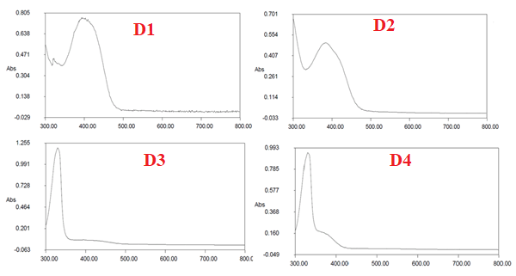

**Fig. S1**: Electronic spectra of the compounds (**D1-D4**) in chloroform

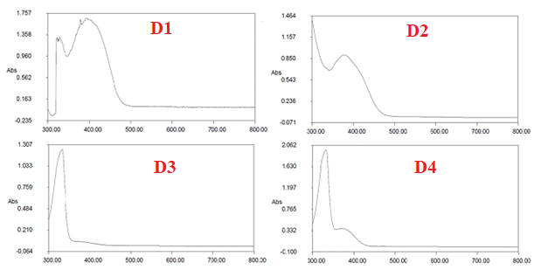

**Fig. S2**: Electronic spectra of the compounds (**D1-D4**) in DMF

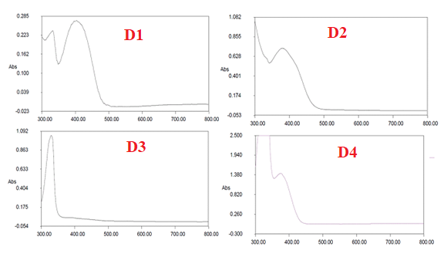

**Fig. S3**: Electronic spectra of the compounds (**D1-D4**) in DMSO

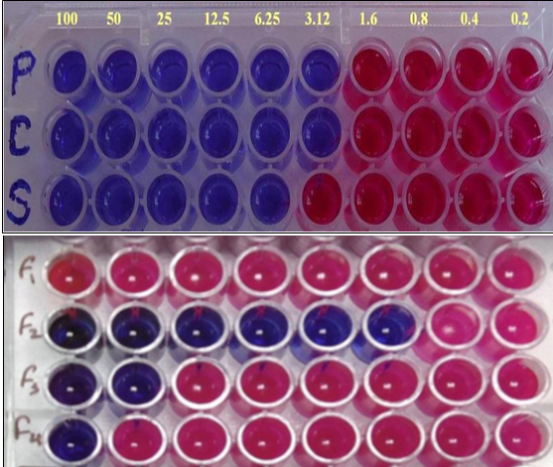

**Fig. S4:** Antimycobacterial results for the dyes (**D1-D4**) and the standard drugs

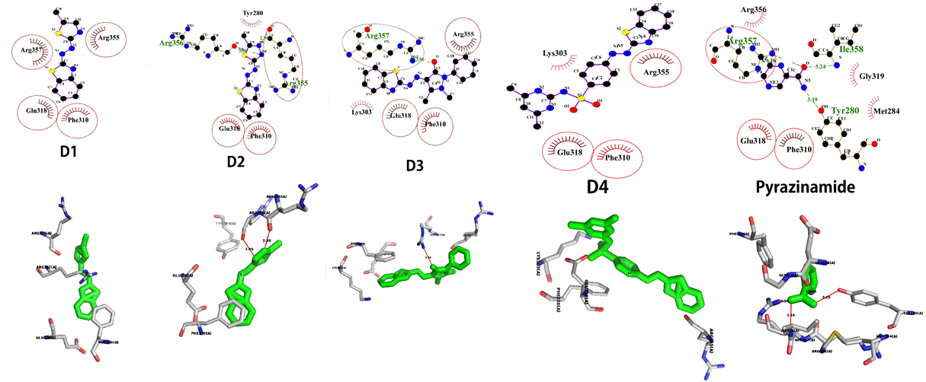

**Fig. S5:** *In silico* molecular docking results of the azo dyes **(D1-D4)**