**An efficient, sustainable approach to the chemo and regioselective synthesis of novel spiroindenoquioxaline grafted piperidone hybrid heterocycles**

_____________________________________________________________________________________________________________________

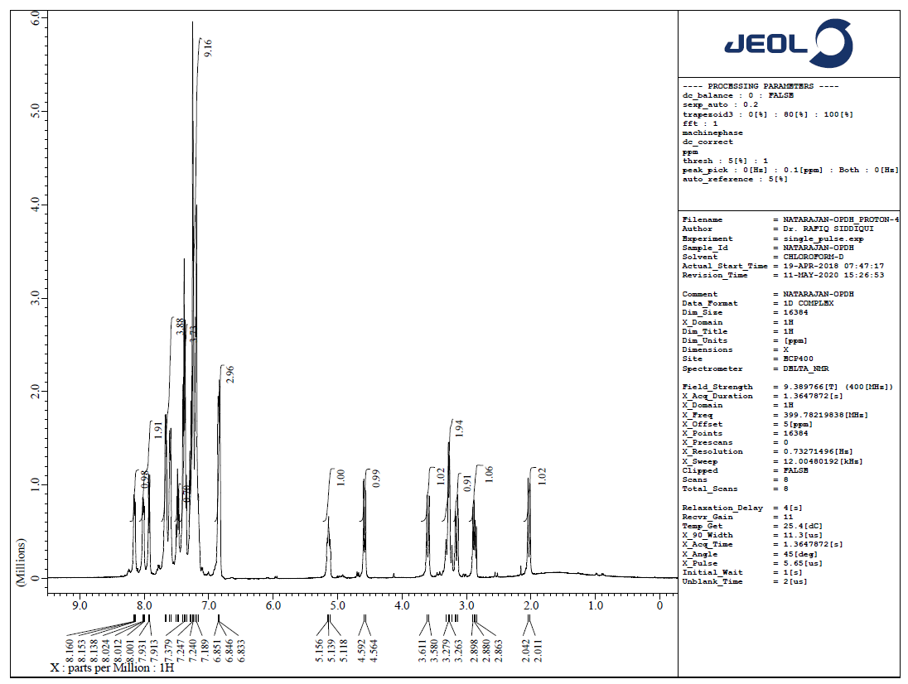

**Figure S1.** 1H NMR spectrum of **5a**

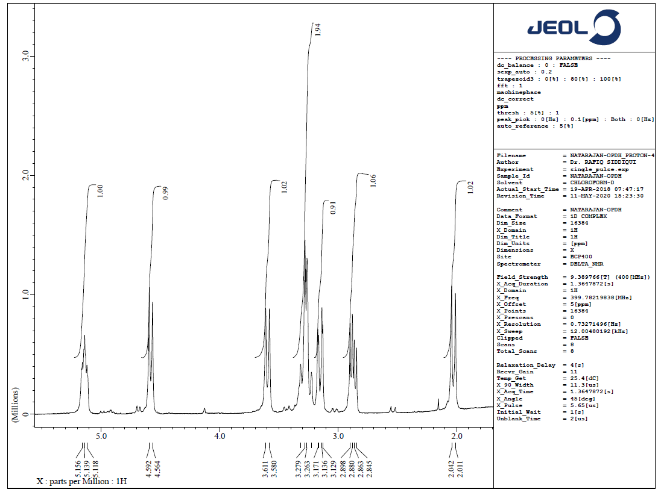

**Figure S2.** 1H NMR spectrum of **5a**

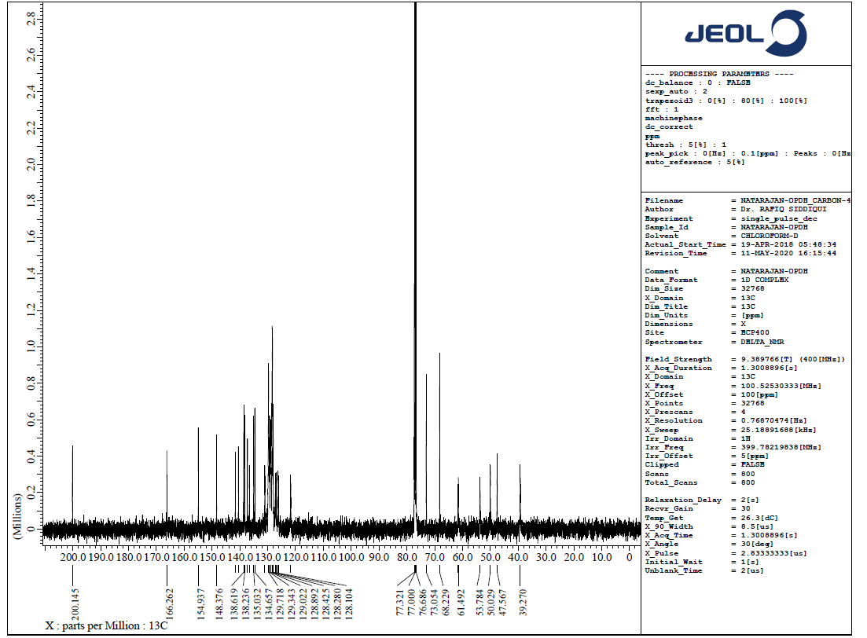

**Figure S2.** 1H NMR spectrum of **5a**

**Experimental section:**

1H and 13C NMR spectra were done on JEOL-400 NMR spectrometers in CDCl3 using TMS as internal standard. Chemical shifts are given in parts per million (δ-scale) and coupling constants are given in hertz. The required elemental analysis of carbon, hydrogen and nitrogen were recorded on a Perkin Elmer 2400 Series II Elemental analyzer. Mass spectra were performed on a Quattro Premier™ instrument (Micromass, Milford, USA) equipped with an electrospray ionization source (Zespray) coupled with an Acquity® UPLC system.

*5-Benzyl-4-(2-chlorophenyl- spiro[2.3'] indenoquinoxalino -spiro[3.3'']-5''-[2-chlorobenzylidenepiperidone-pyrrolidine,* ***5b***

White color solid; 1H NMR (CDCl3, 400MHz): *δ*/ppm 2.06 (d, *J* = 12.4 Hz, 1H), 2.88-2.93 (m, 1H), 3.16-3.20 (m, 1H), 3.25-3.34 (m, 2H), 3.62 (d, *J* = 12.4 Hz, 1H), 4.61 (d, *J* = 11.2 Hz, 1H), 5.14-5.18 (m, 1H), 6.86-6.88 (m, 3H, ArH), 7.18-7.53 (m, 12H, ArH), 7.61-7.70 (m, 4H, ArH), 7.95 (d, *J* = 7.2 Hz, 1H), 8.03-8.05 (m, 1H), 8.17-8.19 (m, 1H, ArH); 13C NMR (CDCl3, 100MHz):39.7, 48.1, 50.6, 53.9, 61.8, 68.4, 73.2, 121.9, 12198, 127.2, 127.7, 127.9, 128.3, 128.5, 128.6, 128.9, 129.0, 129.5, 129.7, 129.9, 131.0, 134.9, 135.1, 136.7, 137.9, 138.5, 138.8, 140.8, 141.7, 148.6, 155.2, 166.7, 200.7; LC/MS(ESI): *m/z* = 680 (M+); Anal. Calcd for C42H32Cl2N4O: C, 74.22; H, 4.75; N, 8.24%; Found C, 74.30; H, 4.84; N, 8.31%.

*5-Benzyl-4-(4-chlorophenyl- spiro[2.3'] indenoquinoxalino -spiro[3.3'']-5''-[4-chlorobenzylidenepiperidone-pyrrolidine,* ***5c***

White color solid; 1H NMR (CDCl3, 400MHz): *δ*/ppm 2.04 (d, *J* = 12.4 Hz, 1H), 2.86-2.91 (dd, *J* = 14.0, 7.2 Hz, 1H), 3.15-3.19 (m, 1H), 3.24-3.33 (m, 2H), 3.61 (d, *J* = 12.4 Hz, 1H), 4.59 (d, *J* = 11.0 Hz, 1H), 5.14-5.17 (m, 1H), 6.85-6.87 (m, 3H, ArH), 7.18-7.52 (m, 12H, ArH), 7.60-7.69 (m, 4H, ArH), 7.94 (d, *J* = 7.2 Hz, 1H), 8.02-8.04 (m, 1H), 8.16-8.18 (m, 1H, ArH); 13C NMR (CDCl3, 100MHz 39.5, 47.3, 50.4, 53.9, 61.9, 68.5, 73.3, 121.5, 121.4, 126.7, 127.2, 127.4, 127.6, 128.2, 128.3, 128.4, 128.6, 129.1, 129.5, 129.9, 131.1, 134.4, 135.2, 136.8, 137.5, 138.3, 138.5, 140.8, 141.7, 148.2, 154.7, 166.6, 200.3; LC/MS(ESI): *m/z* = 680 (M+); Anal. Calcd for C42H32Cl2N4O: C, 74.22; H, 4.75; N, 8.24%; Found C, 74.32; H, 4.82; N, 8.35%.

*5-Benzyl-4-(4-bromophenyl- spiro[2.3'] indenoquinoxalino -spiro[3.3'']-5''-[4-bromobenzylidenepiperidone-pyrrolidine,* ***5d***

White color solid; 1H NMR (CDCl3, 400MHz): *δ*/ppm 2.08 (d, *J* = 12.4 Hz, 1H), 2.90-2.96 (m, 1H), 3.19-3.23 (m, 1H), 3.28-3.37 (m, 2H), 3.64 (d, *J* = 12.4 Hz, 1H), 4.64 (d, *J* = 11.0 Hz, 1H), 5.18-5.21 (m, 1H), 6.90-6.91 (m, 3H, ArH), 7.22-7.56 (m, 12H, ArH), 7.64-7.73 (m, 4H, ArH), 7.98 (d, *J* = 7.2 Hz, 1H), 8.06-8.08 (m, 1H), 8.19-8.22 (m, 1H, ArH); 13C NMR (CDCl3, 100MHz 40.1, 47.5, 50.6, 54.1, 62.0, 68.7, 73.5, 121.3, 121.6, 126.5, 127.5, 127.7, 127.8, 128.4, 128.3, 128.4, 128.7, 129.3, 129.6, 130.2, 131.3, 134.5, 135.7, 136.9, 137.6, 138.5, 138.7, 140.9, 141.9, 148.3, 154.9, 166.8, 200.7; LC/MS(ESI): *m/z* = 768 (M+); Anal. Calcd for C42H32Br2N4O: C, 65.64; H, 4.20; N, 7.29%; Found C, 65.71; H, 4.30; N, 7.37%.

*5-Benzyl-4-(4-methylphenyl- spiro[2.3'] indenoquinoxalino -spiro[3.3'']-5''-[4-methylbenzylidenepiperidone-pyrrolidine,* ***5e***

White color solid; 1H NMR (CDCl3, 400MHz): *δ*/ppm 2.03 (d, *J* = 12.4 Hz, 1H), 2.29 (s, 3H), 2.35 (s, 3H), 2.86-2.91 (dd, *J* = 14.0, 7.2 Hz, 1H), 3.16-3.22 (m, 2H), 3.37-3.41 (m, 1H), 3.65 (d, *J* = 13.0 Hz, 1H), 4.63 (d, *J* = 10.8 Hz, 1H), 5.21-5.23 (m, 1H), 6.76-6.85 (m, 3H, ArH), 7.11-7.56 (m, 12H, ArH), 7.34-7.38 (m, 4H, ArH), 7.60-7.64 (m, 1H), 7.73-7.77 (m, 1H), 7.87-7.94 (m, 1H, ArH); 13C NMR (CDCl3, 100MHz) 21.1, 21.4, 39.4, 46.9, 52.8, 53.1, 61.9, 66.6, 72.7, 121.1, 121.5, 125.9, 126.5, 127.4, 127.6, 127.9, 128.5, 128.1 128.3, 128.6, 129.2, 129.5, 130.1, 131.4, 134.6, 135.8, 137.5, 137.6, 138.2, 138.9, 140.1, 141.6, 147.9, 155.1, 166.6, 200.1; LC/MS(ESI): *m/z* = 638 (M+); Anal. Calcd for C44H38N4O: C, 82.73; H, 6.00; N, 8.77%; Found C, 82.79; H, 6.09; N, 8.85%.

*5-Benzyl-4-(4-methoxyphenyl- spiro[2.3'] indenoquinoxalino -spiro[3.3'']-5''-[4-methoxybenzylidenepiperidone-pyrrolidine,* ***5f***

White color solid; 1H NMR (CDCl3, 400MHz): *δ*/ppm 2.03 (m, 1H), 2.89-2.91 (m, 1H), 3.14-3.17 (m, 2H), 3.38-3.42 (m, 1H), 3.63 (d, *J* = 13.0 Hz, 1H), 3.79 (s, 3H), 3.80 (s, 3H), 4.62 (d, *J* = 10.8 Hz, 1H), 5.14-5.20 (m, 1H), 6.82-6.88 (m, 3H, ArH), 7.20-7.39 (m, 12H, ArH), 7.57-7.64 (m, 2H, ArH), 7.72-7.76 (m, 2H, ArH), 7.87-7.89 (m, 1H), 7.91-7.93 (m, 1H), 8.09-8.13 (m, 1H, ArH); 13C NMR (CDCl3, 100MHz 39.5, 47.0, 52.6, 53.1, 55.2, 55.3, 61.7, 66.4, 72.6, 121.2, 121.4, 125.5, 126.3, 127.7, 127.5, 127.9, 128.7, 128.3 128.4, 128.7, 129.2, 129.4, 130.3, 131.5, 134.6, 135.9, 137.4, 137.3, 138.0, 138.7, 140.0, 141.4, 147.6, 155.2, 166.2, 200.2; LC/MS(ESI): *m/z* = 670 (M+); Anal. Calcd for C44H38N4O3: C, 78.78; H, 5.71; N, 8.35%; Found C, 78.85; H, 5.78; N, 8.42%.