**Journal:** **Journal of King Saud University-Science**

**Title: Multiple resistance mechanisms in *Staphylococcus* sp. strain AS6 under arsenite stress and its potential use in amelioration of waste water**

**Authors:** Shahid Shera, Syed Zajif Hussainb, Abdul Rehmana*

aDepartment of Microbiology and Molecular Genetics, University of the Punjab, Lahore, Pakistan

bDepartment of Chemistry, SBA School of Science and Engineering (SBASSE), Lahore University of Management Sciences (LUMS), DHA, Lahore Cantt-54792, Pakistan

## *Correspondence author

## Dr. Abdul Rehman

Associate Professor

Department of Microbiology & Molecular Genetics

University of the Punjab, New Campus,

Lahore 54590, Pakistan

Tel: 92-42-9231249

Email: rehman_mmg@yahoo.com

**Supplementary data (Table and Figures)**

**Table S1:** Physiochemical properties of waste water sample from where the bacterium isolated.

|  |  |
| --- | --- |
| **Physiochemical parameter** | **Results** |
| Color | Light black |
| Temperature | 32 |
| pH | 7.5 |
| Electrical conductivity (μS/cm) | 1356 |
| Turbidity (NTU) | 11.8 |
| TDS (total dissolved solids) (μg/L) | 681 |
| Arsenic concentration (μg/L) | 200 |

**Table S2: MIC of different heavy metals in isolated bacterium.**

|  |  |
| --- | --- |
| **Metal ions used** | **MIC (mM)** |
| Arsenite (As+3) | 25 |
| Arsenate (As+5) | 150 |
| Lead (Pb) | 5 |
| Cadmium (Cd) | 3 |
| Chromium (Cr) | 5 |
| Mercury(Hg) | 2.5 |
| Selenium (Se)  Cobalt(Co)  Nickel (Ni) | 4  3  5 |

**Table S3:** Morphological and biochemical characteristics of isolated bacterial strain *Staphylococcus* sp. strain AS6.

|  |  |
| --- | --- |
| Morphological and biochemical tests | Results |
| Form | Circular |
| Surface | Smooth |
| Color | Yellow |
| Margin | Entire |
| Elevation | Convex |
| Opacity | Opaque |
| Cell shape | Cocci |
| Motility | Non-motile |
| Gram staining | Gram positive cocci |
| Catalase | Positive |
| Oxidase | Negative |
| Coagulase | Negative |
| Urease | Positive |
| Citrate | Positive |
| Lactose fermentation | Negative |
| H2S | Negative |
| Nitrate reduction | Positive |
| Indole | Negative |
| Methyl red | Positive |
| Voges proskauer (VP) | Positive |
| Manitol salt agar growth/color | Positive with no color change |

**Table S4:** Glutathione and non-protein thiols concentration under 15 mM arsenite stress in isolated bacterium *Staphylococcus* sp. strain AS6.

|  |  |  |  |  |  |  |  |
| --- | --- | --- | --- | --- | --- | --- | --- |
| **Arsenite concentration**  **(mM)** | **GSH**  **(mM g-1 FW)** | **GSSG (mM g-1 FW)** | **GSH+ GSSG (mM g-1 FW)** | **GSH/GSSG** | **% increase in**  **GSH/GSSG** | **Non-protein thiols** | **% increase in non-protein thiol** |
| 0 | 6.4 | 0.5 | 6.90 | 12.80 | 5.77:12.80*100  = 45.08 % | 1.7 | 1.3:1.7*100 =76.47 % |
| 15 | 13.0 | 0.7 | 13.70 | 18.57 |  | 3.0 |  |

**Table S5:** Enzymatic activities of SOD, CAT, POX, and APX of *Staphylococcus* sp. strainAS6 with and without metal stress.

|  |  |  |
| --- | --- | --- |
| **Antioxidant enzymes**  **U min-1 mg protein-1** | **Strain AS6 (without arsenite stress)** | **Strain AS6 (with arsenite stress -10 mM)** |
| Superoxide dismutase (SOD) | 10.44 ± 0.12 | 6.56 ± 0.26 |
| Catalase (CAT) | 14.22 ± 0.33 | 28.45 ± 0.54 |
| Peroxidase (POX) | 0.372 ± 0.03 | 0.200 ± 0.05 |
| Ascorbate peroxidase (APX) | 0.290 ± 0.01 | 0.345 ± 0.02 |

**Table S6: Genes responsible for the resistance of other metals and their putative functions.**

|  |  |  |  |  |  |
| --- | --- | --- | --- | --- | --- |
| **Genes and its position** | **Product** | **Putative function** | **Closest related sequence** | **% Query coverage** | **% Ident** |
| *czcD_1*  18465-19418 | Cobalt-zinc-cadmium resistance protein CzcD | Inorganic ion transport and metabolism | [WP_019467694.1](https://www.ncbi.nlm.nih.gov/protein/WP_019467694.1?report=genbank&log$=prottop&blast_rank=1&RID=1VCC7044014) | 85% | 100% |
| *cadA_1*  52258-54675 | Cadmium transporting P- type ATPase | Play role in translocating cadmium and other heavy metal divalent ions | [WP_019469244.1](https://www.ncbi.nlm.nih.gov/protein/WP_019469244.1?report=genbank&log$=prottop&blast_rank=1&RID=1VC5ZTV3014) | 99% | 100% |
| *cadA_2*  9765-12158 | Putative cadmium transporting ATPase | Translocate cadmium ions | [WP_019467776.1](https://www.ncbi.nlm.nih.gov/protein/WP_019467776.1?report=genbank&log$=prottop&blast_rank=1&RID=1VD2NJ6D014) | 99% | 100% |
| cadC_1  12175-12543 | Cadmium resistance transcriptional regulatory protein CadC | Regulate the transportation of arsenic and other divalent heavy metal ions | [WP_011304078.1](https://www.ncbi.nlm.nih.gov/protein/WP_011304078.1?report=genbank&log$=prottop&blast_rank=1&RID=1VD93DJH01R) | 99% | 100% |
| *czcD_2*  1879-2820 | Cobalt-zinc-cadmium resistance protein CzcD | Inorganic ion transport and metabolism | [WP_019467694.1](https://www.ncbi.nlm.nih.gov/protein/WP_019467694.1?report=genbank&log$=prottop&blast_rank=1&RID=1VCC7044014) | 85% | 100% |
| cadC_2  11923-12270 | Cadmium resistance transcriptional regulatory protein CadC | Regulate the transportation of arsenic and other divalent heavy metal ions | [WP_011304078.1](https://www.ncbi.nlm.nih.gov/protein/WP_011304078.1?report=genbank&log$=prottop&blast_rank=1&RID=1VD93DJH01R) | 99% | 100% |
| PROKKA_02635  12289-12906 | Cadmium resistance transporter | Play role in cadmium resistance or sequestration | [WP_002472504.1](https://www.ncbi.nlm.nih.gov/protein/WP_002472504.1?report=genbank&log$=prottop&blast_rank=2&RID=1VDUU58K01R) | 99% | 99.51% |
| *CorC_1*  41022-42041 | Magnesium and cobalt efflux protein | Efflux Mg+2 and Cobalt from cell | [WP_019469692.1](https://www.ncbi.nlm.nih.gov/protein/WP_019469692.1?report=genbank&log$=prottop&blast_rank=1&RID=1VE2651101R) | 95% | 100% |
| *CorC_2*  26889-28241 | Magnesium and cobalt efflux protein | Efflux Mg+2 and Cobalt from cell | [WP_019469692.1](https://www.ncbi.nlm.nih.gov/protein/WP_019469692.1?report=genbank&log$=prottop&blast_rank=1&RID=1VE2651101R) | 95% | 100% |

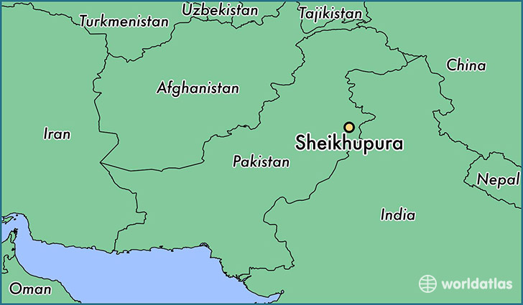

**Figure S1:** Geographical map of District Sheikhupura, Pakistan.

**(a)**

**(b)**

**Figure S2:** Growth (OD) of isolated bacterium at different temperature and pH.

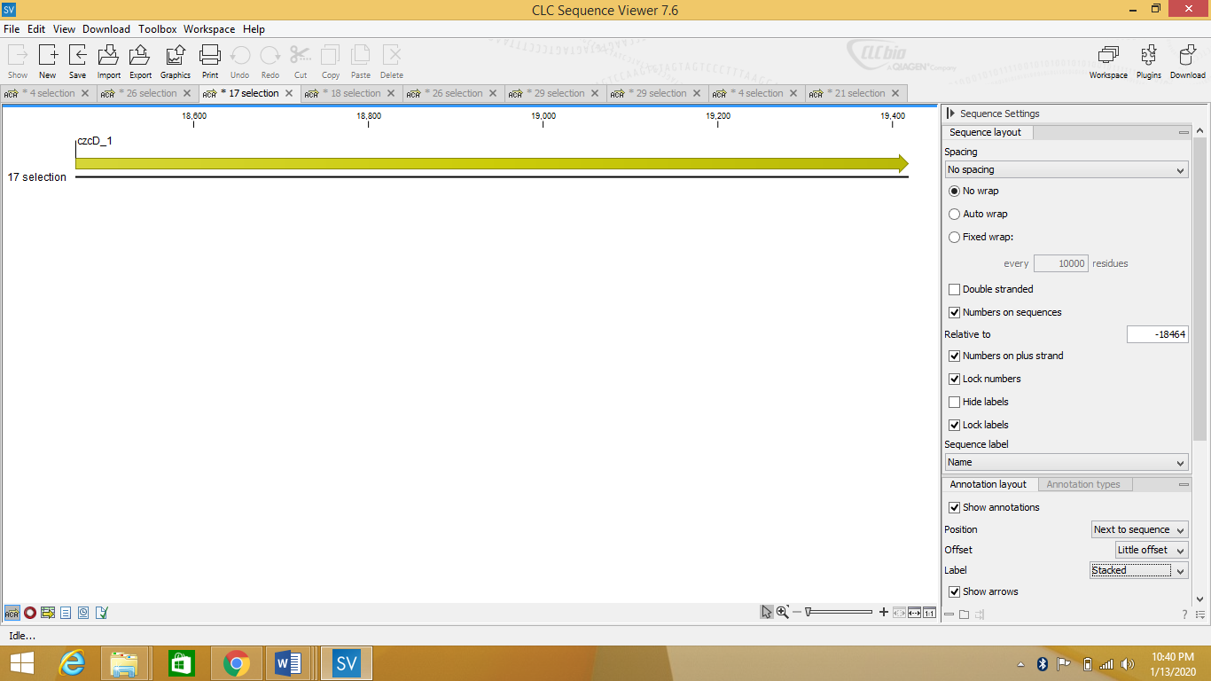

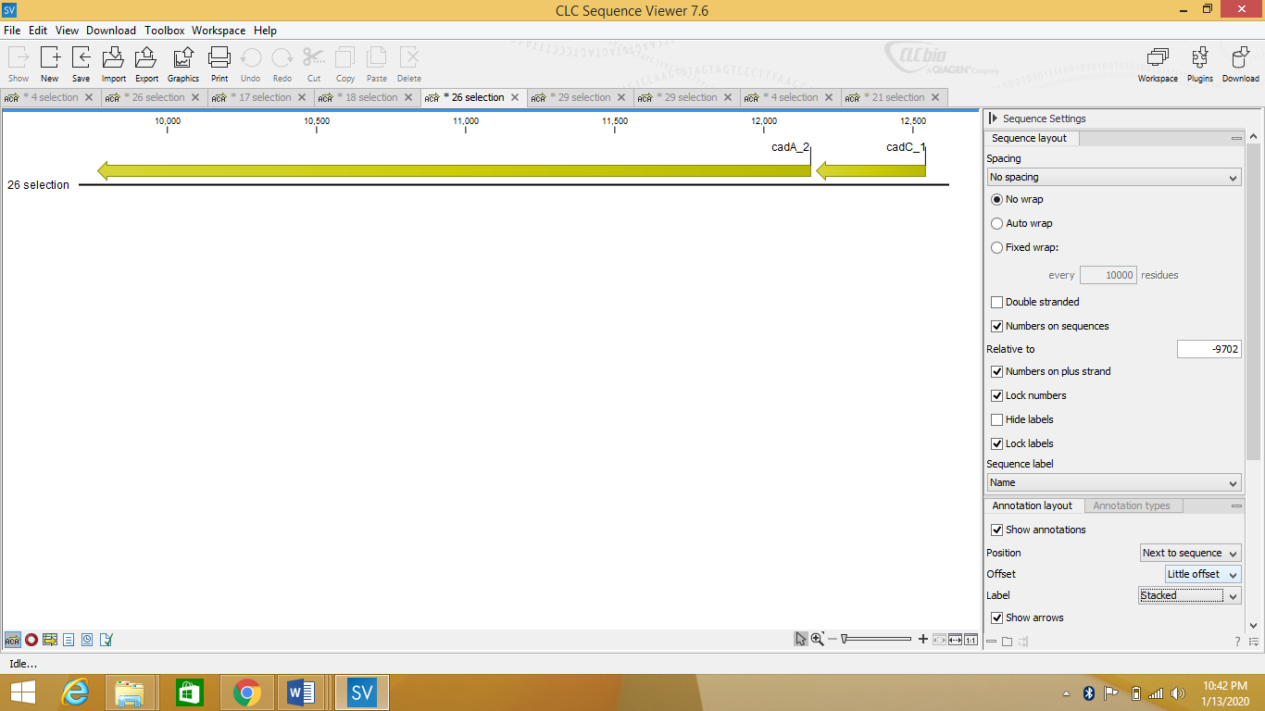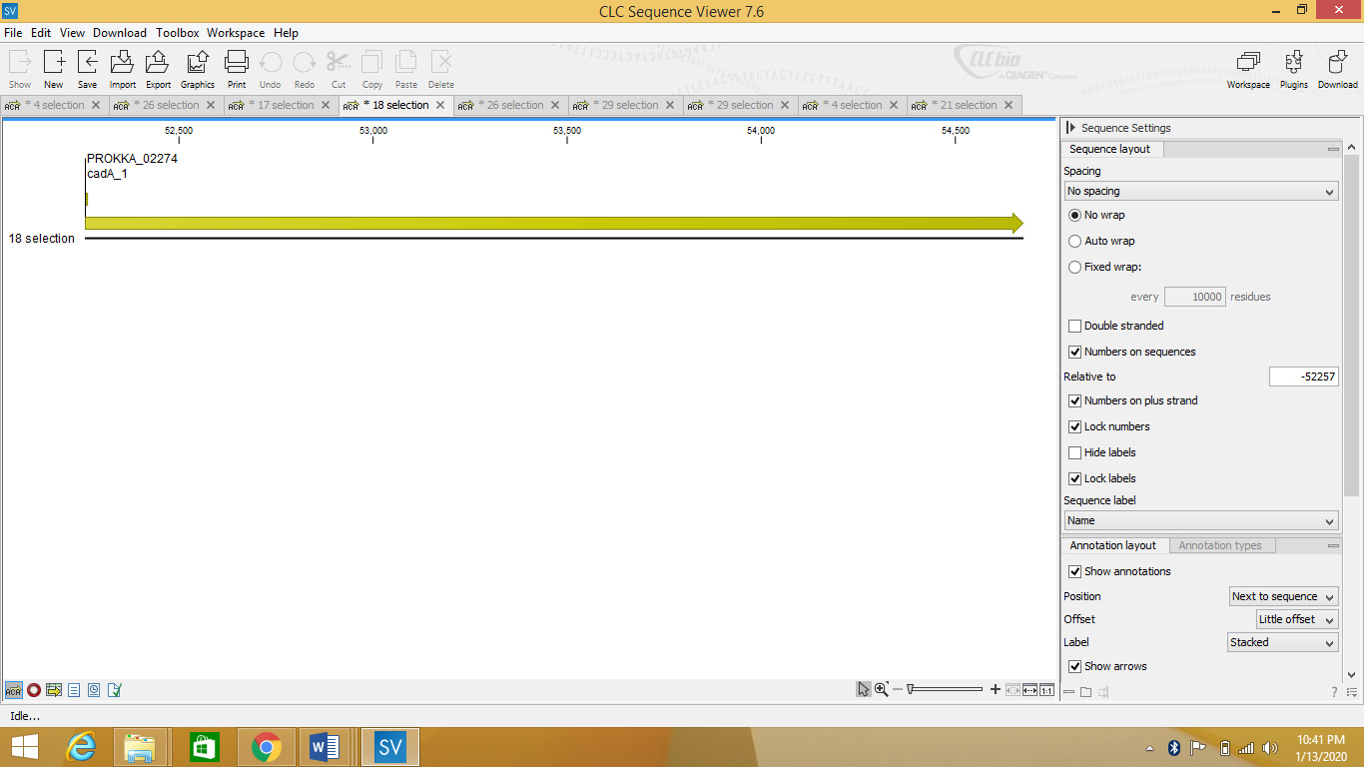

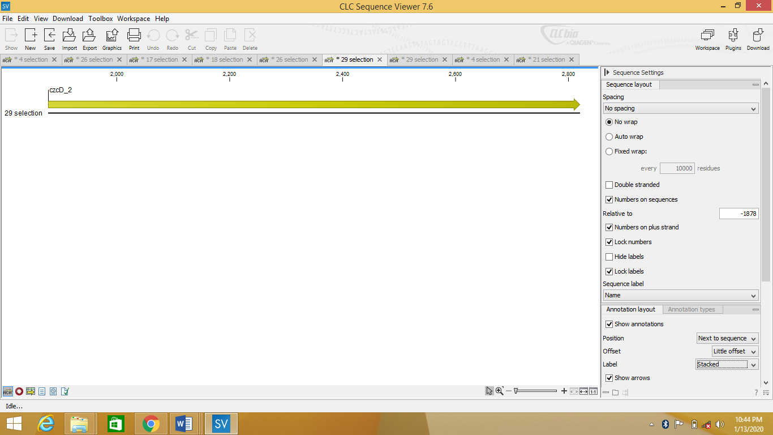



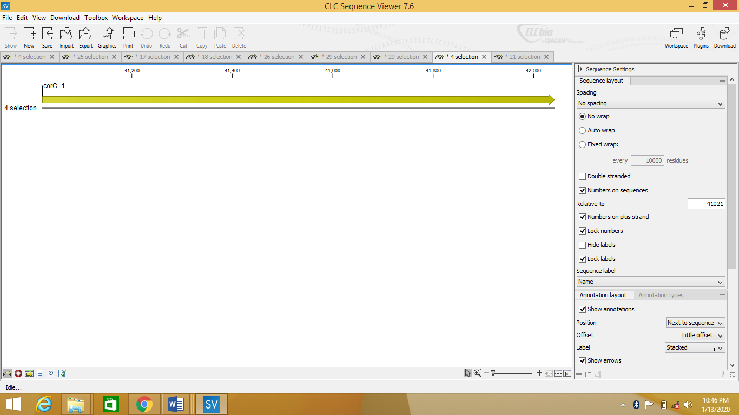

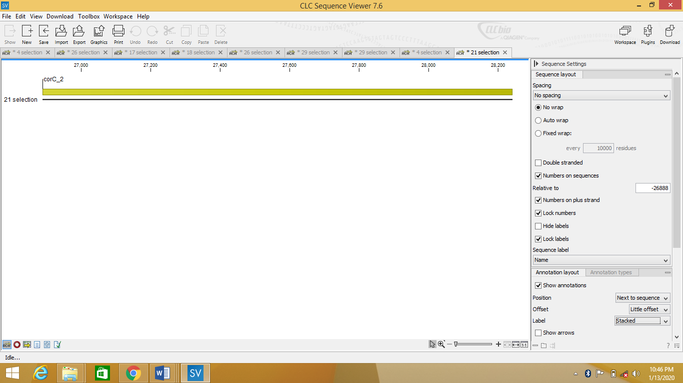

**Figure S3: The annotated genes responsible for other heavy metals resistance.**