Supplementary Table 1: Antibacterial activity (MIC) of two compounds (10th Yellow fraction and 13thYellow fraction) isolated from micrococcus species OUS9

Bacteria Pathogens |  | Zone of inhibition in mm
 |  | 10th Yellow fraction |  |  |  |  | 13th fraction
 |  | 10 | 15 | 25 | 75 | 100 | 10 | 15 | 25 | 75 | 100
1 | Bacillus subtills | 0 | 9 | 11 | 15 | 18 | 0 | 12 | 13 | 13 | 21
2 | Escherichia coli | 0 | 10 | 12 | 14 | 23 | 0 | 13 | 15 | 12 | 19
3 | S. aureus | 0 | 0 | 0 | 0 | 5 | 0 | 14 | 16 | 14 | 181
4 | Salmonella | 0 | 0 | 0 | 19 | 21 | 0 | 16 | 18 | 19 | 21

Supplementary Table 2: IC50 Concentrations of the test compounds against HeLa and MCF7 cell lines observed in the MTT assay

Anticancer activity IC 50
Cell lines
 | KLUF 10 | KLUF 13
HeLa(ug/ml) | 34.5 | 28.9
MCF7 (ug/ml) | 34.95 | 26.6

Supplementary Figure 1: Percentage of cell viability KLUF 13 and KLUF 10 with MCF7 and HeLa cell lines against test compounds

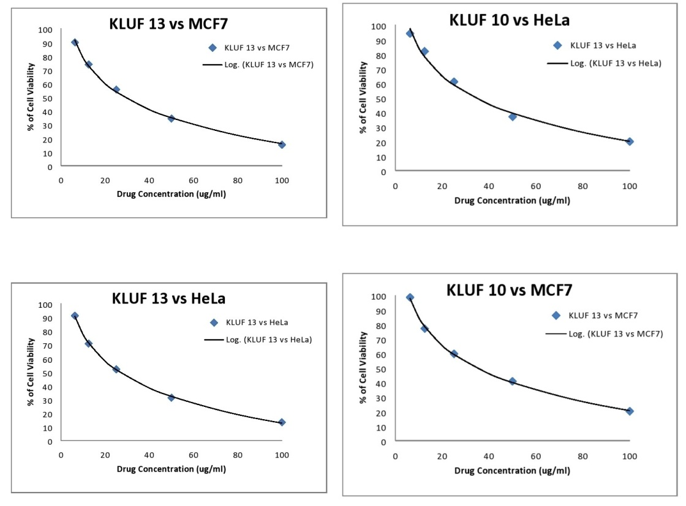
Supplementary Figure 2: Microscopic images for which anticancer activity of the test compounds against HeLa and MCF7 cell lines observed in the MTT assay

KLUF 10
MCF-7
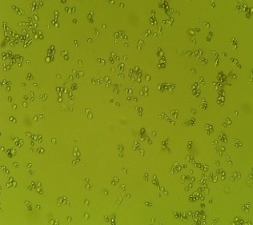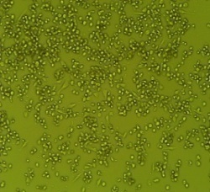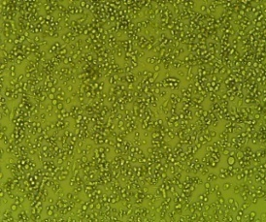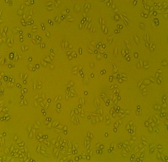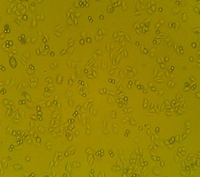
A B C D E
HeLa
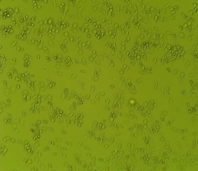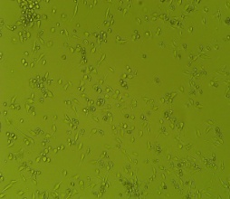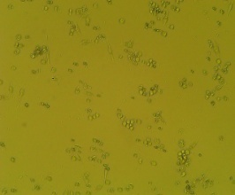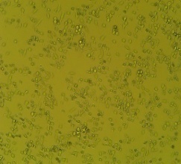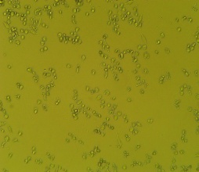

KLUF 13
MCF-7
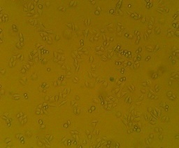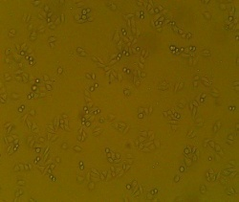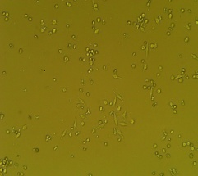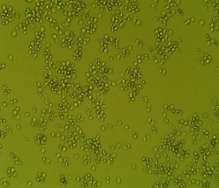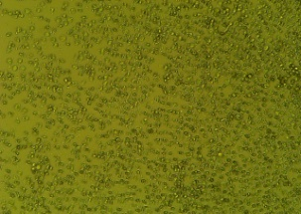
A B C D E

HeLa
