DFT investigation on the linear and nonlinear optical properties of the tautomers and derivatives of 2-aminobenzothiazole (ABT) in the gas phase and different solvents
Nuha Wazzan ^{a ‡}, , Zaki Safi ^{b}, Ohoud Al-Qurashi ^{a, c}
ª Department of Chemistry, Faculty of Science, King Abdulaziz University, P. O. Box 42805, Jeddah 21589, Saudi Arabia
^{b} Department of Chemistry, Faculty of Science, Al Azhar University-Gaza, Gaza City, P. O. Box 1277, Palestine
^{c} University of Jeddah, Chemistry Department, Faculty of Science, P.O Box 42805 Jeddah 21589, Saudi Arabia
‡ Corresponding author: E-Mail: nwazzan@kau.edu.sa; Fax: + 966 2 695 2000/63170; Tel: + 966561404754
Supplementary data
Table SD 1: Geometrical parameters, bond lengths (in Å), bond angles and dihedrals (in º) of the crystal structure of 1,3-benzothiazol-2-amine (T1 ABT).
S1—C1 | 1.747 (2) | C2—C3 | 1.375 (4)
S1—C7 | 1.760 (2) | C3—C4 | 1.402 (3)
N1—C6 | 1.389 (3) | C4—C5 | 1.388 (4)
N1—C7 | 1.303 (3) | C5—C6 | 1.393 (3)
N2—C7 | 1.352 (3) | C2—H2 | 0.9500
N2—H2B | 0.83 (2) | C3—H3 | 0.9500
N2—H2A | 0.80 (2) | C4—H4 | 0.9500
C1—C6 | 1.410 (3) | C5—H5 | 0.9500
C1—C2 | 1.380 (3)
C1—S1—C7 | 88.64 (10) | N1—C6—C1 | 115.36 (18)
C6—N1—C7 | 110.53 (17) | N1—C6—C5 | 125.68 (19)
H2A—N2—H2B | 117 (3) | S1—C7—N1 | 116.18 (16)
C7—N2—H2B | 123.7 (18) | S1—C7—N2 | 118.60 (16)
C7—N2—H2A | 115 (2) | N1—C7—N2 | 125.1 (2)
C2—C1—C6 | 122.2 (2) | C1—C2—H2 | 121.00
S1—C1—C6 | 109.29 (16) | C3—C2—H2 | 121.00
S1—C1—C2 | 128.54 (17) | C2—C3—H3 | 120.00
C1—C2—C3 | 118.3 (2) | C4—C3—H3 | 120.00
C2—C3—C4 | 120.7 (2) | C3—C4—H4 | 119.00
C3—C4—C5 | 121.0 (2) | C5—C4—H4 | 120.00
C4—C5—C6 | 118.8 (2) | C4—C5—H5 | 121.00
C1—C6—C5 | 119.0 (2) | C6—C5—H5 | 121.00
C7—S1—C1—C2 | −179.8 (2) | S1—C1—C6—N1 | 0.0 (2)
C7—S1—C1—C6 | 0.41 (17) | S1—C1—C6—C5 | −179.83 (17)
C1—S1—C7—N1 | −0.79 (18) | C2—C1—C6—N1 | −179.8 (2)
C1—S1—C7—N2 | −176.53 (19) | C2—C1—C6—C5 | 0.4 (3)
C7—N1—C6—C1 | −0.6 (3) | C1—C2—C3—C4 | 1.4 (4)
C7—N1—C6—C5 | 179.2 (2) | C2—C3—C4—C5 | −0.6 (4)
C6—N1—C7—S1 | 0.9 (2) | C3—C4—C5—C6 | −0.3 (4)
C6—N1—C7—N2 | 176.3 (2) | C4—C5—C6—N1 | −179.4 (2)
S1—C1—C2—C3 | 179.0 (2) | C4—C5—C6—C1 | 0.4 (3)
C6—C1—C2—C3 | −1.2 (4)
Hydrogen-bond geometry (Å, º)
D—H···A | D—H | H···A | D···A | D—H···A
N2—H2B···N1^{i} | 0.83 (2) | 2.14 (2) | 2.964 (3) | 172 (2)
N2—H2A···N2^{ii} | 0.80 (2) | 2.46 (2) | 3.217 (3) | 157 (2)

Symmetry codes: (i) −x, −y+1, −z; (ii) −x, y−1/2, −z+1/2.

Table SD 2: The electronegativity ($χ$), chemical hardness ($η$), chemical softness ($σ$), and electrophilicity index ($ω$) (in eV unit) for ABT in its tautomeric forms, T1, T2, and T3, in the gas phase and in solvents of different polarities (dielectric constant $ε$) as calculated at the B3LYP/PCMB3LYP/6-311++G(d,p) levels of theory.
 |  | Gas  (1.0) | CCl₄  (2.24) | THF  (7.58) | EtOH (24.5) | MeOH (32.7) | DMSO  (46.7) | H₂O  (80.1)
$$χ$$ | T1 | -3.395 | -3.449 | -3.488 | -3.508 | -3.509 | -3.511 | -3.511
 | T2 | -3.395 | -3.382 | -3.390 | -3.397 | -3.398 | -3.398 | -3.398
 | T3 | -3.391 | -3.379 | -3.388 | -3.396 | -3.397 | -3.398 | -3.398
$$η$$ | T1 | 2.532 | 2.670 | 2.668 | 2.666 | 2.666 | 2.666 | 2.666
 | T2 | 2.532 | 2.554 | 2.573 | 2.580 | 2.581 | 2.582 | 2.582
 | T3 | 2.528 | 2.552 | 2.574 | 2.582 | 2.583 | 2.584 | 2.584
$$σ$$ | T1 | 0.395 | 0.375 | 0.375 | 0.375 | 0.375 | 0.375 | 0.375
 | T2 | 0.395 | 0.392 | 0.389 | 0.388 | 0.387 | 0.387 | 0.387
 | T3 | 0.396 | 0.392 | 0.389 | 0.387 | 0.387 | 0.387 | 0.387
$$ω$$ | T1 | 2.275 | 2.228 | 2.279 | 2.307 | 2.309 | 2.312 | 2.311
 | T2 | 2.275 | 2.239 | 2.233 | 2.236 | 2.236 | 2.236 | 2.237
 | T3 | 2.275 | 2.238 | 2.231 | 2.233 | 2.234 | 2.234 | 2.234

Table SD 3: The average linear polarizability ($〈α〉x{10}^{-23}$), the anisotropy of linear polarizability ($∆αx{10}^{-23}$), the second-order hyperpolarizabilities ($〈γ〉x{10}^{-35}$), and total hyperpolarizability ($β_{tot}x{10}^{-30}$) (in esu unit) for ABT in its tautomeric forms, T1, T2, and T3, in the gas phase and in solvents of different polarity (dielectric constant $ε$) as calculated at the B3LYP/6-311++G(d,p) and PCM/B3LYP/6-311++G(d,p) levels of theory. Note: For comparison reason, similar data for pNA are calculated in this work at the same level of theory are included.
Parameter | Molecule | Gas  (1.0) | CCl₄  (2.24) | THF  (7.58) | EtOH (24.5) | MeOH (32.7) | DMSO  (46.7) | H₂O  (80.1)
$$〈α〉$$ | T1 | 1.73 | 2.01 | 2.28 | 2.40 | 2.42 | 2.43 | 2.44
 | T2 | 1.73 | 2.01 | 2.28 | 2.40 | 2.41 | 2.43 | 2.44
 | T3 | 1.72 | 1.99 | 2.27 | 2.38 | 2.39 | 2.41 | 2.42
 | pNA | 1.51 | 1.79 | 2.10 | 2.24 | 2.25 | 2.27 | 2.29
$$Δα$$ | T1 | 1.36 | 1.62 | 1.83 | 1.89 | 1.90 | 1.90 | 1.91
 | T2 | 1.42 | 1.70 | 1.92 | 1.99 | 2.00 | 2.01 | 2.01
 | T3 | 1.40 | 1.68 | 1.90 | 1.97 | 1.98 | 1.98 | 1.99
 | pNA | 1.33 | 1.74 | 2.19 | 2.41 | 2.44 | 2.46 | 2.49
$$〈γ〉$$ | T1 | 1.70 | 2.56 | 3.78 | 4.43 | 4.51 | 4.59 | 4.67
 | T2 | 1.61 | 2.52 | 3.79 | 4.46 | 4.55 | 4.63 | 4.70
 | T3 | 1.59 | 2.47 | 3.72 | 4.37 | 4.45 | 4.53 | 4.60
 | pNA | 1.51 | 2.58 | 4.08 | 4.83 | 4.91 | 5.00 | 5.08
$$β_{tot}$$ | T1 | 4.03 | 6.87 | 10.35 | 11.99 | 12.20 | 12.39 | 12.57
 | T2 | 4.46 | 6.62 | 9.06 | 10.17 | 10.29 | 10.42 | 10.53
 | T3 | 4.65 | 6.69 | 9.00 | 10.01 | 10.13 | 10.24 | 10.24
 | pNA | 14.27 | 27.60 | 47.06 | 57.43 | 58.68 | 59.93 | 61.13

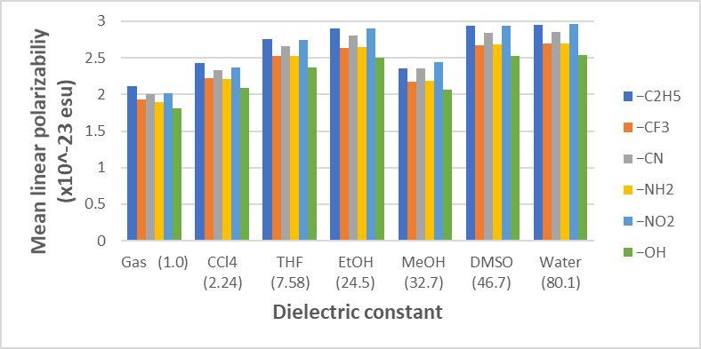 | 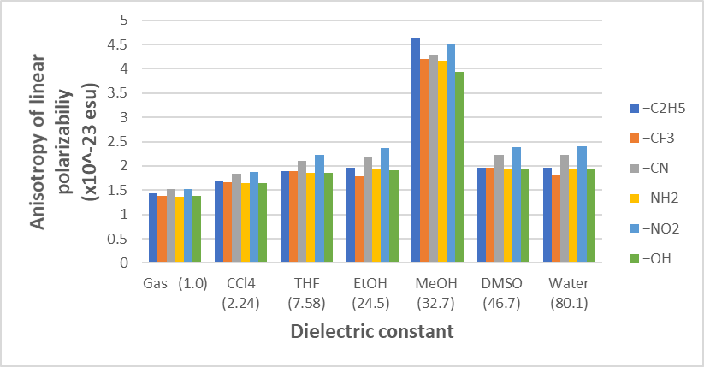
(a) | (b)
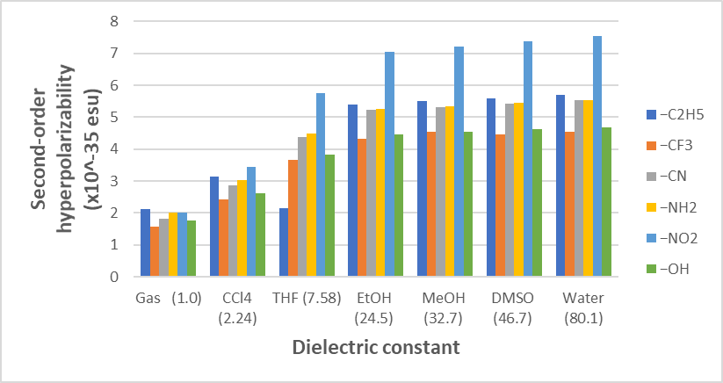 | 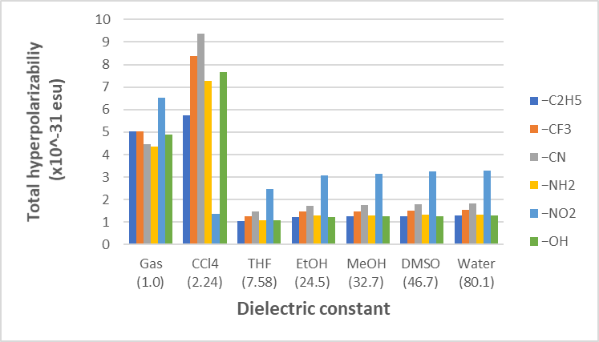
(c) | (d)
Figure SD 1: Graphical representations of the relationships between the solvent dielectric constant and linear and nonlinear polarizabilities included (a) average linear polarizability, (b) anisotropy of linear polarizability, (c) second-order hyperpolarizability, and (d) total hyperpolarizability for the six derivatives of T1ABT.

Cartesian coordinates of the optimized geometries
T1
C | 0.40168 | -0.64737 | -0.00015
C | 0.33443 | 0.76472 | -0.00397
C | 1.52371 | 1.50015 | -0.00306
C | 2.73974 | 0.82532 | 0.00221
C | 2.78876 | -0.57431 | 0.00746
C | 1.61560 | -1.32655 | 0.00722
C | -1.83941 | 0.37688 | 0.00162
H | 1.47723 | 2.58244 | -0.00649
H | 3.66421 | 1.39140 | 0.00228
H | 3.74669 | -1.08109 | 0.01133
H | 1.65313 | -2.40935 | 0.01075
S | -1.23414 | -1.30423 | -0.00985
N | -3.18835 | 0.60915 | -0.05647
H | -3.45722 | 1.56427 | 0.13348
H | -3.80824 | -0.09285 | 0.31619
N | -0.94261 | 1.30511 | 0.00248

T2
C | -0.37004 | -0.65121 | 0.00000
C | -0.34508 | 0.75289 | 0.00000
C | -1.53462 | 1.47714 | 0.00000
C | -2.74274 | 0.77937 | 0.00000
C | -2.76626 | -0.61584 | 0.00001
C | -1.57343 | -1.34292 | 0.00000
C | 1.99143 | 0.36024 | 0.00000
H | -1.51950 | 2.56114 | 0.00000
H | -3.67400 | 1.33350 | 0.00000
H | -3.71307 | -1.14219 | 0.00001
H | -1.58755 | -2.42627 | 0.00001
S | 1.27755 | -1.30629 | 0.00000
N | 3.21067 | 0.71421 | 0.00001
H | 3.85650 | -0.06845 | 0.00001
N | 0.94388 | 1.26245 | -0.00001
H | 1.15944 | 2.24837 | 0.00000

T3
C | -0.36891 | -0.65042 | 0.00000
C | -0.34334 | 0.75285 | 0.00000
C | -1.52775 | 1.48336 | 0.00000
C | -2.73955 | 0.79084 | 0.00000
C | -2.76664 | -0.60405 | 0.00000
C | -1.57665 | -1.33569 | 0.00000
C | 1.99267 | 0.33341 | 0.00000
H | -1.50887 | 2.56755 | 0.00000
H | -3.66868 | 1.34844 | 0.00000
H | -3.71531 | -1.12715 | 0.00000
H | -1.59555 | -2.41901 | 0.00000
S | 1.27300 | -1.31406 | 0.00000
N | 3.25105 | 0.50111 | 0.00000
H | 3.51868 | 1.48423 | 0.00000
N | 0.95358 | 1.25652 | 0.00000
H | 1.15036 | 2.24575 | 0.00000

−C₂H₅
C | 0.62566 | 1.08671 | -0.00119
C | -0.05768 | -0.14762 | -0.00024
C | -1.46684 | -0.17530 | 0.00308
C | -2.12699 | 1.05364 | 0.00658
C | -1.43506 | 2.27310 | 0.00751
C | -0.04456 | 2.30665 | 0.00446
C | 2.00362 | -0.95842 | 0.00174
H | -3.20973 | 1.07511 | 0.00839
H | -1.99186 | 3.20318 | 0.01022
H | 0.49228 | 3.24747 | 0.00438
S | 2.36365 | 0.78958 | -0.01088
N | 3.03000 | -1.85998 | -0.05689
H | 2.77281 | -2.81492 | 0.15030
H | 3.93547 | -1.57785 | 0.28561
N | 0.75042 | -1.27748 | 0.00564
C | -2.17763 | -1.51312 | 0.00247
H | -1.82331 | -2.08727 | -0.86101
C | -3.70629 | -1.46606 | -0.00860
H | -4.10454 | -0.95478 | 0.87244
H | -4.09106 | -0.95618 | -0.89642
H | -4.11075 | -2.48137 | -0.01073
H | -1.83597 | -2.08199 | 0.87475

−CF₃
C | 1.16909 | 1.15956 | -0.00048
C | 0.23849 | 0.09384 | -0.00158
C | -1.13330 | 0.40591 | -0.00076
C | -1.53110 | 1.74171 | 0.00210
C | -0.58968 | 2.77399 | 0.00418
C | 0.77461 | 2.49149 | 0.00380
C | 2.07404 | -1.13114 | 0.00169
H | -2.58616 | 1.98043 | 0.00241
H | -0.92500 | 3.80371 | 0.00600
H | 1.50436 | 3.29205 | 0.00522
S | 2.80102 | 0.49897 | -0.00564
N | 2.87230 | -2.22853 | -0.04792
H | 2.42078 | -3.11589 | 0.12104
H | 3.83841 | -2.15717 | 0.22821
N | 0.77794 | -1.17496 | 0.00288
C | -2.15365 | -0.69785 | -0.00082
F | -2.04777 | -1.50461 | -1.08433
F | -2.05385 | -1.49791 | 1.08911
F | -3.42187 | -0.21828 | -0.00547

−CN
C | -0.31266 | -1.10392 | -0.00055
C | 0.23377 | 0.20092 | -0.00194
C | 1.63623 | 0.33984 | -0.00088
C | 2.44094 | -0.80900 | 0.00169
C | 1.87115 | -2.08013 | 0.00373
C | 0.48374 | -2.24078 | 0.00353
C | -1.88856 | 0.79047 | 0.00172
H | 3.51770 | -0.69585 | 0.00222
H | 2.51111 | -2.95368 | 0.00562
H | 0.04539 | -3.23127 | 0.00533
S | -2.06969 | -0.98624 | -0.00475
N | -2.98669 | 1.58293 | -0.04388
H | -2.83892 | 2.56999 | 0.10912
H | -3.88886 | 1.21367 | 0.20872
N | -0.66880 | 1.23761 | 0.00202
C | 2.23175 | 1.63680 | -0.00088
N | 2.73985 | 2.67543 | -0.00008

−NH₂
C | 0.09044 | -0.97061 | -0.00480
C | 0.28943 | 0.42109 | -0.00688
C | 1.59918 | 0.94257 | -0.00849
C | 2.66114 | 0.03064 | -0.00074
C | 2.43563 | -1.34948 | 0.00383
C | 1.14690 | -1.87981 | -0.00152
C | -1.92058 | 0.47221 | -0.00015
H | 0.97944 | -2.94915 | 0.00105
H | 3.28635 | -2.02149 | 0.01033
H | 3.67861 | 0.40729 | -0.00509
S | -1.64473 | -1.29160 | 0.00669
N | -3.19930 | 0.95804 | 0.06872
H | -3.94417 | 0.37874 | -0.28763
H | -3.29075 | 1.94104 | -0.14763
N | -0.85630 | 1.20643 | -0.00575
N | 1.79118 | 2.31810 | -0.07305
H | 2.65796 | 2.66310 | 0.31233
H | 0.98641 | 2.86839 | 0.19274

−NO₂
C | 0.74991 | 1.15525 | 0.03354
C | 0.00542 | -0.05462 | 0.01310
C | -1.39579 | 0.07138 | 0.01607
C | -2.00800 | 1.32288 | 0.02323
C | -1.23990 | 2.48254 | 0.06028
C | 0.15433 | 2.40728 | 0.06612
C | 2.01636 | -0.95151 | -0.06244
H | -3.08809 | 1.37197 | 0.01030
H | -1.72780 | 3.44865 | 0.08513
H | 0.75342 | 3.30942 | 0.08973
S | 2.46740 | 0.77322 | -0.00820
N | 2.97539 | -1.90090 | -0.16176
H | 2.68222 | -2.85975 | -0.04390
H | 3.93598 | -1.68374 | 0.04737
N | 0.74295 | -1.21012 | -0.04615
N | -2.26675 | -1.11010 | 0.01732
O | -3.36096 | -1.00437 | -0.53537
O | -1.87518 | -2.12180 | 0.58253

−OH
C | 0.08265 | -0.95017 | 0.00025
C | 0.27584 | 0.44697 | -0.00141
C | 1.59235 | 0.94059 | -0.00029
C | 2.65448 | 0.03904 | 0.00230
C | 2.42918 | -1.34280 | 0.00469
C | 1.13777 | -1.86041 | 0.00489
C | -1.92956 | 0.48301 | 0.00181
H | 3.67167 | 0.41844 | 0.00229
H | 3.27748 | -2.01708 | 0.00600
H | 0.96404 | -2.92892 | 0.00613
S | -1.64809 | -1.28183 | -0.00711
N | -3.20836 | 0.96311 | -0.06003
H | -3.30261 | 1.94936 | 0.13949
H | -3.95415 | 0.38374 | 0.29348
N | -0.87034 | 1.22373 | 0.00429
O | 1.76285 | 2.29485 | -0.00141
H | 2.70469 | 2.49966 | -0.00559

