**A facile ionic liquid-accelerated, four-component cascade reaction protocol for the regioselective synthesis of biologically interesting ferrocene engrafted spiropyrrolidine hybrid heterocycles**

**______________________________________________________**

|  |  |  |
| --- | --- | --- |
| S. No | List of Figures | Page No |
| **1** | 1H NMR spectrum of **6b** | **5** |
| **2** | 13C NMR spectrum of **6b** | **6** |
| **3** | DEPT-135 spectrum of **6b** | **7** |
| **4** | 1H,1H-COSY spectrum of **6b** | **8** |
| **5** | 13C, 1H-COSY(HMQC) spectrum of **6b** | **9** |
| **6** | HMBC spectrum of **6b** | **10** |

**General methods**

1H and 13C NMR spectra were recorded on a Varian Mercury JEOL-400/500 NMR spectrometers in CDCl3 using TMS as internal standard. Chemical shifts are given in parts per million (δ-scale) and coupling constants are given in hertz. Elemental analyses were performed on a Perkin Elmer 2400 Series II Elemental CHNS analyzer. Mass spectra were recorded on a Quattro Premier™ instrument (Micromass, Milford, USA) equipped with an electrospray ionization source (Zespray) coupled with an Acquity® UPLC system.

*Spiro-[2.11']-indeno[1,2-b]quinoxaline-3-ferrocenyl-4-benzoyl-5-benzylpyrrolidine****, 6a***

Mp: Mp: 186-189 oC; Brown solid; 1H NMR (CDCl3, 400MHz): *δ*/ppm 2.89-2.97 (m, 1H), 3.38-3.40 (m, 1H), 3.89-3.95 (m, 1H), 4.08-4.24 (m, 7H), 4.38-4.48 (m, 2H), 5.14 (d, *J* = 9.5 Hz, 1H), 6.77-6.79 (m, 2H), 6.94-6.99 (d, *J* = 8.5 Hz, 2H), 7.15-7.38 (m , 9H), 7.65-7.70 (m, 3H), 8.03 (d, *J* = 7.5 Hz, 1H), 8.17 (d, *J* = 6.5 Hz, 1H): 13C NMR (CDCl3, 100 MHz): *δ/*ppm 40.5, 45.1, 62.5, 65.6, 66.1, 67.3, 67.6, 68.2, 69.1, 69.8, 70.3, 71.6, 89.6, 117.9, 121.4, 126.4, 127.3, 128.4, 128.7, 128.9, 129.1, 129.4, 129.9, 131.4, 132.6, 132.8, 136.2, 136.9, 138.7, 141.8, 142.5, 147.5, 147.8, 153.3, 166.2. LC/MS(ESI): *m/z* = 652 (M+).

*Spiro-[2.11']-indeno[1,2-b]quinoxaline-3-ferrocenyl-4-(p-chlorobenzoyl)-5-benzylpyrrolidine,* ***6c***

Mp: 245-247 oC; Light brown solid; 1H NMR (CDCl3, 500MHz): *δ*/ppm 2.92-2.96 (dd, *J* =13.5, 8.5 Hz, 1H), 3.38-3.41 (m, 1H), 3.91 (t, *J* = 9.5 Hz, 1H), 4.08-4.22 (m, 7H), 4.35-4.37 (m, 1H), 4.47-4.59 (m, 2H), 5.07 (d, *J* = 9.0 Hz, 1H), 6.82 (d, *J* = 8.0 Hz, 2H), 6.96 (d, *J* = 8.0 Hz, 2H), 7.17-7.45 (m, 7H), 7.73-7.77 (m, 3H), 7.91 (d, *J* =8.0 Hz, 1H), 8.08 (d, *J* = 8.0 Hz, 1H), 8.19 (d, *J* = 7.2 Hz, 1H): 13C NMR (CDCl3, 125 MHz): *δ/*ppm 40.6, 45.6, 62.6, 65.6, 66.2, 67.4, 67.8, 68.7, 69.2, 69.9, 70.3, 71.7, 89.4, 118.5, 121.6, 126.5, 126.8, 128.4, 128.6, 128.8, 128.9, 129.1, 129.3, 129.5, 129.6, 129.8, 129.9, 131.8, 135.4, 136.4, 137.0, 138.8, 139.3, 141.9, 142.7, 147.6, 153.3, 166.1. LC/MS(ESI): *m/z* = 686 (M+).

*Spiro-[2.11']-indeno[1,2-b]quinoxaline-3-ferrocenyl-4-(p-methylbenzoyl)-5-benzylpyrrolidine,* ***6d***

Mp: 176-178 oC; Light brown solid; 1H NMR (CDCl3, 400 MHz): *δ*/ppm 2.91-2.96 (dd, *J* =13.2, 8.0 Hz, 1H), 3.36-3.44 (m, 1H), 3.91 (t, *J* = 9.6 Hz, 1H), 4.07-4.19 (m, 8H), 4.34-4.47 (m, 2H), 5.12 (d, *J* = 9.6 Hz, 1H), 6.33 (d, *J* = 6.8 Hz, 2H), 6.96 (d, *J* = 7.2 Hz, 2H), 7.16-7.31 (m, 8H), 7.68-7.71 (m, 3H), 8.03-8.05 (m, 1H), 8.18-8.19 (m, 1H): 13C NMR (CDCl3, 100 MHz): *δ/*ppm 21.3, 40.5, 45.5, 62.3, 65.5, 67.2, 67.3, 68.5, 68.6, 70.3, 89.6, 121.3, 126.2, 126.4, 126.7, 127.5,, 127.6, 128.5, 128.7, 128.9, 129.0, 129.2, 129.5, 129.6, 129.7, 131.6, 134.5, 136.2, 138.7, 142.4, 142.5, 147.8, 153.3, 166.3. LC/MS(ESI): *m/z* = 666 (M+).

*Spiro-[2.11']-indeno[1,2-b]quinoxaline-3-ferrocenyl-4-(o-methoxybenzoyl)-5-benzylpyrrolidine,* ***6e***

Mp: 206-208 oC; Light brown solid; 1H NMR (CDCl3, 400MHz): *δ*/ppm 2.90 (s, 3H), 2.94-2.99 (m, 1H), 3.35-3.38 (m, 1H), 3.86 (t, *J* = 9.6 Hz, 1H), 4.15-4.35 (m, 9H), 4.52 (m, 1H), 5.51 (d, *J* = 9.6 Hz, 1H), 6.13 (d, *J* = 7.2 Hz, 1H), 6.45-6.47 (m, 1H), 6.74 (d, *J* = 6.8 Hz, 1H), 7.01-7.31 (m, 9H), 7.65-7.67 (m, 3H), 7.99-8.0 (m, 1H), 8.10-8.11 (m, 1H): 13C NMR (CDCl3, 100 MHz): *δ/*ppm 40.7, 44.6, 54.6, 65.6, 65.9, 66.5, 67.1, 67.5, 68.6, 68.8, 70.4, 90.2, 110.0, 120.1, 121.2, 126.3, 126.4, 127.3, 128.5, 128.7, 128.9, 129.0, 129.3, 129.5, 129.6, 130.9, 131.7, 133.3, 136.7, 138.7, 141.8, 142.2, 148.4, 153.2, 157.1, 166.6. LC/MS(ESI): *m/z* = 682 (M+).

*Spiro-[2.11']-indeno[1,2-b]quinoxaline-3-ferrocenyl-4-(m-methoxybenzoyl)-5-benzylpyrrolidine,* ***6f***

Mp: 236-238 oC; Brown solid; 1H NMR (CDCl3, 400MHz): *δ*/ppm 2.97-3.03 (m, 1H), 3.35 (s, 3H), 3.45-3.48 (m, 1H), 3.94-3.96 (m, 1H), 4.12-4.44 (m, 9H),451-4.53 (m,1H), 5.23 (d, *J* = 9.6 Hz, 1H), 6.55-6.60 (d, *J* = 7.2 Hz, 2H), 6.72-6.75 (m, 2H), 7.21-7.32 (m, 8H), 7.76-7.77 (m, 3H), 8.10-8.12 (m, 1H), 8.24-8.26 (m, 1H): 13C NMR (CDCl3, 100 MHz): *δ/*ppm 40.6, 45.1, 54.8, 63.0, 65.3, 66.3, 67.6, 68.6, 68.7, 68.9, 70.3, 89.7, 110.2, 119.8, 121.3, 126.3, 126.8, 128.5, 128.8, 128.7, 128.8, 129.1, 129.3, 129.5, 129.6, 130.9, 131.7, 138.4, 138.6, 141.9, 142.5, 148.9, 159.2, 166.6. *m/z* = 682 (M+).

*Spiro-[2.11']-indeno[1,2-b]quinoxaline-3-ferrocenyl-4-(p-methoxybenzoyl)-5-benzylpyrrolidine,* ***6g***

Mp: 215-217 oC; Light brown solid; 1H NMR (CDCl3, 400MHz): *δ*/ppm 2.96-3.01 (dd, *J* = 13.2, 8.0 Hz, 1H), 3.40-3.49 (m, 1H), 3.62 (s, 3H), 3.96 (t, *J* = 9.6 Hz, 1H), 4.12-4.24 (m, 7H), 4.37-4.39 (m, 1H), 4.49-4.61 (m, 2H), 5.13 (d, *J* = 9.6 Hz, 1H), 6.34 (d, *J* = 7.2 Hz, 2H), 6.98-7.37 (m, 10H), 7.76-7.77 (m, 3H), 8.01-8.10 (m, 3H), 8.23 (d, *J* = 6.8 Hz, 1H): 13C NMR (CDCl3, 100 MHz): *δ/*ppm 40.5, 45.5, 55.2, 62.0, 65.5, 66.1, 67.2, 67.5, 68.6, 68.9, 69.7, 70.5, 71.2, 89.6, 113.2, 113.7, 121.3, 126.3, 126.8, 128.5, 128.8, 129.0, 129.1, 129.5, 129.6, 129.7, 130.6, 131.6, 136.1, 138.8, 141.9, 142.5, 145.7, 147.9, 153.4, 163.0, 166.0. *m/z* = 682 (M+).

*Spiro-[2.11']-indeno[1,2-b]quinoxaline-3-ferrocenyl-4-(m-nitrobenzoyl)-5-benzylpyrrolidine,* ***6h***

Mp: 236-238 oC; Light brown solid; 1H NMR (CDCl3, 400MHz): *δ*/ppm 2.92-3.02 (dd, *J* = 14.0, 8.0 Hz, 1H), 3.32-3.36 (m, 1H), 3.88 (t, *J* = 9.6 Hz, 1H), 4.08-4.24 (m, 9H), 4.48-4.49 (m, 1H), 5.11 (d, *J* = 9.6 Hz, 1H), 6.53 (t, *J* = 8.8 Hz, 2H), 7.04-7.09 (dd, *J* = 8.8, 5.2 Hz, 2H), 7.17-7.29 (m, 8H), 7.71-7.78 (m, 3H), 8.07-8.09 (m, 1H), 8.20-8.22 (m, 1H): 13C NMR (CDCl3, 100 MHz): *δ/*ppm 40.2, 45.4, 61.6, 65.4, 66.1, 66.9, 67.4, 68.6, 68.9, 69.5, 70.0, 71.3, 89.7, 116.5, 121.4, 126.5, 128.5, 128.7, 129.1, 129.2, 129.3, 129.6, 132.1, 133.6, 136.1, 141.9, 142.8, 147.7, 153.1, 163.2, 166.4. *m/z* = 697 (M+).

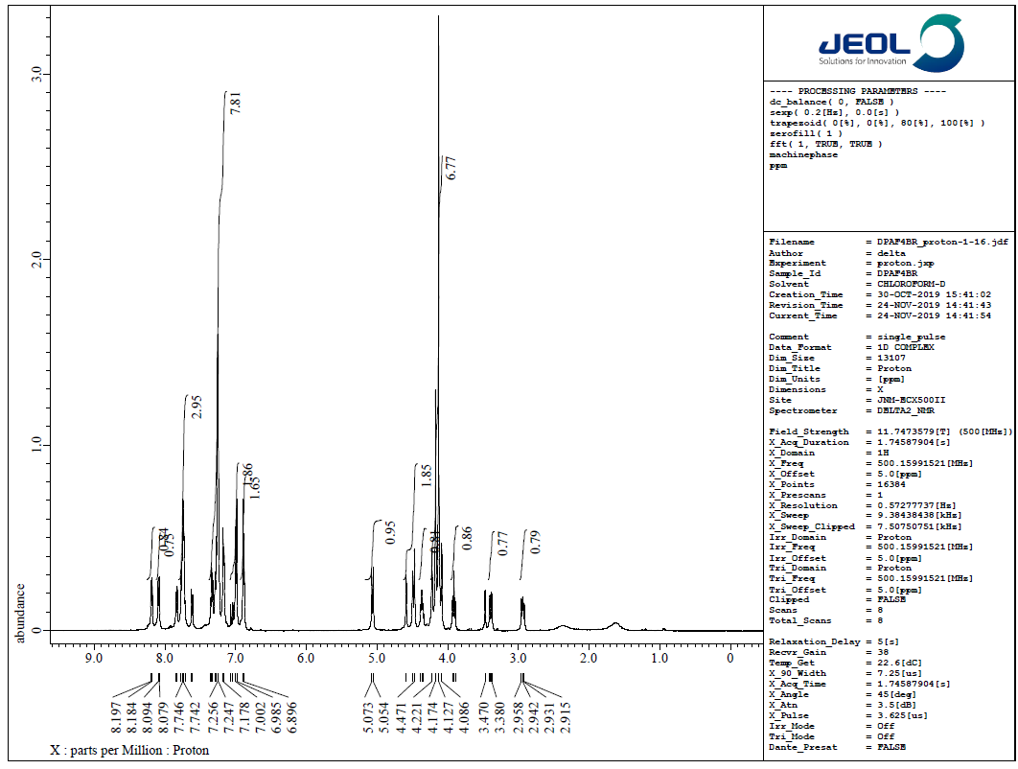

**Figure 1.** 1H NMR spectrum of **6b**

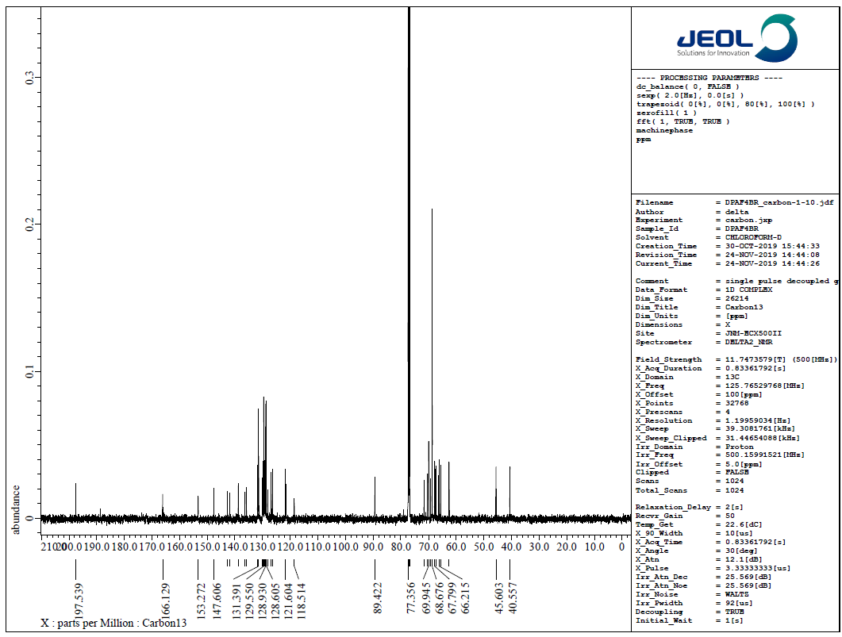

**Figure 2.** 13C NMR spectrum of **6b**

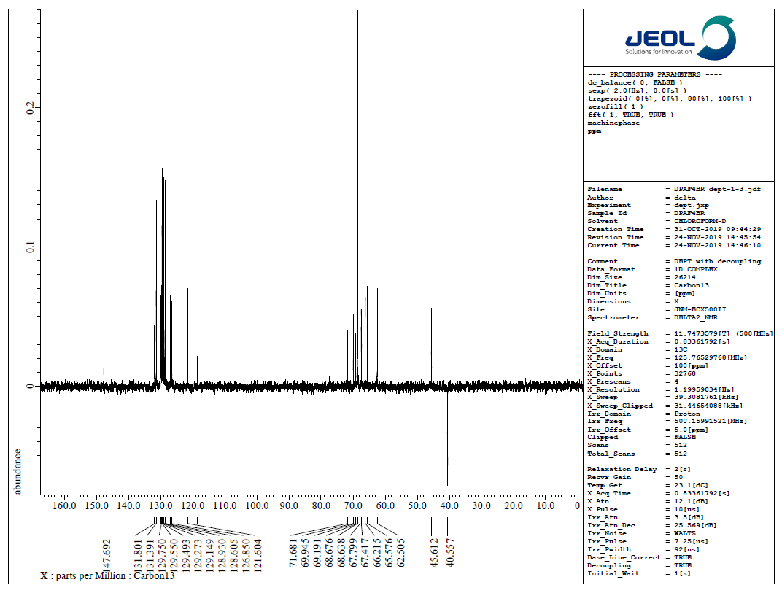

**Figure 3.** DEPT-135 spectrum of **6b**

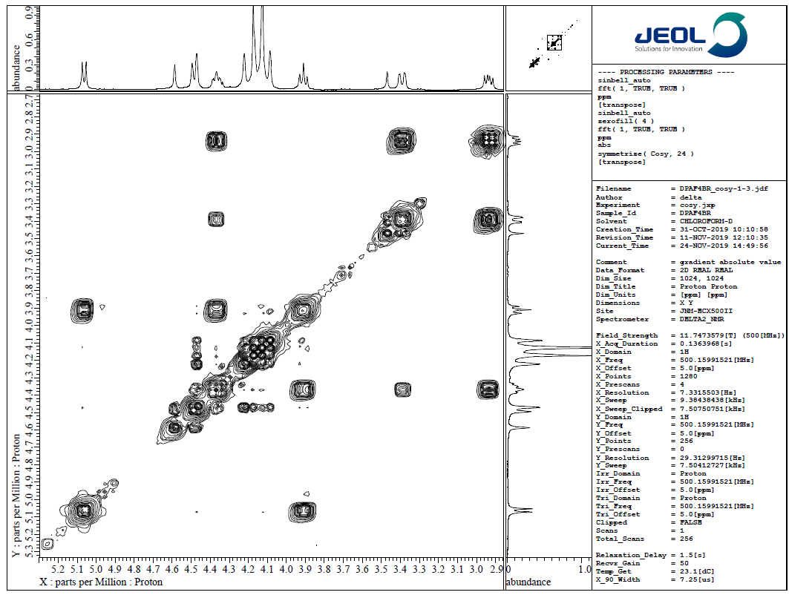

**Figure 4. H, H-COSY** spectrum of **6b**

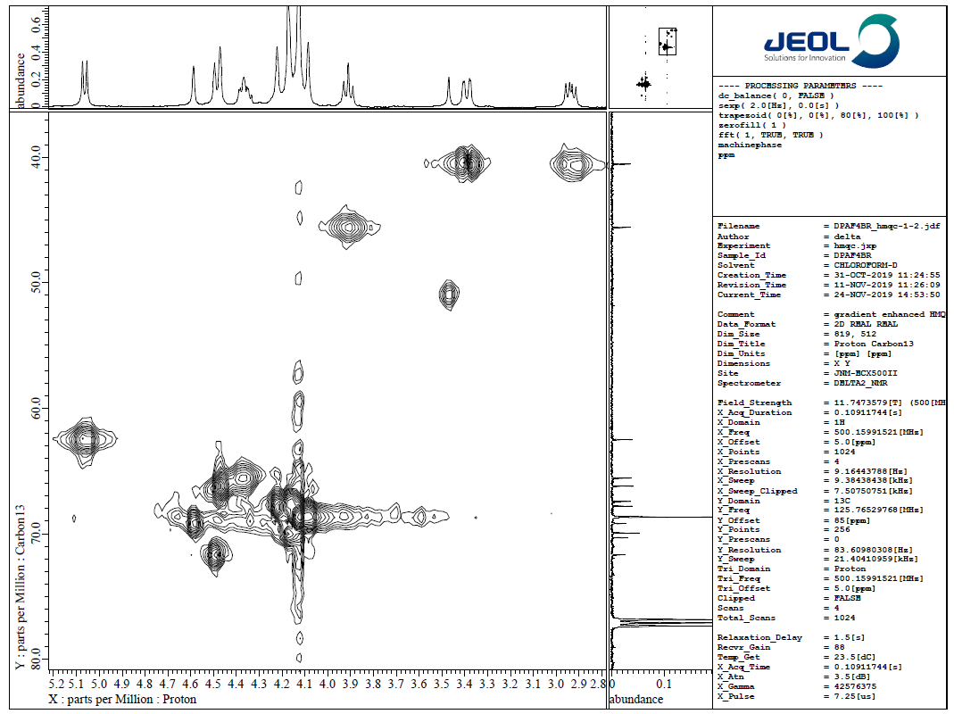

**Figure 5.** C, H-COSY spectrum of **6b**

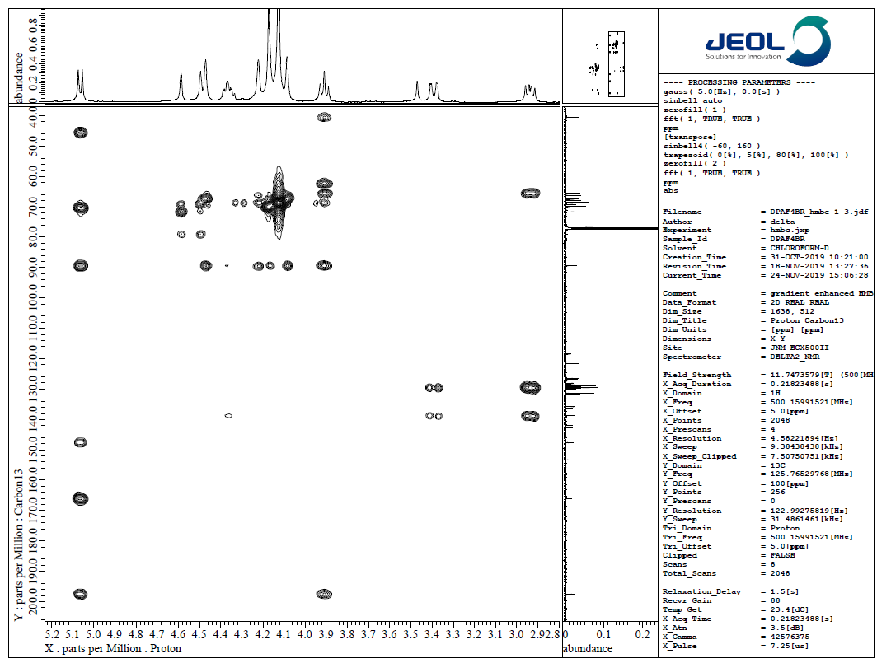

**Figure 6.** HMQC spectrum of **6b**