Electronic supplementary Information for:

**Waste PET plastic derived ZnO@NMC nanocomposite via MOF-5 construction for hydrogen and oxygen evolution reactions**

Mohd Ubaidullaha*, Abdullah M. Al-Enizia, Shoyebmohammed Shaikha, Mohamed A.

Ghanema, and Rajaram S. Maneb

aDepartment of Chemistry, College of Science, King Saud University, Riyadh 11451, Saudi Arabia

bCenter for Nanomaterials & Energy Devices, School of Physical Sciences, S. R. T. M. University, Nanded (MS)-431606, India

*To whom correspondence should be addressed

E-mail: [amenizi@ksu.edu.sa](mailto:amenizi@ksu.edu.sa) (Abdullah M. Al-Enizi)

**Figure S-1:** FTIR curves of (a) PET derived ***1***, 4 Benzene dicarboxylic acid/Terephthalic acid/BDC and (b) commercial ***1***, 4 Benzene dicarboxylic acid/Terephthalic acid/BDC purchased from BDH Chemicals Company.

**Figure S-2:** Thermogravimetric (TG) curve of synthesized MOF-5 in this work at a heating rate of 10o C·min-1 with a nitrogen flow.

**Figure S-3:** Powder XRD patterns of MOF-5.

**Figure S-4:** XPS survey spectrum of ZnO@NMC nanocomposite.

**Table S-1:** Detailed BET surface area and pore size analysis of ZnO@NMC nanocomposite.

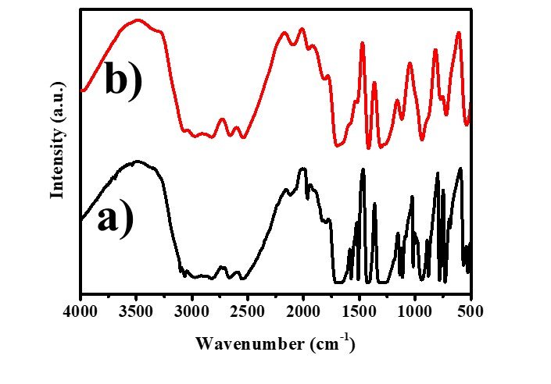

**Figure S-1:** FTIR curves of (a) PET derived ***1***, 4 Benzene dicarboxylic acid/Terephthalic acid/BDC and (b) commercial ***1***, 4 Benzene dicarboxylic acid/Terephthalic acid/BDC purchased from BDH Chemicals Company.

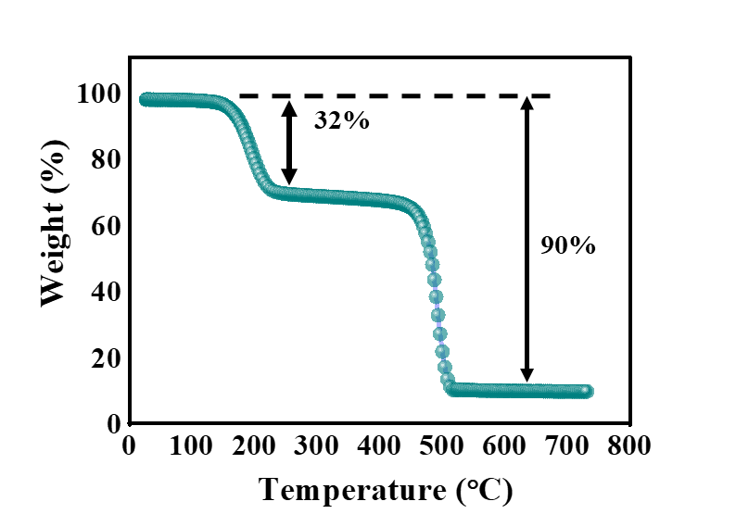

**Figure S-2:**Thermogravimetric (TG) curve of MOF-5 used in this work at a heating rate of 10o C min-1 with a helium flow



**Figure S-3:** Powder XRD patterns of synthesized MOF-5.



**Figure S-4:**XPS survey spectrum ofZnO@NMC nanocomposite.

|  |  |  |
| --- | --- | --- |
| **Relative pressure**  **[P/P0]** | **Volume**  **[cc/g]** | **1 / [ W((P0/P) – 1)]** |
| 0.059278 | 204.2653 | 0.000308 |
| 0.078779 | 215.3403 | 0.000397 |
| 0.099372 | 225.3955 | 0.00049 |
| 0.11937 | 234.1962 | 0.000579 |
| 0.139572 | 242.4545 | 0.000669 |
| 0.159866 | 250.3262 | 0.00076 |
| 0.180215 | 257.976 | 0.000852 |
| 0.200868 | 265.5408 | 0.000947 |
| 0.253451 | 284.5629 | 0.001193 |
| 0.307614 | 304.6596 | 0.001458 |
| **BET Summary**  Slope = 0.004604 ± 0.000029 g/cm³ STP  Intercept = 0.000029 ± 0.000005 g/cm³ STP  Correlation coefficient, r = 0.9998360  C constant = 157.333929  Surface area =939.5502 ± 6.0714 m²/g | | |

**Table S-1:** Detailed BET surface area and pore size analysis of ZnO@NMC nanocomposite.