**COMSOL multiphysics 3.5a package for simulating the cadmium transport in the sand bed-bentonite low permeable barrier**

Ayad A. H. Faisala, Manal M.Ibreesama, Nadhir Al-Ansari*b, Laith A. Najia, Mu. Naushad*c, Tansir Ahamadc

a Department of Environmental Engineering, College of Engineering, University of

Baghdad, Iraq

bDepartment of Civil, Environmental and Natural Resources Engineering, Lulea University of Technology, 97187 Lulea, Sweden. Tel.: +46-920-491-858***.***

cDepartment of Chemistry, College of Science, Bld#5, King Saud University, Riyadh, Saudi Arabia

*Corresponding author: [nadhir.alansari@ltu.se](mailto:nadhir.alansari@ltu.se) (N.Al-Ansari,); mnaushad@ksu.edu.sa (M. Naushad)

**Text S1: Materials**

Iraqi bentonite is the rocks collected from the Cariamn region - Sulaymaniyah Governorate – Iraq (Figure S1). These rocks were crushed to be powder using grinding machine (sliver crest, powder machine, china). The real density and surface area of crushed bentonite are equal to 2.46 g/cm3 and 63.2 m2/g respectively. The chemical composition of this material are consisted of SiO2, Al2O3, Fe2O3, CaO, MgO, Na2O and K2O with percentages of 54.26, 14.87, 4.94, 5.53, 3.80, 0.98 and 0.38% respectively.

Sand was obtained from the granular filter factory in Najaf, Iraq with particle size ranged from 0.6 mm to 1 mm. It was thoroughly washed with distilled water and then dried using the oven for 2 hours under 230**˚**C. The sand has bulk density, porosity and hydraulic conductivity coefficient equal to 1.7335 g/cm3, 0.31, and 4.1×10-4 m/s respectively with d50 of 0.7674 mm. This sand was used as aquifer to simulate the real situation in the field scale because it has very low reactivity and high permeability.

**Contaminant**

The preparation of stock solution contaminated with 1000 mg/L of cadmium element can be achieved by mixing of 2.744 g Cd (NO3)2.4H2O with 1 liter of distilled water. The solution kept at room temperature and, then, can be diluted to obtain the desired concentration. The 0.1 M of acetic acid or sodium hydroxide can be added to prepare solution to get the acidic condition (i.e. pH= 3).

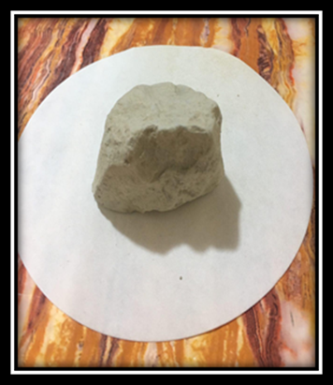 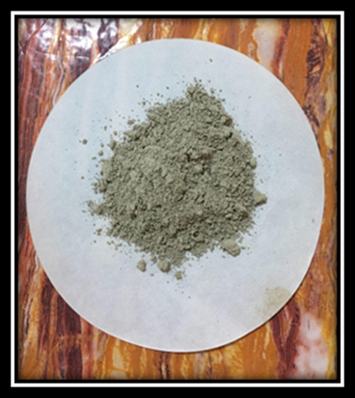

**(a)**

**(b)**

Figure S1. Physical appearance of a) natural bentonite and (b) bentonite after crushing.

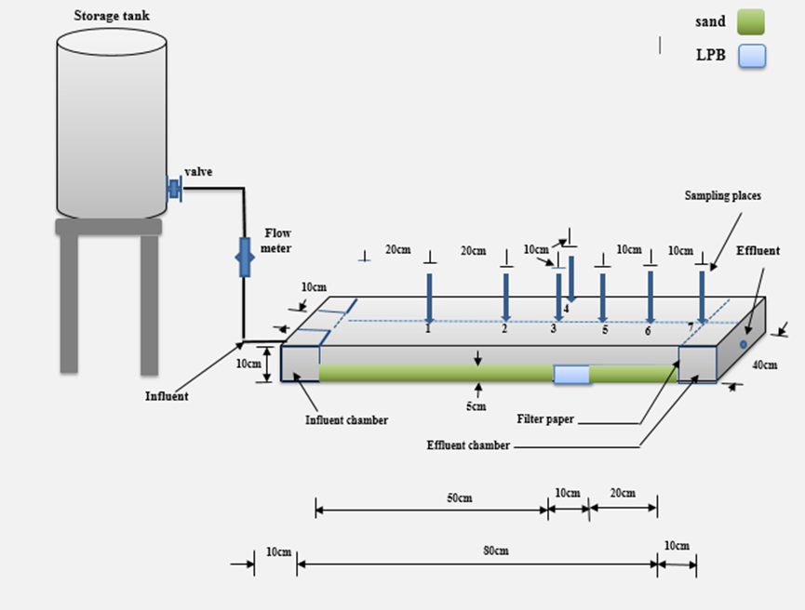

Figure S2.Schematic diagram of the bench-scale model used in the present study.

Figure S3. Variation of hydraulic conductivity coefficient for bentonite reactive material.

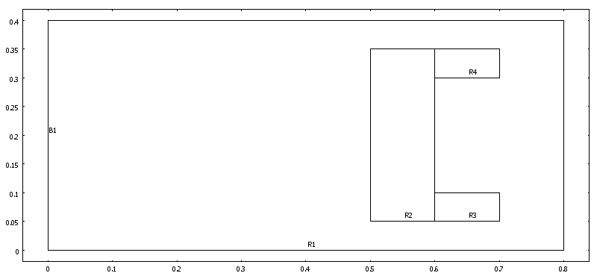

Figure S4. Geometry of the bench-scale model aquifer (R1) with proposed configuration of LPB (R2, R3 and R4) and line source (B1) as plotted by COMSOL Multiphysics 3.5a (all dimensions in m).

Figure S5. Predicted values of cadmium normalized concentrations using COMSOL package at port 5 beyond the proposed configuration of the bentonite LPB.