**Synthesis, Molecular Docking and Biological Evaluation of Pyrimidine and Quinazoline Derivatives of 1,5-Benzodiazepine as a Potential Anticancer Agents**

Apoorva Misra1, Dharma Kishore1, Ved Prakash Verma1, Sunil Dubey2, Subhash Chander3, Neha Gupta4, Sameer Bhagyawant4, Jaya Dwivedi1*, Zeid A Alothman5,Saikh Mohammad Wabaidur5 and Swapnil Sharma6

*1Department of Chemistry, Banasthali Vidyapith, Banasthali-304022, Rajasthan, India*

*2Birla Institute of Technology & Science, Pilani Campus, Pilani- 333031, Rajasthan, India*

*3School of Pharmacy, Maharaja Agrasen University, Solan, Himachal Pradesh-174103, India*

*4School of Studies in Biotechnology, Jiwaji University, Gwalior-474011 Madhyapradesh India*

*5Department of Chemistry, College of Science, King Saud University, Riyadh-11451, Kingdom of Saudi Arabia*

*6Department of Pharmacy, Banasthali Vidyapith, Banasthali-304022, Rajasthan, India*

**2. Experimental**

**2.1. Preparation of (Z)-2-benzoyl-3-(dimethyl-amino) acrylonitrile (2).**

mp 95°C. IR (in cm-1): 3063 [C-HAr str.], 2254 [CN str.], 1674 [C=O str.], 1645 [C=C α, β-unsat. str.], 1540 [C=C Ar str.], 1320 [C-N str.]. 1H NMR (400 MHz, DMSO-d6): δ7.82-7.62 (m, 5H); 7.35 (s, 1H); 3.64 (s, 6H). 13C NMR (100 MHz, DMSO-d6): δ 189.80 (C1); 160.62 (C3); 137.40 (C5); 135.45 (C8); 131.39 (C6); 129.80 (C7); 119.80 (C9); 81.79 (C2); 51.70 (C4). Anal. calc. for C12H12N2O: C , 71.98; H, 6.01; N, 13.99. Found, C, 71.95; H, 6.01; N, 13.94.

**2.2. Preparationof4-Phenyl-1H-benzo[b] [1,4]diazepine-3-carbonitrile (4).**

mp 138 °C. IR (in cm-1): 3321 [N-H str.], 3074 [C-H Ar str.], 2190 [CN str.], 1623 [C=N str.], 1563 [C=C Ar str.], 1317 [C-N str.]. 1H NMR (400 MHz, DMSO-d6): δ 7.94-7.80 (s, 2H), 7.55-6.89 (m, 7H), 5.36 (s, 1H), 4.14 (s, 1H). 13C NMR (400 MHz, DMSO-d6): δ 167.70 (C1); 161.40 (C3); 141.67 (C9); 135.45 (C4); 131.39 (C11,C14); 129.80 (C12,C13); 125.45 (C6.C7,C8); 117.40 (C10); 111.20 (C5); 79.20 (C2). Anal. calc. forC16H11N3: C, 78.35; H, 4.52; N, 17.13. Found: C, 78.33; H, 4.54; N, 17.13.

**2.4. Preparation of 5, 6–Dihydroxy–2–(4–phenyl–1H–benzo[b][1,4]diazepin–3–yl) –pyrimidine–4-carboxylic acid methyl ester (A)**

mp 176°C. IR (in cm-1): 3618 [O-H str.], 3335 [N-H str.], 2976 [C-H str. ArH], 1742 [C=O str. ester gr.], 1684 [C=N str.], 1503 [C=C str. ArH], 1249 [C-O ester gr.] 1344 [C-N str.], 1303 [C-O str.]. 1H NMR (400 MHz, DMSO-d6): δ 12.36 (s, 1H); 8.02 (s, 2H); 7.57-6.74 (m, 7H); 5.56 (s, 1H); 4.81 (s, 1H); 3.83 (s, 4H). 13C NMR (100 MHz, DMSO-d6): δ167.40 (C1,C6,C18); 151.67 (C2); 144.26 (C3,C4,C7); 137.19 (C12,C13); 135.45 (C14); 130.62 (C17); 127.21 (C15,C16); 125.20 (C8, C10); 122.17 (C9); 111.79 (C5, C11); 65.39 (C19). Anal. calc. for C21H16N4O4: C, 64.94; H, 4.15; N, 14.43. Found: C, 64.95; H, 4.14; N, 14.41. m/z: 388.0461.

**2.5. Preparation of (*Z*) –3– (dimethylamino) acryloyl cyanide (7)**

mp 102 °C. IR (in cm-1):3023 [C-H str.], 2361 [CN str.], 1702 [C=O str.], 1648 [C=C str.], 1215 [C-N str.]. 1H NMR (400 MHz, DMSO-d6): δ 6.86 (d, *J*=28 Hz,1H); 5.30 (d, *J*=4 Hz, 1H); 3.89 (s, 6H). 13C NMR (100 MHz, DMSO-d6): δ 185.45 (C1); 167.40 (C3); 119.80 (C5); 111.79 (C2); 39.68 (C4). Anal. calc. for C6H8N2O: C, 58.05; H, 6.50; N, 22.57. Found: C, 58.07; H, 6.47; N, 22.53.

**2.6. Preparation of 5*H*–Benzo[*b*][1,4]diazepine–2–carbonitrile (8)**

mp 148 °C. IR (in cm-1): 3025 [C-H str. Ar], 2833 [C-H str.], 2213 [CN str.], 1602 [C=N str.], 1507 [C=C Ar str.], 1278 [C-N str.]. 1H NMR (400 MHz, DMSO-d6): δ 7.23-6.75 (m, 4H); 5.02 (d, *J*= 4Hz, 1H); 4.51 (d, *J*=4 Hz, 1H); 4.14 (s, 1H). 13C NMR (100 MHz, DMSO-d6): δ 141.18 (C3); 137.19 (C4, C9); 127.21 (C1); 125.20 (C6, C8); 117.22 (C10); 111.20 (C5); 79.20 (C2). Anal. calc. for C10H7N3: C, 70.99; H, 4.17; N, 24.84. Found: C, 70.98; H, 4.15; N, 24.87.

**2.7. Preparation of4-(2-phenylquinazolin-4-yl)-1*H*-benzo[*b*][1,4]diazepine (B)**

mp 144 °C. IR (in cm-1): 3231 [N-H str.], 3066 [C-H ArH str.], 1456 [C=N str.], 1315 [C=C str.], 1054 [C-N str.]. 1H NMR (400 MHz, DMSO-d6): δ7.59-6.16 (m, 13H); 4.54 (d, *J*=4 Hz, 1H); 4.18 (d, *J*=4 Hz, 1H); 3.41 (s, 1H). 13C NMR (400 MHz, DMSO-d6): δ 168.85 (C9); 160.62 (C1); 153.04 (C8); 144.32 (C2, C11); 135.45 (C12, C17, C18, C21, C4); 128.86 (C3, C5, C6, C16, C19, C20); 123.26 (C7, C14, C15); 111.90 (C13); 93.04 (C10). Anal. calc. for C23H16N4: C, 79.29; H, 4.63; N, 16.08. Found: C, 79.31; H, 4.65; N, 16.04. m/z: 348.1998.

**2.8. General procedure of 2–benzoyl–3, 3–bis (methylthio) acrylonitrile (10)**

mp 110 °C. IR (in cm-1): 3023 [C-H Ar str.], 2976 [C-H str.], 2255 [CN str.], 1729 [C=O str.], 1641 [C=C α,β-unsat. str.], 1451 [C=C ArH str.], 729 [C-S str.]. 1H NMR (400 MHz, DMSO-d6): δ 7.82-7.53 (m, 5H); 2.88 (s, 6H). 13C NMR (100 MHz, DMSO-d6): δ 196.89 (C1); 179.35 (C3); 137.40 (C5); 135.45 (C8); 131.39 (C6); 129.80 (C7); 111.90 (C9); 105.45 (C2); 15.17 (C4). Anal. calc. for C12H11NOS2: C, 57.80; H,4.41; N,5.62. Found: C, 57.83; H, 4.41; N, 5.64.

**2.9. Preparation of 2–Methylsulfanyl–4–phenyl–1H–benzo[b][1,4]diazepine–3–carbonitrile (11).**

mp 153 °C. IR (in cm-1): 3447 [N-H str.], 3026 [C-H str. Ar], 2360 [CN str.], 1699 [C=N str.], 1621 [C=C Ar str.], 1214 [C-N str.], 670 [C-S str.]. 1H NMR (400 MHz, DMSO-d6): δ 7.94-7.89 (s, 2H); 7.55-6.89 (s, 5H); 4.14 (s, 1H); 1.73 (s, 1H). 13C NMR (100 MHz, DMSO-d6): δ 167.40 (C3); 161.70 (C1); 141.67 (C9); 135.45 (C4); 131.39 (C12, C15); 129.80 (C13, C14); 125.45 (C6, C7, C8); 117.40 (C10); 111.90 (C5); 65.39 (C2); 15.64 (C11). Anal. calc. for C17H13N3S: C, 70.05; H, 4.50; N, 14.42. Found: C, 70.05; H, 4.53; N, 14. 40.

2.10. **Preparation of 2-(methylthio)-4-phenyl-3-(2-phenylquinazolin-4-yl)–1H–benzo[b][1,4]diazepine (C)**

mp 150 °C. IR (in cm-1): 3617 [N-H str.], 3037 [C-H ArH str.], 1604 [C=N str.], 1451 [C=C str.], 1199 [C-N str.], 686 [C-S str.]. 1H NMR (400 MHz, DMSO-d6): δ**7**.80 (s, 2H); 7.65 (s, 4H); 7.24-7.19 (m, 4H); 7.18-6.74 (m, 8H); 4.19 (s, 1H); 1.82 (s, 3H). 13C NMR (100 MHz, DMSO-d6): δ 163.26 (C1, C8, C17); 154.26 (C2, C10, C16); 139.32 (C4, C11, C18, C21, C22, C25); 130.62 (C3, C5, C19, C20); 128.86 (C15, C23, C24); 123.26 (C6, C7, C13, C14); 115.64 (C12); 59.32 (C9); 15.64 (C26). Anal. calc. for C30H22N4S: C, 76.57; H, 4.71; N, 11.91. Found: C, 76.55; H, 4.69; N, 11.93. m/z: 470.0388.

**2.11. Preparation of 2, 4–Dioxo–2, 3, 4, 5–tetrahydro–1*H*-benzo[*b*][1,4]diazepine–7–carbonitrile (14)**

mp 142 °C. IR (in cm-1): 3409 [N-H str.], 3188 [C-H str. Ar], 2903 [C-H str.], 2218 [CN str.], 1695 [C=O str.], 1645 [C=O str.], 1582 [NH bending], 1451 [C=C Ar str.], 1246 [C-N str.]. 1H NMR (400 MHz, DMSO-d6): δ 8.02 (s, 1H); 7.60-7.57 (m, 3H); 3.26 (s, 1H). 13C NMR (400 MHz, DMSO-d6): δ 161.70 (C1, C3); 144.56 (C4, C9); 135.20 (C8); 127.28 (C6); 125.81 (C5); 117.57 (C10); 111.29 (C7); 53.11 (C2). Anal. calc. for C10H7N3O2: C, 59.70; H, 3.51; N, 20.89. Found: C, 59.68; H, 3.53; N, 20.87.

**2.13. Preparation of Methyl-2-(2, 4-dioxo-2, 3, 4, 5-tetrahydro-1H-benzo[b][1,4] diazepin-7yl)-5,6-dihydroxypyrimidine-4-carboxylate (D)**

mp 149 °C. IR (in cm-1): 3359 [O-H str], 3165 [N-H str], 3058 [C-H str ArH], 1744 [C=O str], 1646 [C=N str], 1571 [C=C strArH], 1384 [C-O str ester], 1293 [C-N str], 1179 [C-O str]. 1H NMR (400 MHz, DMSO-d6): δ11.90 (s, 1H); 8.02 (s, 2H); 7.60-7.57 (s, 3H); 5.56 (s, 1H); 4.17 (s, 3H), 3.26 (s, 2H). 13C NMR (100 MHz, DMSO-d6): δ167.45 (C1, C14); 161.90 C8, C10); 148.86 (C2, C4); 144.86 (C3, C7); 135.26 (C11); 130.62 (C5); 128.86 (C13); 123.32 (C6); 111.90 (C12); 59.26 (C9, C15). Anal. calc. for C15H12N4O6: C, 52.33; H, 3.51; N, 16.27. Found: C, 52.34; H, 3.49; N, 16.25. m/z: 344.9862.

**2.14. Preparation of (*E*)-ethyl-2-cyano-3-phenylacrylate (17)**

mp 90 °C. IR (in cm-1): 3078 [C-H Ar str.], 2976 [C-H str], 2215 [CN str.], 1714 [C=O str.], 1598 [C=C α, β-unsat. str.], 1435 [C=C ArH str.], 1294 [C-O str.]. 1H NMR (400 MHz, DMSO-d6): δ 8.28 (s, 1H); 7.21-7.18 (m, 5 H); 4.16 (q, *J*= 8 Hz, 2H); 1.24 (t, *J*= 6 Hz, 3H). 13C NMR (100 MHz, DMSO-d6): δ 160.62 (C3); 153.04 (C5); 137.40 (C6); 135.45 (C7); 131.39 (C8); 129.80 (C9); 115.45 (C10); 107.39 (C4); 60.62 (C2); 15.45 (C1). Anal. calc. for C12H11NO2: C, 71.63; H, 5.51; N, 6.96. Found: C, 71.66; H, 5.48; N, 6.92.

**2.15. Preparation of 2-oxo-4-phenyl-2, 3, 4, 5-tetrahydro-1H-benzo[b][1,4]diazepine 3-carbonitrile (18)**

mp 145 °C. IR (in cm-1): 3191 [N-H str.], 3026 [C-H str. Ar], 2217 [CN str.], 1692 [C=O str.], 1583 [NH bending], 1448 [C=C Ar str.], 1318 [C-N str.]. 1H NMR (400 MHz, DMSO-d6): δ 8.86 (s, 1H); 7.91 (s, 2H); 7.57-6.74 (m, 7H); 4.41 (d, *J*= 8 Hz, 1H); 4.16 (d, *J*= 8 Hz, 1H); 3.89 (s, 1H). 13C NMR (100 MHz, DMSO-d6): δ 164.26 (C1); 141.67 (C11); 137.40 (C4); 127.40 (C12, C13, C14); 125.45 (C6, C8, C9); 117.40 (C5, C7); 111.90 (C10); 65.39 (C3, C2). Anal. calc. for C16H13N3O: C, 72.99; H, 4.98; N, 15.96. Found: C, 72.96; H, 4.95; N, 15.99.

**2.16. Preparation of 4-phenyl-3-(2-phenylquinazolin-4-yl)-4, 5-dihydro-1*H*-benzo[*b*] [1,4]diazepine-2(3*H*)-one (E)**

mp 180 °C. IR (in cm-1): 3334 [N-H str.], 3072 [C-H ArH str.], 1742 [C=O str.], 1684 [C=N str.], 1503 [C=C str.], 1303 [C-N str.]. 1H NMR (400 MHz, DMSO-d6): δ8.18 (s, 1H); 8.02 (s, 3H); 7.60-7.52 (m, 5H); 7.29-6.75 (m, 10H); 4.58 (s, 1H); 4.18 (d, *J*= 8 Hz, 1H); 4.15 (d, *J*= 4 Hz, 1H). 13C NMR (100 MHz, DMSO-d6): δ 167.40 (C10); 161.70 (C1, C8); 151.67 (C2, C18); 144.26 (C16); 137.40 (C22); 131.67 (C4, C25); 127.40 (C3, C20, C24, C5, C11, C23); 125.45 (C19, C21, C14, C6, C7); 117.40 (C12, C13, C15); 65.39 (C17); 59.32 (C9). Anal. calc. for C29H22N4O: C, 78.71; H, 5.01; N, 12.66. Found: C, 78.68; H, 5.04; N, 12.64. m/z: 442.0388

**2.18. Preparation of 5,6-Dihydroxy-2-(2-oxo-4-phenyl-2,3,4,5-tetrahydro-1H-benzo[b][1,4]diazepin-3-yl)-pyrimidine-4-carboxylic acid methyl ester (F)**

mp 173 °C. IR (in cm-1): 3648 [O-H str], 3231 [N-H str], 3066 [C-H str ArH], 1740 [C=O str ester gr], 1677 [C=N str], 1456 [C=C str ArH], 1315 [C-O str ester gr], 1054 [C-N str]. 1H NMR (400 MHz, DMSO-d6): δ12.36 (s, 1H); 7.91 (s, 1H); 7.89 (s, 2H); 7.57-6.74 (m, 7H); 5.17 (s, 1H); 4.41 (d, *J*= 8 Hz, 1H); 4.16 (d, *J*= 8 Hz, 1H); 3.89 (s, 4H)**.** 13C NMR (100 MHz, DMSO-d6): δ 167.40 (C13); 160.62 (C1, C18); 151.67 (C4); 141.67 (C2); 135.45 (C3, C7, C14) ; 131.39 (C17); 129.80 (C15, C16); 125.45 (C9, C10, C11, C12); 119.80 (C8); 81.79 (C6); 51.70 (C5, C19). Anal. calc. for C21H18N4O5: C, 62.06; H, 4.46; N, 13.79. Found: C, 62.05; H, 4.45; N, 13.75. M/z406.0477

**Table 1S: Elemental analysis for showing purity of synthesized compounds**

|  |  |  |  |  |  |  |  |
| --- | --- | --- | --- | --- | --- | --- | --- |
| **Compd.** | **Molecular**  **Formula** | **Calculated** | | | **Found** | | |
| **C%** | **H%** | **N%** | **C%** | **H%** | **N%** |
| 2 | C12H12N2O | 71.98 | 6.01 | 13.99 | 71.95 | 6.01 | 13.94 |
| 4 | C16H11N3 | 78.35 | 4.52 | 17.13 | 78.33 | 4.54 | 17.13 |
| A | C21H16N4O4 | 64.94 | 4.15 | 14.43 | 64.95 | 4.14 | 14.41 |
| 7 | C6H8N2O | 58.05 | 6.50 | 22.57 | 58.07 | 6.47 | 22.53 |
| 8 | C10H7N3 | 70.99 | 4.17 | 24.84 | 70.98 | 4.15 | 24.87 |
| B | C23H16N4 | 79.29 | 4.63 | 16.08 | 79.31 | 4.65 | 16.04 |
| 10 | C12H11NOS2 | 57.80 | 4.41 | 5.62 | 57.83 | 4.41 | 5.64 |
| 11 | C17H13N3S | 70.05 | 4.50 | 14.42 | 70.05 | 4.53 | 14.40 |
| C | C30H22N4S | 76.57 | 4.71 | 11.91 | 76.55 | 4.69 | 11.93 |
| 14 | C10H7N3O2 | 59.70 | 3.51 | 20.89 | 59.68 | 3.53 | 20.87 |
| D | C15H12N4O6 | 52.33 | 3.51 | 16.27 | 52.34 | 3.49 | 16.25 |
| 17 | C12H11NO2 | 71.63 | 5.51 | 6.96 | 71.66 | 5.48 | 6.92 |
| 18 | C16H13N3O | 72.99 | 4.98 | 15.96 | 72.96 | 4.95 | 15.99 |
| E | C29H22N4O | 78.71 | 5.01 | 12.66 | 78.68 | 5.04 | 12.64 |
| F | C21H18N4O5 | 62.06 | 4.46 | 13.79 | 62.05 | 4.45 | 13.75 |

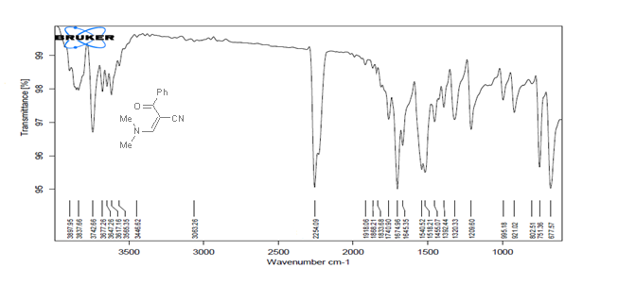

**IR spectrum of compound 2**

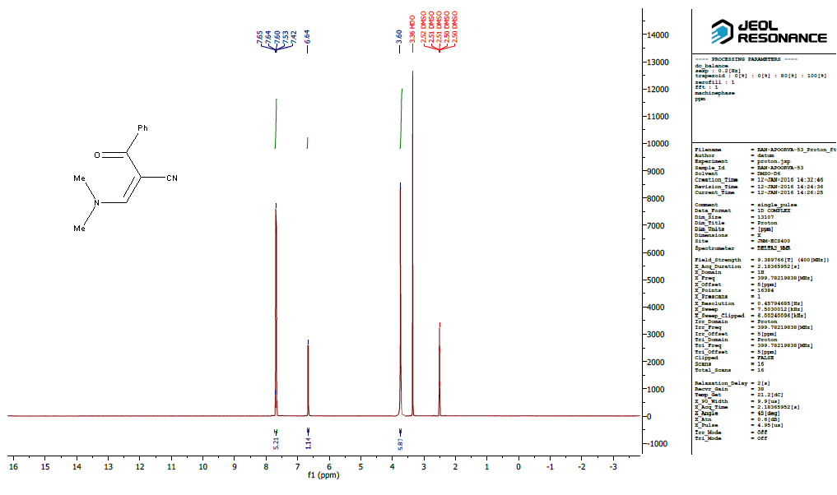

**1H NMR spectrum of compound 2**

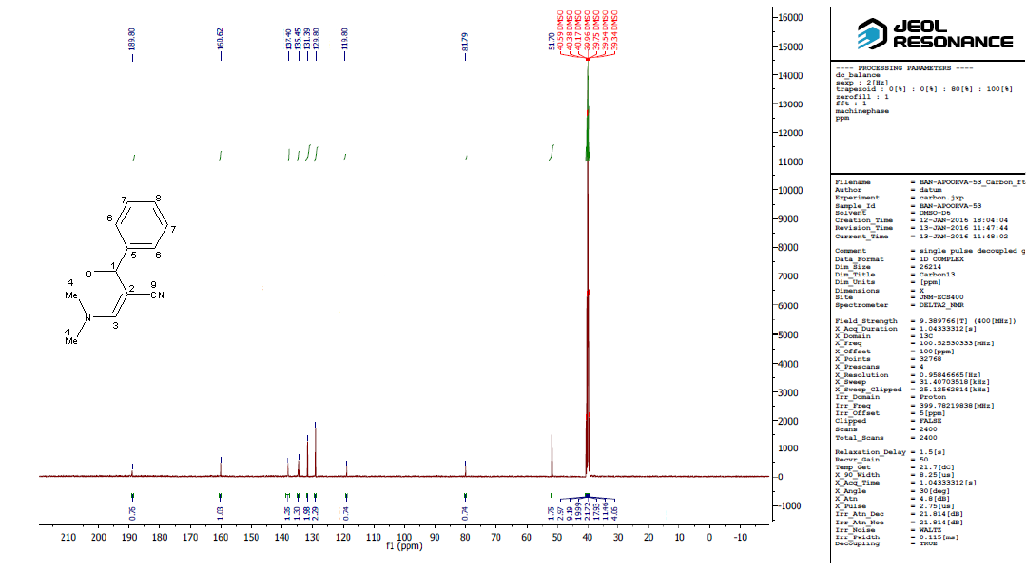

**13C NMR spectrum of compound 2**

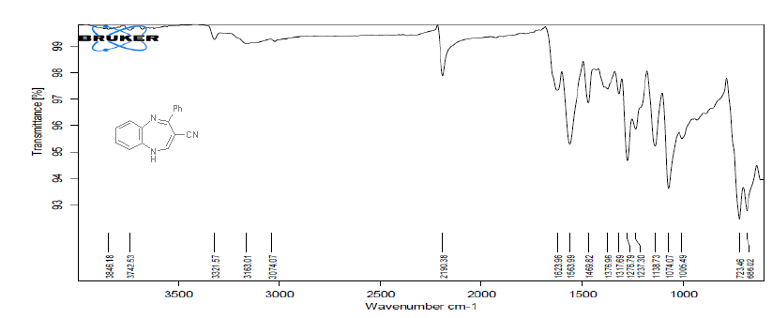

**IR spectrum of compound 4**

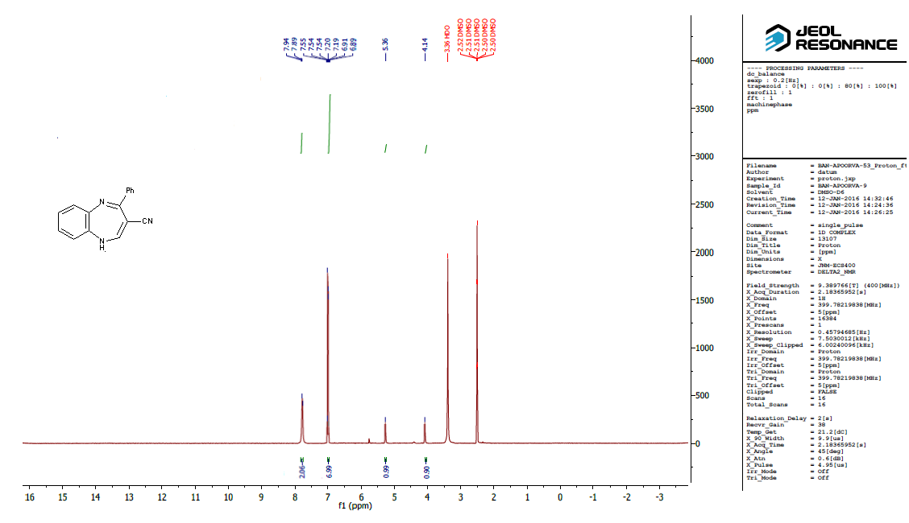

**1H NMR spectra of compound 4**

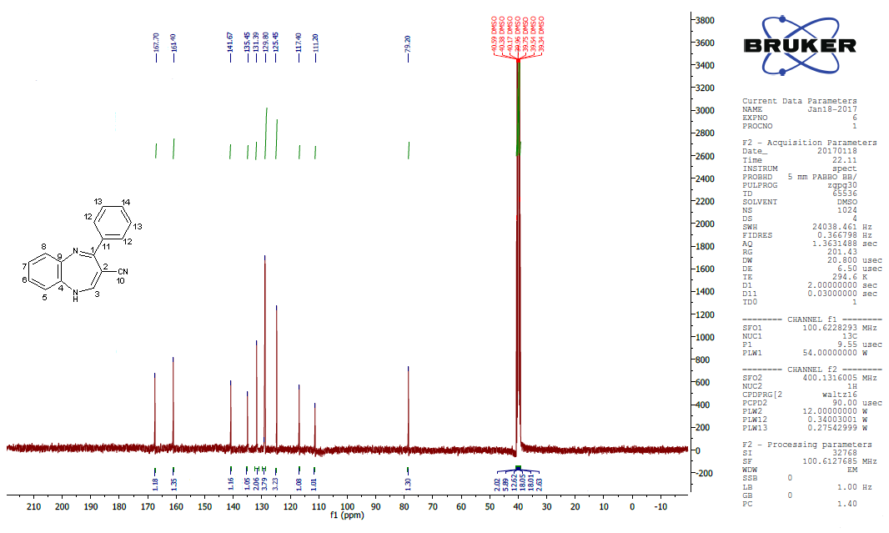

**13C NMR spectrum of compound 4**

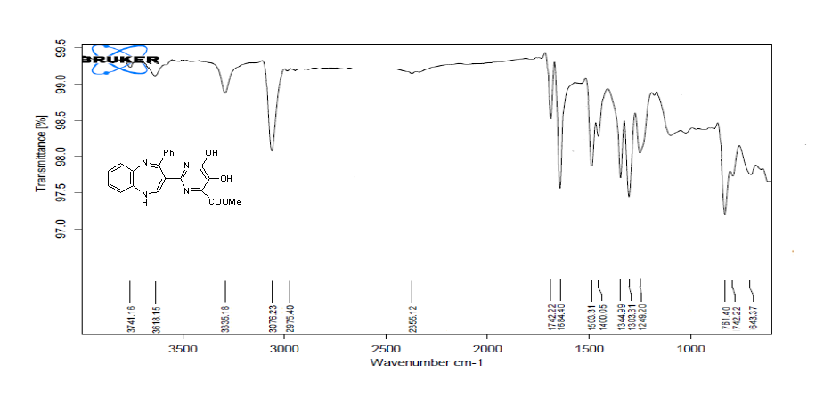

**IR spectra of compound A**

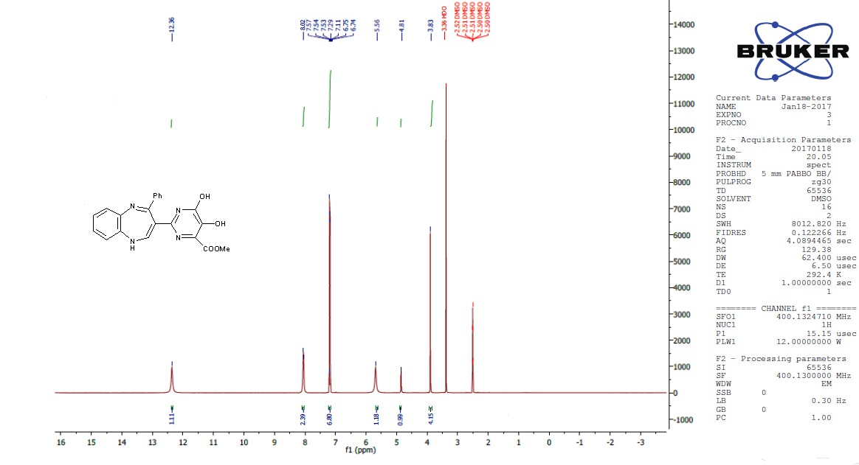

**1H NMR spectra of compound A**

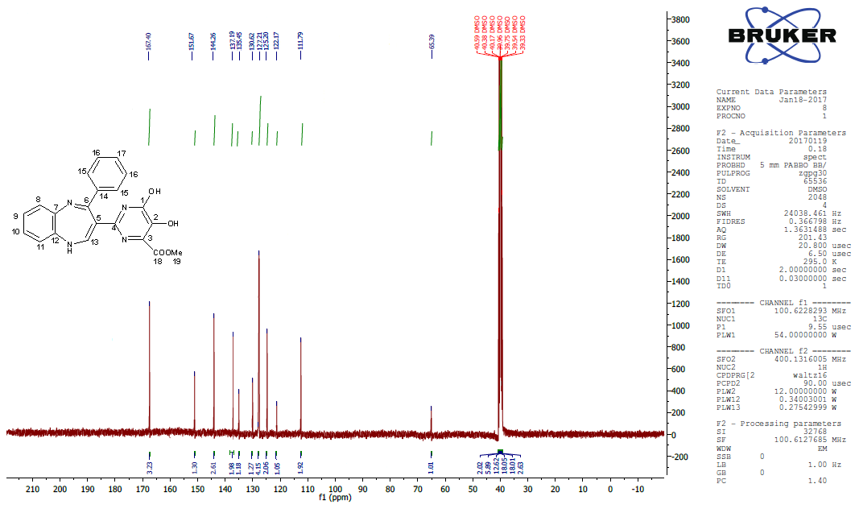

**13C NMR spectra of compound A**

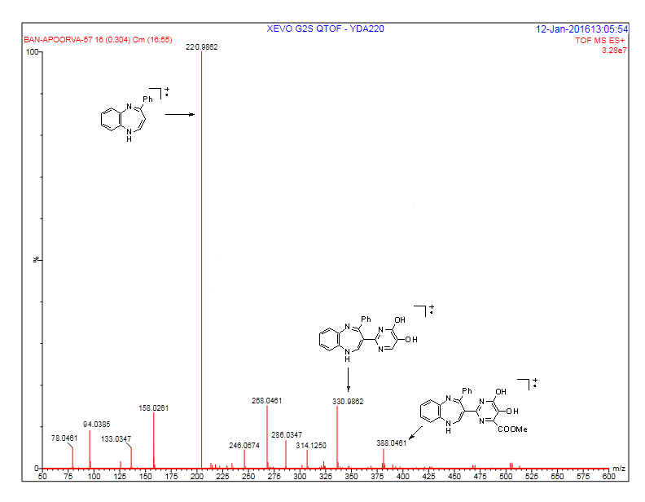

**Mass spectra of compound A**

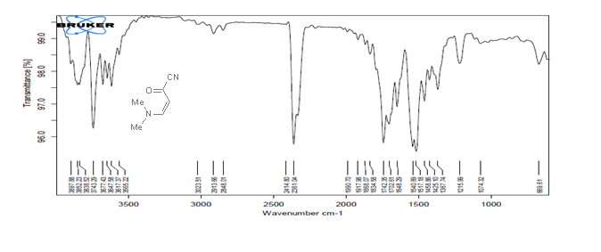

**IR spectrum of compound 7**

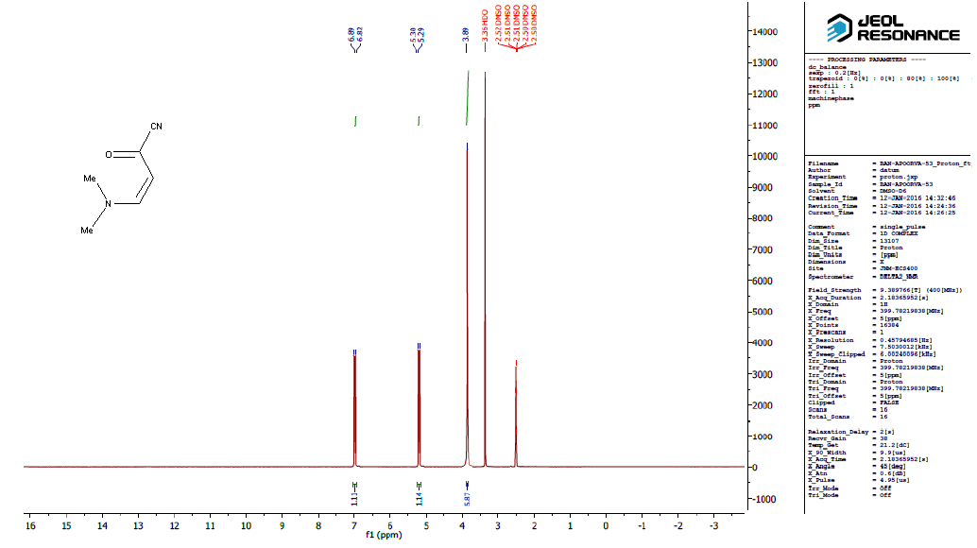

**1H NMR spectrum of compound 7**

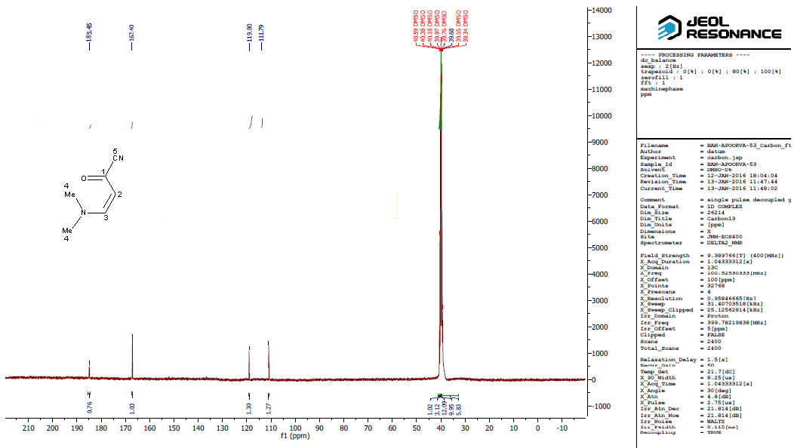

**13C NMR spectrum of compound 7**

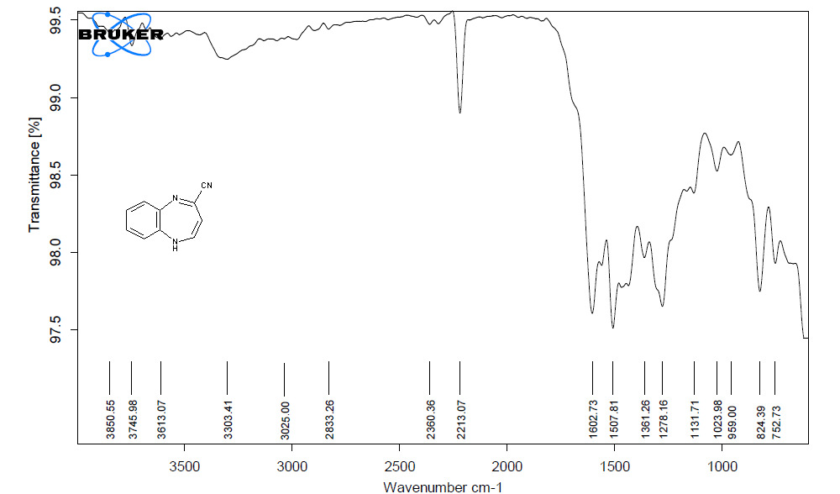

**IR spectrum of compound 8**

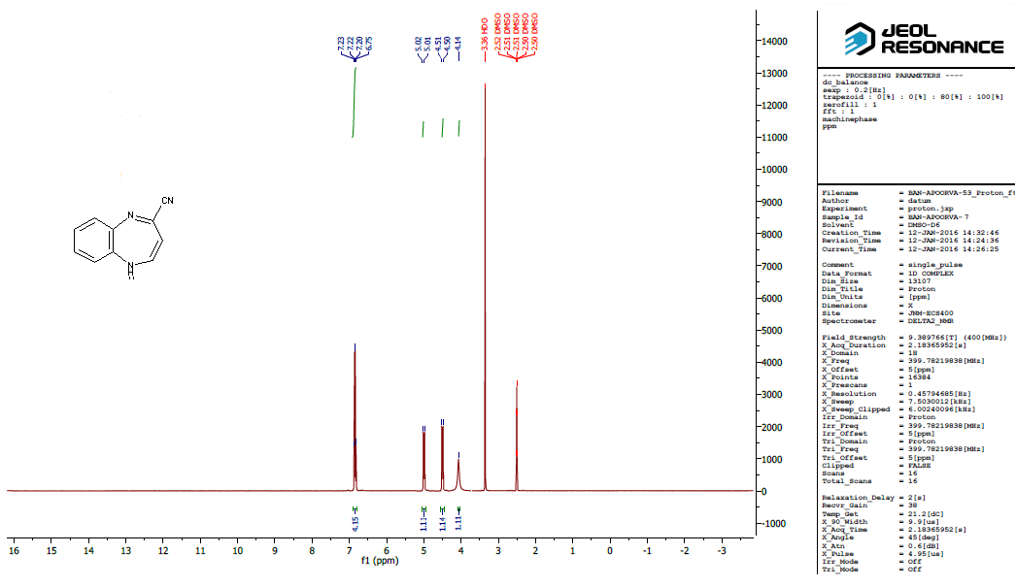

**1H NMR spectrum of compound 8**

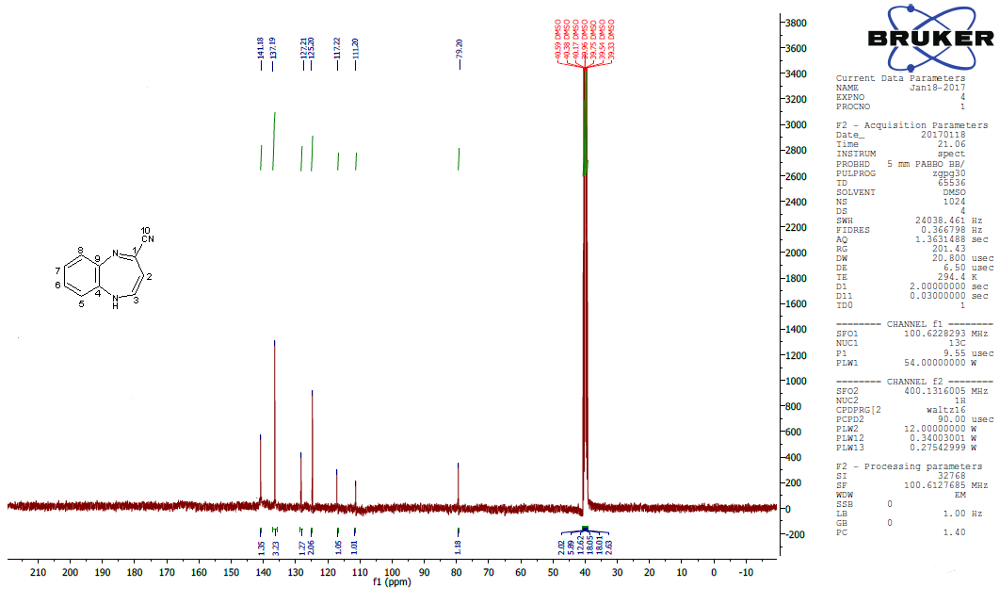

**13C NMR spectrum of compound 8**

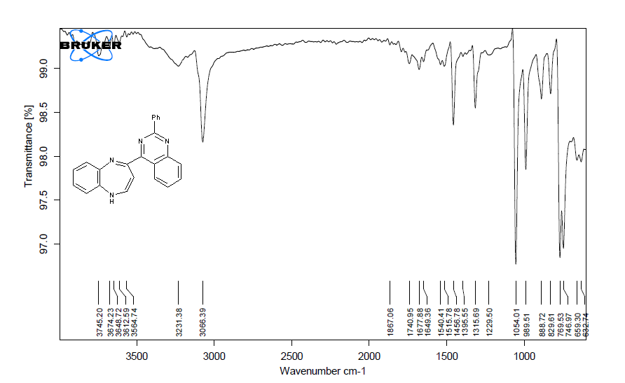

**IR spectra of compound B**

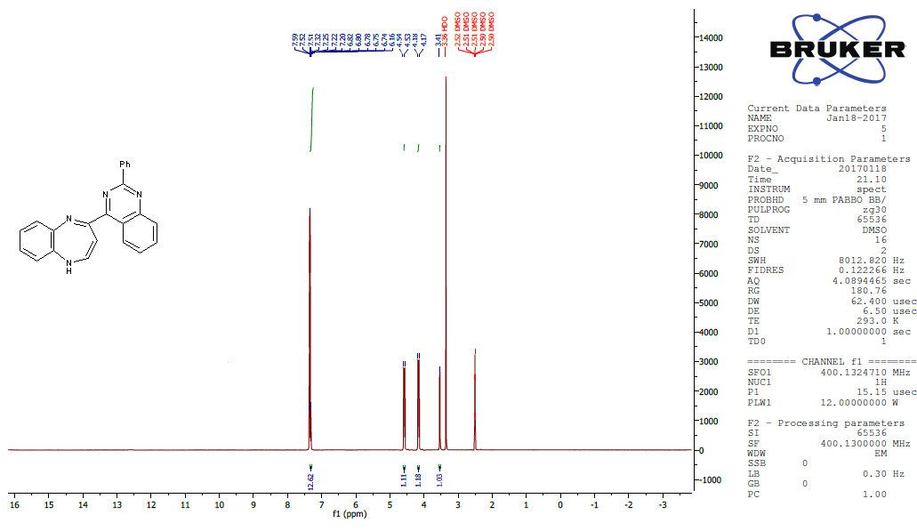

**1H NMR spectra of compound B**

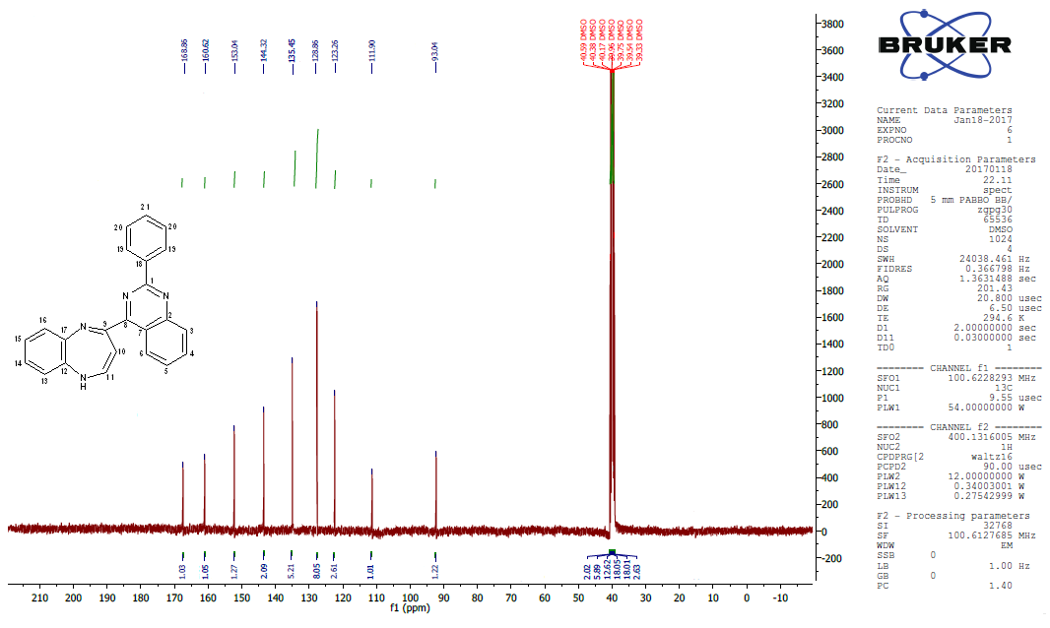

**13C NMR spectra of compound B**

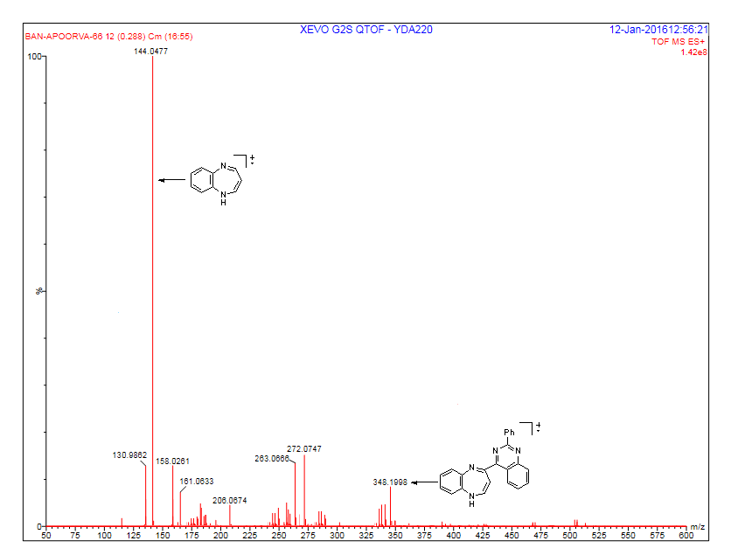

**Mass spectra of compound B**

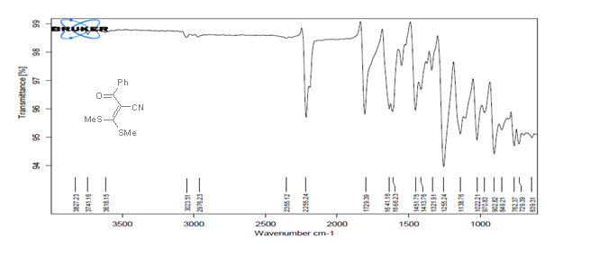

**IR spectrum of compound 10**

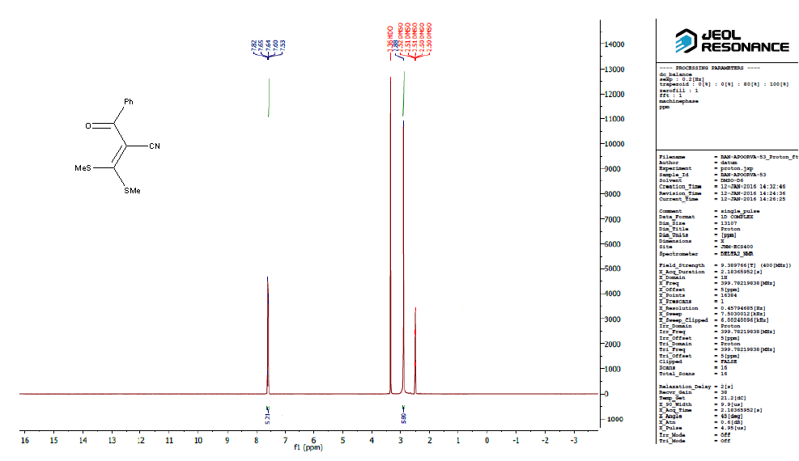

**1H NMR spectrum of compound 10**

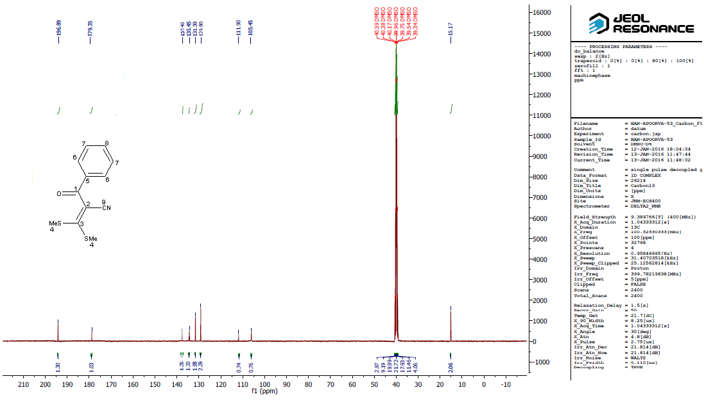

**13C NMR spectrum of compound 10**

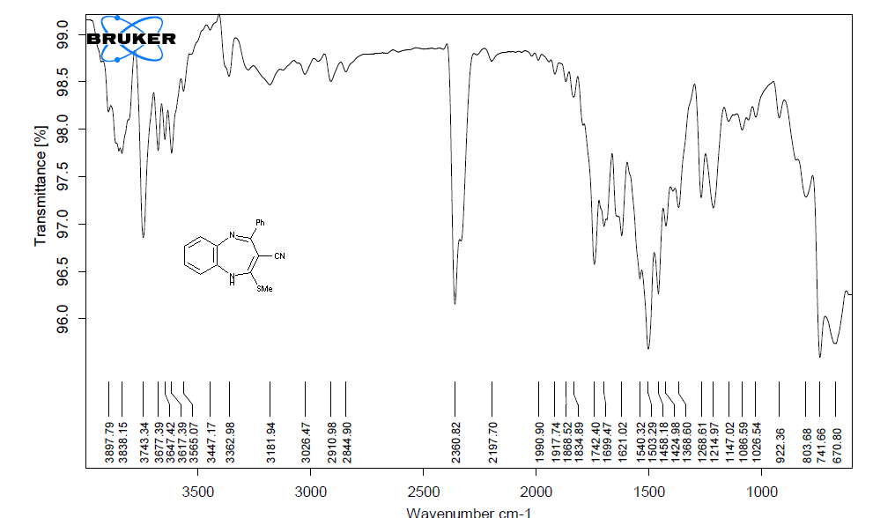

**Chart 3.6: IR spectrum of compound 11**

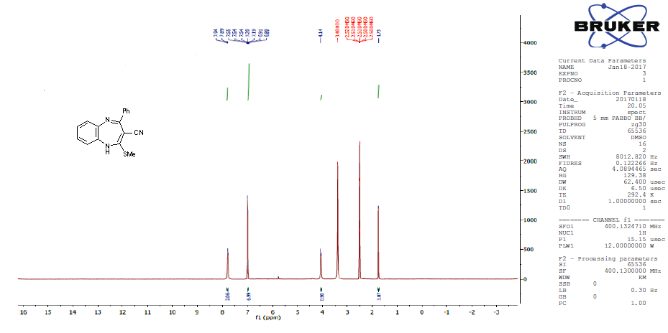

**1H NMR spectrum of compound 11**

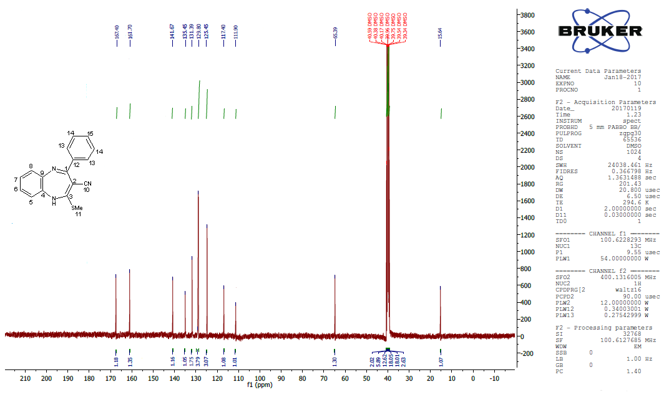

**13C NMR spectrum of compound 11**

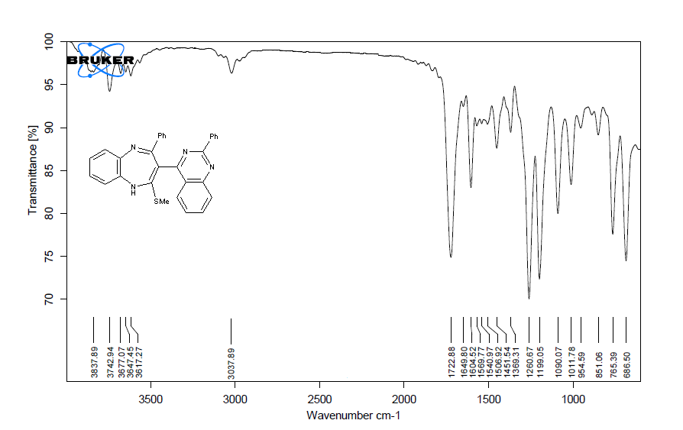

**IR spectra of compound C**

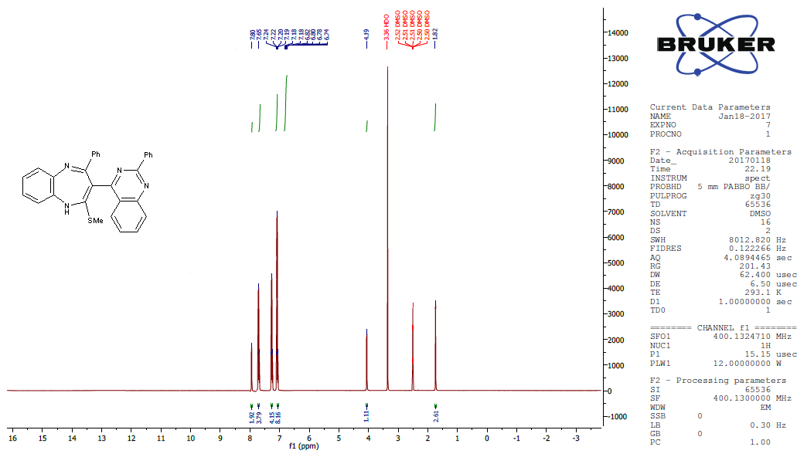

**1H NMR spectra of compound C**

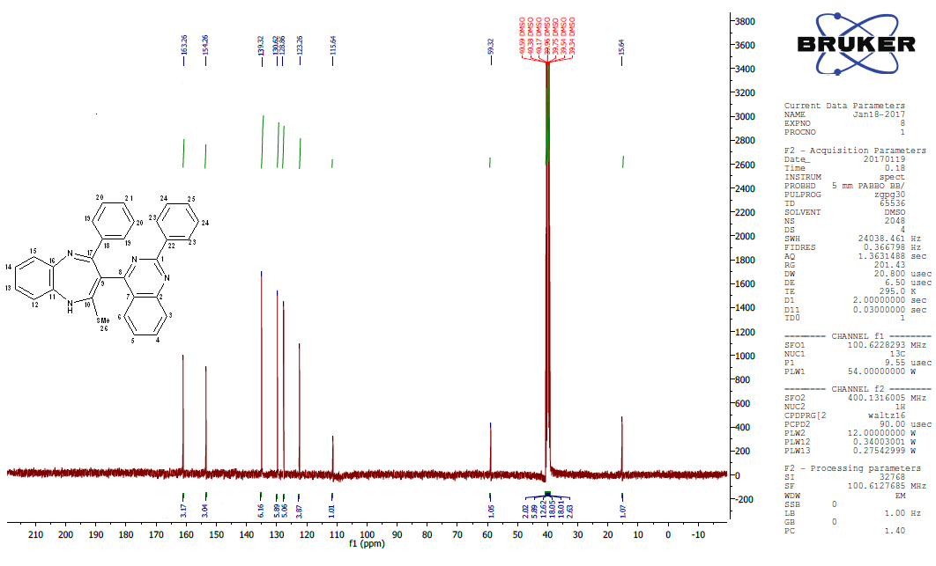

**13C NMR spectra of compound C**

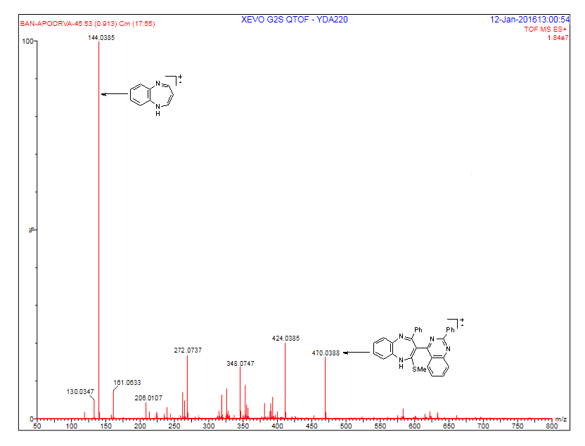

**Mass spectra of compound C**

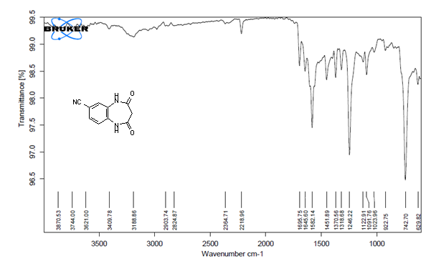

**IR spectrum of compound 14**

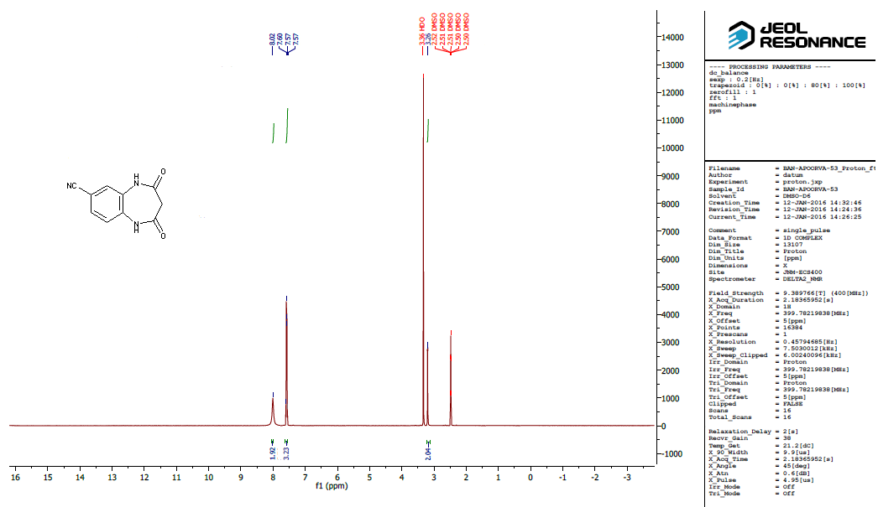

**1H NMR spectrum of compound 14**

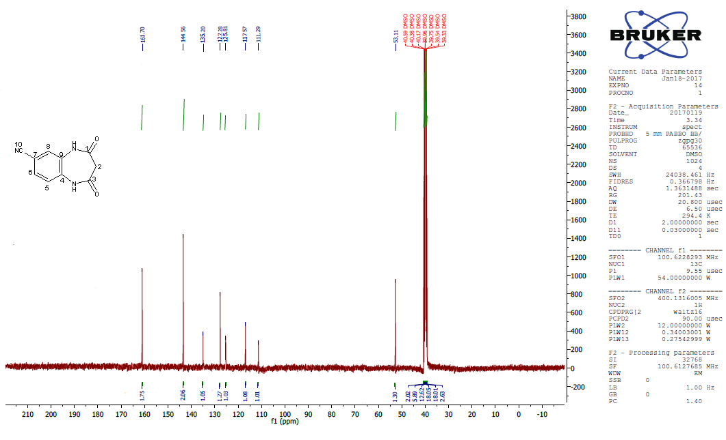

**13C NMR spectrum of compound 14**

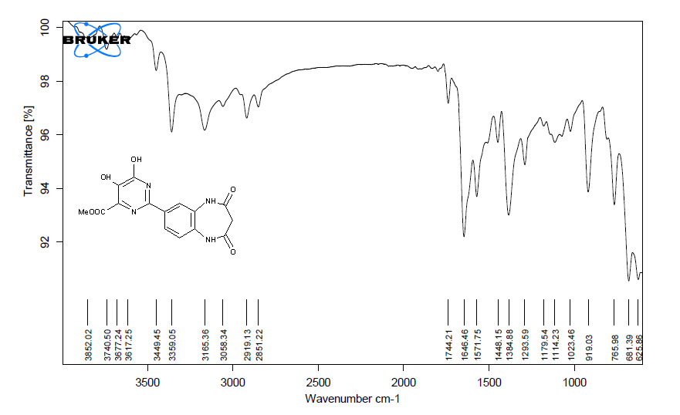

**Chart 4.10: IR spectra of compound D**

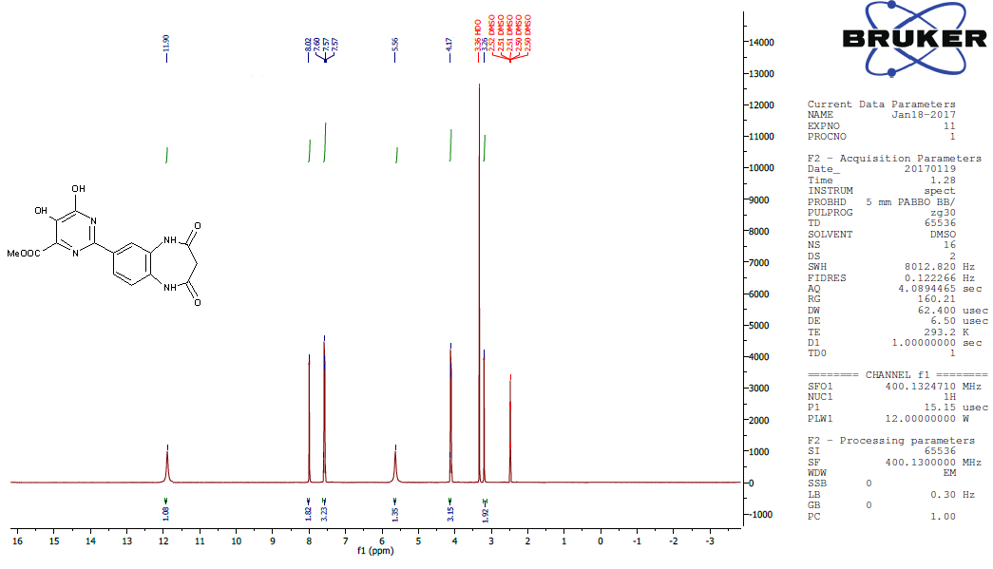

**1H NMR spectra of compound D**

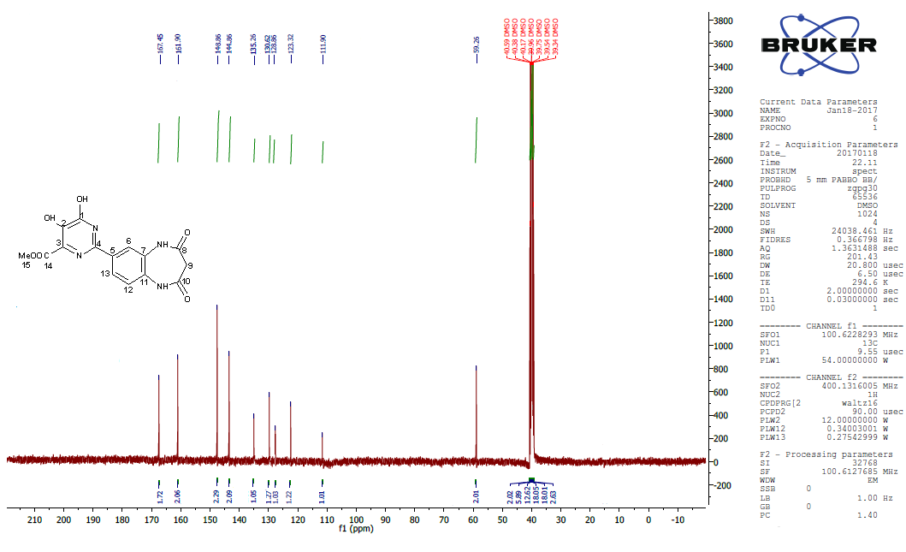

**13C NMR spectra of compound D**

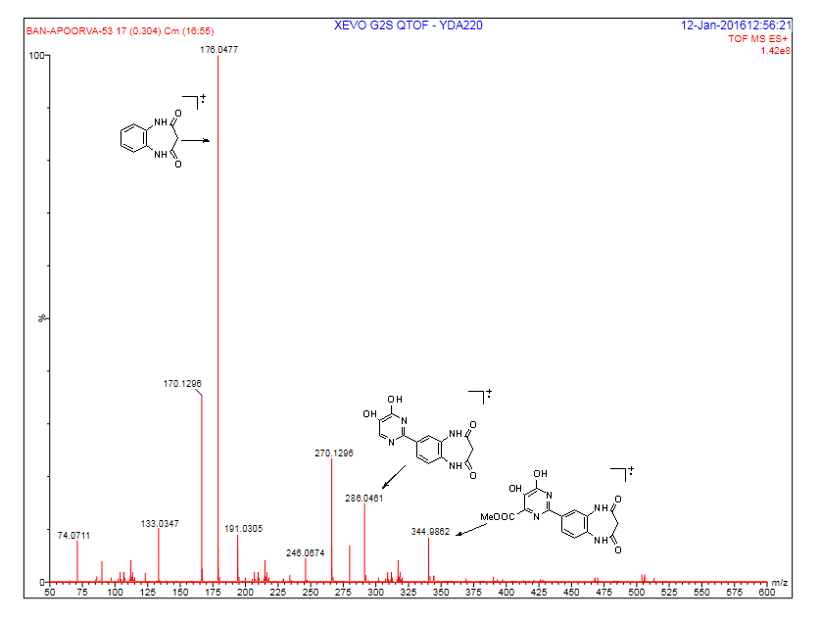

**Mass spectra of compound D**

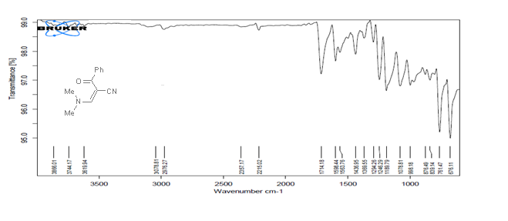

**IR spectrum of compound 17**

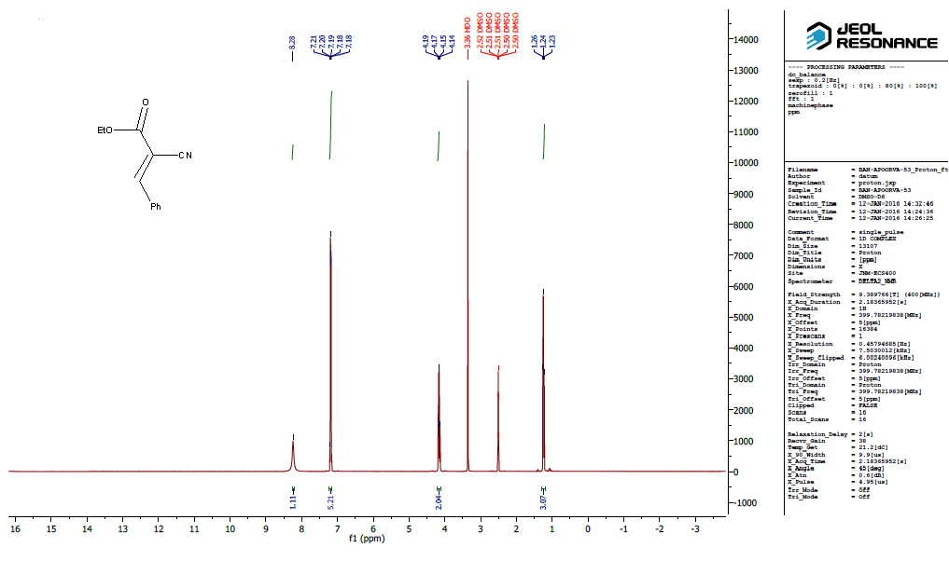

**1H NMR spectrum of compound 17**

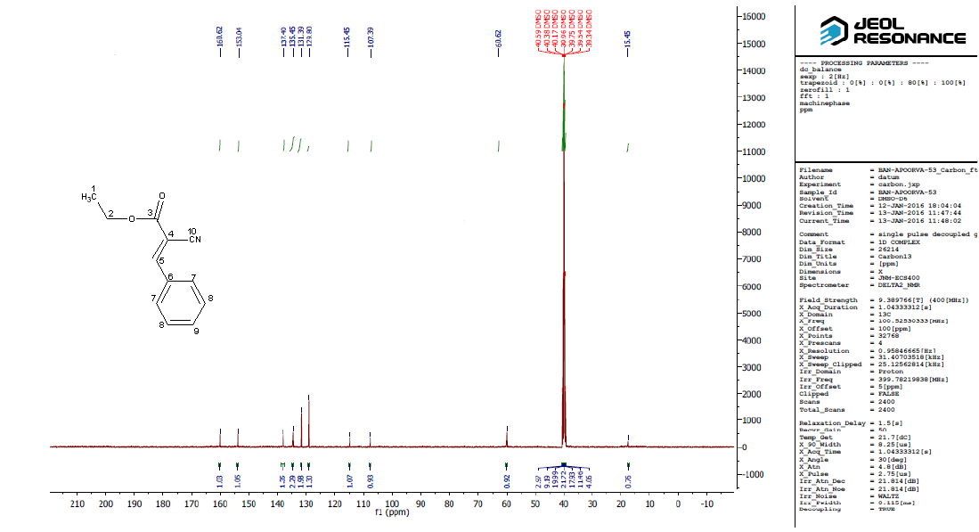

**13C NMR spectrum of compound 17**

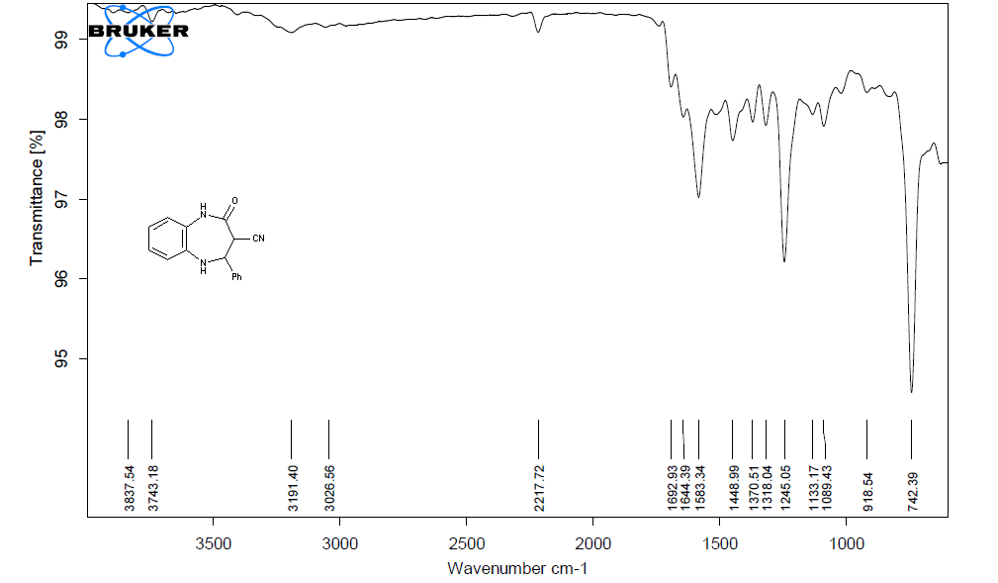

**Chart 3.3: IR spectrum of compound 18**

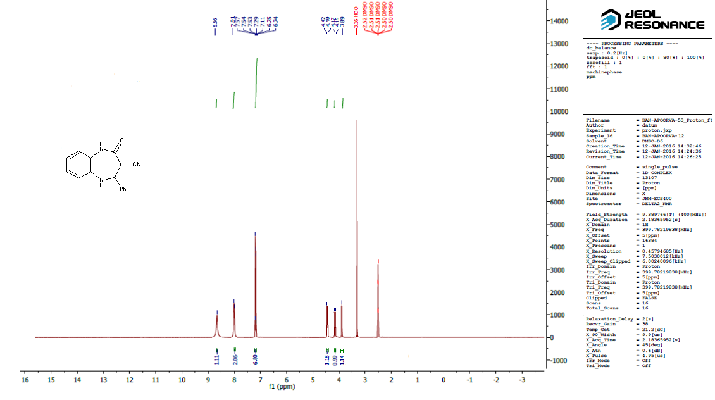

**Chart 3.13: 1H NMR spectrum of compound 18**

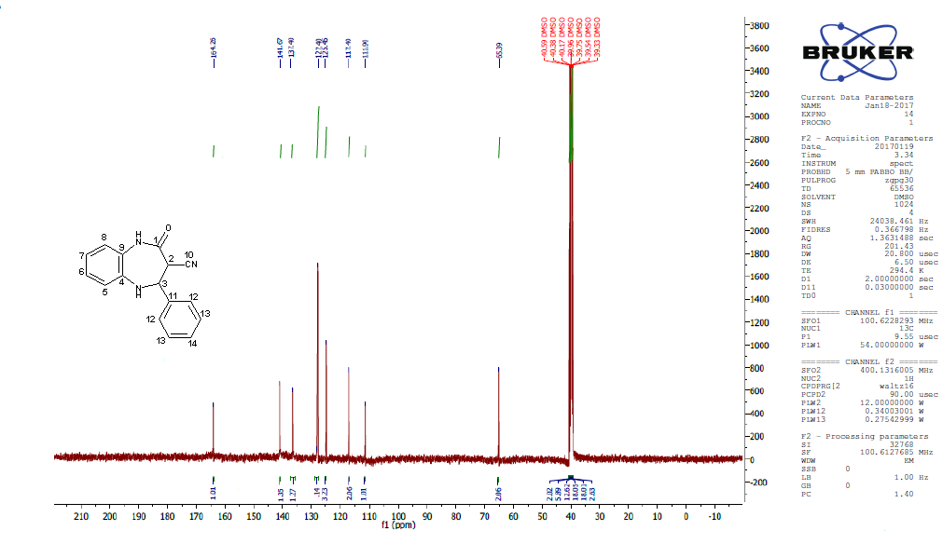

**13C NMR spectrum of compound 18**

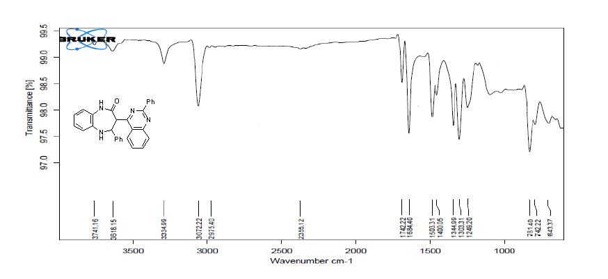

**IR spectra of compound E**

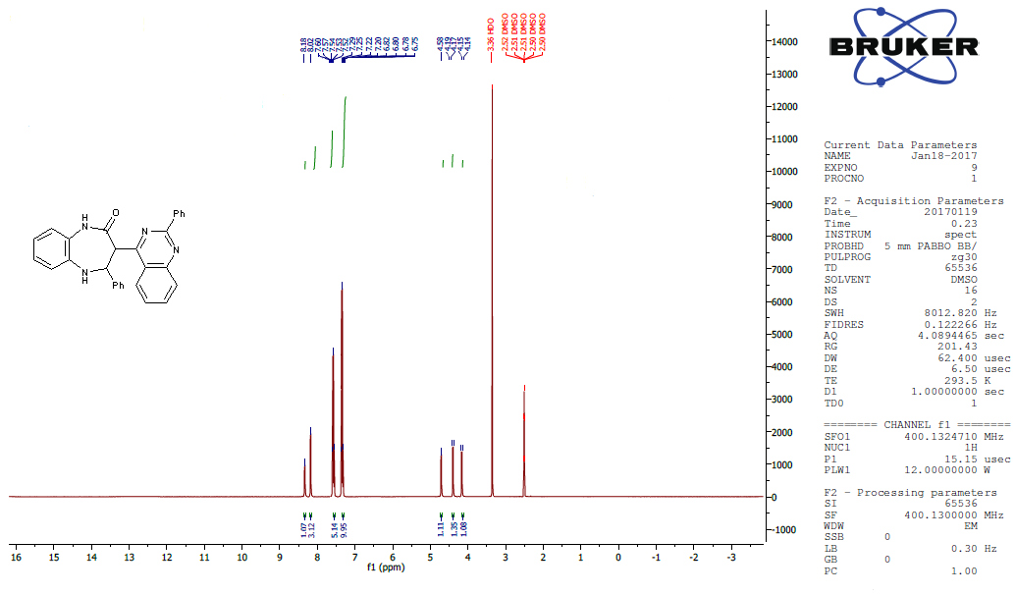

**1H NMR spectra of compound E**

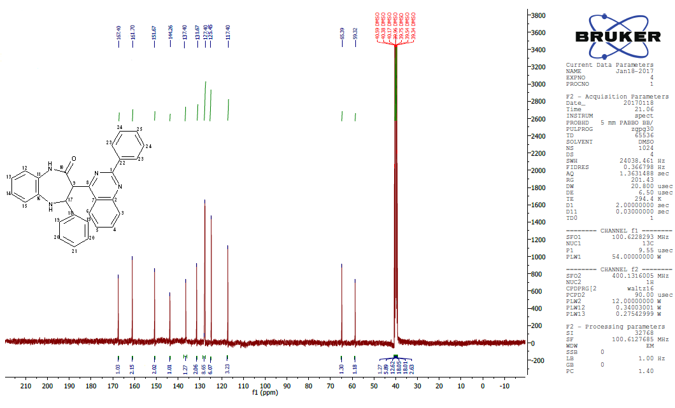

**13C NMR spectra of compound E**

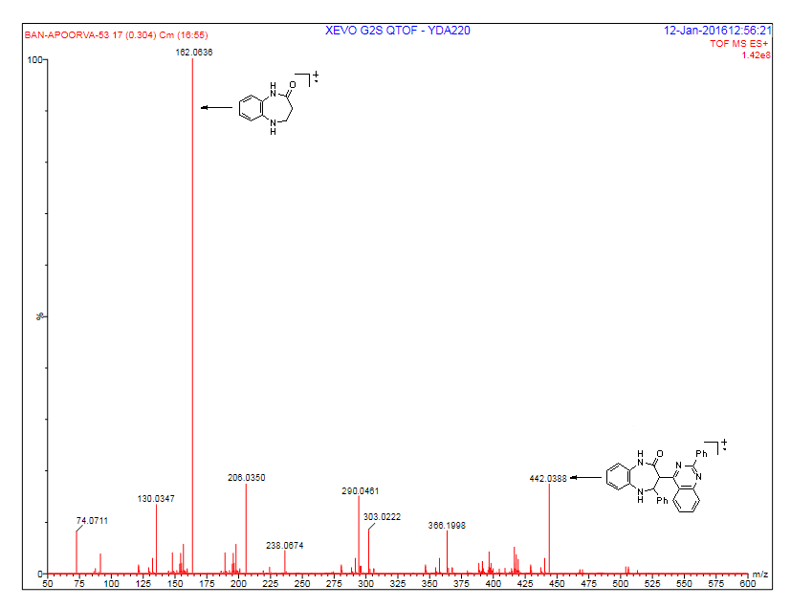

**Mass spectra of compound E**

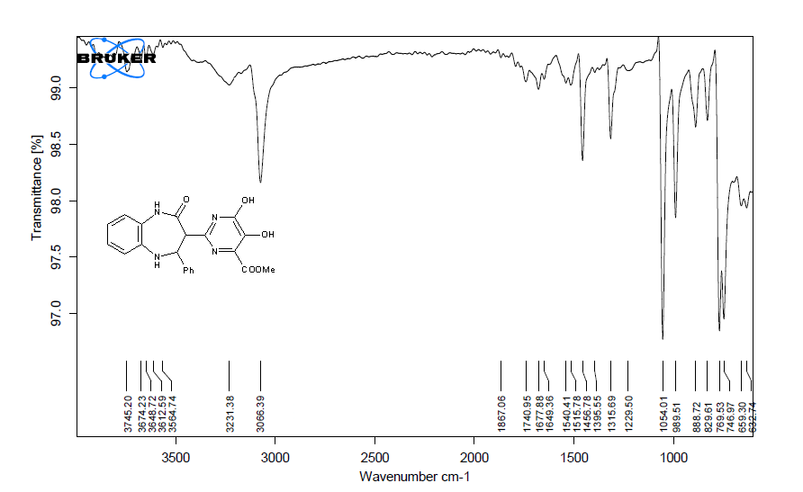

**IR spectra of compound F**

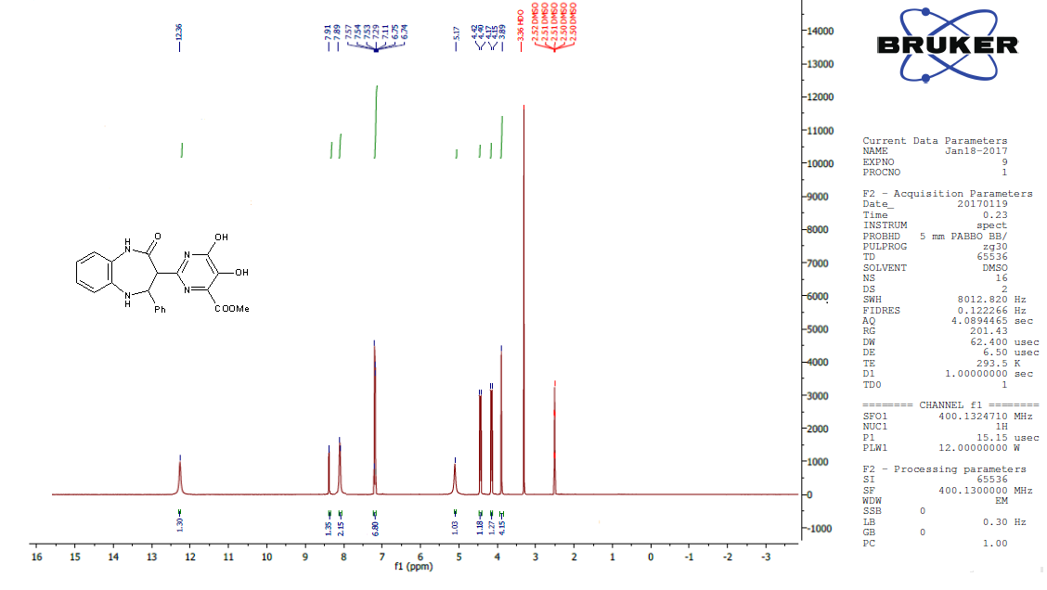

**1H NMR spectra of compound F**

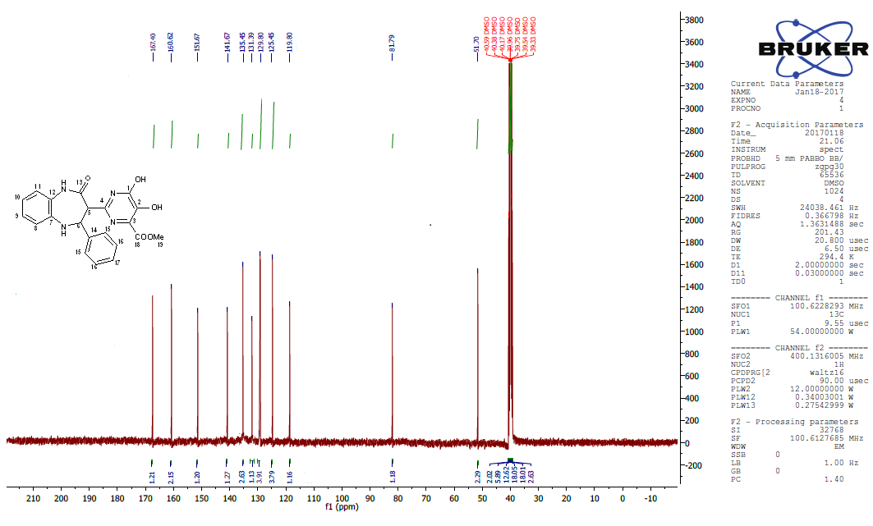

**13C NMR spectra of compound F**

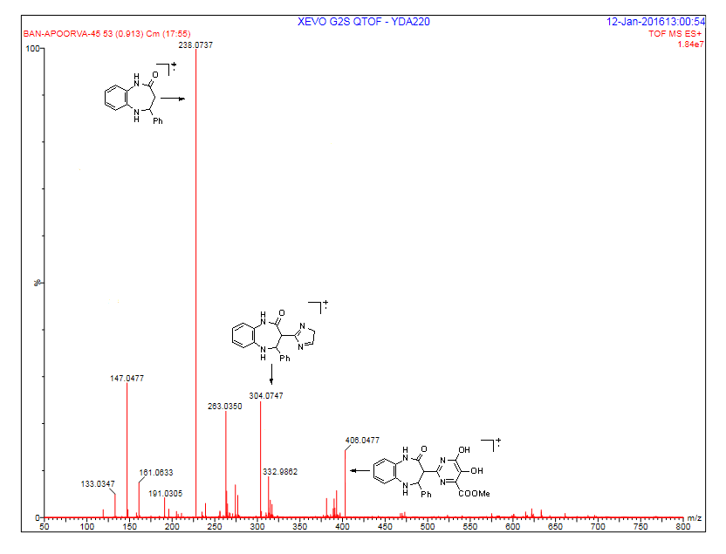

**Mass spectra of compound F**

**Atom numbering in C NMR data**

