**Supplementary Information**

**A facile approach to develop industrial waste encapsulated cryogenic alginate beads to sequester toxic bivalent heavy metals**

Ayoub Abdullah Alqadamia, Moonis Ali Khan a,*, Masoom Raza Siddiquia, Zeid Abdullah Alothmana, Sadia Sumbulb

aChemistry Department, College of Science, King Saud University, Riyadh 11451,

Saudi Arabia

bDepartment of Chemistry, College of Science, Princess Noura Bint Abdul Rehman University, Riyadh, Saudi Arabia

________________________________________________________________________

*Corresponding Author: Moonis Ali Khan

E-mail addresses: [mokhan@ksu.edu.sa](mailto:mokhan@ksu.edu.sa); [moonisalikhan@gmail.com](mailto:moonisalikhan@gmail.com)

**Table of content**

|  |  |
| --- | --- |
| **Index** | **Caption** |
| **Figure S1** | EDX plots of pristine **(a)**, Pb(II) saturated **(b)**, and Cd(II) saturated **(c)** SMFCAB. Inset: Elemental analysis data. |
| **Table S1** | Comparison of the maximum monolayer adsorption capacities (qm) and equilibration time (t) for Pb(II)/Cd(II) adsorption on beads |
| **Text S1** | Isotherm models |
| **Text S2** | Kinetics models |
| **Text S3** | Thermodynamics parameters |

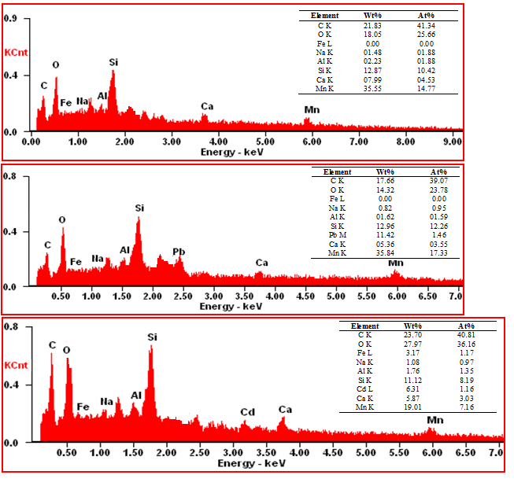

**Figure S1.** EDX plots of pristine **(a)**, Pb(II) saturated **(b)**, and Cd(II) saturated **(c)** SMFCAB.

Inset: Elemental analysis data.

|  |  |  |  |  |  |
| --- | --- | --- | --- | --- | --- |
| **Adsorbent** | **Experimental conditions** | | **qm**  **(mg/g)** | **t**  **(min)** | **Reference** |
| Surfactant modified chitosan beads | | *Co*:50 mg/L; pH: 5 ; T: 301K; *m*: 0.675g/L | Pb(II)/100 | 480 | (Pal and Pal, 2017) |
| Chelating polyacrylonitrile beads | | *Co*: 9-10.5 mg/L;pH:7 T: 303K;  *m*: 5g/L | Pb(II)/145  Cd(II)/156 | 600 | (Bhunia et al., 2018) |
| Chitosan-alginate beads | | *Co*: 20 – 300 mg/L; pH: 4.5; T: 298K; *m*: 0.2g/L | Pb(II)/60.3 | 100 | (Nagh et al., 2010) |
| Chitosan@Fe3O4 nanocomposite  beads | | *Co*: 70 mg/L; pH: 6; T: 298K | Pb(II)/63.3 | 120 | (Tran et al., 2010) |
| Porous attapulgite/polymer  beads | | *Co*:100 – 500 mg/L; pH: 5.2 ; T: 293K; *m*: 0.250g | Cd(II)/32.7 | 360 | (Feng et al., 2017) |
| Magnetic poly(vinyl alcohol)/modified  gum taracanth/graphene oxide hydrogel  beads | | *Co*: 20 – 200 mg/L; pH: 6 ; T: 298K;  *m*: 0.05g | Pb(II)/81.8 | 540 | (Sahraei et al., 2017) |
| SMFCAB | | *Co*: 25 to 300 mg/L; T: 298K; *m*: 0.01g; pH: 5.5 for Pb(II) and 7.2 for Cd(II) | Pb(II)/200  Cd(II)/178.6 | Pb(II)/90  Cd(II)/120 | This study |

**Table S1.** Comparison of the maximum monolayer adsorption capacities (*qm*) and equilibration time (t) for Pb(II)/Cd(II) adsorption on beads

**Text S1. Isotherm models**

Langmuir isotherm model assumes formation of monomolecular layer over adsorbent surface without interaction between the adsorbed molecules. Langmuir isotherm model in linearized form is expressed as (Langmuir, 1918): $$\frac{C_{e}}{q_{e}} =\frac{1}{K_{L}q_{m}} +\frac{1}{q_{m}} ×C_{e} (S1)$$  
where *qm* (mg/g) and *KL* (L/mg) are the constants for maximum monolayer adsorption capacity and a constant related to the heat of adsorption, respectively.

The essential feature of Langmuir isotherm can be expressed by separation factor (*RL*), a dimensionless constant, can be represented as:

$$R_{L}=\frac{1}{1+K_{L}C_{o}} (S2)$$

The magnitude of *RL* reflects the nature of adsorption. If *RL* > 1(unfavorable adsorption process), 0 < *RL* < 1 (favorable adsorption process), *RL* =1 (linear adsorption process), *RL* = 0 (irreversible adsorption process).

Freundlich isotherm in non-linear form is expressed as (Freundlich, 1906):

${log q}_{e}=logK_{F}+ \frac{1}{n} logC_{e} (S3)$

where *KF* ((mg/g) (L/mg)(1/n)) and *n* are the Freundlich constants related to bonding energy and deviation in adsorption from linearity, respectively. If *n =*1 (linear adsorption process), *n* < 1 (chemical adsorption process), *n* > 1 (physical adsorption process).

**Text S2. Kinetic models**

The pseudo-first-order (Lagergren, 1898)and pseudo-second-order (Ho and McKay, 1998) kinetics models in linearized forms are expressed as:

$$log{(q}_{e}-q_{t})=logq_{e}-\frac{K_{1}}{2.303}×t (S4)$$

$$\frac{t}{q_{t}}= \frac{1}{K_{2}q_{e}^{2}}+\frac{1}{q_{e}}×t (S5)$$

where *qe* and *qt* are the adsorption capacities at equilibrium, and at time *t*, respectively, *K1* and *K2* are the pseudo-first-order and pseudo-second-order rate constants, respectively.

**Text S3.** **Thermodynamic parameters**

Thermodynamic parameters viz. standard Gibb’s free energy change (*ΔG°*), entropy change (*ΔS°*), and enthalpy change (*ΔH°*) were calculated as:

$∆G°=-RT ln K_{c} (S6)$

$$ln K_{c}= \frac{∆S°}{R}- \frac{∆H°}{R}×\frac{1}{T} (S7)$$

where *R* is the universal gas constant (8.314 J/mol-K), *T* is the absolute temperature (K), and *Kc* is a separation factor. *ΔS°* and *ΔH°* were calculated from the intercept and slope of the plot of *ln* *Kc* versus 1/*T*.