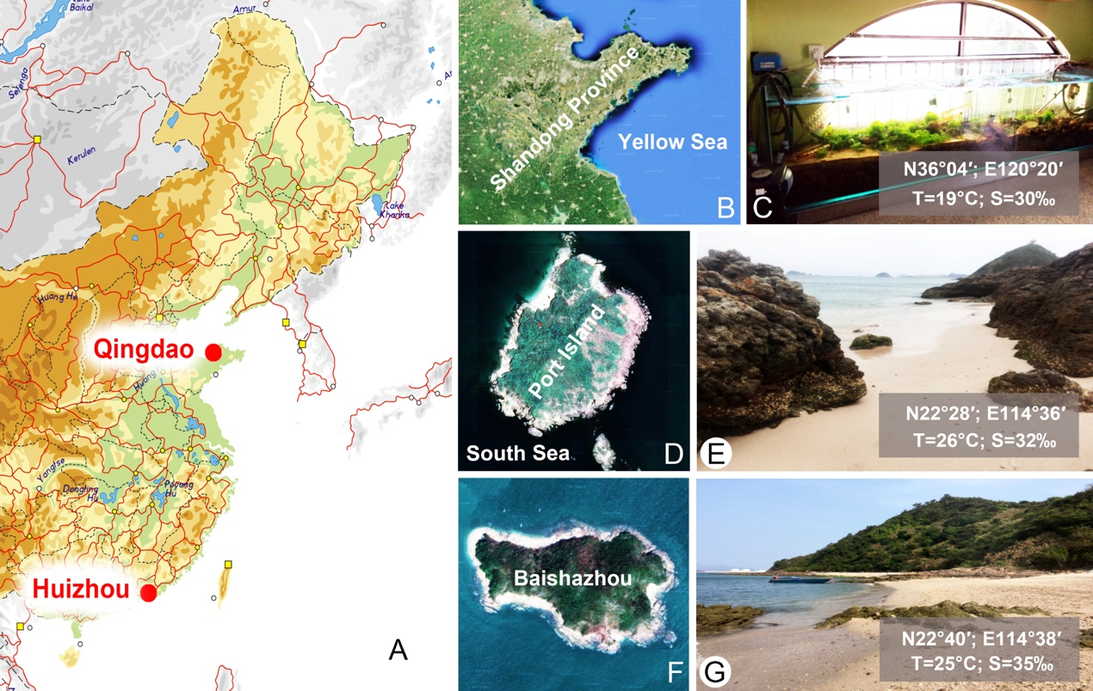

**Fig. S1.**(A) Map showing collecting sites. (B, C) A water tank in Lab of Protozoology, Ocean University of China, Qingdao, China. (D, E) Showing the sampling site and the corresponding ambient environment at Chizhou Island, Huizhou, China. (F, G) Showing the sampling site at Baishazhou, Huizhou, China,

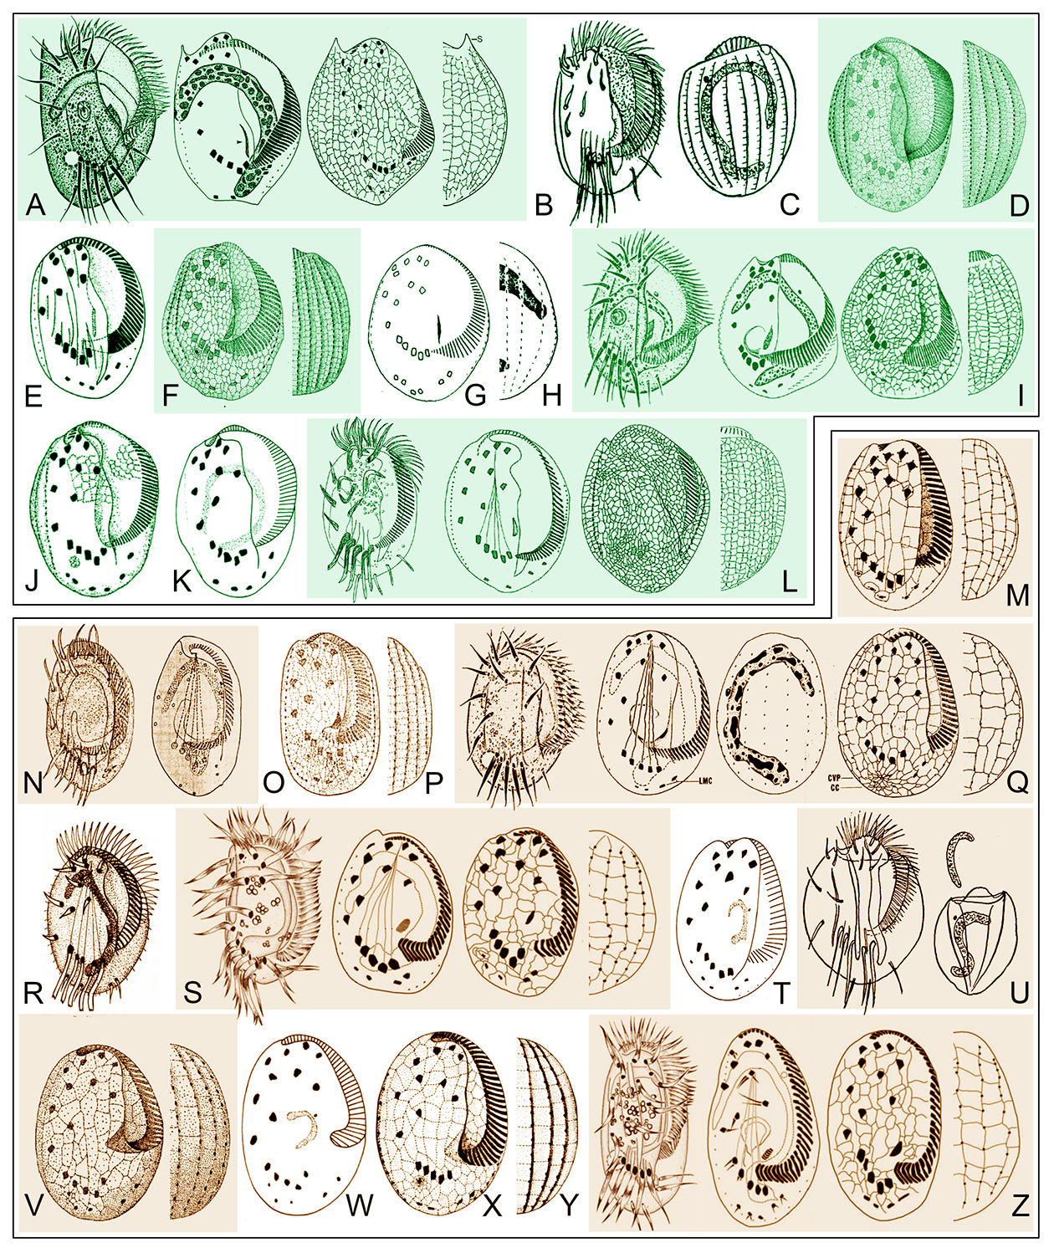

**Fig. S2.** Morphologically similar marine *Euplotes* species with *E.* *bergeri* n. sp. (A–L) and *E.* *shini* n. sp. (M–Z). (A) *Euplotes acanthodus* Petz et al., 1995 (from Petz et al., 1995). (B–L) *Euplotes charon* (Müller, 1773) Ehrenberg, 1830 (B, C, from Kahl, 1932; D, from Tuffrau, 1960; E, from Borror, 1968; F, from Agamaliev, 1974; G, H, form Wang and Song, 1995; I, from Song and Packroff, 1997; J, from Dragesco and Dragesco-Kernéis, 1986; K, from Carey, 1992; L, from Kwon and Shin, 2006). (M–T) *Euplotes minuta* Yocum, 1930 (M, from Borror, 1962; N, from Yocum, 1930; O, P, from Agamaliev, 1971; Q, from Song and Wilbert, 1997; R, from Kattar, 1970; S, from Park et al., 2010; T, from Carey, 1992). (U–Z) *Euplotes* *cristatus* Kahl, 1932 (U, from Kahl, 1932; V, from Tuffrau, 1960; W, from Carey, 1992; X, Y, from Cater, 1972; Z, from Park et al., 2010).

**Table S1** Comparison of *Euplotes**bergeri* n. sp. with those related congeners.

|  |  |  |  |  |  |  |  |
| --- | --- | --- | --- | --- | --- | --- | --- |
|  | Body size | No. of AM | No. of MC and CC *** | No. of DK | No. of BB in mid-DK | Biotope | Data source |
| *E. bergeri* n. sp. | 70–80×45–50 | 43–57 | 2 + (3–4) | 12–14 | 14–20 | marine water, China | present work |
| *E. acanthodus* | 90×60 | 60–76 | 2 + 2 | 12 | 15–20 | Weddell Sea | Petz et al., 1995 |
| *E. charon* | 90–130×60–90 | 54–80 | 4 | 12 | 21–25 | Taechwa River, Korea | Kwon and Shin, 2006 |
| *E. charon* | 70–110 | 51–60 | 4–7 | 9–10 | 10–25 | marine, Shandong, China | Song and Packroff, 1997 |
| *E. charon* | 96× ? |  | 5–8 |  |  |  | Carey, 1992 |
| *E. charon* | 72–87×55–63 |  | 5 | 12 | 18–21 | tidal marsh pond, UK | Borror, 1968 |
| *E. charon* | 70–96* | ca. 70 | 6–8 | 12 | 18–21 | brackish water, Benin | Dragesco and Dragesco-Kernéis, 1986 |
| *E. charon* | 70–96 |  | 5–8 | 12 | 34** |  | Tuffrau, 1960 |
| *E. charon* | 68–84×52–68* |  | 2 + (2–4) | 11–12 |  | Marine water, China | Wang and Song, 1995 |
| *E. charon* | 70–90×? |  |  |  |  | Baltic Sea | Kahl, 1932 |
| *E. charon* | 120×? | 50–58 | 5–8 | 10–12 | 20–25 | Caspian Sea, Azerbaijan | Agamaliev, 1974 |

Abbreviations: AM = Adoral membranelles; BB = Basal bodies; DK = Dorsal kineties; MC = Marginal cirri. *Measurement after silver impregnation. ** Counted from published illustrations. *** Total number or respective numbers beside the plus sign (left for marginal, right for caudal cirri).

**Table S2** Comparison of *Euplotes shini* n. sp. with those related congeners.

|  |  |  |  |  |  |  |  |  |
| --- | --- | --- | --- | --- | --- | --- | --- | --- |
|  | Body size | No. of AM | No. of MC and CC** | No. of DK | No. of dikinetids in mid-DK | Macronucleus | Biotope | Data source |
| *E. minuta* | 44–55 × 27–32 |  | 4–5 |  |  | G-shaped | USA | Yocom, 1930 |
| *E. minuta* | 44–64 × 25–31 | 31–40 | 4 | 9 | 15 | G-shaped | USA | Borror, 1962 |
| *E. minuta* | 50 × 32 | 35 | 4 | 7 |  | G-shaped | Brazil | Kattar, 1970 |
| *E. minuta* sensu Agamaliev, 1971 | 60–65 × ? | 60–65 | 4 | 10 | 18–22 | C-shaped | Island of Artem | Agamaliev, 1971 |
| *E. minuta* | 54 × ? |  | 4 |  |  | C-shaped |  | Carey, 1992 |
| *E. minuta* | 50–70 × 40–55 | 33–41 | 2 + 2 | 7–9 |  | C-shaped | China | Song and Wilbert, 1997 |
| *E. minuta* | 70 × ? |  | 4 |  |  | C-shaped | Saudi Arabia | Al-Rasheid, 1999 |
| *E. minuta* | 44–53 × 26–35 | 31–41 | 4 | 9 | 10–12 | C-shaped | Korea | Park et al., 2010 |
| *E. cristatus* | 60–120 × ? |  |  |  |  |  | Bay of Kiel | Kahl, 1932 |
| *E. cristatus* | 55–75 × ? | 27* | 4 | 8 | 11* | sickle blade shaped |  | Tuffrau, 1960 |
| *E. cristatus* | 55–70 × 35–50 | 38–47 | 4 | 8 | 11–18 | C-shaped | USA | Cater, 1972 |
| *E. cristatus* | 60 × ? |  | 4 |  |  | C-shaped |  | Carey, 1992 |
| *E. cristatus* | 60–84 × 38–68 | 35–50 | 4–5 | 8 | 10–16 | C-shaped | Korea | Park et al., 2010 |
| *E. shini* | 65–75 × 35–45 | 37–46 | 2 + (2–3) | 9 | 10–14 | C-shaped | China | present |

Abbreviations: AM = Adoral membranelles; DK = Dorsal kineties; MC = Marginal cirri. * Counted from published illustrations. ** Total number or respective numbers beside the plus sign (left for marginal, right for caudal cirri).