**Supporting information**

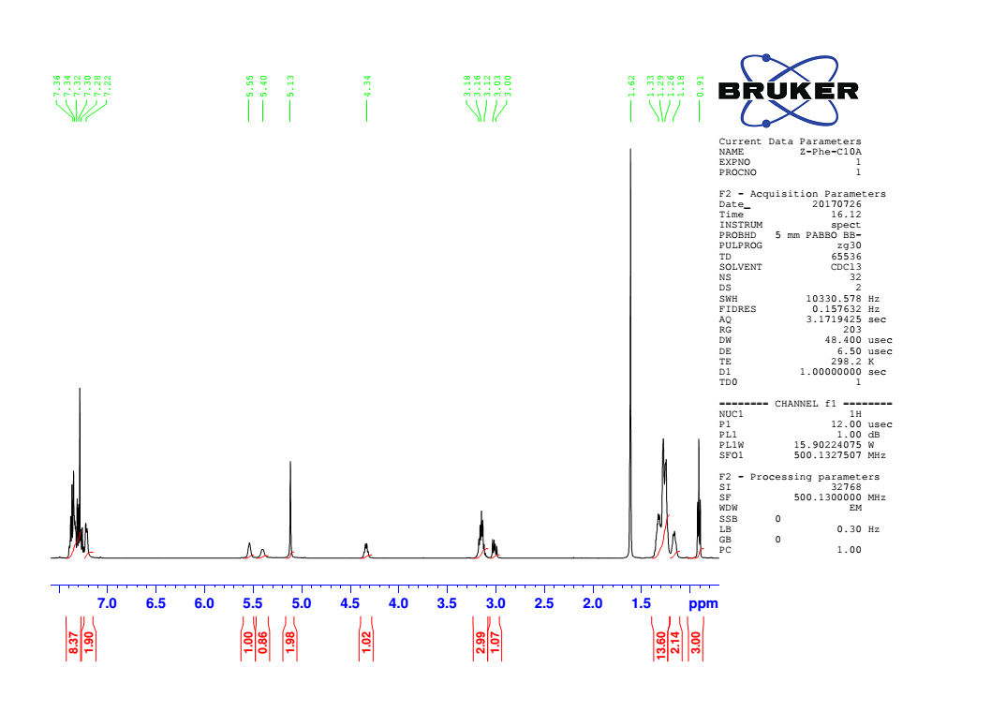

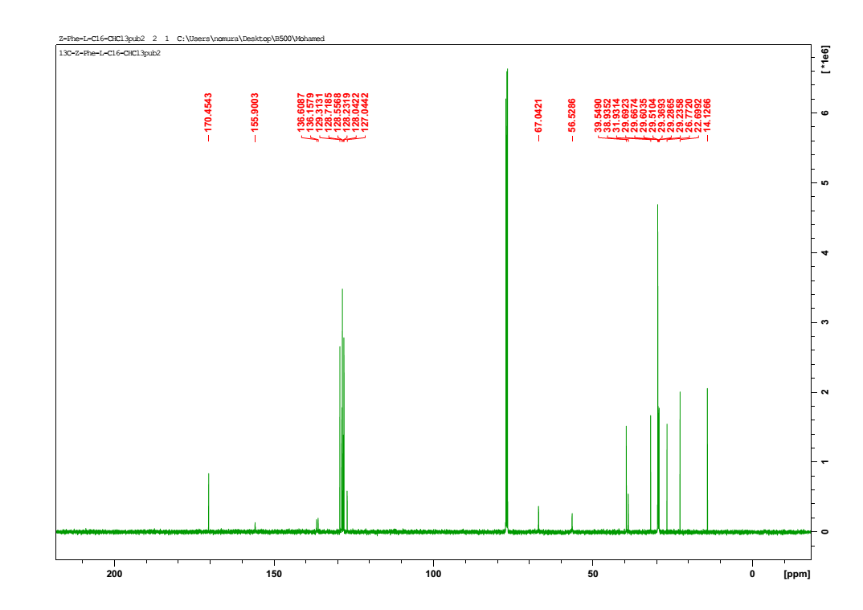**Fig. 1S.** 1H NMR chart of **1** (in CHCl3 at 25°C).

**Fig. 2S.** 13C NMR chart of **1** (in CHCl3 at 25°C).

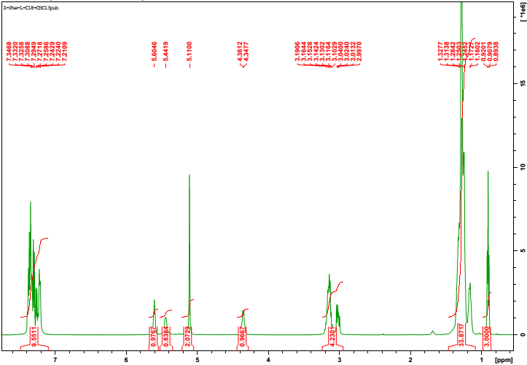

**Fig.3S.** 1H NMR chart of **2**(in CHCl3 at 25°C).

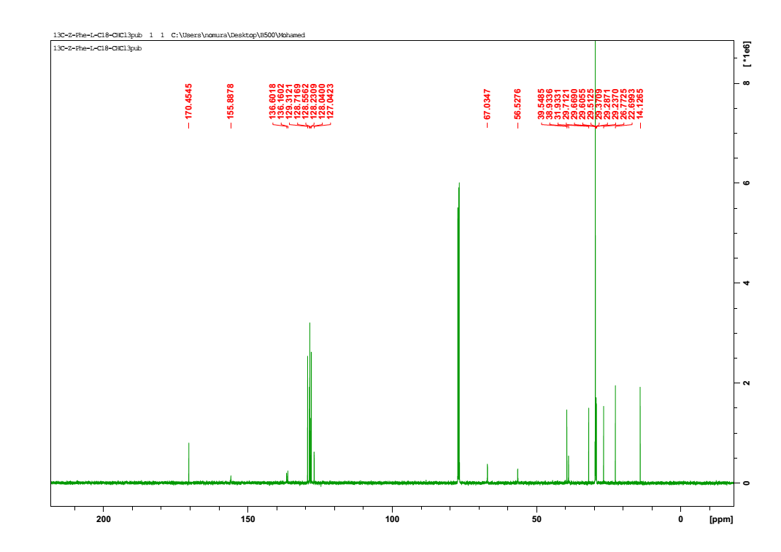

**Fig.4S.** 13C NMR chart of **2**(in CHCl3 at 25°C).

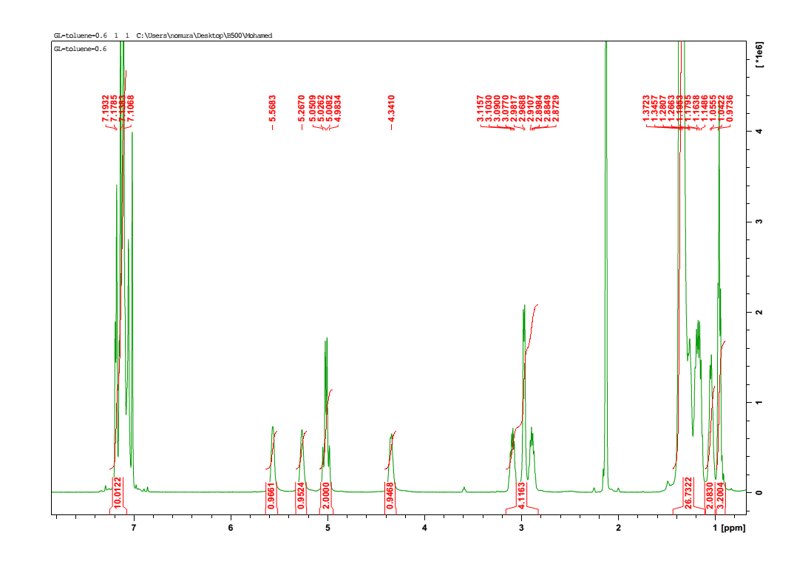

**Fig.5S.** 1H NMR chart of **2** in gel state (in toluene 0.6 wt% at 25°C).

.

C:\Users\Mohamed\Desktop\122.tif

**Fig.6S.**FT-IR spectra (extended at 1500-1700 cm-1) of **2** in solid state and in gel state (in toluene at different concentrations, 1, 3, 5 wt%)



**Fig. 7S.** FT-IR spectra (extended at 2750-3000 cm-1) of **2** in solid state and in gel state (in toluene at different concentrations, 1, 3, 5 wt%)

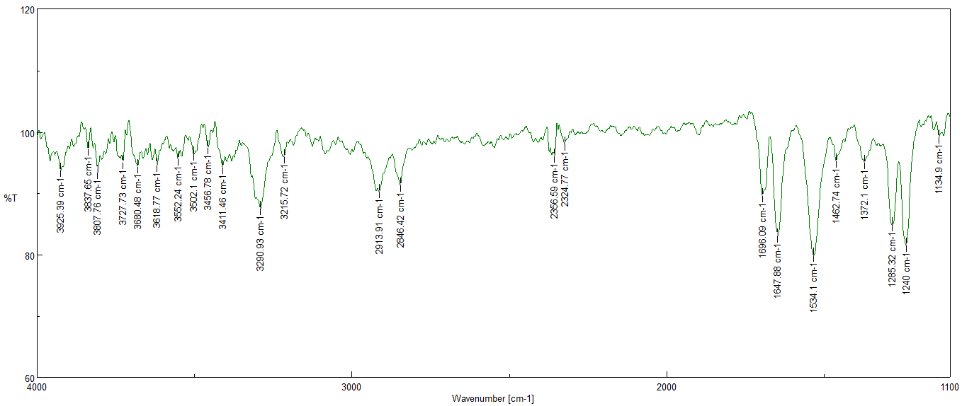**Fig. 8S.** FT-IR spectra of **2** in ethanol.

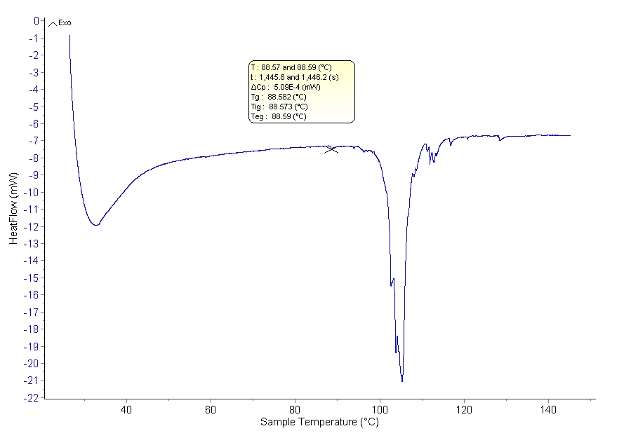

**Fig. 9S.** DSC thermogram of **1** (in paraffin at 1.5wt%).

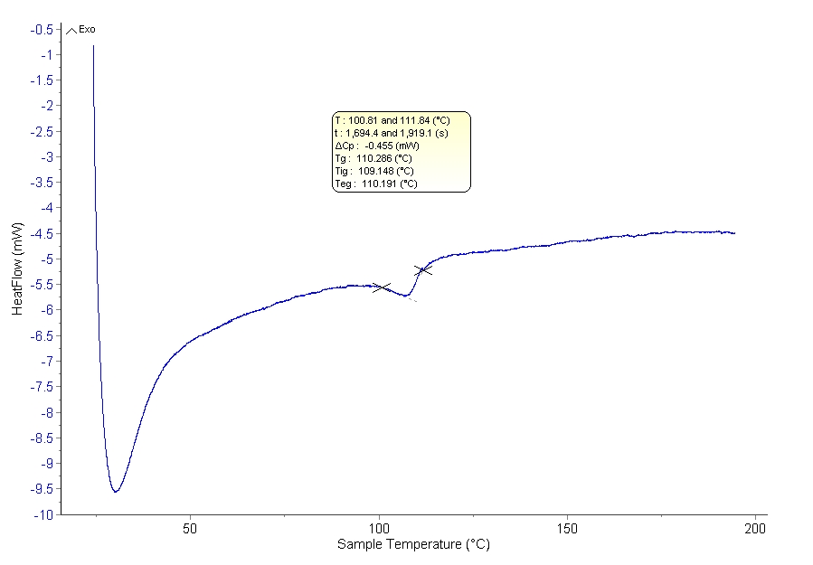

**Fig. 10S.** DSC thermogram of **1** (in paraffin at 3wt%).

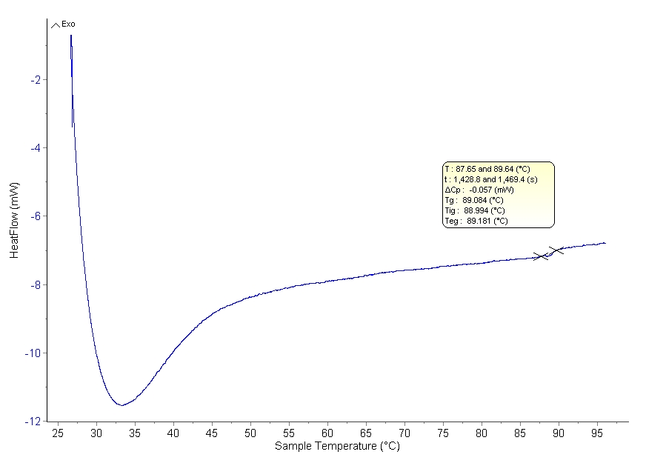

**Fig. 11S.** DSC thermogram of **2**(in paraffin at 0.6 wt%).

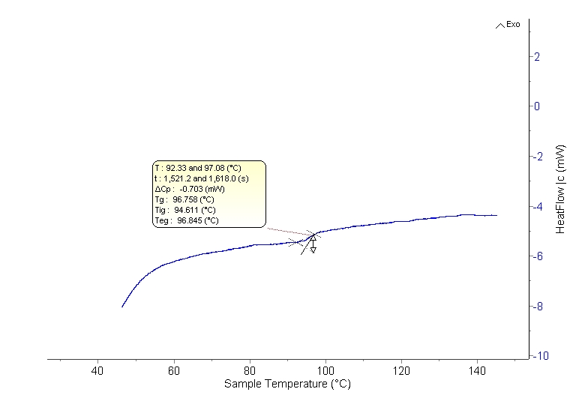

**Fig. 12S.** DSC thermogram of **2** (in paraffin at 1.2 wt%).

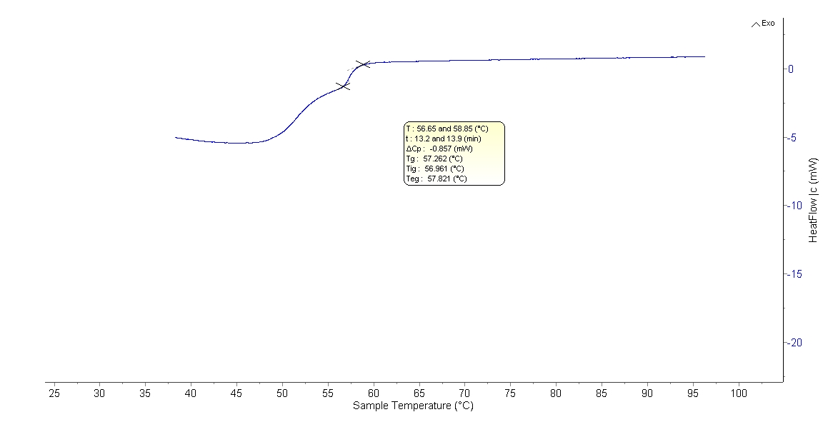

**Fig. 13S.** DSC thermogram of **2** (in toluene at 4.0 wt%).

**F:\king saud photos\fig 3a.tifF:\king saud photos\fig 3b.tif**

**Fig. 14S.** left) T*gel* as a function of gelators concentrations in toluene, right) Arrhenius plot of ln[c] versus (1/T*gel*)