Supporting Information

Surface Functionalization of Highly Luminescent Carbon Nanodots from Dioscorea hispida with Polyethylene Glycol and Branched Polyethyleneimine and their In Vitro Study

Regina Sisika A. Sonthanasamy,ª Shazrul Fazry,^{b} Bohari M. Yamin,ª and Azwan Mat Lazim*ª

ª School of Chemical Sciences and Food Technology, Faculty of Science and Technology, Universiti Kebangsaan Malaysia, 43600 Bangi, Selangor, Malaysia
^{b} School of Bioscience and Biotechnology, Faculty of Science and Technology, Universiti Kebangsaan Malaysia, 43600 Bangi, Selangor, Malaysia

*Corresponding author. Azwan Mat Lazim
School of Chemical Sciences and Food Technology
Faculty of Science and Technology
Universiti Kebangsaan Malaysia
43600 Bangi, Selangor
Malaysia
Phone: +603-8921 5446

Email: azwanlazim@ukm.edu.my

- RESULT AND DISCCUSION SECTION

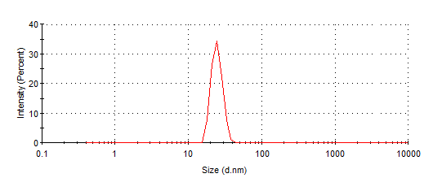
(a)
(b)
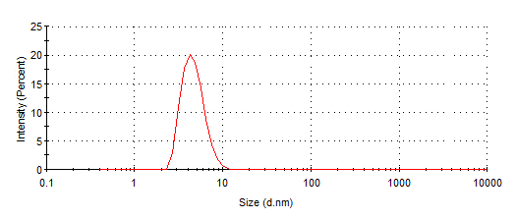
(c)
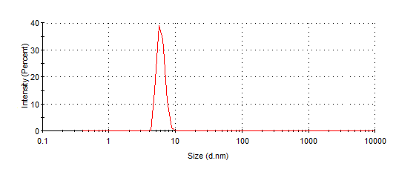

FIGURE S1: Particle size of an unmodified C-dots (a) and modified C-dots with PEG_{1500N} (b) and BPEI (c)

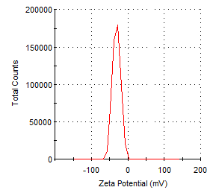
(a)
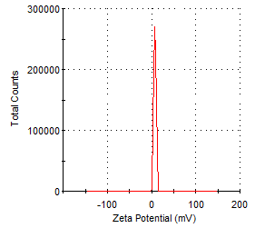
(b)
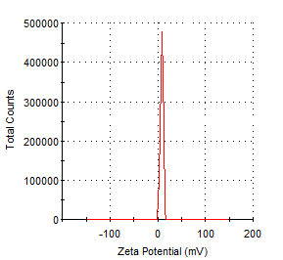
(c)

FIGURE S2: Zeta Potential of an unmodified C-dots (a) and modified C-dots with PEG_{1500N} (b) and BPEI (c)

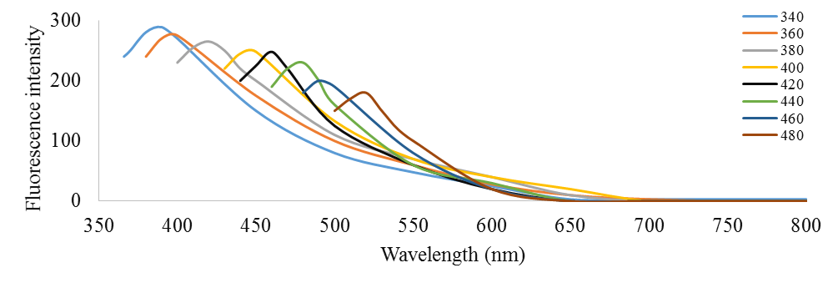
(a)
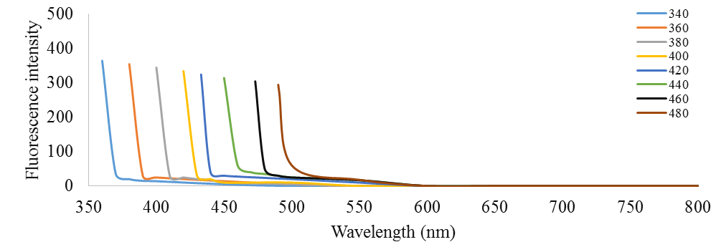
(b)
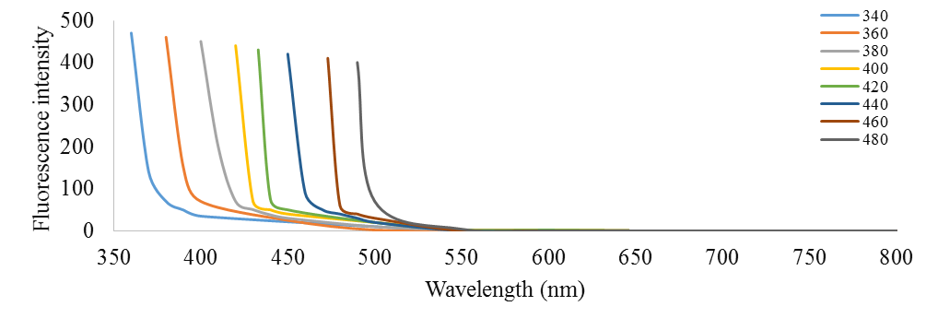
(c)
FIGURE S3: The fluorescent emission spectra of (a) PEG_{1500N}; (b) BPEI; and (c) Starch at different excitation wavelength.

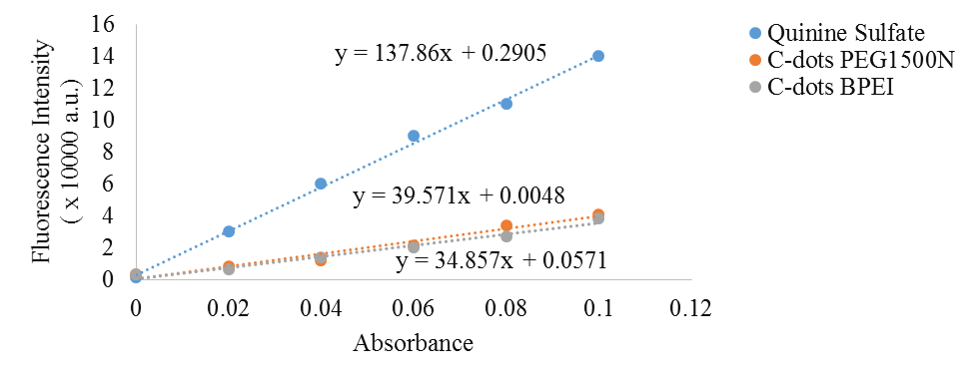
FIGURE S4: Fluorescence and abosrbance of modified C-dots and Quinine Sulfate

 | C-dots
(a) | 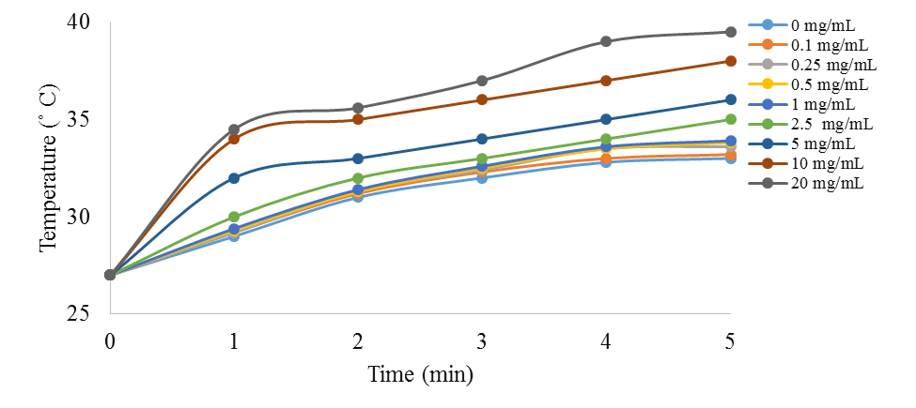
(b) | 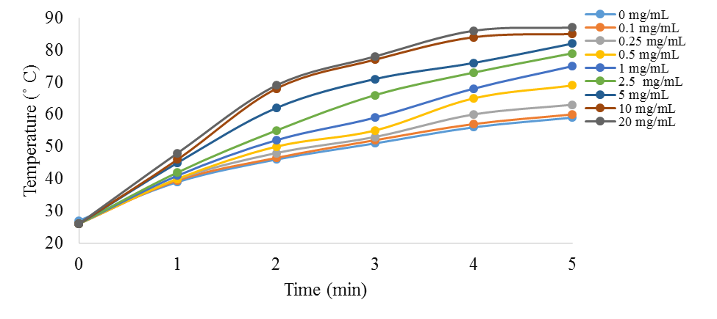
(c) | 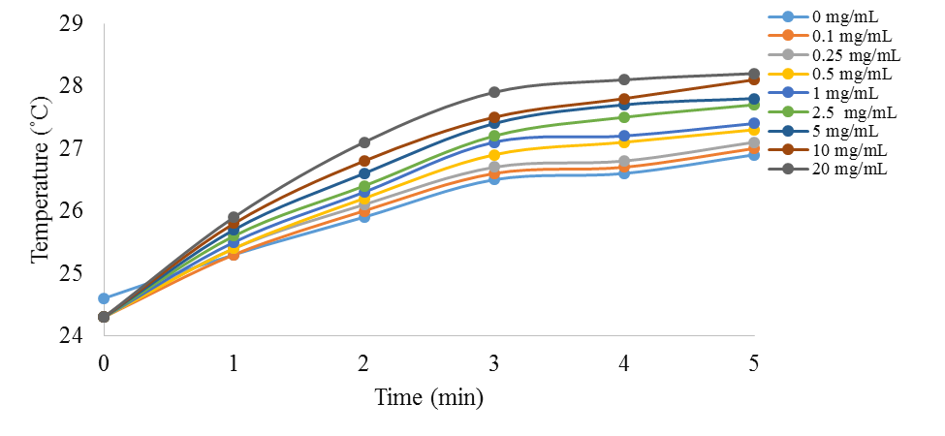

 | C-dots-PEG_{1500N}
(a) | 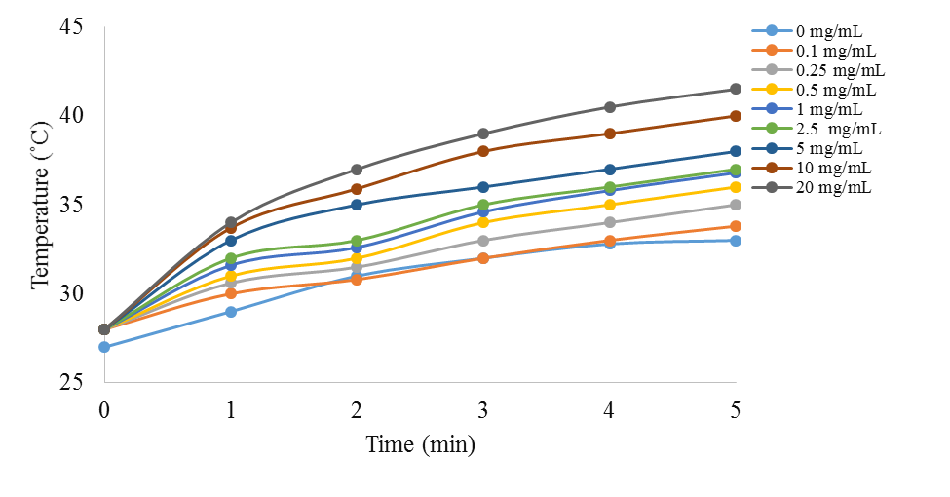
(b) | 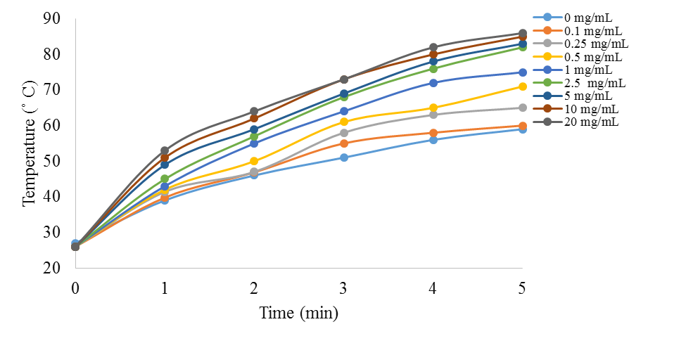
(c) | 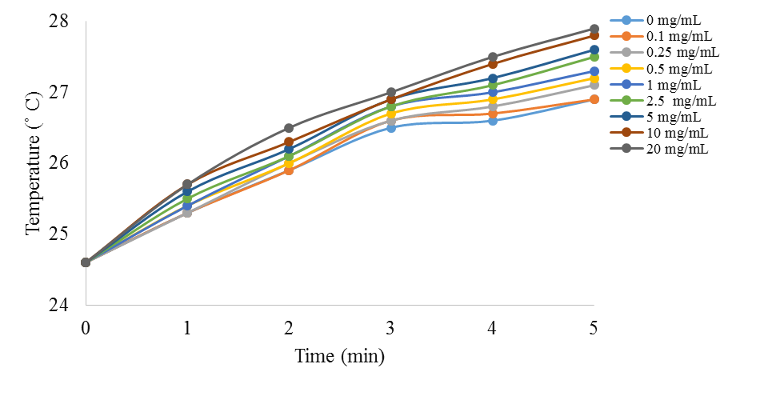

 | C-dots-BPEI
(a) | 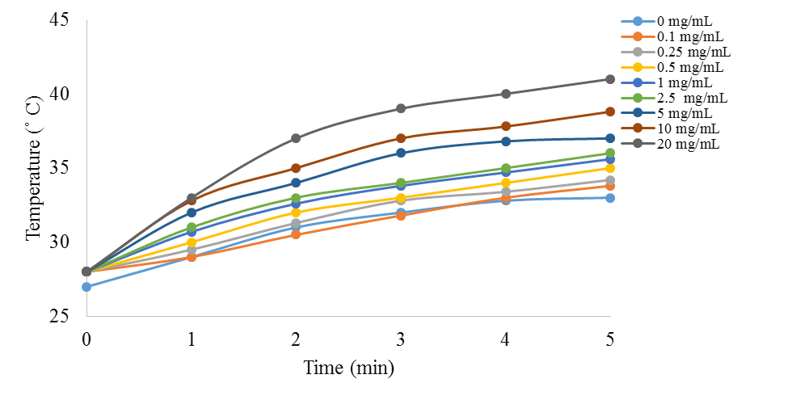
(b) | 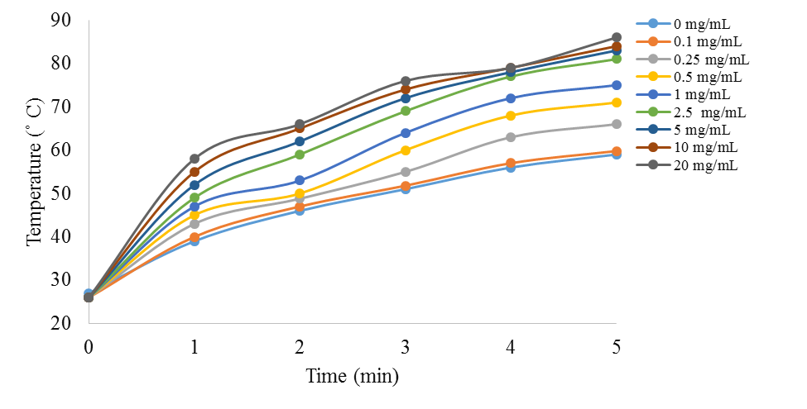
(c) | 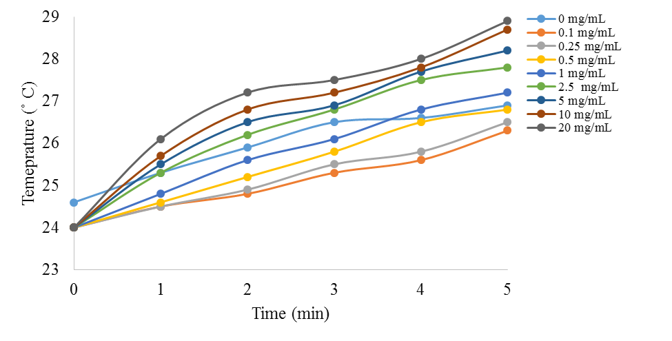

Figure S5 : Temperature increment of C-dots, C-dots-PEG_{1500N} and C-dots-BPEI (0.1 - 20 mg/mL) after irradiation with UV-lamp (a), visible lamp (b) and Laser (c) for 5 min.

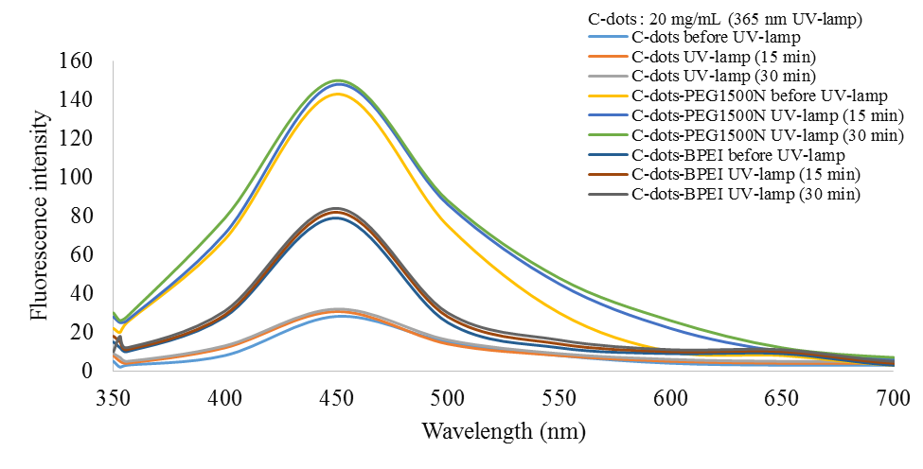
(a)
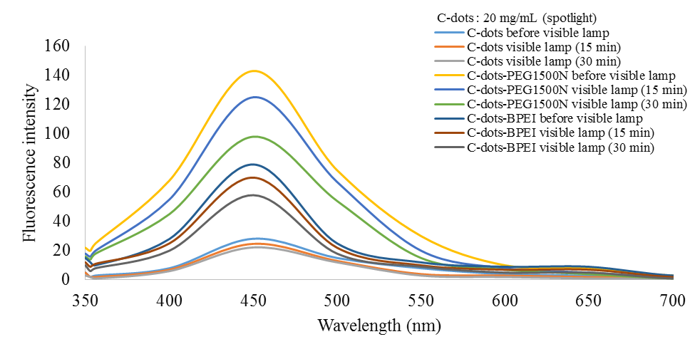
(b)
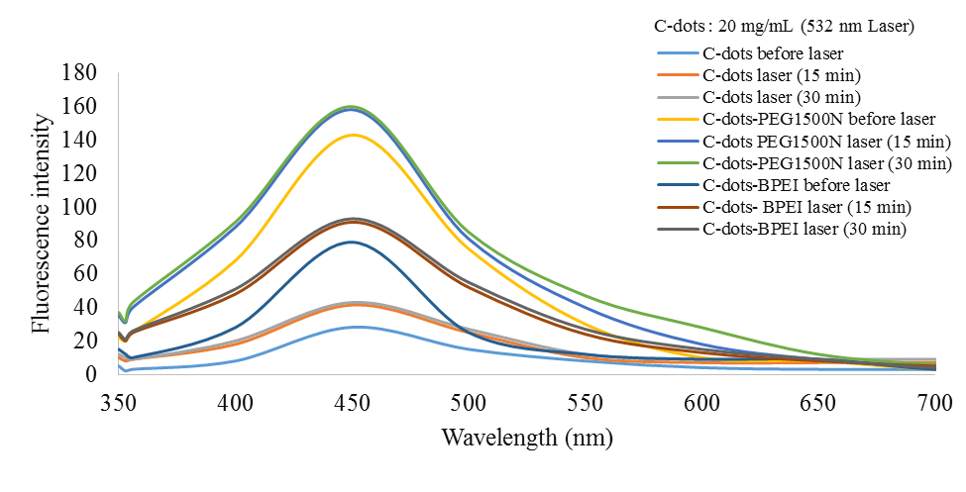
(c)
Figure S6 : Fluorescence intensity of C-dots, C-dots-PEG_{1500N}, and C-dots-BPEI after exposure to (a) UV-lamp (365 nm), (b) visible lamp and (c) laser (532 nm).

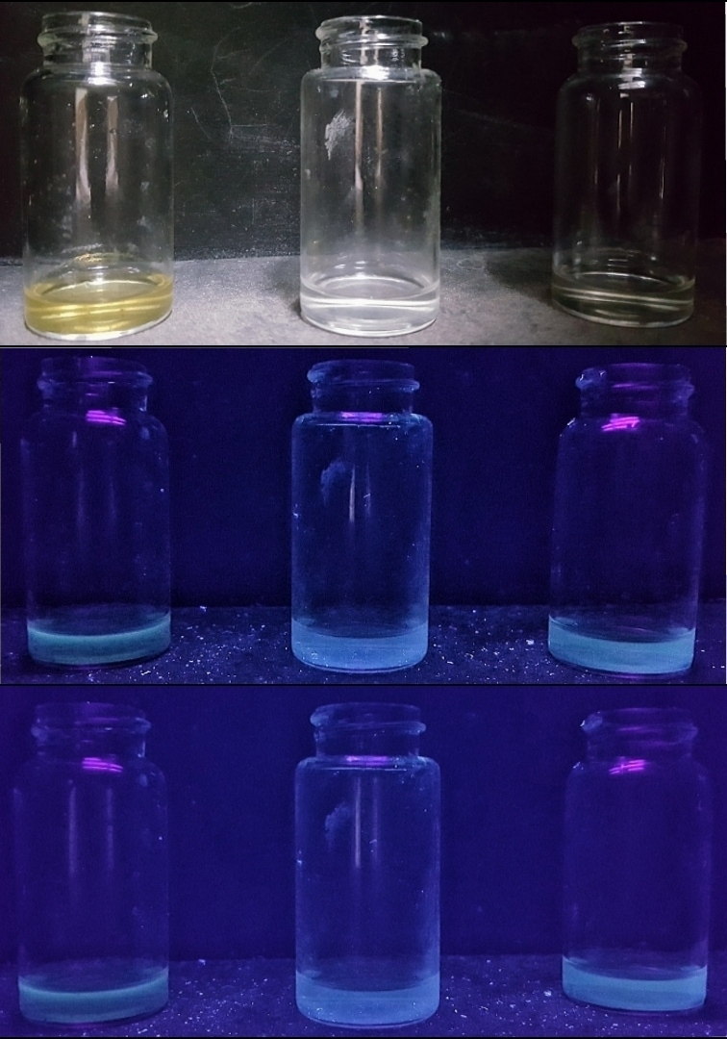
(a)
(b)
(c)
(i)
(iii)
(ii)
Figure S7 : Fluorescence of C-dots (i) C-dots-PEG_{1500N} (ii) and C-dots-BPEI (iii) under excitation of 365 nm of UV-lamp before (b) and after (c) laser irradation for 15 min showing no apparent change in fluorescence.

