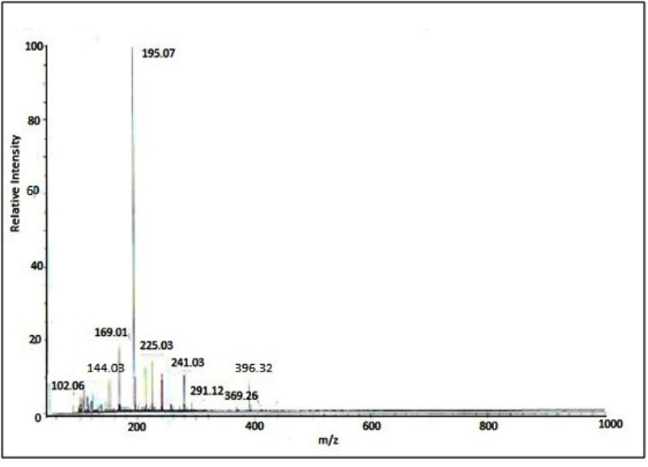

**Figure S1:** ESI-mass spectrum of [VO (dha)(8-hq)(H2O)].

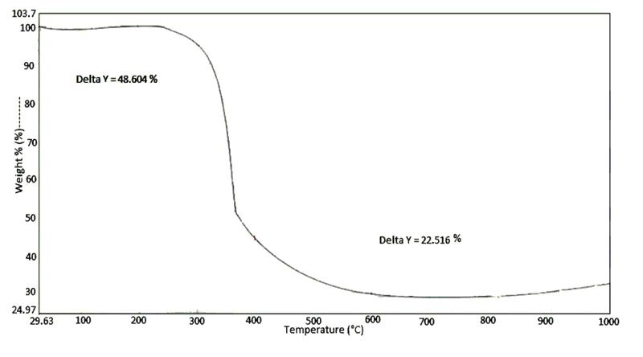

**Figure** **S2:** TG curve of complex [VO(dha)(8-hq)(H2O)]

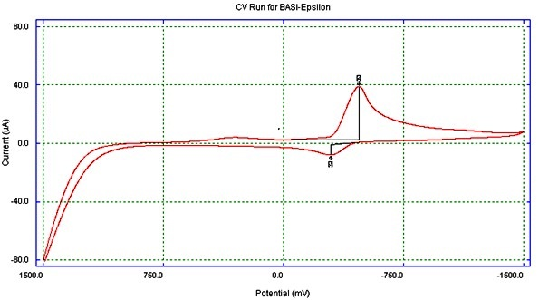

**Figure S3:** Cyclic voltammogram of complex [VO(dha)(8-hq)(H2O)]

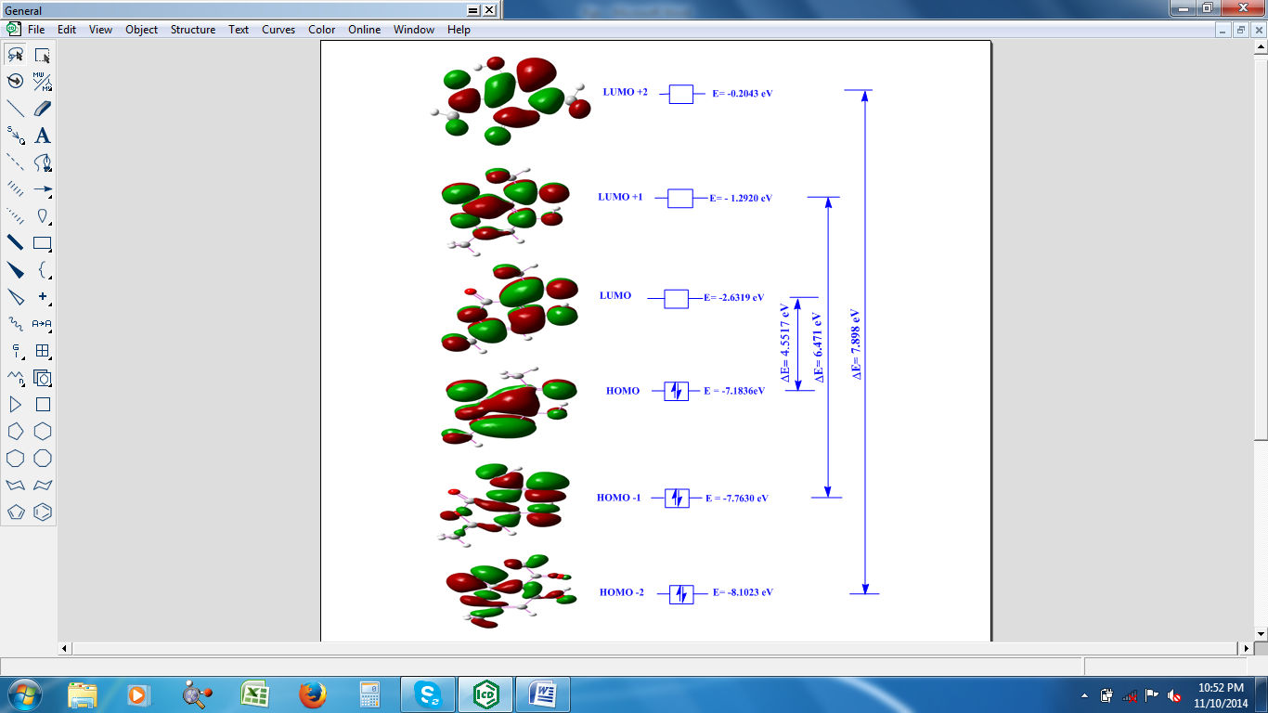

**Figure S4 (a):** HOMO-LUMO structure with energy level diagram of dehydroacetic acid

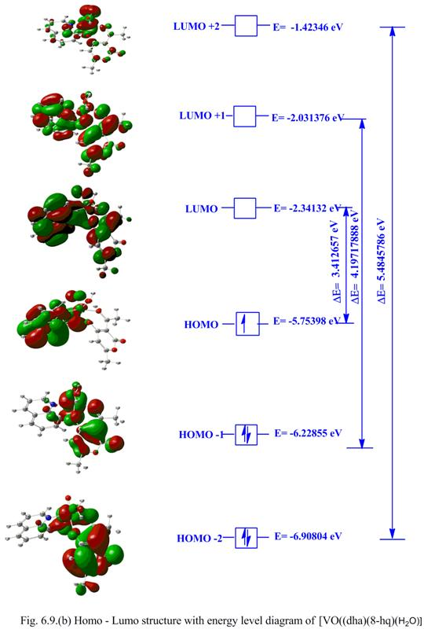

**Figure S4 (b):** HOMO-LUMO structure with energy level diagram of [VO(dha)(8-hq)(H2O)]

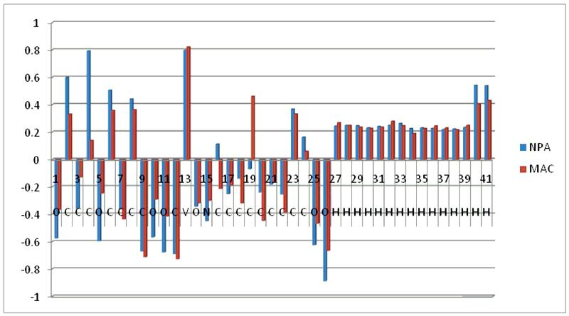

**Figure S5:** Graphical presentation of Natural Population Analysis and Mulliken atomic charges of the complex.