**Supporting Information:**

**Rapid naked eye detection of arginine by pomegranate peel extract stabilized gold nanoparticles**

**Table of content**

1. UV-vis absorption spectra, TEM and SAED images of pomegranate peel extract stabilized AuNPs synthesized at different concentrations of HAuCl4 (10-2 to 10-5 M).
2. UV-vis absorption spectra of AuNP1 and AuNP2 with the addition of different amino acids.
3. UV-vis absorption spectra of AuNP3 and AuNP4 with the addition of different amino acids.
4. The plot of A650/ A527 vs the concentration of arginine.
5. Table: Zeta potential of amino acids and with the addition of AuNPs.
6. DLS measurement of AuNPs with the addition of arginine.
7. EDAX pattern and mapping of AuNP2 + arginine system.
8. FT-IR spectrum of a) pomegranate peel extract b) arginine (10-3 M) and c) pomegranate peel extract stabilized AuNP2 + arginine (10-3 M).
9. Interference study of AuNP1 + arginine, AuNP3 + arginine and AuNP4 + arginine in presence of other amino acids.
10. UV-vis absorption spectra of extract, arginine and extract + arginine.
11. Table S2: Comparison of present work with the reportedmethods for the colorimetric detection of arginine (Arg).

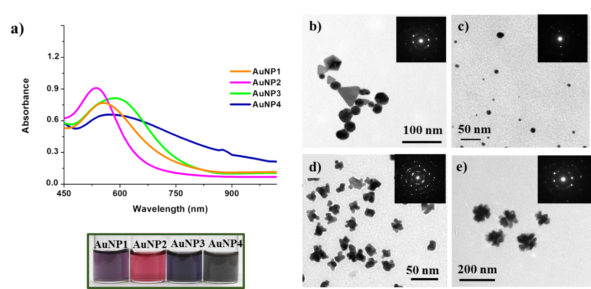

**Fig. S1.** a) UV-vis absorption spectra, the corresponding photographic image (bottom panel) of pomegranate peel extract stabilized AuNPs synthesized at different concentrations of HAuCl4 (10-2 to 10-5 M) (The as-synthesized AuNPs are represented as: AuNP1 (10-2 M), AuNP2 (10-3 M), AuNP3 (10-4 M) and AuNP4 (10-5 M)) and TEM images of b) AuNP1, c) AuNP2, d) AuNP3 and e) AuNP4. Insets are the corresponding SAED (b-e) images.

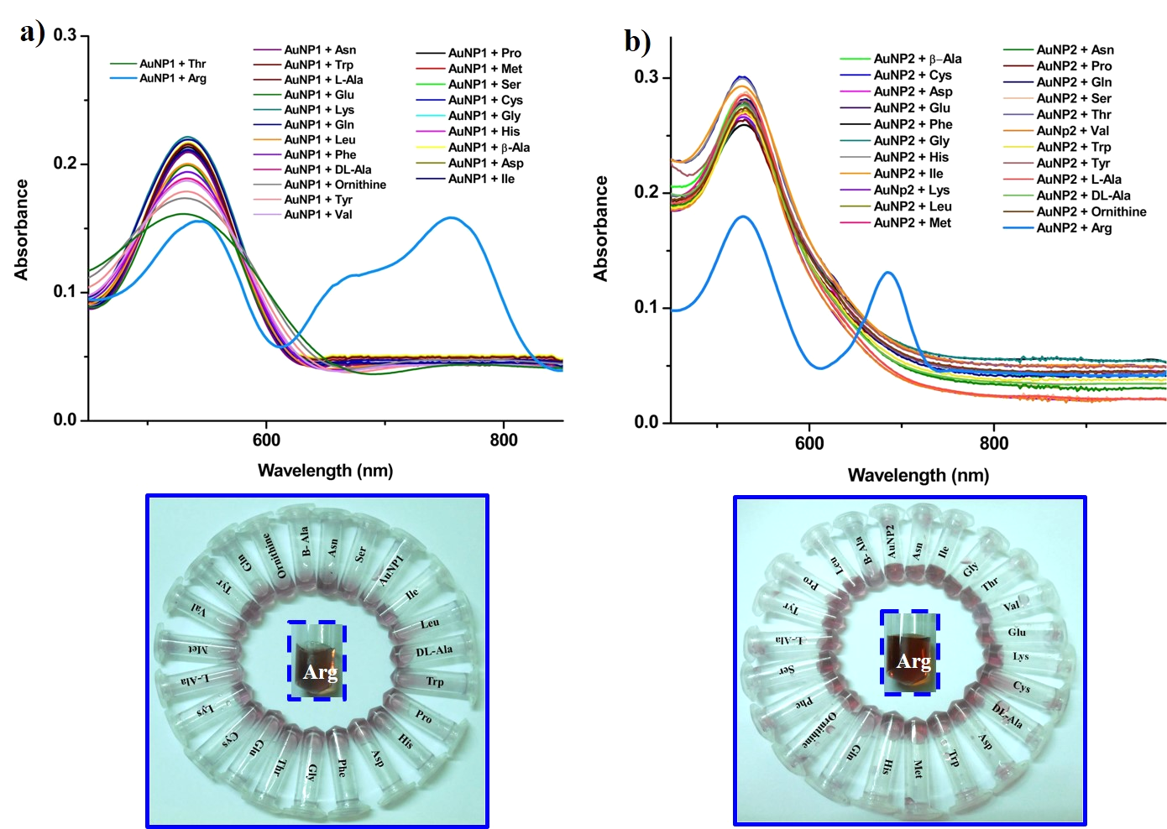

**Fig. S2.** UV-vis spectra of the a) AuNP1 and b) AuNP2, upon addition of different amino acids (10-2 M) and (bottom panel) corresponding photographic images.

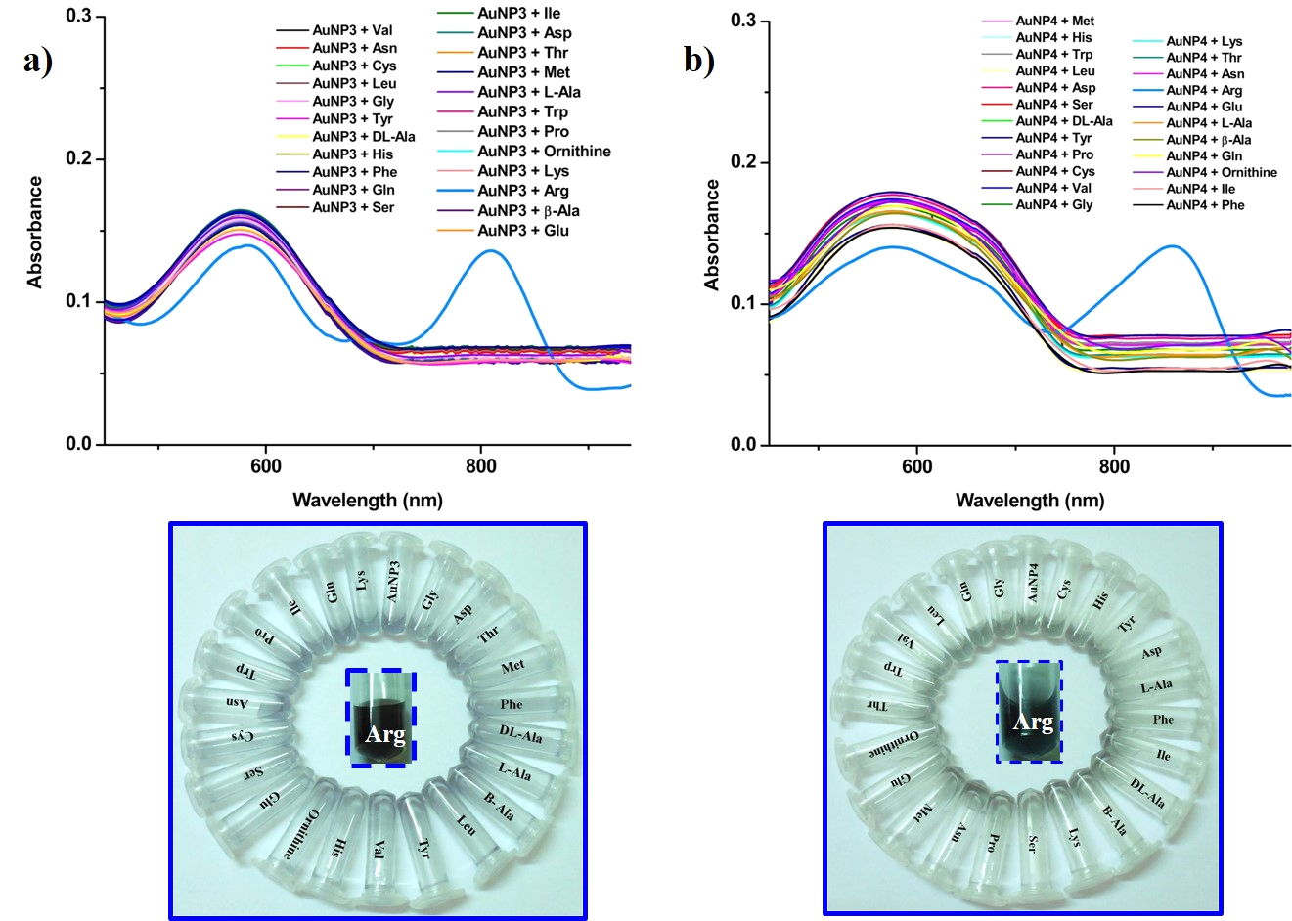

**Fig. S3.** UV-vis spectra of the a) AuNP3 and b) AuNP4, upon addition of different amino acids (10-2 M) and (bottom panel) corresponding photographic images.

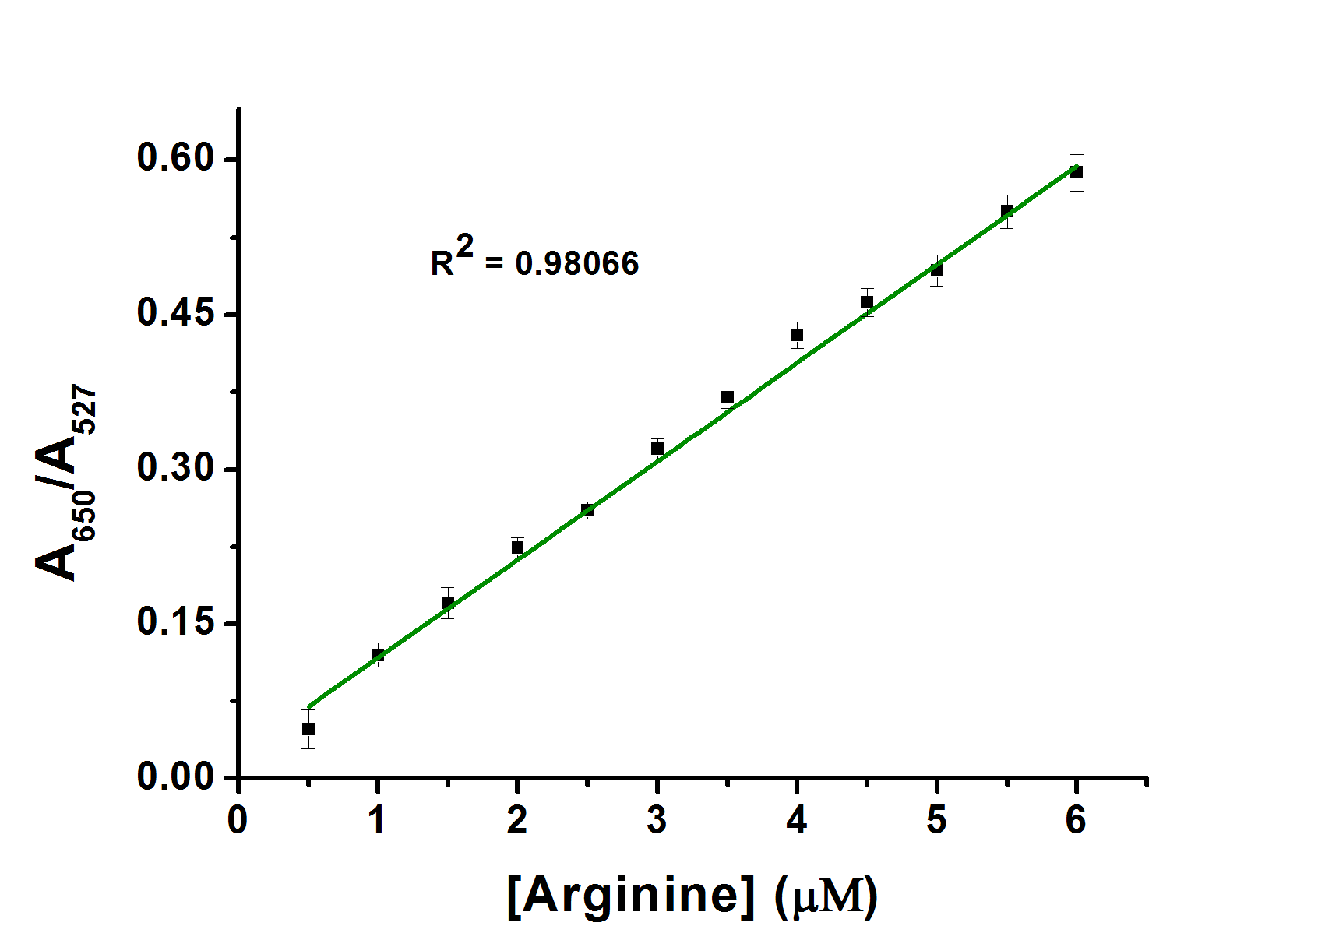

**Fig. S4.** The plot of A650/ A527 vs the concentration of arginine (the error bares illustrate the standard deviation from three independent measurements).

**Table S1** Zeta potential of different amino acids (10-2 M) in distilled water and with the addition of AuNP1, AuNP2, AuNP3 and AuNP4.

|  |  |  |  |  |  |  |  |  |  |
| --- | --- | --- | --- | --- | --- | --- | --- | --- | --- |
| S. NO | Amino acids (AA) [10-2 M] | Zeta potential (eV) | | Zeta potential of AA+AuNP1 (eV) | Zeta potential of AA+AuNP2 (eV) | | Zeta potential of AA+AuNP3 (eV) | | Zeta potential of AA+AuNP4 (eV) |
| 1 | L-Ala | -14.40 | | -17.85 | -25.20 | | -22.05 | | -22.25 |
| 2 | Β-Ala | -16.50 | | -23.00 | -26.40 | | -23.20 | | -22.15 |
| 3 | Dl-Ala | -15.90 | | -21.30 | -23.90 | | -21.60 | | -22.15 |
| 4 | Cys | -12.20 | | -21.45 | -21.40 | | -24.80 | | -24.15 |
| 5 | Asp | -3.90 | | -19.00 | -24.20 | | -19.00 | | -20.45 |
| 6 | Glu | -5.70 | | -21.75 | -21.80 | | -20.45 | | -22.85 |
| 7 | Phe | -19.90 | | -20.25 | -23.80 | | -20.45 | | -21.85 |
| 8 | His | -12.30 | | -17.20 | -20.14 | | -17.25 | | -18.25 |
| 9 | IIe | -20.80 | | -19.15 | -23.30 | | -20.80 | | -22.65 |
| 10 | Lys | -9.40 | | -16.80 | -20.04 | | -17.80 | | -17.75 |
| 11 | Leu | -16.90 | | -20.95 | -22.25 | | -21.15 | | -23.75 |
| 12 | Met | -13.70 | | -21.50 | -21.55 | | -22.25 | | -23.25 |
| 13 | Asn | -1.027 | | -19.95 | -24.90 | | -26.60 | | -23.95 |
| 14 | Pro | -16.80 | | -20.50 | -26.05 | | -18.80 | | -27.10 |
| 15 | Gln | -11.50 | | -22.45 | -21.95 | | -21.15 | | -19.55 |
| 16 | **Arg** | **-26.10** | | **-11.46** | **-12.65** | | **-12.46** | | **-9.65** |
| 17 | Ser | -13.60 | | -19.45 | -22.05 | | -20.10 | | -21.65 |
| 18 | Thr | -17.30 | | -19.20 | -20.80 | | -23.00 | | -22.50 |
| 19 | Val | -14.70 | | -23.35 | -21.50 | | -21.01 | | -20.95 |
| 20 | Trp | -16.60 | | -23.75 | -21.05 | | -19.65 | | -23.45 |
| 21 | Tyr | -20.10 | | -22.15 | -21.40 | | -19.30 | | -21.15 |
| 22 | Ornithine | -1.02 | -16.95 | | -20.35 | -17.30 | | -17.45 | |
| 23 | Gly | -17.08 | -19.00 | | -20.34 | -20.05 | | -21.02 | |

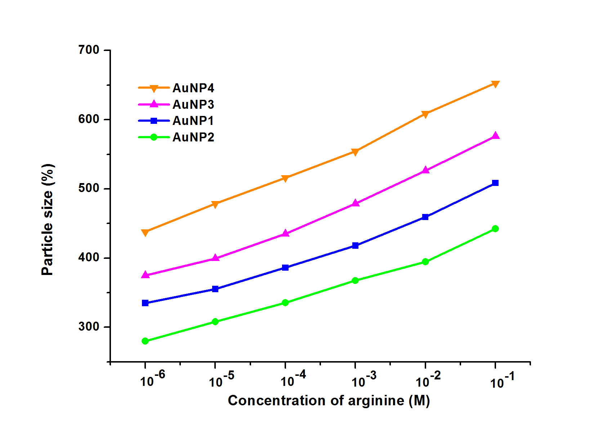

**Fig. S5.** Change in the particle size of AuNPs (1-4) upon addition of arginine by dynamic light scattering measurement.

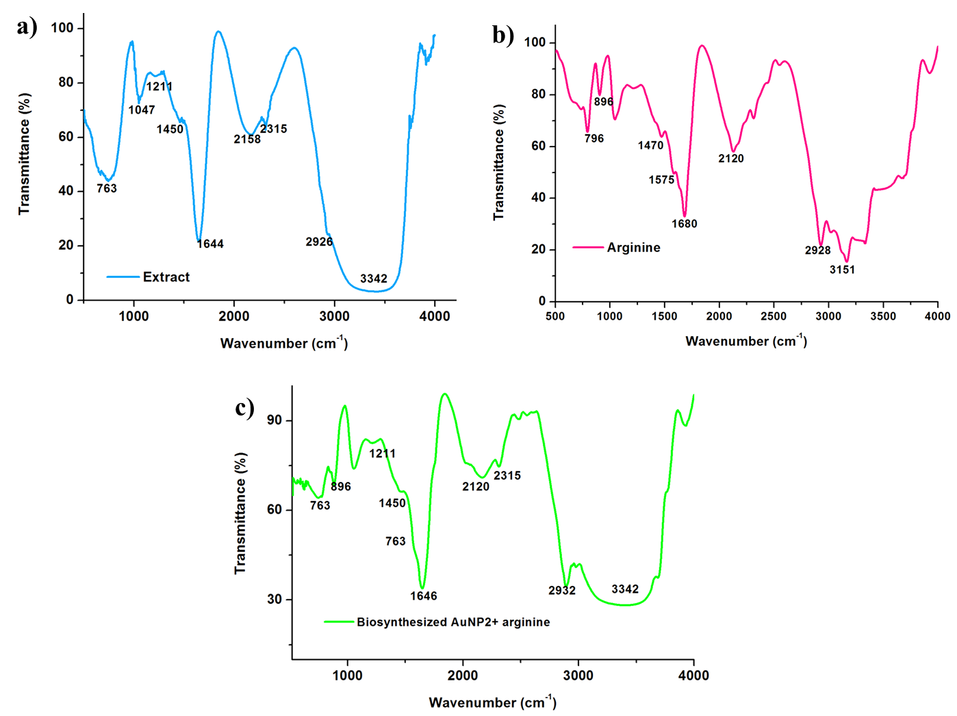

**Fig S6.** FT-IR spectrum of a) pomegranate peel extract b) arginine (10-3 M) and c) pomegranate peel extract stabilized AuNP2 + arginine (10-3 M).

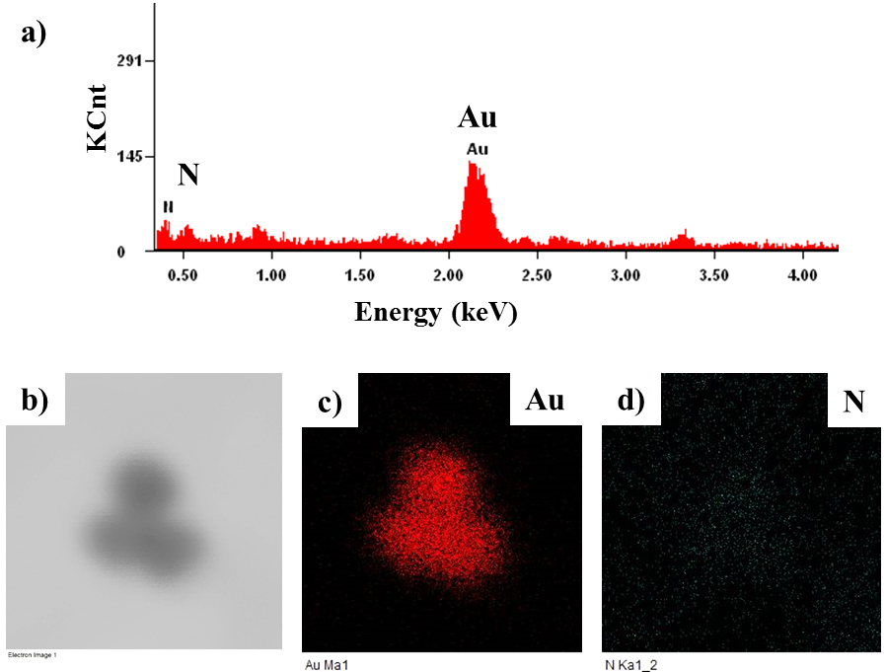

**Fig. S7.** a) EDAX pattern,b) STEM image of AuNP2 + arginine system [10-4 M], elemental mapping shows the presence of c) Au and d) N in the system.

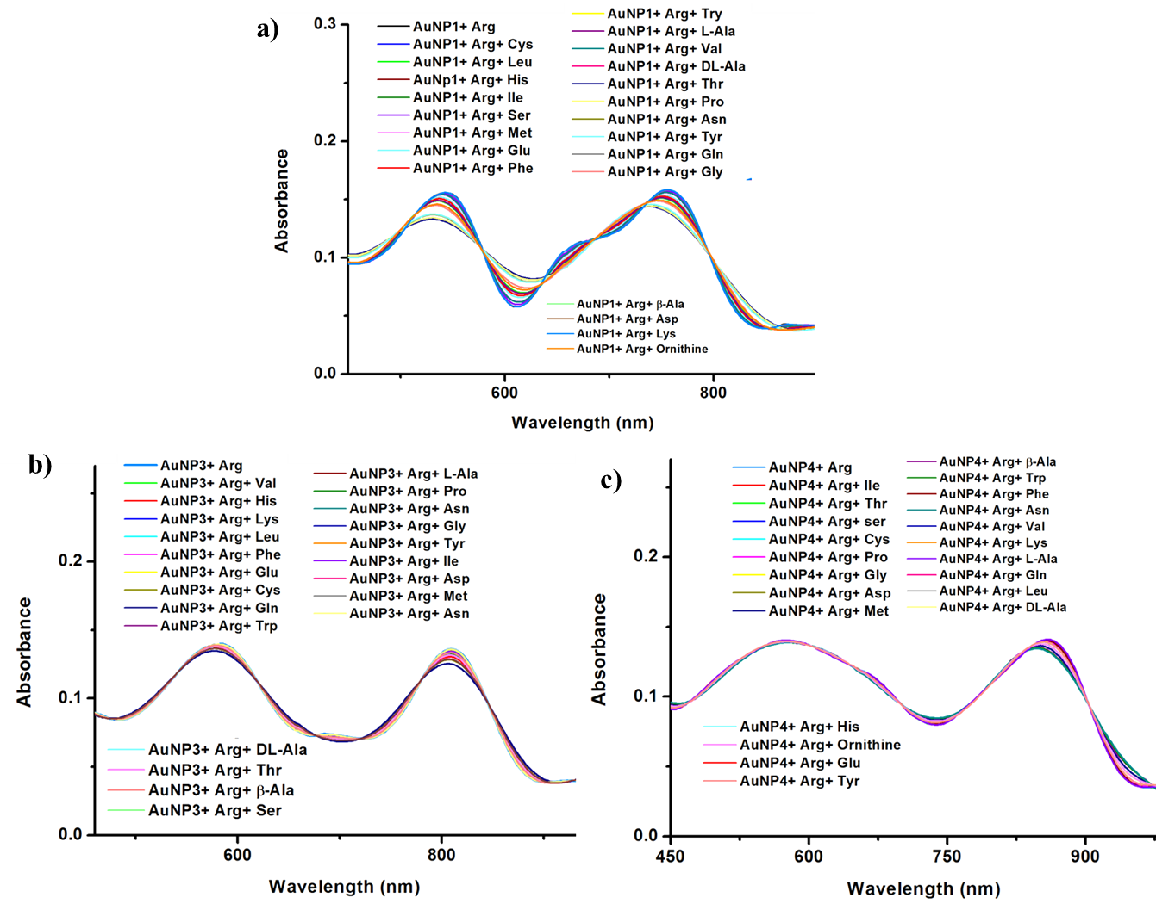

**Fig. S8.** Interference study of a) AuNP1 + arginine b) AuNP3 + arginine and c) AuNP4 + arginine in the presence of other amino acid (10-2 M).

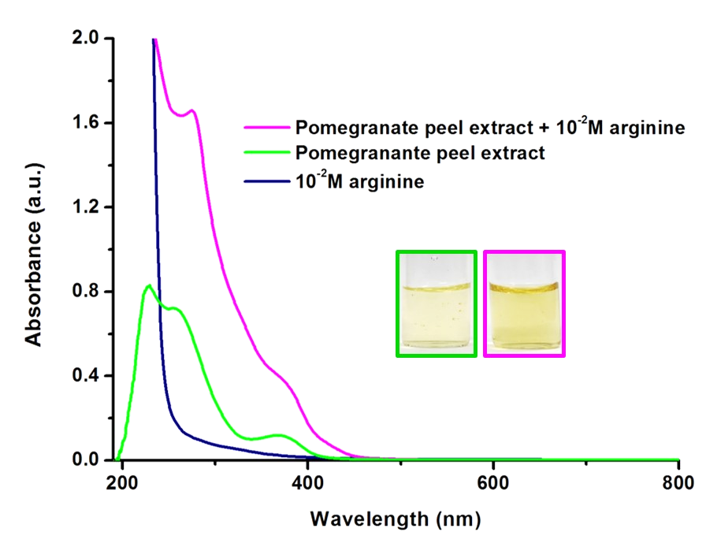

**Fig. S9.** UV-vis absorption spectra of extract, arginine (10-2 M-200 µL) and extract + arginine. Inset shows the corresponding photographs.

**Table S2:** Comparsion of present work with the reportedmethods for the colorimetric detection of arginine (Arg).

|  |  |  |  |
| --- | --- | --- | --- |
| **Reducing and stabilizing agent** | **Reaction condition** | **Detection range** | **References** |
| Sodium citrate dihydrate | ~ 100̊ C | 0.08-13.2 µM | 18 |
| Quercetin and NaOH | Room temperature | 2.5–1,250 μM | 19 |
| 4-Amino nicotinic acid | Heating at 100̊ C | 0.001-100 µM | 21 |
| Pomegranate peel extract | Room temperature | 1µM-0.1M | Our work |