**Supplementary Information**

**Spectroscopic Exploration in aggregation with *In silico* Molecular Modeling and *In vitro* Assay on Antioxidant** **7-chloro-2-(4-fluorophenyl)-3-hydroxychromen-4-one**

C. N. Dipunadas, V. Bena Jothy*

Department of Physics and Research Centre,Women's Christian college, Nagercoil**-**629 001

E-Mail: di[punaabynraj@gmail.com](mailto:punaabynraj@gmail.com) (C. N. Dipunadas); *[benaezhil@yahoo.com](mailto:benaezhil@yahoo.com) (V. Bena Jothy)

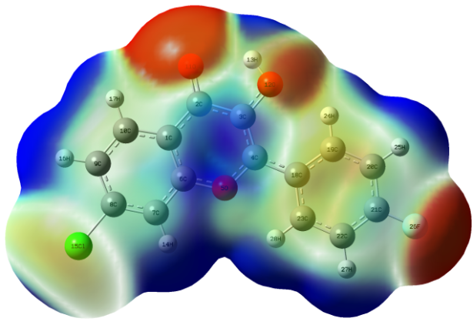

**Figure S1.** Electrostatic potential map of CFPHC

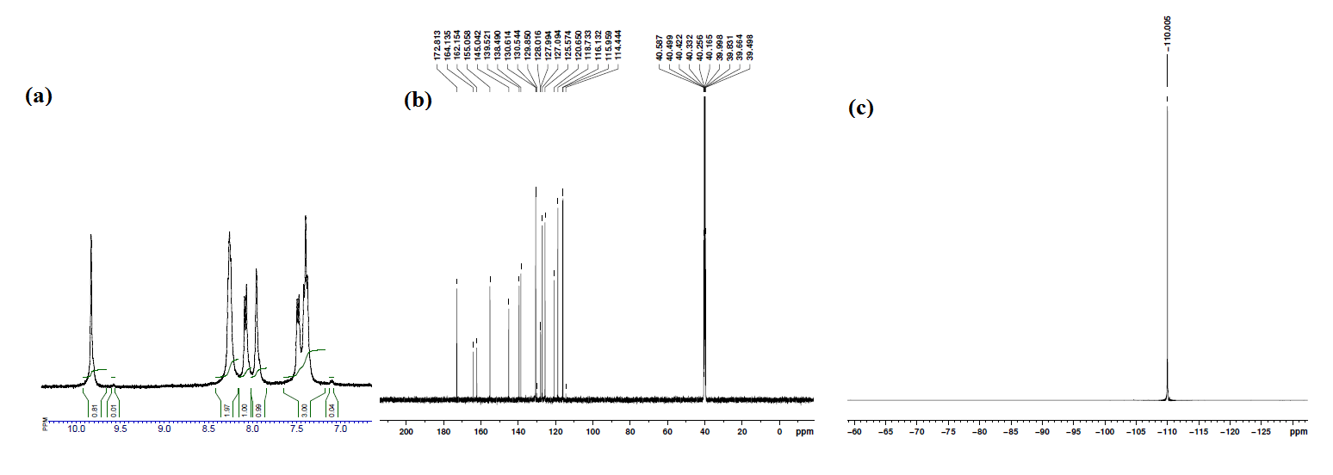

**Figure S2. (a)** 1H **(b)** 13C **(c)** 19F NMR spectra of CFPHC

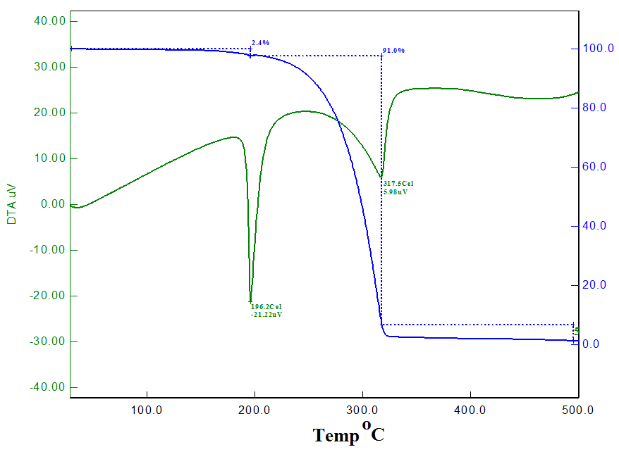

**Figure** S3. TG and DTA Thermograms of CFPHC.

D:\G\DCN\7C\7C-FOR JOURNAL\Figures for journal-Final\Figures-CFPHC\Fig.S1.tif

**Figure S4** Polynomial curve fitting of thermodynamic parameters at different temperatures of CFPHC.

D:\G\DCN\7C\7C-FOR JOURNAL\Figures for journal-Final\Figures-CFPHC\Fig.S2.tif

**Figure S5** **(a)** Antioxidant activity of CFPHC compared to Ascorbic acid

**(b)** Anti-inflammatory activity of CFPHC.

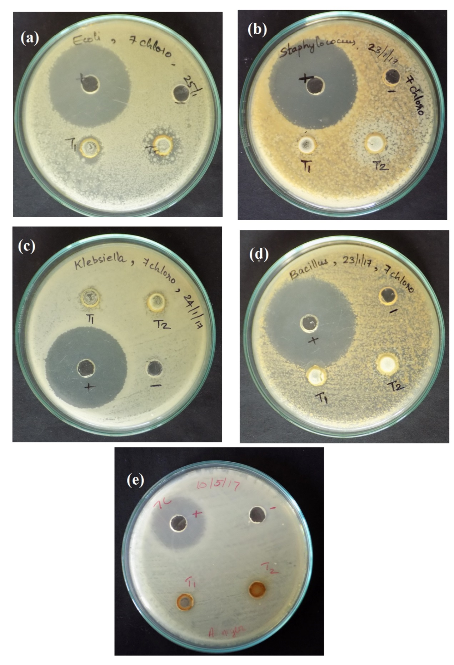

**Figure** **S6**. Photographs of antimicrobial activity of CFPHC

**Table S1. Crystal data and structural refinement parameters of CFPHC**

|  |  |
| --- | --- |
| C15H8ClFO3 | *Z* = 2 |
| *Mr* = 290.66 | *F*(000) = 296 |
| Triclinic *P $\overline{1}$* | *D*x = 1.592 Mg m-3 |
| *a* = 7.19(1) Å | Mo *K* radiation,  = 0.71Å |
| *b* = 7.86 (2) Å | 5074 reflections |
| *c* = 11.36 (2) Å | ❑ = 2.7–29.2° |
| ** = 101.87 (1)° | ❍ = 0.33 mm-1 |
| ** = 103.14 (1)° | *T* = 293 K |
| ** = 95.09 (2)° | 0.25 × 0.25 × 0.20 mm |
| *V* = 606.23 (2) Å3 | *R*int = 0.059 |
| *T*min = 0.60, *T*max = 0.74 | max = 27.0°, min = 2.7° |
| *R*[*F*2 > 2(*F*2)] = 0.05 | *h* = -99 |
| *wR*(*F*2) = 0.13 | *k* = -1010 |
| (/)max < 0.00 | *l* = -1414 |
| *ρ*max = 0.29 e Å-3 | *ρ*min = -0.36 e Å-3 |

**Table S2. Hydrogen-bond geometry by X-ray Crystallography of CFPHC**

|  |  |  |  |  |
| --- | --- | --- | --- | --- |
| *D*—H···*A* | *D*—H (Å) | H···*A* (Å) | *D*···*A* (Å) | *D*—H···*A* (°) |
| C6—H6···Cl1i | 0.93 | 2.83 | 3.48 (3) | 128 |
| C14—H14···F1ii | 0.93 | 2.61 | 3.41 (4) | 145 |
| O3—H3*A*···O2 | 0.82 | 2.29 | 2.70 (3) | 112 |
| O3—H3*A*···O2iii | 0.82 | 2.00 | 2.76 (3) | 157 |
|  |  |  |  |  |

Symmetry codes: (i) x+1, y, z+1; (ii) −x+1, −y, −z+1; (iii) −x+3, −y+1, −z+1.

**Table S3. Structural geometrical parameters of CFPHC**

|  |  |  |  |  |  |  |  |  |
| --- | --- | --- | --- | --- | --- | --- | --- | --- |
| **Bond Length(Å)** | | | **Bond Angle (°)** | | | **Dihedral Angle (°)** | | |
| **Parameters** | **Calc.** | **Expt.** | **Parameters** | **Calc.** | **Expt.** | **Parameters** | **Calc.** | **Expt.** |
| C1-C2 | 1.45 | 1.45 | C2-C1-C6 | 118.6 | 119.2 | C6-C1-C2-C3 | 0.00 | 126 |
| C1-C6 | 1.39 | 1.38 | C2-C1-C10 | 122.6 | 122.1 | C6-C1-C2-O11 | -179.9 | 179.5 |
| C2-C3 | 1.45 | 1.44 | C6-C1-C10 | 118.8 | 118.7 | C10-C1-C2-C3 | -179.9 | -177.5 |
| C2-O11 | 1.23 | 1.23 | C1-C2-C3 | 115.8 | 115.4 | C10-C1-C2-O11 | 0.00 | 0.65 |
| C3-C4 | 1.36 | 1.36 | C1-C2-O11 | 125.4 | 123.4 | C2-C1-C6-O5 | 0.00 | -1.2 |
| C3-O12 | 1.35 | 1.35 | C3-C2-O11 | 118.8 | 121.1 | C2-C1-C6-C7 | 180 | 179.8 |
| C4-O5 | 1.37 | 1.37 | C2-C3-C4 | 122.4 | 122.2 | C10-C1-C6-O5 | -180 | 177.6 |
| C1-O10 | 1.41 | 1.39 | C2-C3-O12 | 114.1 | 117.5 | C10-C1-C6-C7 | 0.00 | -0.99 |
| C4-C18 | 1.46 | 1.46 | C4-C3-O12 | 123.4 | 120.7 | C2-C1-C10-C9 | -180 | 178.9 |
| O5-C6 | 1.35 | 1.35 | C3-C4-O5 | 119.1 | 119.9 | C2-C1-C10-H17 | -0.00 | -1.19 |
| C8-Cl15 | 1.75 | 1.73 | C1-C6-C7 | 121.4 | 121.7 | O11-C2-C3-C4 | 179.9 | 177.8 |
| C9-C10 | 1.38 | 1.37 | O5-C6-C7 | 116.6 | 116.1 | O11-C2-C3-O12 | -0.00 | 1.4 |
| C9-H16 | 1.08 | 0.93 | C6-C7-C8 | 118.1 | 117.3 | C2-C3-C4-O5 | 0.00 | -2.1 |
| C10-H17 | 1.08 | 0.93 | C6-C7-H14 | 120.1 | 121.4 | C2-C3-C4-C18 | -179.9 | 176.3 |
| O12-H13 | 0.97 | 0.82 | C8-C7-H14 | 121.7 | 121.3 | O12-C3-C4-O5 | -180 | 178.5 |
| C19-H24 | 1.07 | 0.93 | C8-C9-C10 | 118.9 | 118.9 | C3-C4-O5-C6 | -0.00 | 2.21 |
| C22-C23 | 1.38 | 1.38 | C1-C10-C9 | 120.8 | 120.5 | C3-C4-C18-C23 | 0.012 | 0.07 |
| C22-H27 | 1.08 | 0.93 | C1-C10-H17 | 118.0 | 119.7 | O5-C4-C18-C19 | 0.015 | 0.08 |
| C21-F26 | 1.35 | 1.36 | C4-C18-C19 | 121.9 | 122.4 | C4-O5-C6-C7 | -180 | 178.2 |
| C23-H28 | 1.08 | 0.93 | C4-C18-C23 | 119.8 | 119.5 | Cl15-C8-C9-H16 | 0.00 | 1.16 |
| C20-H25 | 1.08 | 0.93 | C19-C18-C23 | 118.3 | 118.1 | Cl15-C8-C9-C10 | -179.9 | -178.9 |
| C22-H27 | 1.08 | 0.93 | C20-C21-F26 | 119.1 | 118.3 | F26-C21-C22-C23 | 180 | 178.5 |
| C23-H28 | 1.08 | 0.93 | C22-C21-F26 | 118.9 | 119.1 | F26-C21-C22-H27 | 0.00 | 1.5 |

**Table S4. Calculated excitation energies, absorbance and oscillator strength (ƒ) of CFPHC**

|  |  |  |  |  |  |  |  |
| --- | --- | --- | --- | --- | --- | --- | --- |
| Sl.No | | Wavelength  (nm) | | Excitation  energy  (eV) | Oscillator  Strength (ƒ) | Major contributes | Minor contributes |
| Expt. | Calc. |
| **Solvent : Ethanol** | | | |  |  |  | |
| 1 | 347 | | 350 | 3.45 | 0.53 | HOMO-4>LUMO (11%),  HOMO-3>LUMO (29%) | HOMO-2>LUMO (56%) |
| 2 | 309 | | 301 | 4.12 | 0.17 | HOMO->LUMO(93%) | HOMO-1>LUMO (2%) |
| 3 | - | | 298 | 4.14 | 0.00 | HOMO-1>LUMO (88%) | HOMO>LUMO -1(4%) |
| 4 | - | | 280 | 4.44 | 0.01 | HOMO-3>LUMO (41%),  HOMO-2>LUMO (22%) | HOMO>LUMO-1(28%),  HOMO-2>LUMO-1(2%) |
| 5 | - | | 278 | 4.45 | 0.00 | HOMO-4>LUMO (14%),  HOMO-2>LUMO (17%) | HOMO>LUMO-1(50%),  HOMO-1>LUMO-1(3%) |
| 6 | 253 | | 265 | 4.66 | 0.12 | HOMO-4>LUMO (58%),  HOMO-3->LUMO (11%) | HOMO-1>LUMO-1(15%),  HOMO>LUMO-1(7%) |

**Table S5. Natural charges and electrostatic potential values of CFPHC**

|  |  |  |  |
| --- | --- | --- | --- |
| Atom labels | Natural Electron Configuration | Natural Charge (e) | Electrostatic Potential  (a.u) |
| C1 | 2*s*0.892*p*3.284*p*0.01 | -0.18 | -14.73 |
| C2 | 2*s*0.812*p*2.713*s*0.013*d*0.014*p*0.02 | 0.44 | -14.67 |
| C3 | 2*s0.83*2*p2.94*3*d0.01*4*p0.01* | 0.20 | -14.68 |
| C4 | 2*s*0.822*p*2.843*p*0.013*d*0.014*p*0.01 | 0.31 | -14.66 |
| O5 | 2*s*1.562*p*4.913*p*0.01 | -0.48 | -22.27 |
| C6 | 2*s*0.812*p*2.803*d*0.014*p*0.01 | 0.36 | -14.66 |
| C7 | 2*s*0.932*p*3.304*p*0.01 | -0.24 | -14.73 |
| C8 | 2*s*0.942*p*3.063*d*0.014*p*0.02 | -0.02 | -14.67 |
| C9 | 2*s*0.952*p*3.274*p*0.01 | -0.23 | -14.73 |
| C10 | 2*s*0.942*p*3.174*p*0.01 | -0.12 | -14.73 |
| O11 | 2*s*1.702*p*4.913*p*0.01 | -0.62 | -22.37 |
| O12 | 2*s*1.662*p*5.013*p*0.01 | -0.67 | -22.32 |
| H13 | 1*s*0.49 | 0.50 | -0.96 |
| H14 | 1*s*0.76 | 0.23 | -1.06 |
| Cl15 | 3*s*1.843*p*5.123*d*0.014*p*0.01 | 0.02 | -64.37 |
| H16 | 1*s*0.77 | 0.22 | -1.07 |
| H17 | 1*s*0.76 | 0.23 | -1.07 |
| C18 | 2*s*0.882*p*3.234*p*0.01 | -0.13 | -14.73 |
| C19 | 2*s*0.932*p*3.194*p*0.01 | -0.13 | -14.74 |
| C20 | 2*s*0.962*p*3.294*p*0.01 | -0.26 | -14.75 |
| C21 | 2*s*0.842*p*2.713*d*0.014*p*0.02 | 0.42 | -14.67 |
| C22 | 2*s*0.962*p*3.294*p*0.01 | -0.26 | -14.75 |
| C23 | 2*s*0.942*p*3.204*p*0.01 | -0.15 | -14.74 |
| H24 | 1*s*0.76 | 0.24 | -1.09 |
| H25 | 1*s*0.77 | 0.22 | -1.07 |
| F26 | 2*s*1.832*p*5.51 | -0.34 | -26.57 |
| H27 | 1*s*0.77 | 0.22 | -1.07 |
| H28 | 1*s*0.78 | 0.22 | -1.08 |

**Table S6. Second order perturbation theory analysis of Fock matrix in NBO Basis of CFPHC**

|  |  |  |  |  |  |  |
| --- | --- | --- | --- | --- | --- | --- |
| Donor (i) | ED(i) (e) | Acceptor (j) | ED(j) (e) | E(2)a  (kcal /mol) | E(j) –E(i)b  (a.u) | F(i,j)c  (a.u) |
| LP1O5 | 1.96 | σ*C23-H28 | 0.13 | 43.06 | 0.8 | 0.16 |
| LP1O11 | 1.97 | σ*O12-H13 | 0.02 | 0.59 | 1.11 | 0.02 |
| LP2O11 | 1.87 | σ*O12-H13 | 0.02 | 4.59 | 0.66 | 0.05 |
| LP1O12 | 1.97 | σ*C19-H24 | 0.01 | 0.82 | 3.21 | 0.04 |
| LP2O12 | 1.86 | σ*C19-H24 | 0.01 | 5.41 | 3.04 | 0.11 |
| LP1F26 | 1.98 | σ*C20-H25 | 0.01 | 926.5 | 0.71 | 0.72 |
| LP1F26 | 1.98 | σ*C22-H27 | 0.01 | 7828.5 | 0.19 | 1.07 |
| LP2O11 | 1.87 | σ*C1-C2 | 0.05 | 18.4 | 0.73 | 0.10 |
| LP2O11 | 1.87 | σ*C2-C3 | 0.06 | 20.83 | 0.61 | 0.10 |
| LP2O12 | 1.86 | σ*C2-C3 | 0.06 | 16.45 | 0.79 | 0.10 |
| LP2O12 | 1.86 | π*C3-C4 | 0.30 | 23.95 | 0.46 | 0.09 |
| σC4-C18 | 1.97 | σ*C23-H28 | 0.01 | 991.7 | 2.96 | 1.53 |
| σC4-C18 | 1.97 | σ*C19-H24 | 0.01 | 55.55 | 5.32 | 0.48 |
| σC18-C19 | 1.97 | σ*C23-H28 | 0.01 | 167.7 | 0.92 | 0.35 |
| σC4-O5 | 1.98 | σ*C23-H28 | 0.01 | 16.71 | 1.08 | 0.12 |
| πC3-C4 | 1.76 | π*C2-O11 | 0.33 | 22.01 | 0.31 | 0.07 |
| πC3-C4 | 1.76 | σ*C3-O12 | 0.01 | 0.88 | 0.54 | 0.02 |
| σC8-Cl15 | 1.98 | σ*C9-C10 | 0.01 | 2.33 | 1.31 | 0.04 |
| πC18-C19 | 1.62 | σ*C19-H24 | 0.01 | 18.27 | 3.72 | 0.25 |
| σC6-C7 | 1.96 | σ*C8-Cl15 | 0.03 | 5.69 | 0.86 | 0.06 |
| σC8-C9 | 1.97 | σ*C7-C8 | 0.02 | 3.24 | 1.28 | 0.05 |
| σC8-C9 | 1.97 | σ*C7-H14 | 0.01 | 2.39 | 1.14 | 0.04 |
| σC7-H14 | 1.97 | σ*C7-C8 | 0.02 | 1.57 | 1.08 | 0.03 |
| σC9-C10 | 1.97 | σ*C8-Cl15 | 0.03 | 4.81 | 0.86 | 0.05 |
| σC9-C10 | 1.97 | σ*C8-C9 | 0.02 | 3.37 | 1.26 | 0.05 |
| σC9-C10 | 1.97 | σ*C9-H16 | 0.01 | 1.24 | 1.15 | 0.03 |
| σC9-C10 | 1.97 | σ*C10-H17 | 0.01 | 1.12 | 1.17 | 0.03 |
| σC1-C2 | 1.97 | σ*C1-C6 | 0.03 | 2.35 | 1.23 | 0.04 |
| σC1- C2 | 1.97 | σ*C1-C10 | 0.02 | 2.96 | 1.23 | 0.05 |
| σC1-C10 | 1.97 | σ*O5-C6 | 0.02 | 1.95 | 13.1 | 0.14 |
| σC1-C10 | 1.97 | σ*C9-H16 | 0.01 | 0.87 | 13.2 | 0.09 |
| σC2-O11 | 1.99 | σ*C1-C6 | 0.03 | 0.98 | 1.59 | 0.03 |
| σC2-O11 | 1.99 | σ*C3-C4 | 0.02 | 1.17 | 1.61 | 0.03 |
| σC2-O11 | 1.99 | π*C1-C6 | 0.42 | 4.56 | 0.38 | 0.04 |
| πC2-O11 | 1.97 | π*C3-C4 | 0.30 | 5.56 | 0.39 | 0.04 |
| σC3-C4 | 1.97 | σ*C4-O5 | 0.02 | 1.36 | 1.2 | 0.03 |
| σC3-O12 | 1.98 | σ*C2-C3 | 0.06 | 0.65 | 1.27 | 0.02 |
| σC3-O12 | 1.98 | σ*C3-C4 | 0.02 | 1.52 | 1.49 | 0.04 |
|  |  |  |  |  |  |  |
| a Energy of hyperconjugative interactions.  b Energy difference between donor and acceptor i and j NBO orbitals.  c F(i,j) is the Fock matrix elements between i and j NBO orbitals. | | | | | | |