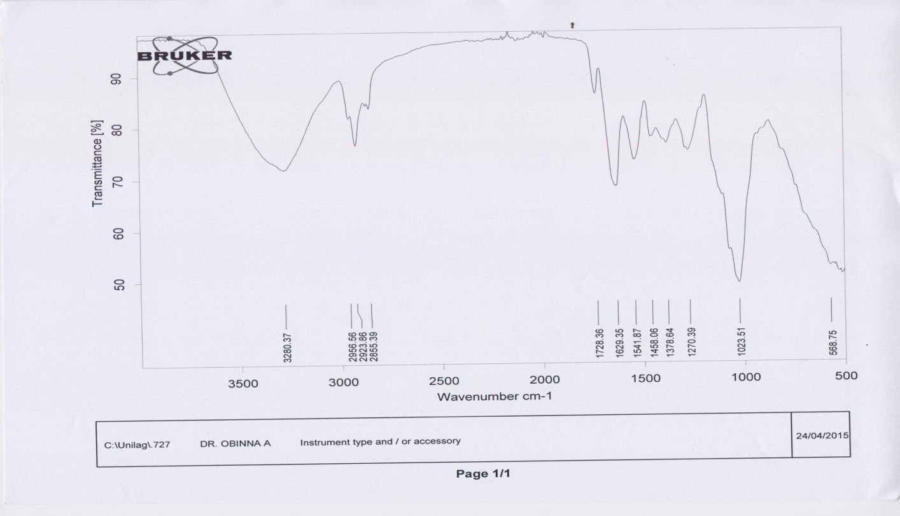

**Figure 5a. FT-IR analysis of Sample A**

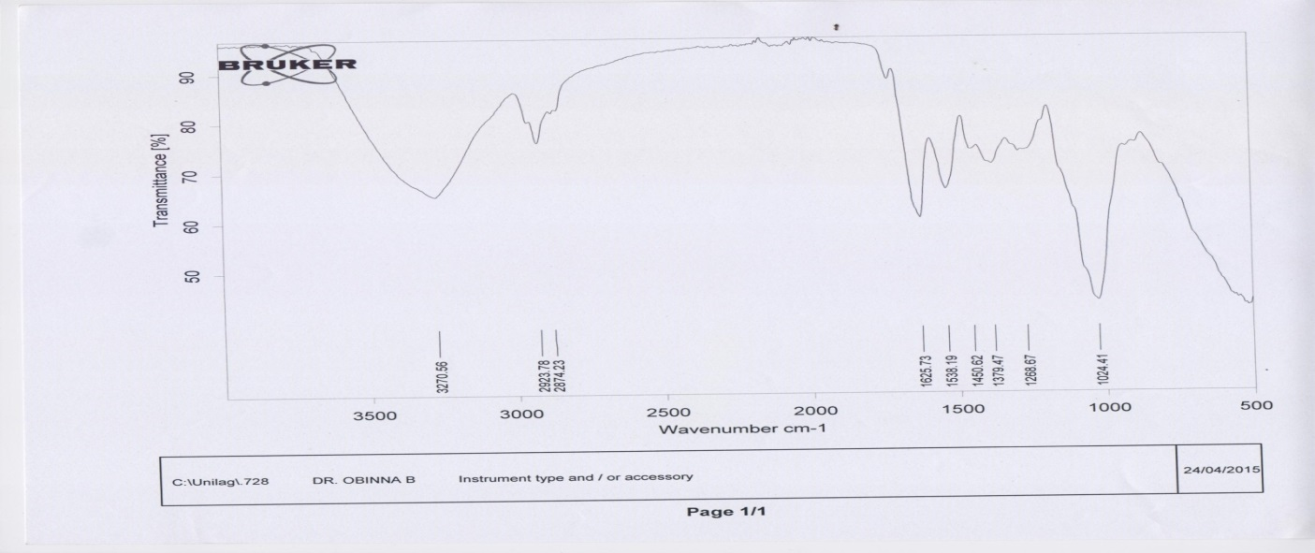

**Figure 5b. FT-IR analysis of Sample B**

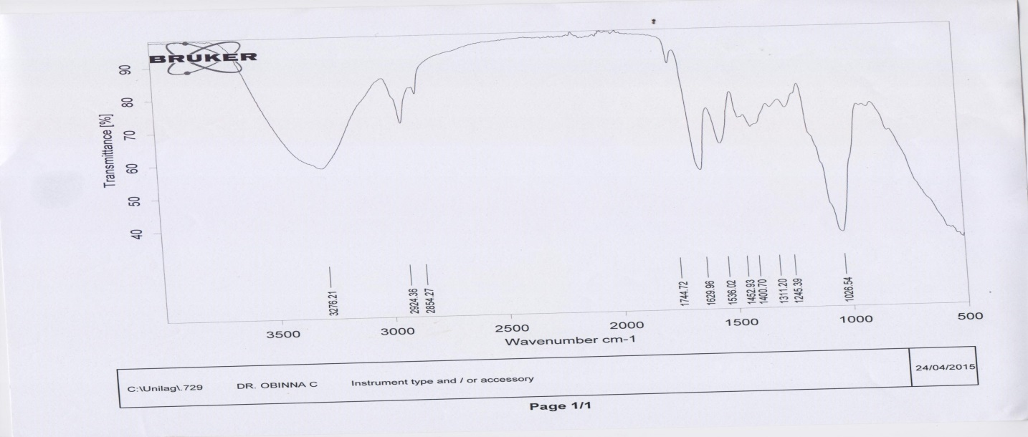

**Figure 5c. FT-IR analysis of Sample C**

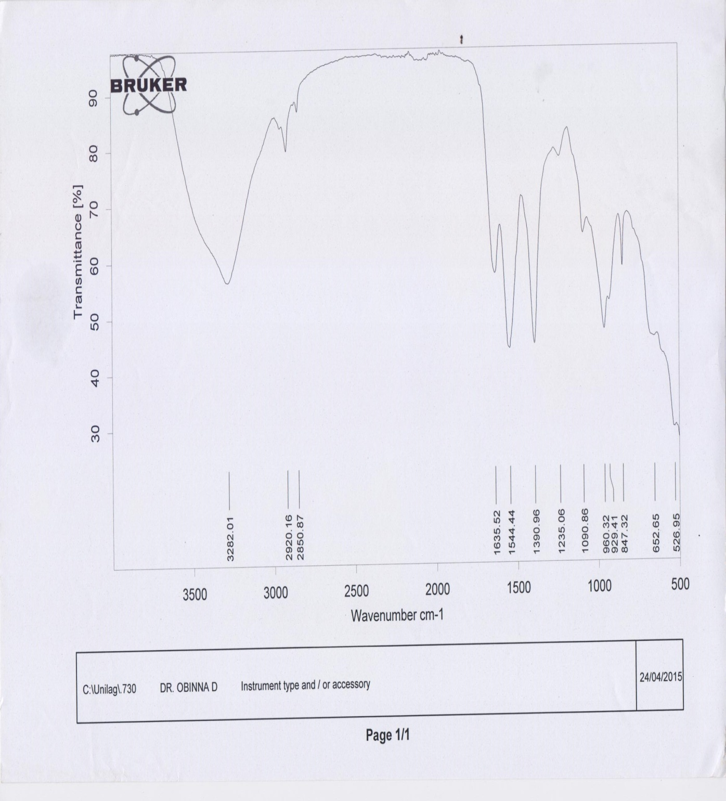

**Figure 5d. FT-IR analysis of Sample D**

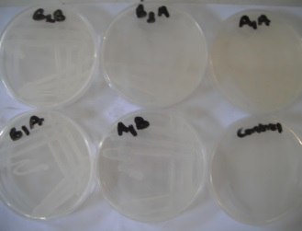 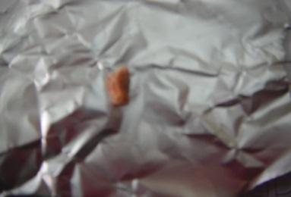

**Plate.1a: Isolates growth of the on Mineral Salt Agar. b. Sample of Polyhyroxyalkanoate**