Annex 1



**Figure 4.** View of the optimum grid (3.264.000 cells) at the longitudinal Z-Y plane.

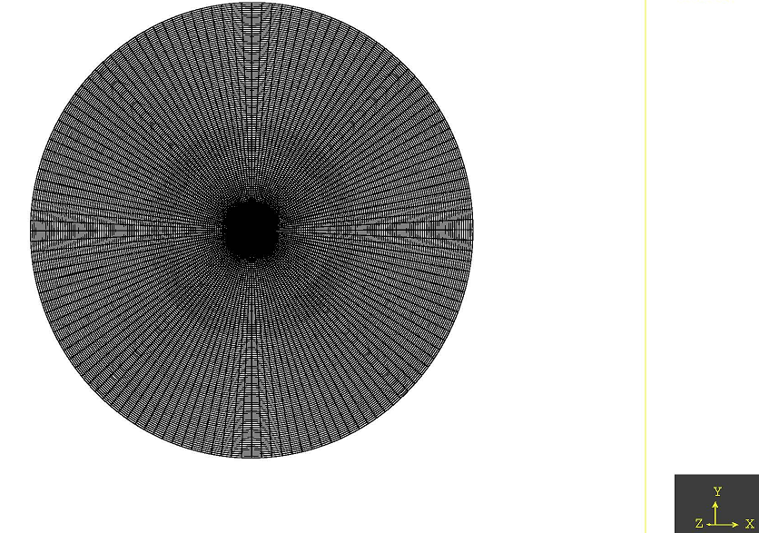

**Figure 5.** View of the optimum grid (3.264.000 cells) at the polar plane Y-X