SUPPLEMENTARY MATERIAL:

In the following figures we present MEV images and chemical element analysis for the fossils A, B, C and D belonging to Pedra do Fogo Formation. As established in the paper, the sample A corresponds to the fossil of a gymnosperm, collected from Duque Bacelar municipality; the sample B corresponds to a pteridophyta fossil, also collected from Duque Bacelar; the sample C belongs to a gymnosperm fossil from Teresina municipality and the samples D, originated from Monsenhor Gil municipality, corresponds to a pteridophyta fossil specimen.

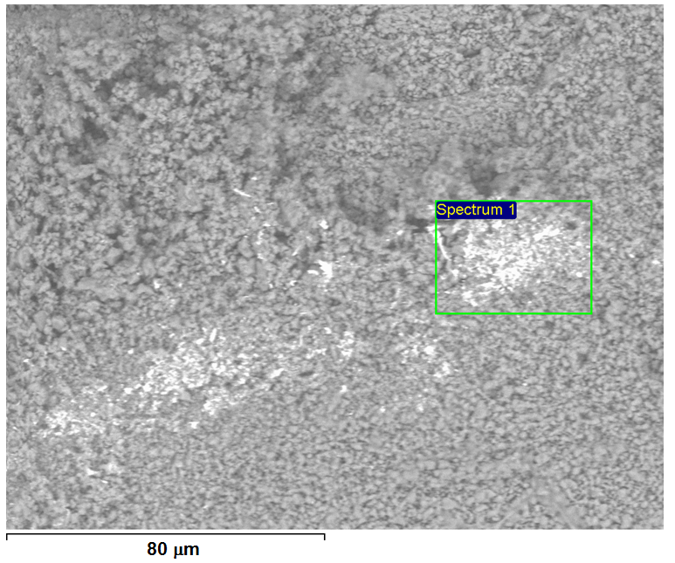 | 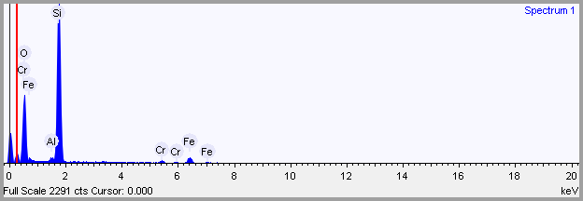
  Element | Weight % | Weight % σ | Atomic %
  Aluminum | 0.642 | 0.121 | 0.507
  Silicon | 39.328 | 0.404 | 29.880
  Chromium | 2.447 | 0.252 | 1.004
  Iron | 8.611 | 0.439 | 3.290
  Oxygen | 48.973 | 0.447 | 65.318
Figure S1 - Image obtained through MEV on the surface of sample A.

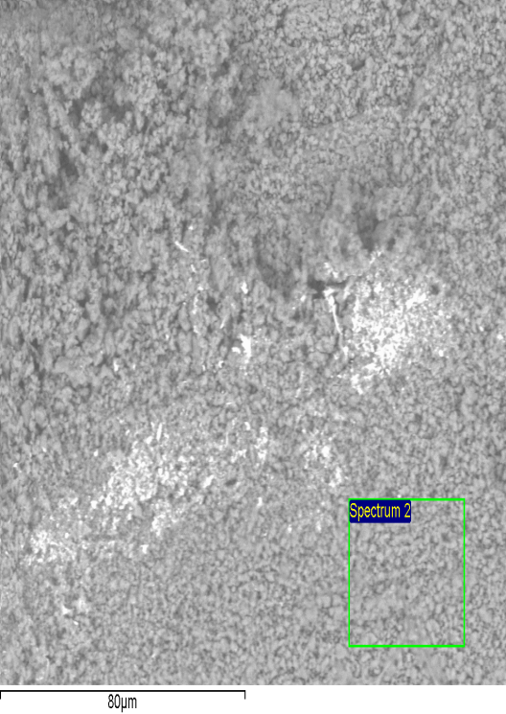 | 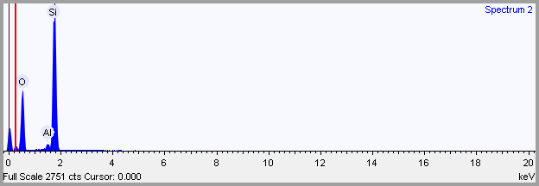
  Element | Weight % | Weight % σ | Atomic %
  Aluminum | 1.080 | 0.131 | 0.802
  Silicon | 45.791 | 0.341 | 32.665
  Oxygen | 53.129 | 0.343 | 66.533
Figure S2 - Image obtained through MEV on the surface of sample A.

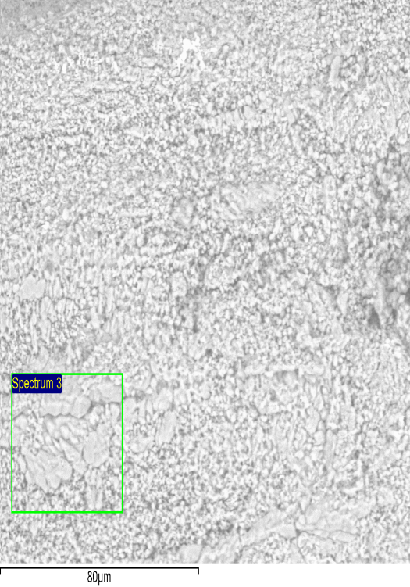 | 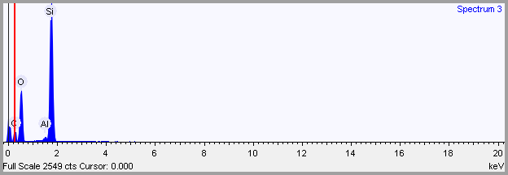
  Element | Weight % | Weight % σ | Atomic %
  Carbon | 14.951 | 0.711 | 20.776
  Aluminum | 0.321 | 0.059 | 0.198
  Silicon | 20.853 | 0.365 | 12.392
  Oxygen | 63.874 | 0.716 | 66.634
Figure S3 - Image obtained through MEV on the surface of sample A.

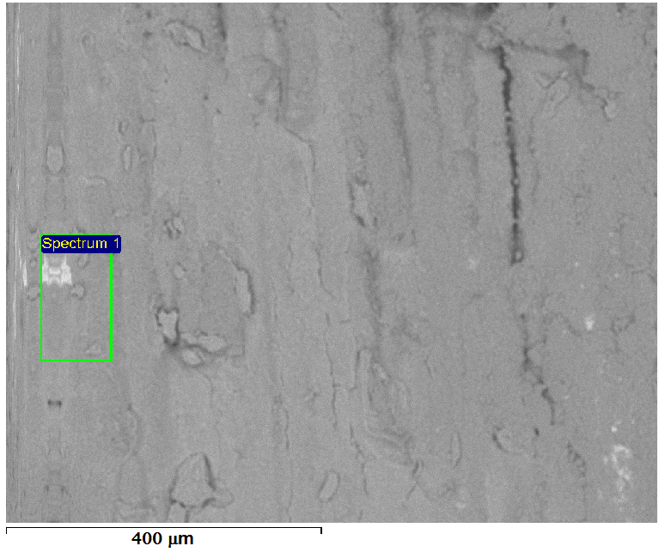 | 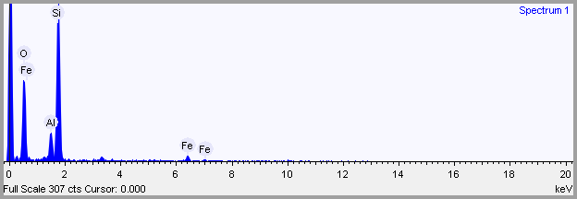
  Elemente |  | Weight % σ | Atomic %
  Aluminum | 4.736 | 0.509 | 3.682
  Silicon | 37.960 | 1.019 | 28.349
  Iron | 7.652 | 1.109 | 2.874
  Oxygen | 49.652 | 1.124 | 65.095
Figure S4 - Image obtained through MEV on the surface of sample B.

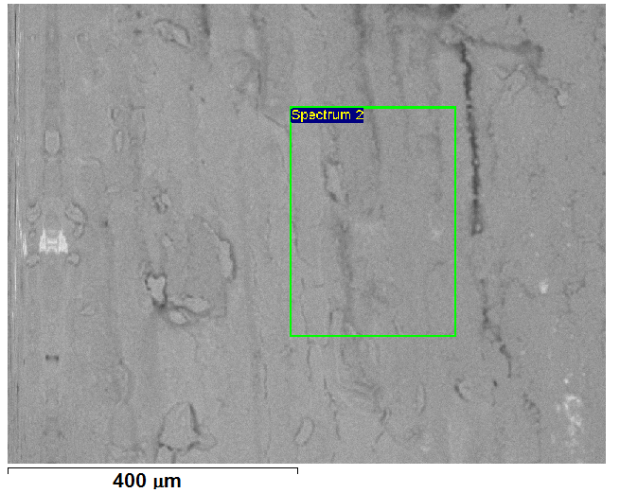 | 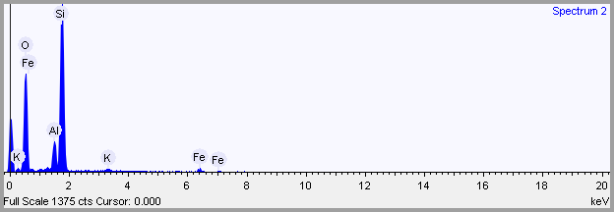
  Element | Weight % | Weight % σ | Atomic %
  Aluminum | 5.552 | 0.251 | 4.252
  Silicon | 38.706 | 0.488 | 28.473
  Potassium | 0.952 | 0.180 | 0.503
  Iron | 4.320 | 0.457 | 1.598
  Oxygen | 50.468 | 0.530 | 65.174
Figure S5 - Image obtained through MEV on the surface of sample B.

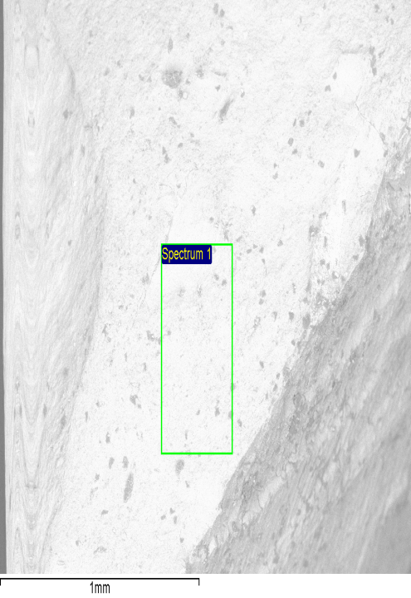 | 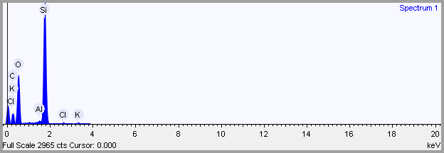
  Element | Weight % | Weight % σ | Atomic %
  Carbon | 12.627 | 2.443 | 18.048
  Aluminum | 0.318 | 0.065 | 0.202
  Silicon | 24.568 | 1.293 | 15.017
  Potassium | 0.275 | 0.063 | 0.121
  Oxygen | 61.969 | 2.394 | 66.494
Figure S6 - Image obtained through MEV on the surface of sample C.

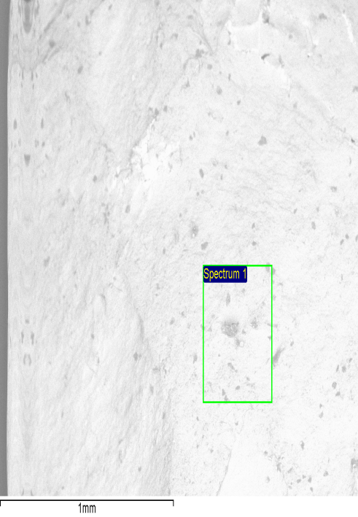 | 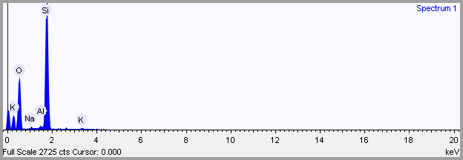
  Element | Weight % | Weight % σ | Atomic %
  Sodium | 0.562 | 0.148 | 0.491
  Aluminum | 0.592 | 0.119 | 0.441
  Silicon | 45.503 | 0.354 | 32.554
  Potassium | 0.647 | 0.133 | 0.333
  Oxygen | 52.696 | 0.360 | 66.181
Figure S7 - Image obtained through MEV on the surface of sample C.

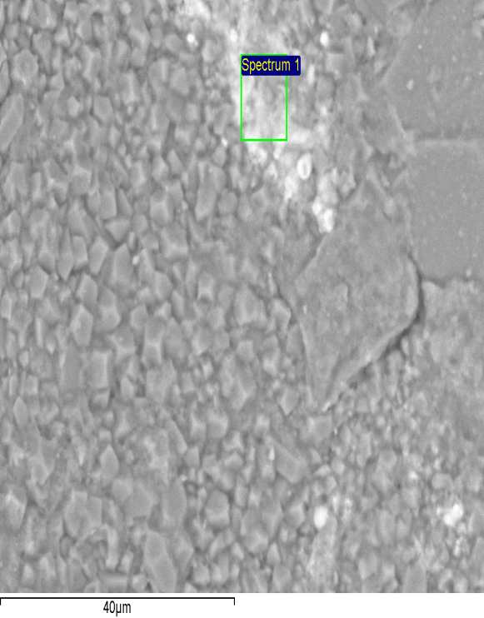 | 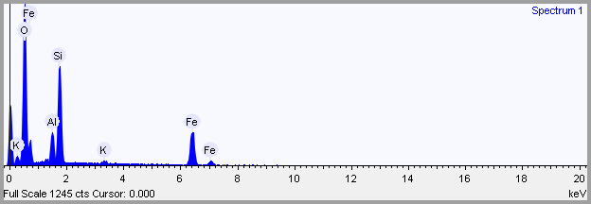
  Element | Weight % | Weight % σ | Atomic %
  Aluminum | 5.831 | 0.259 | 5.468
  Silicon | 19.710 | 0.398 | 17.757
  Potassium | 0.692 | 0.151 | 0.448
  Iron | 35.743 | 0.665 | 16.194
  Oxygen | 38.023 | 0.588 | 60.133
Figure S8 - Image obtained through MEV on the surface of sample D.

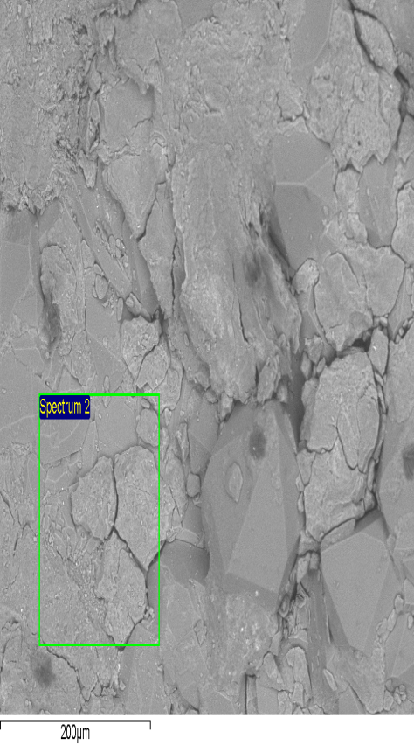 | 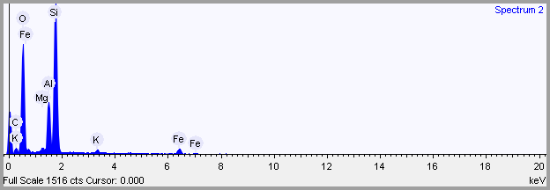
  Element | Weight % | Weight % σ | Atomic %
  Carbon | 5.941 | 2.843 | 9.492
  Magnesium | 0.558 | 0.121 | 0.441
  Aluminum | 7.349 | 0.471 | 5.227
  Silicon | 26.028 | 1.532 | 17.785
  Potassium | 0.929 | 0.134 | 0.456
  Iron | 5.147 | 0.458 | 1.769
  Oxygen | 54.048 | 2.806 | 64.831
Figure S9 - Image obtained through MEV on the surface of sample D.

