**Supporting information**

**How methoxy groups change nature of the thiophene based heterocyclic**

**chalcones from p-channel to ambipolar transport semiconducting materials**

*Computational details*

The B3LYP functional of DFT (Zhang et al., 2013; Chaudhry et al., 2014; Chaudhry et al., 2015) gave good results for geometry optimizations of organic compounds (Sánchez-Carrera et al., 2006; Wong and Cordaro, 2008; Irfan, 2014b, a; Irfan and Al-Sehemi, 2015; Cvejn et al., 2016; Zhu et al., 2016). The experimental optoelectronic and charge transport properties were successfully reproduced by the B3LYP (Zhang et al., 2008). Preat and coworkers revealed that B3LYP/6-31G** level of theory is suitable for the ground state (S0) geometry optimizations (Preat et al., 2009; Preat et al., 2010). Moreover, Huong et al. affirmed that the B3LYP/6-31G** level is decent approach to reproduce the experimental crystal data as well as rational for the electronic and charge transport properties (Huong et al., 2013). In the present study, B3LYP/6-31G** level of theory was adopted to optimize the S0 geometries, whereas the excited state (S1) geometries were optimized at TD-DFT (Matthews et al., 1996) using the TD/B3LYP/6-31G** level. Then the same TD-DFT level was applied to evaluate the absorption and emission spectra which already verified to be a proficient method (Scalmani et al., 2006). The charge transfer proficiency has a vital character within the organic layers. The organic-organic interfaces can be used to refine the charge transfer, while in the bulk, the recombination processes are favored by the high charge mobilities (Greenham et al., 1993). The Marcus theory eq. 1 described the charge transfer rate (Marcus and Sutin, 1985).

W=*t*2/h(π/λkB)1/2 exp(- λ/4kBT) (1)

The self-exchange electron transfer rates and charge mobility can be determined by the two major parameters; i) the transfer integrals (*t*) among contiguous molecules, that ought to be maximized, and ii) the reorganization energy (λ), it should be small for substantial charge transfer. The λ includes; inner λ, which is the modifications in the molecular geometry if an electron, is removed or added to a molecule. Additionally, the modifications caused by polarization effects from the surrounding medium termed as outer λ.

We will focus on inner λ here, which reveals the changes in the geometries of the molecule while going from the charged to neutral state and vice versa. The inner λ is further divided into two parts: and , where  corresponds to the geometry relaxation energy of one molecule from neutral to charged state, and  corresponds to the geometry relaxation energy from charged to neutral state (Irfan, 2014c).

λ = +  (2)

In the evaluation of λ, the two terms were computed directly from the adiabatic potential energy surfaces (Brédas et al., 2002).

λ= +  = [E1 (D+) - E0 (D+)] + [E1 (D) - E0 (D)] (3)

In the above eq. E0(D) and E0(D+) denotes the neutral and charged S0 energies; E1(D) is the neutral molecule energy at the optimized charged geometry; E1(D+) is the charge state energy at the optimized neutral geometry. It is important that the effect of polarization caused by the surrounding molecules along with the reorientation of charge should be ignored to reduce the obstacles associated with the theoretical calculations (Soos et al., 2004).

The adiabatic and vertical electron affinities (EAa and EAv) as well as adiabatic and vertical ionization potentials (IPa and IPv), respectively can be evaluated as:

EAa = E0 (D) – E0 (D-) and EAv = E0 (D) – E1 (D-) (4)

IPa = E0 (D+) – E0 (D) and IPv = E1 (D+) – E0 (D) (5)

where E0 (D), E0 (D+) and E0 (D-) are the energies of neutral, cation and anion at S0, whereas E1 (D+)and E1 (D-)indicate the ­­charged state energy (cation and anion) at the geometries of optimized neutral molecule, respectively.

The hole/electron transfer integrals (*t*h/*t*e) were calculated by following expression:

*t*h/e = 〈⏐F0⏐〉 = 〈⏐hcore⏐〉 +

(〈⏐〉 - 〈⏐〉) (6)

The intrinsic carrier mobility (μ) was estimated via Einstein equation as:

μ = De/TKB (7)

where μ, T, e, KB and D represent the intrinsic carrier mobility, temperature, electronic charge, Boltzmann constant and charge diffusion constant, respectively. The computational methodology details about the *t*h, *t*e, μh and μe calculations can be found in supporting information. All these quantum chemical calculations were performed by using Gaussian09 package (M. J. Frisch, 2009).

Over the last several years, the FF methodology has proved to be a very good approach, especially to calculate the first hyperpolarizability of organic materials due to its consistent results as compared with several other computational approaches (Dehu et al., 1993) and experimental techniques (Nagapandiselvi et al., 2014; Muhammad et al., 2015). In FF methodology, usually static electric field (*F*) is applied and the energy (*E*) of the molecule is given by following Eq.

$E=E^{(0)}-μ_{1}F_{1}-\frac{1}{2}α_{ij}F_{i}F_{j}-\frac{1}{6}β_{ijk}F_{i}F_{j}F_{k}-\frac{1}{24}γ_{ijkl}F_{i}F_{j}F_{k}F_{l}-…$ (8)

where, *i*, *j* and *k* label the *x*, *y* and *z* components, respectively. The total energy of the molecule is represented by *E*(0) withoutany field while μ and α are the dipole moment and linear polarizability. Similarly, the β and γ are the second- and third-order nonlinear polarizabilities, respectively. It is obvious from equation (1) that differentiating E with respect to F attains the 27 components of *β*. According to Kleinman symmetry (βxyy = βyxy = βyyx, βyyz = βyzy = βzyy,… likewise other permutations also take same value), the 27 components of the first static hyperpolarizability (*β*) can be reduced to 10 components as given in Table 5.

The value of *β*tot is calculated by the following equations:

$β_{tot}={\left(β_{x}^{2}+β_{y}^{2}+β_{z}^{2}\right)}^{\frac{1}{2}}$ (9)

where

$β_{x}= β_{xxx}+β_{xyy}+β_{xzz}$ (10)

$β_{y}= β_{yyy}+β_{xxy}+β_{yzz}$ (11)

$β_{z}= β_{zzz}+β_{xxz}+β_{yyz}$ (12)

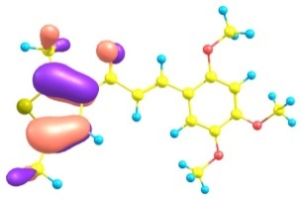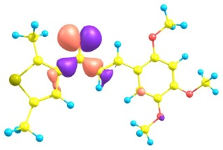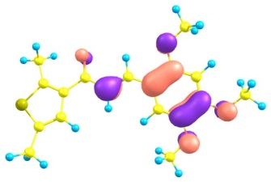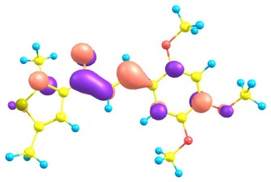

**3**

HOMO-2 HOMO-1 HOMO LUMO

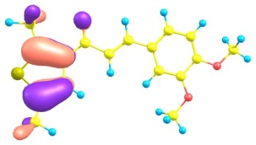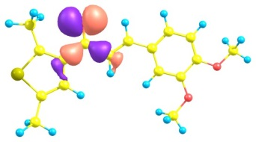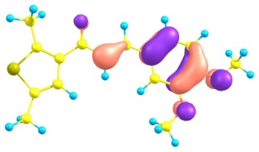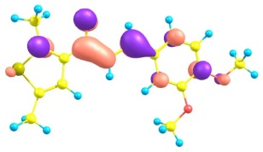

**2**

HOMO-2 HOMO-1 HOMO LUMO

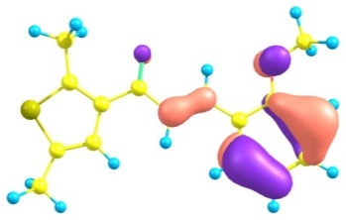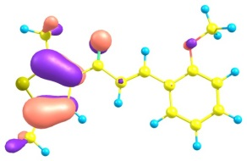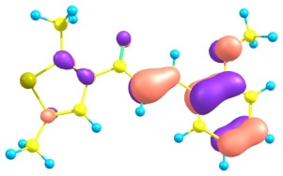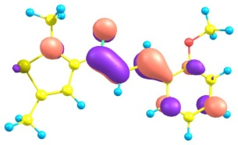

**1**

HOMO-3 HOMO-1 HOMO LUMO

**Fig. S1.** Distribution patterns of the HOMOs and LUMOs of chalcone derivatives at the first excited states.

**Numbering Scheme**

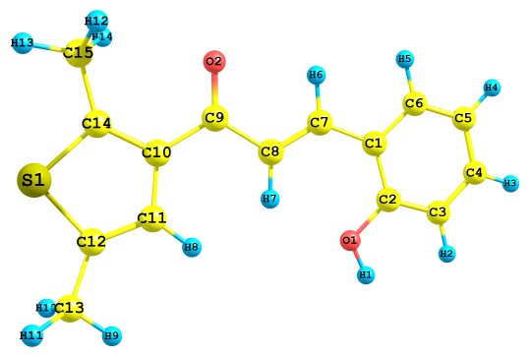

**Table S1**

Selected optimized bond lengths (Angstrom, Å), bond angles and torsion angles (degree, 0) of ground and first excited states for chalcone derivatives at the B3LYP/6-31G** and TD-B3LYP/6-31G** levels of theory, respectively.

|  |  |  |  |  |
| --- | --- | --- | --- | --- |
| Parameters |  | **1**a | **2**b | **3**c |
| S1-C12 | Ground | 1.751  (1.722) | 1.751  (1.716) | 1.751  (1.715) |
|  | Excited | 1.778 | 1.778 | 1.777 |
| S1-C14 | Ground | 1.739  (1.715) | 1.739  (1.706) | 1.741  (1.715) |
|  | Excited | 1.723 | 1.723 | 1.724 |
| C9-O2 | Ground | 1.234  (1.228) | 1.235  (1.220) | 1.235  (1.232) |
|  | Excited | 1.282 | 1.286 | 1.288 |
| C12-S1-C14 | Ground | 93.00  (93.33) | 92.99  (93.32) | 92.96  (93.29) |
|  | Excited | 92.09 | 92.12 | 92.18 |
| C10-C9-O2 | Ground | 120.73  (121.05) | 120.66  (121.02) | 120.52  (120.12) |
|  | Excited | 100.15 | 100.02 | 99.63 |
| C10-C9-C8 | Ground | 118.31  (118.03) | 118.46  (118.71) | 118.15  (118.53) |
|  | Excited | 126.96 | 127.34 | 127.43 |
| C10-C9-C8-C7 | Ground | 178.61  (176.16) | -179.98  (177.63) | -176.27  (175.24) |
|  | Excited | 177.80 | -178.16 | -177.77 |
| C11-C10-C9-O2 | Ground | 174.90  (166.02) | -179.93  (175.23) | -170.06  (171.38) |
|  | Excited | 90.30 | -90.57 | -91.16 |

*a,b,c* exp = Experimental data of compound **1** from reference [14], compound **2** [15], and compound **3** [16] in parentheses, respectively.

**Table S2**

The vertical and adiabatic ionization potentials (IPv/IPa), vertical and adiabatic electronic affinities (EAv/EAa), hole reorganization energies λh and electron reorganization energies λe of chalcone derivatives (in eV) at the B3LYP/6-31G** level of theory.

|  |  |  |  |  |  |  |
| --- | --- | --- | --- | --- | --- | --- |
| Complexes | IPa | EAa | IPv | EAv | λh | λe |
| **1** | 7.11 | 0.52 | 7.22 | 0.33 | 0.232 | 0.397 |
| **2** | 6.82 | 0.45 | 6.96 | 0.28 | 0.296 | 0.331 |
| **3** | 6.43 | 0.39 | 6.62 | 0.18 | 0.405 | 0.409 |

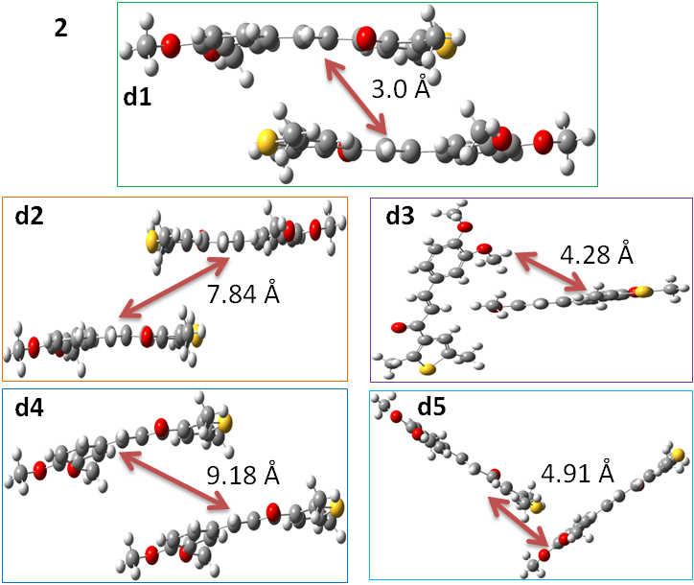

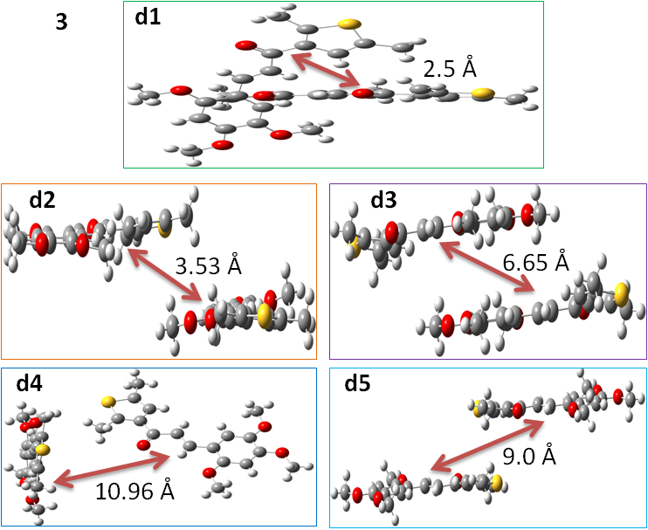

**Fig. S2.** The dimers of chalcone derivatives (**2** and **3**) studied in current investigation to calculate the transfer integrals and intrinsic mobilities.

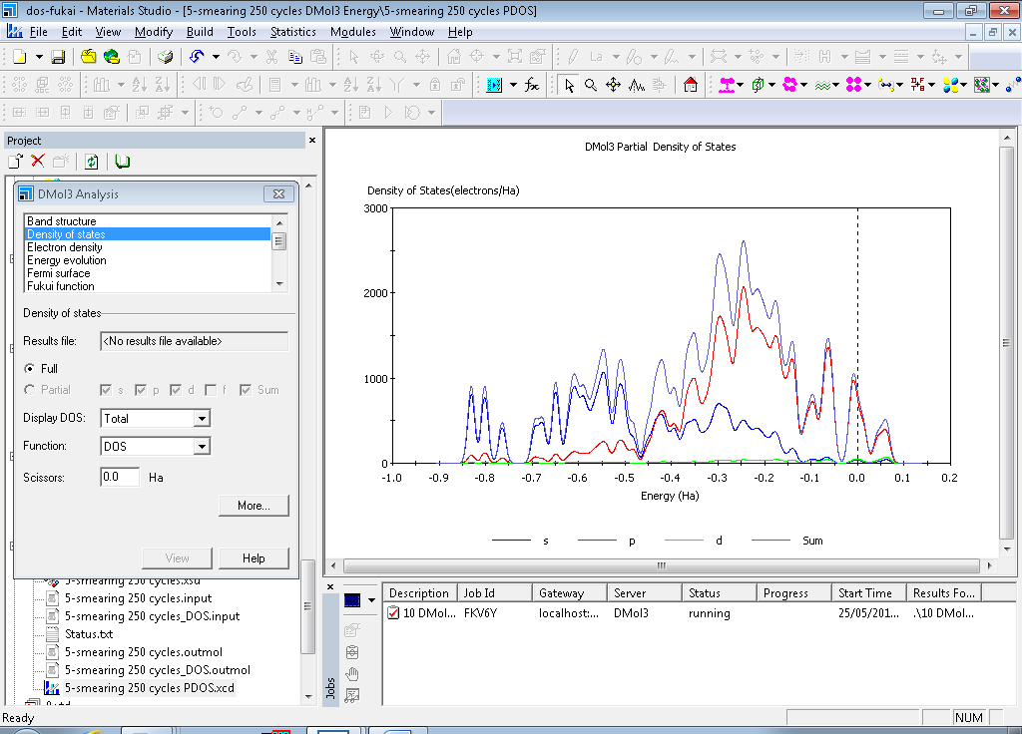

**1**

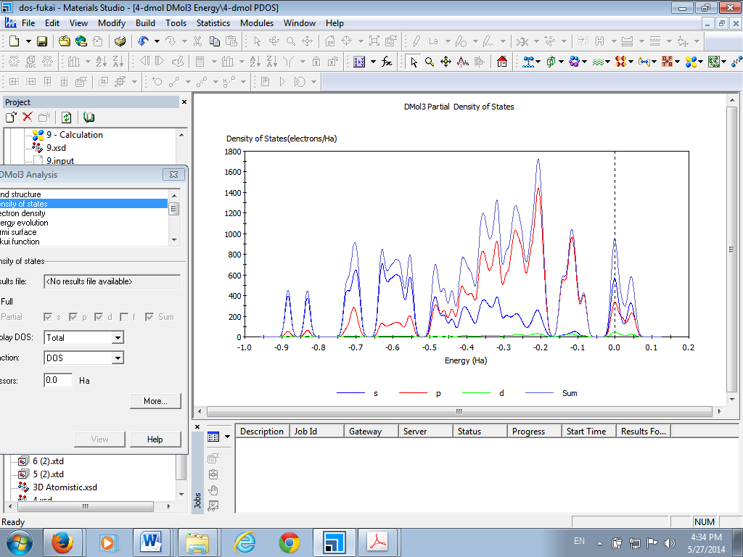

**2**

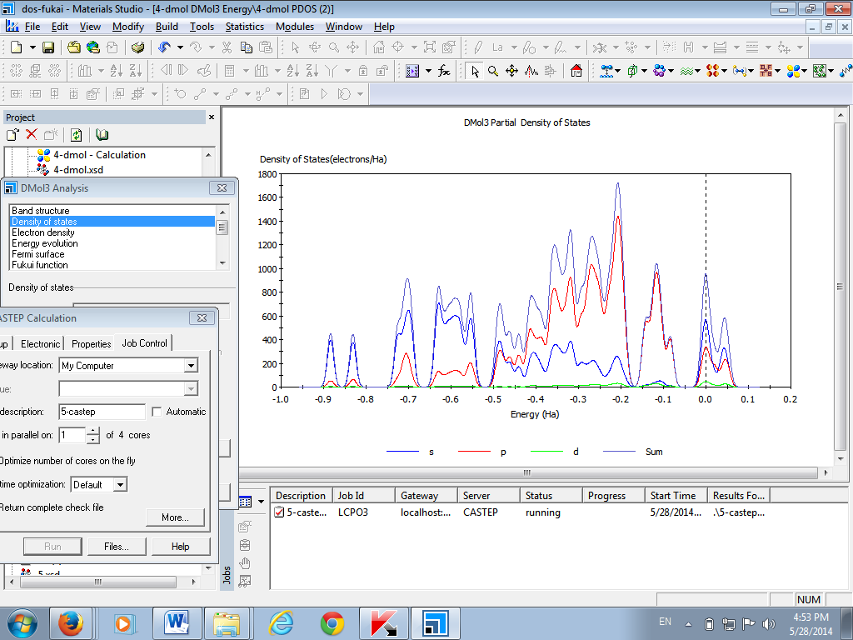

**3**

**Fig. S3.** The total and partial density of states of the chalcone derivatives (**1-3**) calculated by DMol3.

**Table S3**

The second-order polarizability (βtot) and its individual components for chalcone derivatives (**1-3**) at B3LYP/6-31G* level of theory.

|  |  |  |  |  |  |  |  |  |
| --- | --- | --- | --- | --- | --- | --- | --- | --- |
| **1** | | | **2** | | | **3** | | |
| Component | a. u. | | Component | a. u. | | Component |  | a.u. |
| βxxx | 959 | βxxx | | -4635 | βxxx | |  | 4483 |
| βxxy | -887 | βxxy | | -1191 | βxxy | |  | -1405 |
| βxyy | 177 | βxyy | | 178 | βxyy | |  | -50 |
| βyyy | 164 | βyyy | | -78 | βyyy | |  | 45 |
| βxxz | -40 | βxxz | | 1 | βxxz | |  | -76 |
| βxyz | 1 | βxyz | | 1 | βxyz | |  | 7 |
| βyyz | 1 | βyyz | | 0 | βyyz | |  | 8 |
| βxzz | 0 | βxzz | | -23 | βxzz | |  | -8 |
| βyzz | -20 | βyzz | | -1 | βyzz | |  | -15 |
| βzzz | 1 | βzzz | | -1 | βzzz | |  | 7 |
| **βtot** | **1358** | **β****tot** | | **4657** | **βtot** | |  | **4634** |
| βtot (urea) a | 43 | βtot (urea) a | | 43 | βtot (urea) a | |  | 43 |

a Calculated in present study at the same B3LYP/6-31G* level of theory, For β, 1 a. u. = 0.008629×10−30 esu.

*Fukui function analysis*

If the electrons are reformed in a molecule then the local reactivity descriptor e.g. The Fukui function directs the favorite regions where a chemical species will adjust its density. On the jth atom site the condensed or atomic Fukui functions can be defined as:

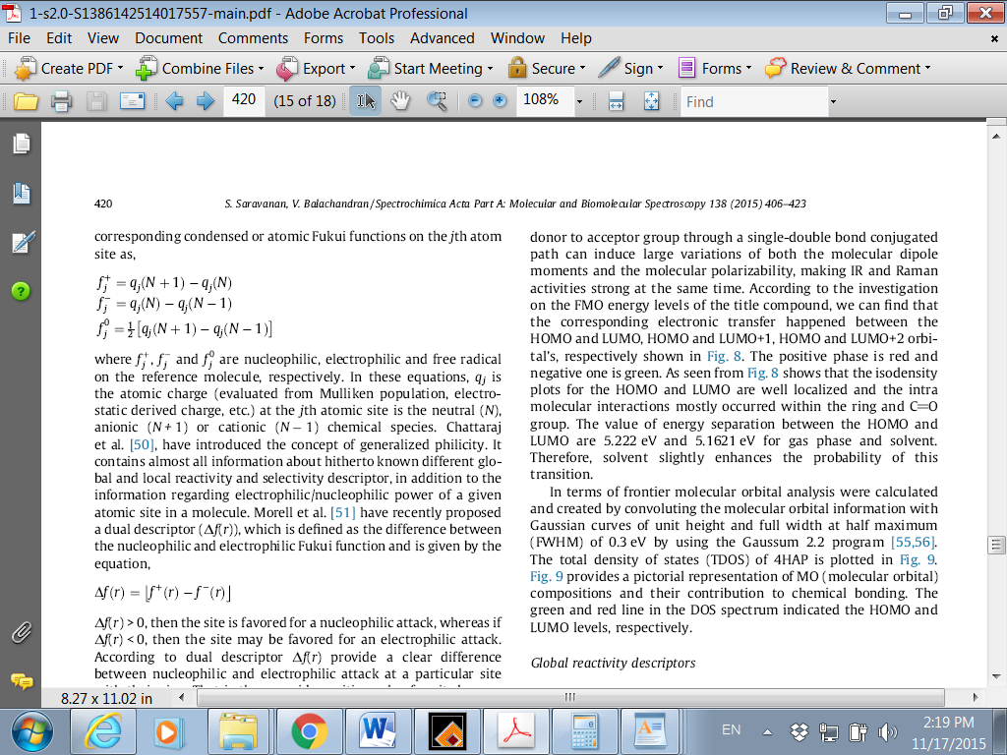 (13)

 (14)

 (15)

where ,  and  are nucleophilic, electrophilic and free radical on the reference molecule, respectively. In these equations, qj is the atomic charge at the jth atomic site is the neutral (N), anionic (N + 1) or cationic (N - 1) chemical species. Previously Morell et al. (Morell et al., 2005) anticipated a dual descriptor (Δƒ(r)), which is the variation between the electrophilic and nucleophilic Fukui function which can be represented by the following eq.

Δƒ(r) =  –  (16)

The chemical species can adjust its density by Fukui function which leads the preferred regions. It also displays the electronic density affinity after the donation or acceptance of electron to distort at a specific position [41].

If the Δƒ(r) > 0, then the site might be ideal for a nucleophilic attack, and if the Δƒ(r) < 0, then the site is favorite for an electrophilic attack. Here the Δƒ(r) delivers a clear difference between nucleophilic and electrophilic attack at a specific position with their sign. The positive value disposed to nucleophilic attack while negative value is suitable for electrophilic attack.

**Table S4**

The calculated Fukui indices Fukui(-), Fukui(+) and Fukui(0) of chalcone derivatives (**1-3**) by DFT.

|  |  |  |  |  |  |
| --- | --- | --- | --- | --- | --- |
| Comp. | Atom No. | Fukui(-) | Fukui(+) | Fukui(0) | Δƒ(r) |
| **1** | S (1)  O (2)  O (3) | 0.013  0.004  0.008 | 0.013  0.004  0.008 | 0.013  0.004  0.008 | 0.000  0.000  0.000 |
| **2** | S (1)  O (2)  O (3)  O (4) | 0.020  0.003  0.005  0.014 | 0.019  0.003  0.005  0.014 | 0.020  0.003  0.005  0.014 | 0.001  0.003  0.000  0.000 |
| **3** | S (1)  O (2)  O (3)  O (4)  O (5) | 0.006  0.004  0.002  0.001  0.007 | 0.006  0.004  0.002  0.001  0.007 | 0.006  0.004  0.002  0.001  0.007 | 0.000  0.000  0.000  0.000  0.000 |

Brédas, J.L., Calbert, J.P., da Silva Filho, D.A., Cornil, J., 2002. Organic semiconductors: A theoretical characterization of the basic parameters governing charge transport. Proc. Natl. Acad. Sci. 99, 5804-5809.

Chaudhry, A., Ahmed, R., Irfan, A., Muhammad, S., Shaari, A., Al-Sehemi, A., 2014. How does the increment of hetero-cyclic conjugated moieties affect electro-optical and charge transport properties of novel naphtha-difuran derivatives? A computational approach. J. Mol. Model. 20, 1-11.

Chaudhry, A.R., Ahmed, R., Irfan, A., Shaari, A., Isa, A.R.M., Muhammad, S., Al-Sehemi, A.G., 2015. Effect of donor strength of extended alkyl auxiliary groups on optoelectronic and charge transport properties of novel naphtha [2, 1-b: 6, 5-b′] difuran derivatives: simple yet effective strategy. J. Mol. Model. 21, 1-16.

Cvejn, D., Achelle, S., Pytela, O., Malval, J.-P., Spangenberg, A., Cabon, N., Bureš, F., Robin-le Guen, F., 2016. Tripodal molecules with triphenylamine core, diazine peripheral groups and extended π-conjugated linkers. Dyes Pigm. 124, 101-109.

Dehu, C., Meyers, F., Bredas, J.L., 1993. Donor-acceptor diphenylacetylenes: geometric structure, electronic structure, and second-order nonlinear optical properties. J. Am. Chem. Soc. 115, 6198-6206.

Greenham, N.C., Moratti, S.C., Bradley, D.D.C., Friend, R.H., Holmes, A.B., 1993. Efficient light-emitting diodes based on polymers with high electron affinities. Nature 365, 628-630.

Huong, V.T.T., Nguyen, H.T., Tai, T.B., Nguyen, M.T., 2013. π-Conjugated Molecules Containing Naphtho[2,3-b]thiophene and Their Derivatives: Theoretical Design for Organic Semiconductors. J. Phys. Chem. C 117, 10175-10184.

Irfan, A., 2014a. First principle investigations to enhance the charge transfer properties by bridge elongation. J. Theor. Comput. Chem. 13, 1450013.

Irfan, A., 2014b. Highly efficient renewable energy materials benzo[2,3-b]thiophene derivatives: Electronic and charge transfer properties study. Optik 125, 4825-4830.

Irfan, A., 2014c. Modeling of efficient charge transfer materials of 4,6-di(thiophen-2-yl)pyrimidine derivatives: Quantum chemical investigations. Comput. Mater. Sci. 81, 488-492.

Irfan, A., Al-Sehemi, A.G., 2015. DFT investigations of the ground and excited state geometries of the benzothiazine and benzisothiazol based anticancer drugs. J. Saudi. Chem. Soc. 19, 318-321.

M. J. Frisch, G.W.T., H. B. Schlegel, G. E. Scuseria, M. A. Robb, J. R. Cheeseman, G. Scalmani, V. Barone, B. Mennucci, G. A. Petersson, H. Nakatsuji, M. Caricato, X. Li, H. P. Hratchian, A. F. Izmaylov, J. Bloino, G. Zheng, J. L. Sonnenberg, M. Hada, M. Ehara, K. Toyota, R. Fukuda, J. Hasegawa, M. Ishida, T. Nakajima, Y. Honda, O. Kitao, H. Nakai, T. Vreven, J. A. Montgomery, Jr., J. E. Peralta, F. Ogliaro, M. Bearpark, J. J. Heyd, E. Brothers, K. N. Kudin, V. N. Staroverov, R. Kobayashi, J. Normand, K. Raghavachari, A. Rendell, J. C. Burant, S. S. Iyengar, J. Tomasi, M. Cossi, N. Rega, J. M. Millam, M. Klene, J. E. Knox, J. B. Cross, V. Bakken, C. Adamo, J. Jaramillo, R. Gomperts, R. E. Stratmann, O. Yazyev, A. J. Austin, R. Cammi, C. Pomelli, J. W. Ochterski, R. L. Martin, K. Morokuma, V. G. Zakrzewski, G. A. Voth, P. Salvador, J. J. Dannenberg, S. Dapprich, A. D. Daniels, Ö. Farkas, J. B. Foresman, J. V. Ortiz, J. Cioslowski, D. J. Fox (2009) Gaussian 09, Revision A. 01,, Gaussian Inc., Wallingford, CT

Marcus, R.A., Sutin, N., 1985. Electron transfers in chemistry and biology. Biochim. Biophys. Acta - Rev. Bioenerg. 811, 265-322.

Matthews, D., Infelta, P., Grätzel, M., 1996. Calculation of the photocurrent-potential characteristic for regenerative, sensitized semiconductor electrodes. Sol. Energy Mater. Sol. Cells 44, 119-155.

Morell, C., Grand, A., Toro-Labbé, A., 2005. New Dual Descriptor for Chemical Reactivity. J. Phys. Chem. A 109, 205-212.

Muhammad, S., Irfan, A., Shkir, M., Chaudhry, A.R., Kalam, A., AlFaify, S., Al‐Sehemi, A.G., Al‐Salami, A., Yahia, I., Xu, H.L., 2015. How does hybrid bridging core modification enhance the nonlinear optical properties in donor‐π‐acceptor configuration? A case study of dinitrophenol derivatives. J. Comput. Chem. 36, 118-128.

Nagapandiselvi, P., Baby, C., Gopalakrishnan, R., 2014. A new Schiff base, (E)-4-((4-chlorophenylimino) methyl)-2-methoxyphenol: Crystal structure, thermal behavior, solid-state fluorescence, DFT calculations and FT NMR spectral analysis. J. Mol. Struct. 1056–1057, 110-120.

Preat, J., Jacquemin, D., Perpète, E.A., 2010. Design of New Triphenylamine-Sensitized Solar Cells: A Theoretical Approach. Environ. Sci. Technol. 44, 5666-5671.

Preat, J., Michaux, C., Jacquemin, D., Perpète, E.A., 2009. Enhanced Efficiency of Organic Dye-Sensitized Solar Cells: Triphenylamine Derivatives. J. Phys. Chem. C 113, 16821-16833.

Sánchez-Carrera, R.S., Coropceanu, V., da Silva Filho, D.A., Friedlein, R., Osikowicz, W., Murdey, R., Suess, C., Salaneck, W.R., Brédas, J.-L., 2006. Vibronic Coupling in the Ground and Excited States of Oligoacene Cations†. J. Phys. Chem. B 110, 18904-18911.

Scalmani, G., Frisch, M.J., Mennucci, B., Tomasi, J., Cammi, R., Barone, V., 2006. Geometries and properties of excited states in the gas phase and in solution: Theory and application of a time-dependent density functional theory polarizable continuum model. J. Chem. Phys. 124, 094107-094115.

Soos, Z.G., Tsiper, E.V., Painelli, A., 2004. Polarization in organic molecular crystals and charge-transfer salts. J. Lumin. 110, 332-341.

Wong, B.M., Cordaro, J.G., 2008. Coumarin dyes for dye-sensitized solar cells: A long-range-corrected density functional study. J. Chem. Phys. 129, -.

Zhang, C., Liang, W., Chen, H., Chen, Y., Wei, Z., Wu, Y., 2008. Theoretical studies on the geometrical and electronic structures of N-methyle-3,4-fulleropyrrolidine. J. Mol. Struct. (TheoChem) 862, 98-104.

Zhang, J., Kan, Y.-H., Li, H.-B., Geng, Y., Wu, Y., Duan, Y.-A., Su, Z.-M., 2013. Cyano or o-nitrophenyl? Which is the optimal electron-withdrawing group for the acrylic acid acceptor of D-π-A sensitizers in DSSCs? A density functional evaluation. J. Mol. Model. 19, 1597-1604.

Zhu, R., Duan, Y.-A., Geng, Y., Wei, C.-Y., Chen, X.-Y., Liao, Y., 2016. Theoretical evaluation on the reorganization energy of five-ring-fused benzothiophene derivatives. Comp. Theor. Chem. 1078, 16-22.