Following are the docking pattern of some very effective derivatives. Where whole of the target protein was taken as docking grid and docked. It was found the similar site as a binding site for all the derivatives taken as ligand, with following amino acid residues

147 ARG, 151 ASN, 155 ASN, 161 ILE, 15 MET, 165 MET, 154 PRO, 162 PRO, 157 TRP, 218 LEU, 216 LYS, 222 PHE, and 215 SER.

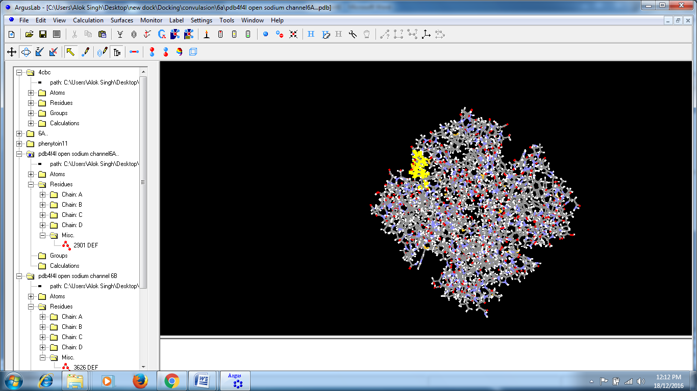 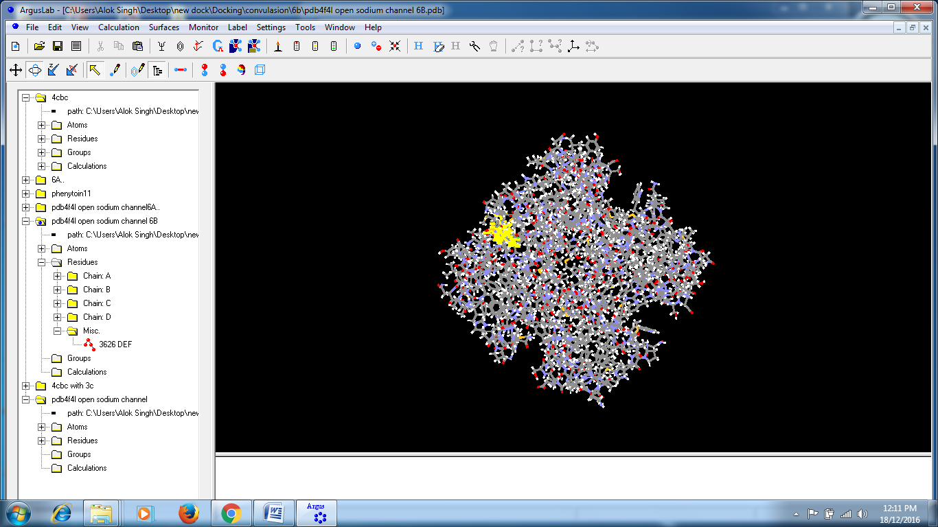

**Docking site for compound 3a** **Docking site for compound 3b**

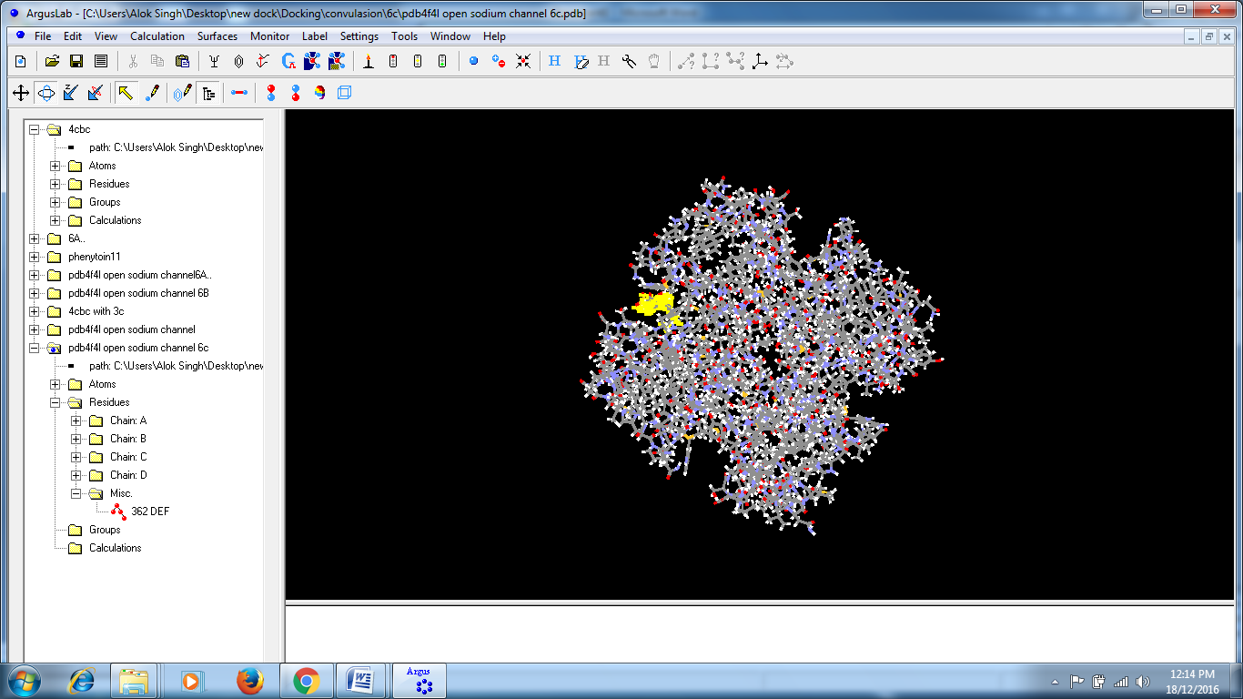

**Docking site for compound 3c**

Another effort has been made to change of protein target i.e. the different PDB file (4cbc) of voltage gated sodium channel and docking was done. This docking result also suggest the nearly similar type of amino acid residues pattern at the binding site that was found in the previous docking study, but with less hydrogen bond and docking score.

New amino acid residue pattern - 200 ILE, 204 MET, 201 PRO, 231 LEU, 235 PHE, 232 THR, 303 VAL, 262 TYR, SER etc.

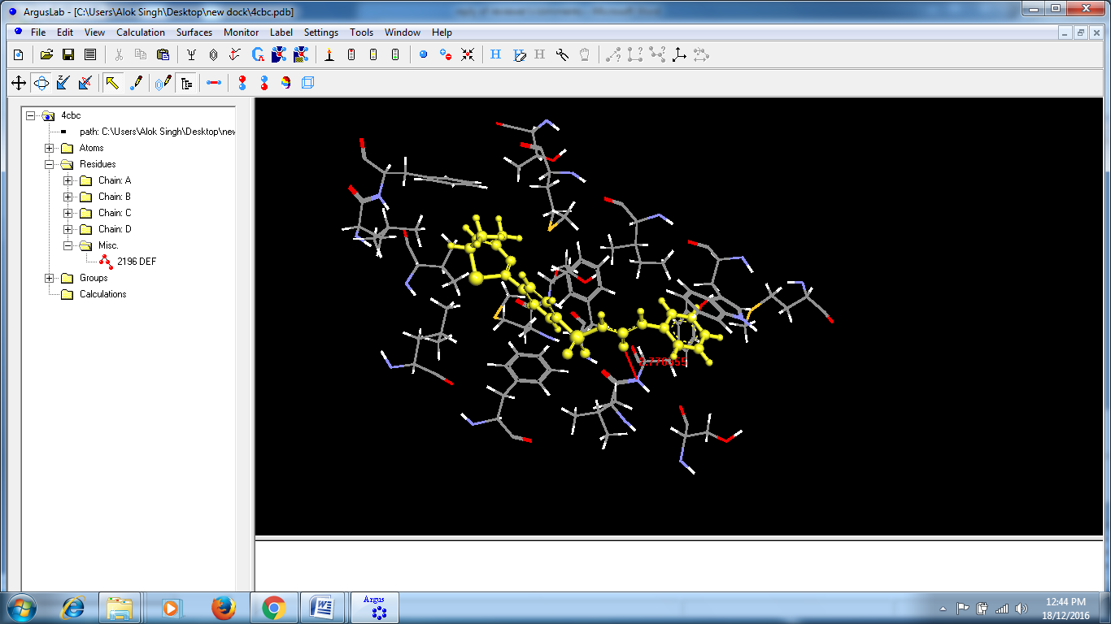

**Binding site for compound 3a with different PDB file**

**FTIR SPECTRA**

**Compound 2**

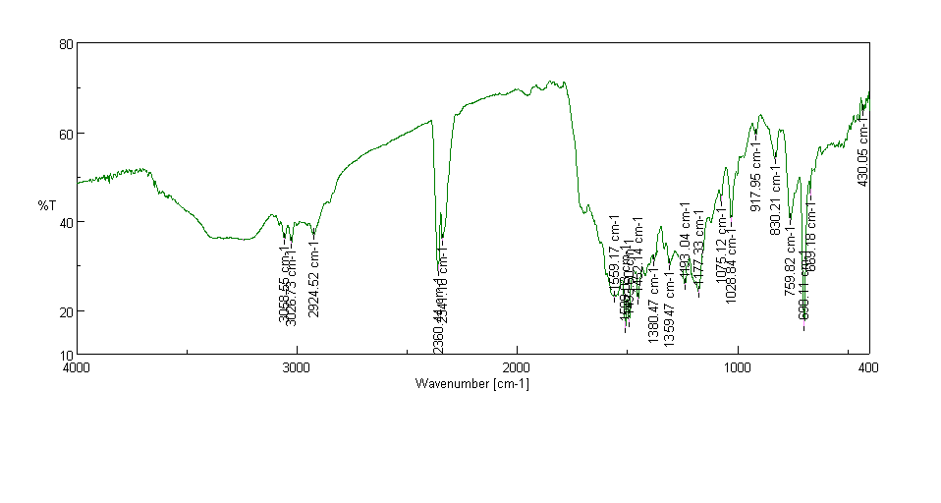

**Compound 3a**

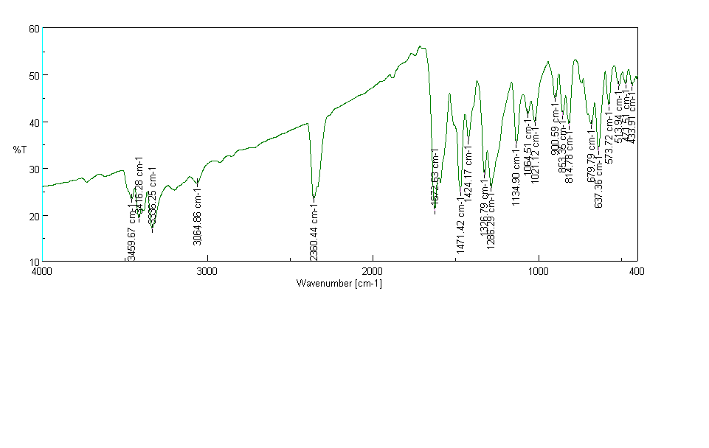

**Compound 3b**

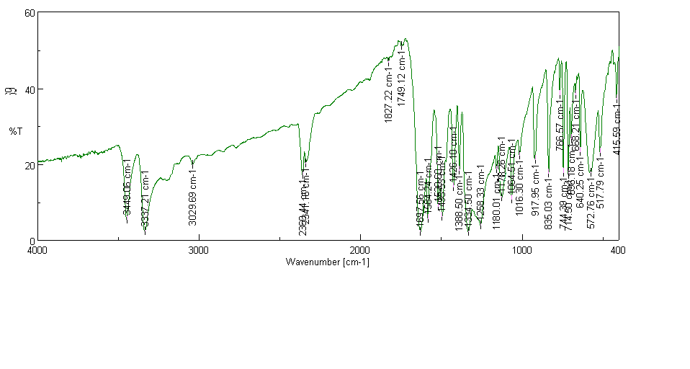

**1H NMR SPECTRA**

**Compound 3a**

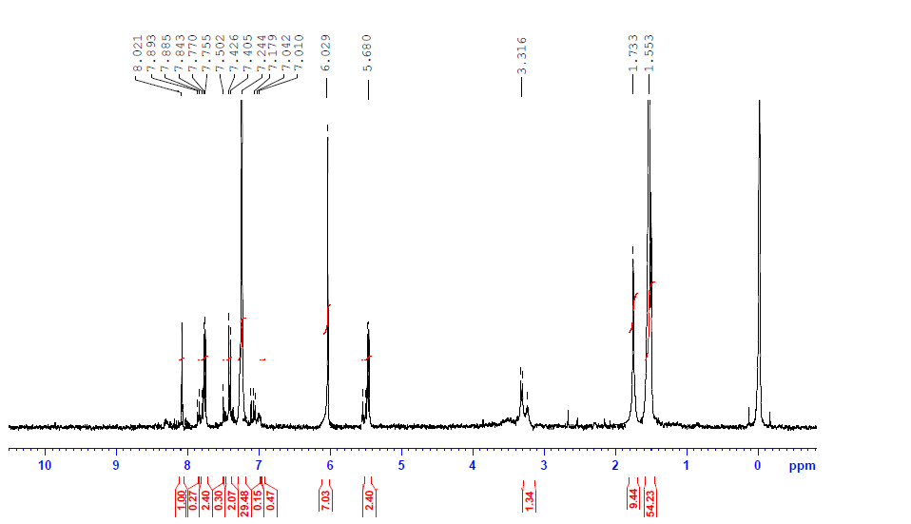

**Compound 3b**

