Supporting information
The structural, electro-optical, charge transport and nonlinear optical properties of oxazole (4Z)-4-Benzylidene-2-(4-methylphenyl)-1,3-oxazol-5(4H)-one derivative
2. Computational details
The charge transfer proficiency has a vital character within the organic layers. The organic-organic interfaces can be used to refine the charge transfer, while in the bulk, the recombination processes are favored by the high charge mobilities . The following equation by Marcus theory described the charge transfer rate .
W=V²/h(π/λk_{B})^{1/2} exp(- λ/4k_{B}T) (1)
The self-exchange electron transfer rates and charge mobility can be determined by the two major parameters; i) the transfer integrals t (electronic coupling) among contiguous molecules, that ought be maximized; and ii) the reorganization energy (λ), it should be small for substantial charge transfer. The reorganization energy (λ) includes; inner λ, which is the modifications in the molecular geometry if an electron, is removed or added to a molecule. Additionally the modifications caused by polarization effects to the surrounding medium termed as outer λ.
We will focus on inner λ here, which reveals the changes in the geometries of the molecule while going from the charged to neutral state and from neutral to the charged one. The inner λ is further divided into two parts: and , where corresponds to the geometry relaxation energy of one molecule from neutral to charged state, and corresponds to the geometry relaxation energy from charged to neutral state .
λ ₌ + (2)
In the evaluation of λ, the two terms were computed directly from the adiabatic potential energy surfaces .
λ ₌ + = [E¹ (M⁺) - E⁰ (M⁺)] + [E¹ (M) - E⁰ (M)] (3)
In the above equation E⁰(M) and E⁰(M⁺) denotes the neutral and charged ground states energies; E¹(M) is the neutral molecule energy at the optimized charged geometry; E¹(M⁺) is the charge state energy at the optimized neutral geometry. It is noteworthy that the effect of polarization caused by the surrounding molecules along with the reorientation of charge should be ignored to reduce the obstacles associated to the theoretical calculations .
The adiabatic and vertical electron affinities a/vEA and ionization potentials (a/vIP) can be evaluated as:
EAa = E⁰ (M) – E⁰ (M⁻) and EAv = E⁰ (M) – E¹ (M⁻) (4)
IPa = E⁰ (M⁺) – E⁰ (M) and IPv = E¹ (M⁺) – E⁰ (M) (5)
Where E⁰ (M), E⁰ (M⁺) and E⁰ (M⁻) are the energies of neutral, cation and anion at ground state, whereas E¹ (M⁺) and E¹ (M⁻) denote the charged state energy (cation and anion) at the geometries of optimized neutral molecule, respectively. The hybrid functional B3LYP with the 6-31G ** basis set is used to compute the charge transfer parameters.
The single crystal structure has been used to generate the nearest neighboring intermolecular hopping pathways in process of transfer integral calculations. To evaluate the transfer integrals; two methods are broadly applied, first one is Koopmans’s theorem based scheme and the second process is the direct evaluation technique of the frontier molecular orbitals (FMOs) . The transfer integrals can be calculated by Koopmans’s theorem by means of half HOMO or LUMO levels splitting for electron and holes. This method has been employed on many conjugated systems by Bredas et al. to probe the charge transport parameters and concluded that this is a suitable technique. Likewise Valeev and co-workers too warned that the site energy correction should also be considered because of the crystal environment if the dimers are not stacked co-facially. In current study, the direct evaluation method is used to explore the charge transfer properties by using our homemade code . The hole and electron electronic coupling t (transfer integrals) has been computed by following expression:
t_{h/e} = ⟨⏐F⁰⏐⟩ = ⟨⏐h_{core}⏐⟩ +
(⟨⏐⟩ - ⟨⏐⟩) (6)
In the above expression, t_{h/e} is hole and electron transfer integrals, whereas and denote to the HOMOs and LUMOs for the two successive molecules while there is no interaction among the contiguous molecules, whereas the Fock operator is represented by F⁰ for the dimer of a static pathway with unperturbed molecular orbitals. It was described previously that “in excitons formation the spin dependence of the charge recombination rates” could be contributed through the exchange term . The self-consistent field (SCF) standard procedure could be applied to evaluate the molecular orbitals separately, which are not interacting with each other for two individual molecules. In equation 1, the two-electron integrals and Fock matrix of the dimer would be constructed by non-interacting molecular orbitals. The dimer Fock matrix can be evaluated by the density matrix associated to these molecular orbitals and the non-interacting molecular orbitals. The non-interacting molecular orbitals are used to construct the density matrix of F⁰ and the Fock matrix is termed as
F = SCεC⁻¹ (7)
Here, “S” links to the dimer overlap matrix from the structure of crystal; The Kohn-Sham orbital and the eigenvalue (C and ε) have been gained from the zeroth-order Fock matrix by “diagonalizing the Fock matrix without any self-consistent field iteration”. The dimer Fock matrix with molecular orbit of unperturbed monomer was directly calculated at then PW91PW91/6-31G** level of DFT to find the inter-molecular transfer integrals. The hybrid functional PW91PW91 provides the best depiction of inter-molecular transfer integral named by Huang and Kertesz . Yang et al. described the direct evaluation method of transfer integral equivalent to “the site-energy corrected frontier orbital splitting method” also the direct method made the transfer integral calculation extremely easy and simple. The INDO (intermediate neglect of differential overlap) calculations normally overemphasize the transfer integrals that utilized the “energy splitting in dimer” scheme and this approach ignores the basis set orthogonalization, revealing the fact that the direct evaluation method has been proved to provide decent and accurate results in the available literature .
The intrinsic carrier mobility (μ) could be evaluated via Einstein equation as:
μ = De/TK_{B} (8)
Where μ, T, e, K_{B} and D represent the intrinsic carrier mobility, temperature, electronic charge, Boltzmann constant and charge diffusion constant, respectively. All these quantum chemical calculations have been performed by using Gaussian09 package .
NLO
The FF method, which is originally developed by Kurtz et al. is usually applied to calculate the first hyperpolarizability of organic molecules because it has provided very reliable results with experiments and other computational approaches. A static electric field (F) is applied in FF approach and the energy (E) of the molecule is given by following Eq.
(9)
In the absence of an electronic field, the total energy of molecule is represented by E⁽⁰⁾, is the dipole moment, is the polarizability, and are the first and second hyperpolarizabilities, respectively, while label the components, respectively. It can be seen from above equation that differentiating E with respect to F obtains the μ, α, β, and γ values. Here β, and γ values represent the origin of second-order (χ²) and third-order (χ³) nonlinear optical (NLO) susceptibilities, respectively. In our present investigation, we have calculated the molecular first hyperpolarizability.

3.4.1. Electronic Dipole moment, Static Polarizability and First Hyperpolarizability (β)
In our present investigation, we have calculated the electronic dipole moment, molecular polarizability and first hyperpolarizability. For a molecule, its dipole moment (μ) is defined as follows:
(10)
The average polarizability () can be calculated by following equation:
(11)
For anisotropy of polarizability (Δα)
(12)
Similarly, the magnitude of the total first static hyperpolarizability (β_{tot}) can also be calculated using following equations:
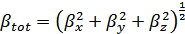 (13)
where
(14)
(15)
(16)
The first static hyperpolarizability (β) that is a third rank tensor that can be described by a 3 × 3 × 3 matrix. According to Kleinman symmetry (β_{xyy} = β_{yxy} = β_{yyx}, β_{yyz} = β_{yzy} = β_{zyy},… likewise other permutations also take same value), the 27 components of the 3D matrix can be reduced to 10 components. These components have been calculated using GAUSSIAN 09. . The details of 10 components have been shown in Table 6.
Table S1
Selected optimized bond lengths in Angstrom (Å) and bond angles (degree) of ground and first excited state for oxazole derivative BMPOª at the B3LYP/6-31G** and TD-B3LYP/6-31G** levels of theory, respectively.
Bond lengths |  | Bond angles
O₁-C₂ | 1.407  (1.391) | C₅-O₁-C₂ | 105.86  (105.21)
 | [1.411] |  | [106.43]
C₃-N₄ | 1.396  (1.402) | C₃-N₄-C₅ | 105.65  (105.41)
 | [1.355] |  | [106.09]
N₄-C₅ | 1.297  (1.292)
 | [1.348]
ª Experimental data in parentheses from reference ;
calculated geometrical parameters
at excited state in brackets

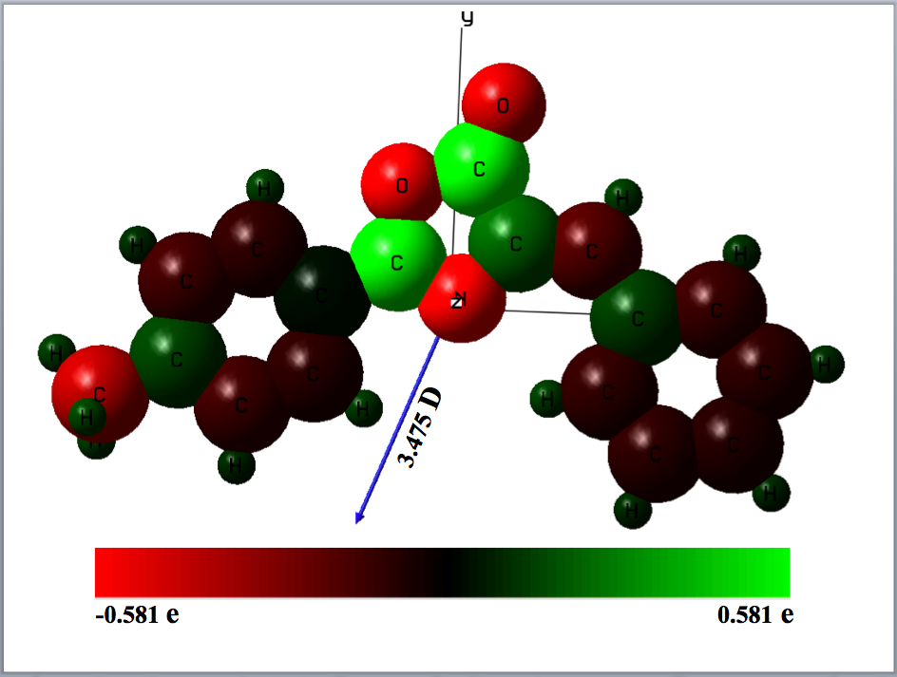
Fig. S1. The representation of partial charges (relative color format) and diplo moment vector calculated using Milliken population analysis at B3LYP/6-31G* levels of theory for BMPO molecule.
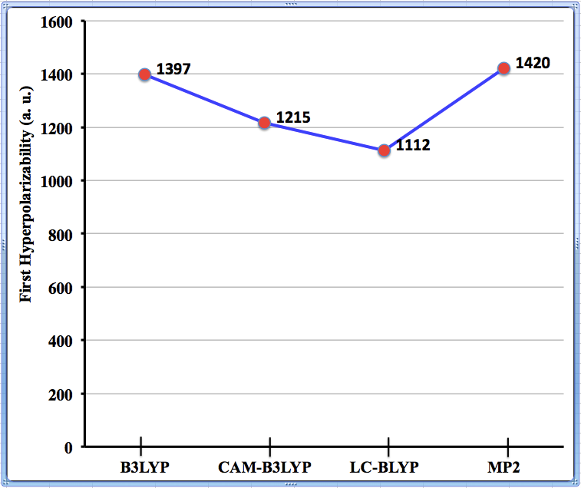
Fig. S2. The graphical representation of First hyperpolarizability at different methods

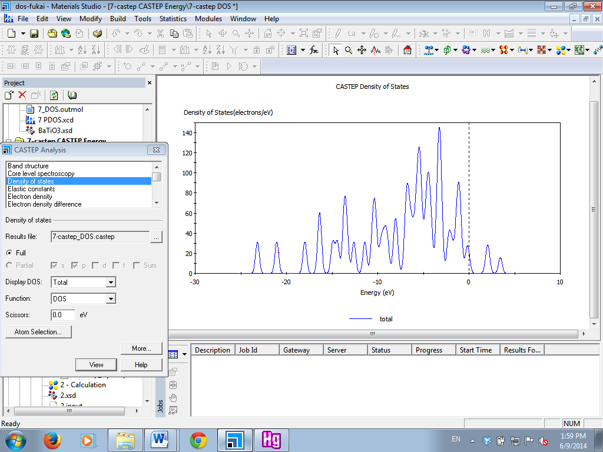
Total
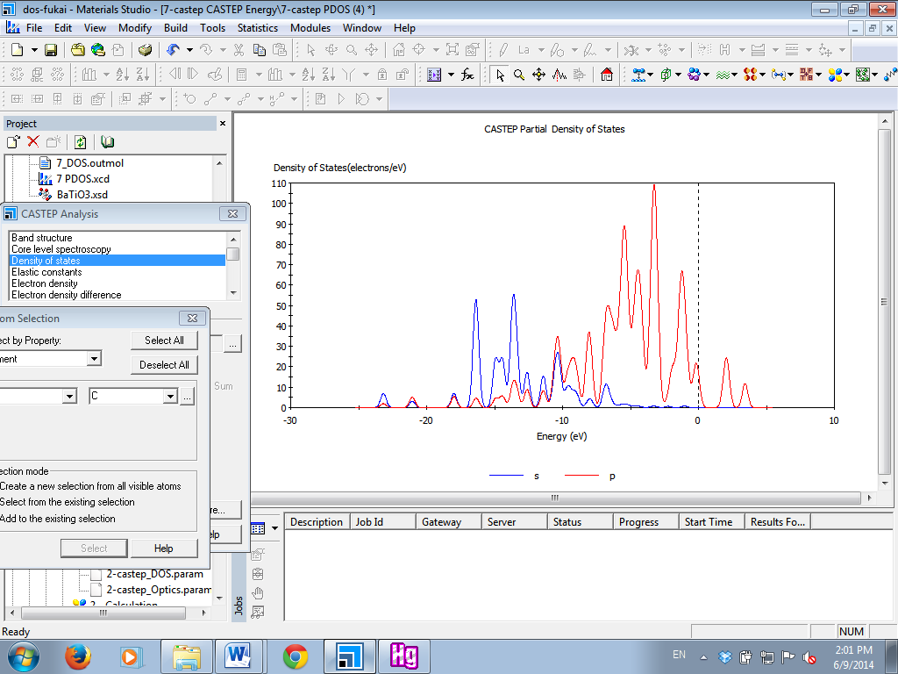
C
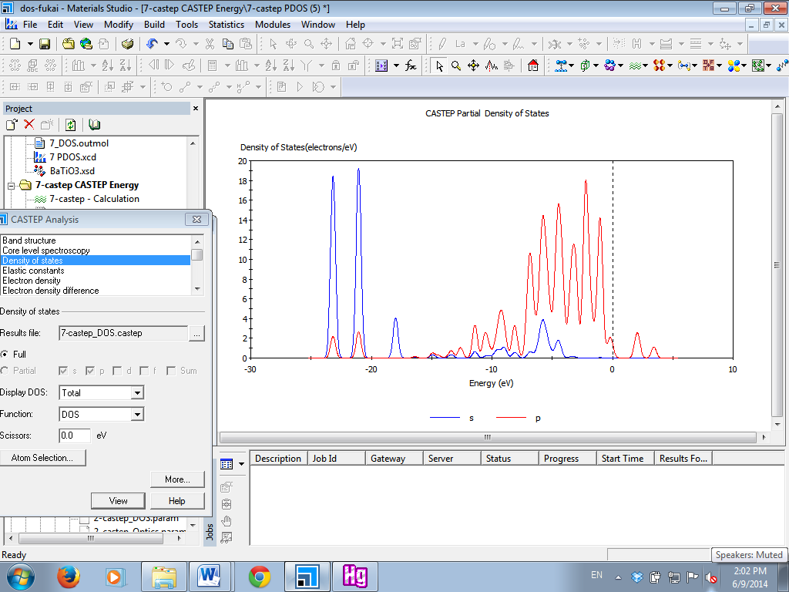
O
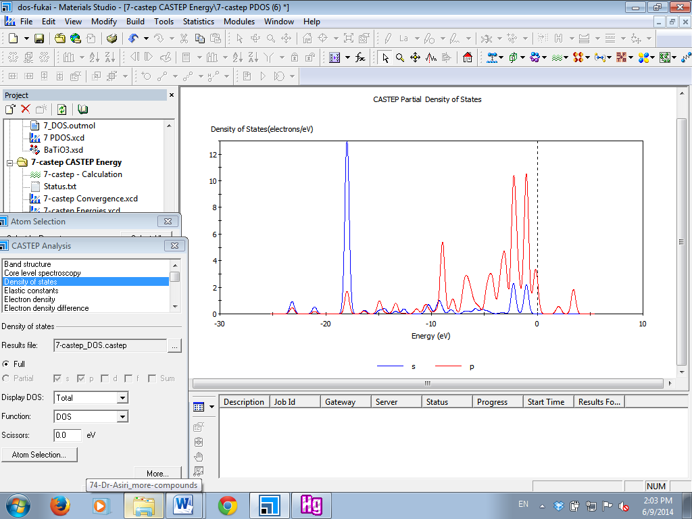
N
Fig. S3. The total and partial density of states of the BMPO calculated by CASTEP.

We have provided the excel spread sheet along with step by step details to calculated first hyperpolarizability amplitudes.
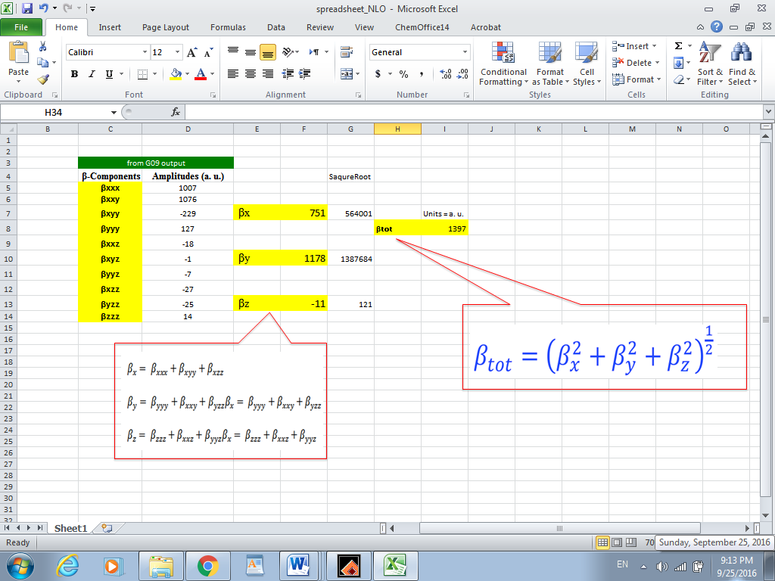
Figure S4. The excel spread sheet to highlight the procedure to calculate the first hyperpolarizability amplitude

Asiri, A.M., Faidallah, H.M., Sobahi, T.R., Ng, S.W., Tiekink, E.R.T., 2015. (4Z)-4-Benzylidene-2-phenyl-1,3-oxazol-5(4H)-one. Corrigendum. Acta Crystallogr. Sect. E 71, e4.
Brédas, J.-L., Beljonne, D., Coropceanu, V., Cornil, J., 2004. Charge-Transfer and Energy-Transfer Processes in π-Conjugated Oligomers and Polymers: A Molecular Picture. Chem. Rev. 104, 4971-5004.
Brédas, J.L., Calbert, J.P., da Silva Filho, D.A., Cornil, J., 2002. Organic semiconductors: A theoretical characterization of the basic parameters governing charge transport. Proc. Natl. Acad. Sci. 99, 5804-5809.
Chaudhry, A.R., Ahmed, R., Irfan, A., Shaari, A., Al-Sehemi, A.G., 2013. Quantum chemical approach toward the electronic, photophysical and charge transfer properties of the materials used in organic field-effect transistors. Mater. Chem. Phys. 138, 468-478.
Dehu, C., Meyers, F., Bredas, J.L., 1993. Donor-acceptor diphenylacetylenes: geometric structure, electronic structure, and second-order nonlinear optical properties. J. Am. Chem. Soc. 115, 6198-6206.
Frisch, M.J., Trucks, G.W., Schlegel, H.B., Scuseria, G.E., Robb, M.A., Cheeseman, J.R., Scalmani, G., Barone, V., Mennucci, B., Petersson, G.A., Nakatsuji, H., Caricato, M., Li, X., Hratchian, H.P., Izmaylov, A.F., Bloino, J., Zheng, G., Sonnenberg, J.L., Hada, M., Ehara, M., Toyota, K., Fukuda, R., Hasegawa, J., Ishida, M., Nakajima, T., Honda, Y., Kitao, O., Nakai, H., Vreven, T., Montgomery, J.A., Peralta, J.E., Ogliaro, F., Bearpark, M., Heyd, J.J., Brothers, E., Kudin, K.N., Staroverov, V.N., Kobayashi, R., Normand, J., Raghavachari, K., Rendell, A., Burant, J.C., Iyengar, S.S., Tomasi, J., Cossi, M., Rega, N., Millam, J.M., Klene, M., Knox, J.E., Cross, J.B., Bakken, V., Adamo, C., Jaramillo, J., Gomperts, R., Stratmann, R.E., Yazyev, O., Austin, A.J., Cammi, R., Pomelli, C., Ochterski, J.W., Martin, R.L., Morokuma, K., Zakrzewski, V.G., Voth, G.A., Salvador, P., Dannenberg, J.J., Dapprich, S., Daniels, A.D., Farkas, Foresman, J.B., Ortiz, J.V., Cioslowski, J., Fox, D.J. (2009) Gaussian 09, Revision B.01. Wallingford CT. doi:citeulike-article-id:9096580
Greenham, N.C., Moratti, S.C., Bradley, D.D.C., Friend, R.H., Holmes, A.B., 1993. Efficient light-emitting diodes based on polymers with high electron affinities. Nature 365, 628-630.
Huang, J., Kertesz, M., 2004. Intermolecular transfer integrals for organic molecular materials: can basis set convergence be achieved? Chem. Phys. Lett. 390, 110-115.
Irfan, A., 2014. Modeling of efficient charge transfer materials of 4,6-di(thiophen-2-yl)pyrimidine derivatives: Quantum chemical investigations. Comput. Mater. Sci. 81, 488-492.
Irfan, A., Al-Sehemi, A.G., Muhammad, S., Zhang, J., 2012. Packing Effect on the Transfer Integrals and Mobility in α, α′-bis (dithieno [3, 2-b: 2′, 3′-d] thiophene)(BDT) and its Heteroatom-Substituted Analogues. Aust. J. Chem. 64, 1587-1592.
Irfan, A., Zhang, J., Chang, Y., 2009. Theoretical investigations of the charge transfer characteristics in dichlorotitanium phthalocyanine (TiCl2Pc) and tin phthalocyanine (SnPc). Chem. Phys. Lett. 483, 143-146.
Irfan, A., Zhang, J., Chang, Y., 2010. Theoretical investigations of the charge transfer properties of anthracene derivatives. Theoretical Chemistry Accounts: Theory, Computation, and Modeling (Theoretica Chimica Acta) 127, 587-594.
Kurtz, H.A., Stewart, J.J.P., Dieter, K.M., 1990. Calculation of the nonlinear optical properties of molecules. J. Comput. Chem. 11, 82-87.
Kwiatkowski, J.J., Nelson, J., Li, H., Bredas, J.L., Wenzel, W., Lennartz, C., 2008. Simulating charge transport in tris(8-hydroxyquinoline) aluminium (Alq3). Phys. Chem. Chem. Phys. 10, 1852-1858.
Lin, B.C., Cheng, C.P., You, Z.-Q., Hsu, C.-P., 2004. Charge Transport Properties of Tris(8-hydroxyquinolinato)aluminum(III): Why It Is an Electron Transporter. J. Am. Chem. Soc. 127, 66-67.
M. J. Frisch, G.W.T., H. B. Schlegel, G. E. Scuseria, M. A. Robb, J. R. Cheeseman, G. Scalmani, V. Barone, B. Mennucci, G. A. Petersson, H. Nakatsuji, M. Caricato, X. Li, H. P. Hratchian, A. F. Izmaylov, J. Bloino, G. Zheng, J. L. Sonnenberg, M. Hada, M. Ehara, K. Toyota, R. Fukuda, J. Hasegawa, M. Ishida, T. Nakajima, Y. Honda, O. Kitao, H. Nakai, T. Vreven, J. A. Montgomery, Jr., J. E. Peralta, F. Ogliaro, M. Bearpark, J. J. Heyd, E. Brothers, K. N. Kudin, V. N. Staroverov, R. Kobayashi, J. Normand, K. Raghavachari, A. Rendell, J. C. Burant, S. S. Iyengar, J. Tomasi, M. Cossi, N. Rega, J. M. Millam, M. Klene, J. E. Knox, J. B. Cross, V. Bakken, C. Adamo, J. Jaramillo, R. Gomperts, R. E. Stratmann, O. Yazyev, A. J. Austin, R. Cammi, C. Pomelli, J. W. Ochterski, R. L. Martin, K. Morokuma, V. G. Zakrzewski, G. A. Voth, P. Salvador, J. J. Dannenberg, S. Dapprich, A. D. Daniels, Ö. Farkas, J. B. Foresman, J. V. Ortiz, J. Cioslowski, D. J. Fox (2009) Gaussian 09, Revision A. 01,, Gaussian Inc., Wallingford, CT
Marcus, R.A., Sutin, N., 1985. Electron transfers in chemistry and biology. Biochim. Biophys. Acta - Rev. Bioenerg. 811, 265-322.
Muhammad, S., Irfan, A., Shkir, M., Chaudhry, A.R., Kalam, A., AlFaify, S., Al‐Sehemi, A.G., Al‐Salami, A., Yahia, I., Xu, H.L., 2015. How does hybrid bridging core modification enhance the nonlinear optical properties in donor‐π‐acceptor configuration? A case study of dinitrophenol derivatives. J. Comput. Chem. 36, 118-128.
Muhammad, S., Xu, H., Janjua, M.R.S.A., Su, Z., Nadeem, M., 2010. Quantum chemical study of benzimidazole derivatives to tune the second-order nonlinear optical molecular switching by proton abstraction. Phys. Chem. Chem. Phys. 12, 4791-4799.
Nagapandiselvi, P., Baby, C., Gopalakrishnan, R., 2014. A new Schiff base, (E)-4-((4-chlorophenylimino) methyl)-2-methoxyphenol: Crystal structure, thermal behavior, solid-state fluorescence, DFT calculations and FT NMR spectral analysis. J. Mol. Struct. 1056–1057, 110-120.
Shuai, Z., Beljonne, D., Silbey, R.J., Brédas, J.L., 2000. Singlet and Triplet Exciton Formation Rates in Conjugated Polymer Light-Emitting Diodes. Phys. Rev. Lett. 84, 131-134.
Song, Y., Di, C.a., Yang, X., Li, S., Xu, W., Liu, Y., Yang, L., Shuai, Z., Zhang, D., Zhu, D., 2006. A Cyclic Triphenylamine Dimer for Organic Field-Effect Transistors with High Performance. J. Am. Chem. Soc. 128, 15940-15941.
Soos, Z.G., Tsiper, E.V., Painelli, A., 2004. Polarization in organic molecular crystals and charge-transfer salts. J. Lumin. 110, 332-341.
Troisi, A., Orlandi, G., 2001. The hole transfer in DNA: calculation of electron coupling between close bases. Chem. Phys. Lett. 344, 509-518.
Valeev, E.F., Coropceanu, V., da Silva Filho, D.A., Salman, S., Brédas, J.-L., 2006. Effect of Electronic Polarization on Charge-Transport Parameters in Molecular Organic Semiconductors. J. Am. Chem. Soc. 128, 9882-9886.
Wang, C., Wang, F., Yang, X., Li, Q., Shuai, Z., 2008. Theoretical comparative studies of charge mobilities for molecular materials: Pet versus bnpery. Org. Electron. 9, 635-640.
Yang, X., Li, Q., Shuai, Z. (2007) Theoretical modelling of carrier transports in molecular semiconductors: molecular design of triphenylamine dimer systems. Nanotechnology, vol 18.
Yin, S., Yi, Y., Li, Q., Yu, G., Liu, Y., Shuai, Z., 2006. Balanced Carrier Transports of Electrons and Holes in Silole-Based CompoundsA Theoretical Study. J. Phys. Chem. A 110, 7138-7143.

