**Supplementary Material**

**Statistical modeling and optimization of cellulase production by *Bacillus licheniformis* NCIM 5556 isolated from the hot spring, Maharashtra, India.**

**Shajahan. S a,b, Ganesh Moorthy. I c, Sivakumar. N d, Selvakumar. G e,\***

*aDepartment of Microbiology, Manonmaniam Sundaranar University, Abisekapatti, Tirunelveli – 627012, Tamil Nadu, India.*

*bTATA Chemicals Ltd, Innovation Centre, Survey No.315, Hissa No.1-14, Ambedveth, Mulshi,Pune- 412111, Maharashtra, India.*

*cDepartment of Biotechnology, Kamaraj College of Engineering and Technology, Virudunagar – 626001, Tamil Nadu, India.*

*dDepartment of Molecular Microbiology, School of Biotechnology, Madurai Kamaraj University, Madurai -625 021, Tamil Nadu, India.*

*eDepartment of Microbiology, DDE, Alagappa University, Karaikudi –630003, Tamil Nadu, India.*

*Corresponding Author: E-Mail: [gselvakumar75@gmail.com](mailto:gselvakumar75@gmail.com); Tel.: +91-9865658184

# F:\ShAaJ\Research\cellulase\paper writting\siva anna\j king saud university\After Reviewer\submitted afte reviewer\After July 2016\Pictures\For supplementary\Figure 1.jpg

# Figure S1 Cellulolytic activity of *Bacillus lichenniformis* NCIM 5556 on CMC Agar plate.

# Identification of 16S rRNA gene sequence analysis

# For analysis of 16S rRNA gene sequences, genomic DNA (Fig. S1) was isolated from the efficient cellulolytic bacteria by using DNA Preparation Kit (ZR Soil Microbe DNA MiniPrep Kit, USA). Using a universal primer set

# (27F 5’AGAGTTTGATCMTGGCTCAG3’ and 1492R 5’GGTTACCTTGTTACGACTT 3’) the PCR product was purified and sequences were analyzed by 3730XL sequencer (Applied Biosystems, Carlsbad, California). Nucleotide sequences were identified by multiple sequence alignment tool (BLAST) and phylogenetic analysis was performed by the Neighbor Joining method. Bootstrap values were based on 1,000 replicates generated using the program Mega 5.1 (The Biodesign Institute, Tempe, AZ 85287-5301 USA), and the 16S rDNA sequences of the isolates has been deposited in the NCBI database.

# Results for 16S rRNA gene sequence analysis:

# Genomic DNA was isolated (Fig. S1-a) and 16S rRNA gene (Fig. S1-b) was completely amplified (~1500 to ~1600 basepairs) by polymerase chain reaction using universal primers. Fig. S1-bL and 1 show that 16S rRNA gene and 1.5kb DNA ladder was equally matched.

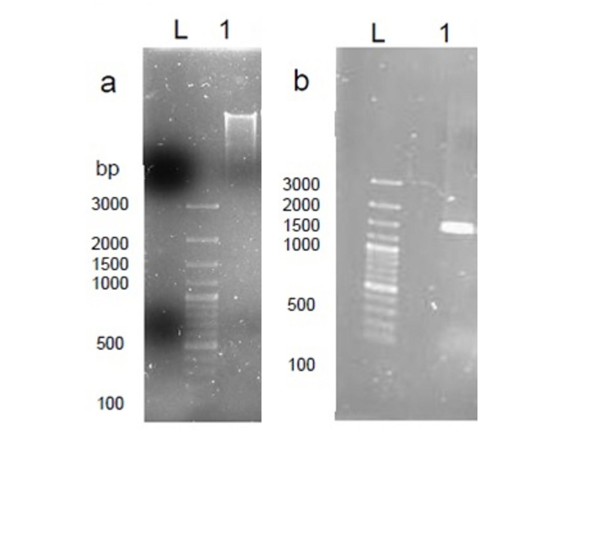

**Figure S2** Genomic DNA and 16S rRNA gene PCR product analysis. aL and bL represents 1.5 kb (Gene Ruler) molecular ladder. Fig. a1 and b1 represents Genomic DNA and 16S rRNA gene amplified PCR product respectively.

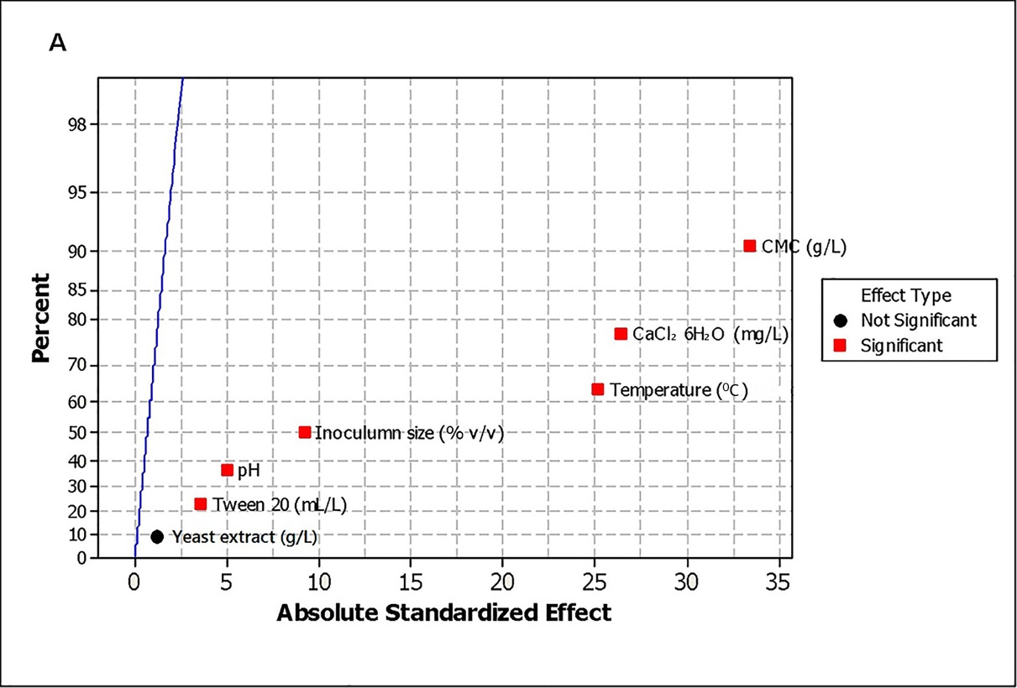

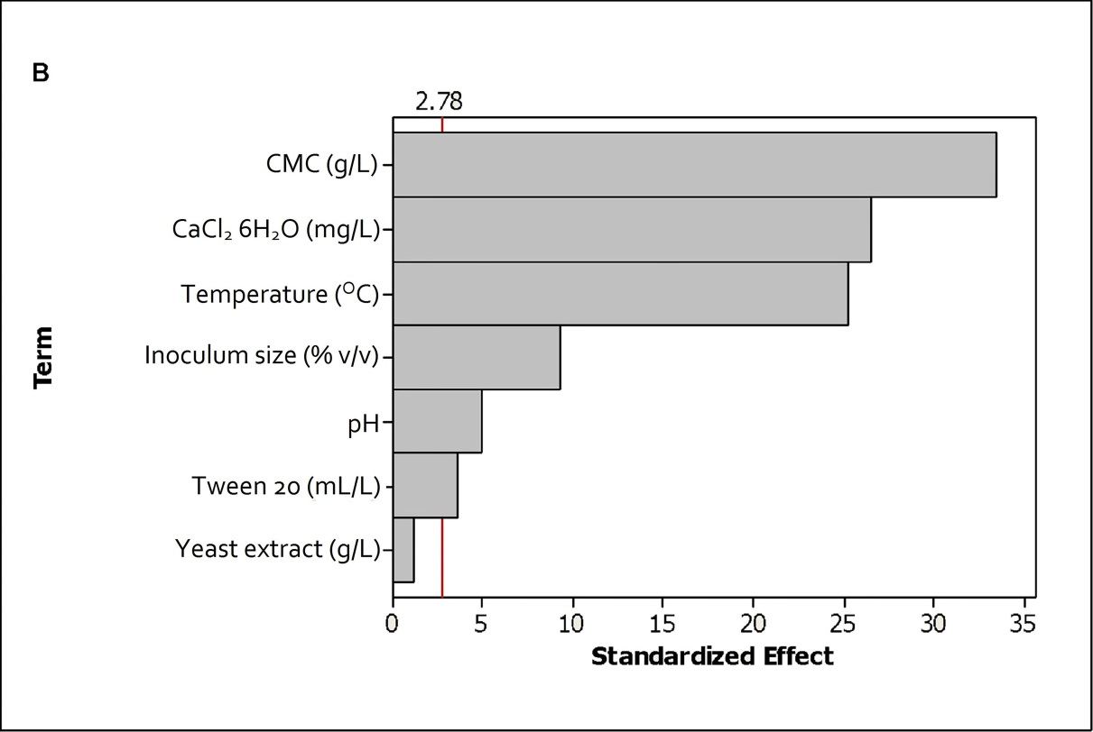

**Figure S3** Analysis of Plackett-Burman design. a) Half Normal plot effects; b) Pareto chart.

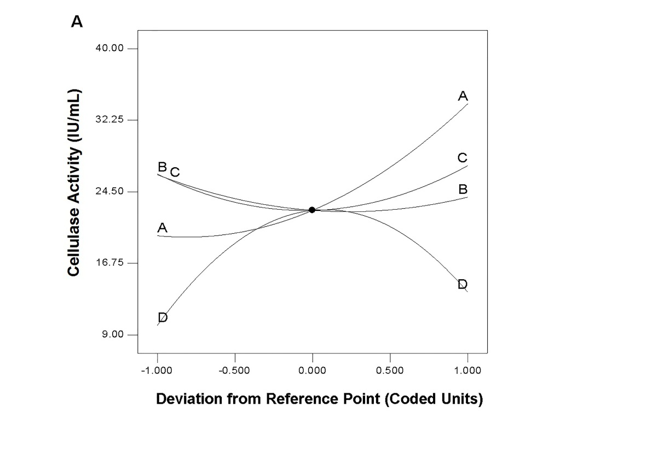

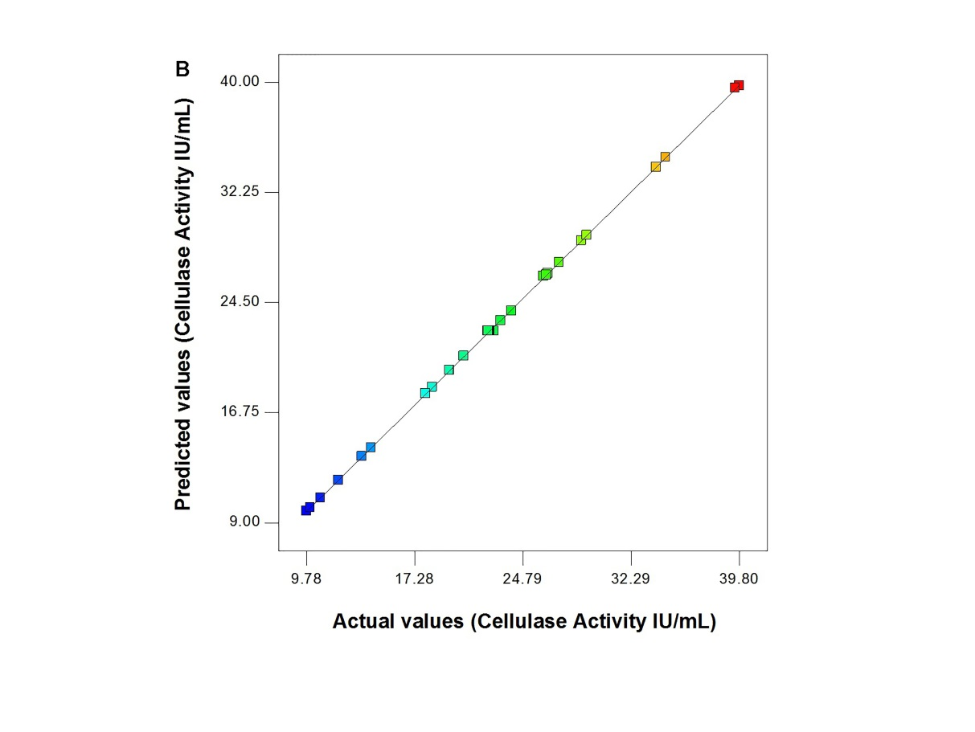

**Figure S4** a) Perturbation plot showing effects variables on cellulase production from *Bacillus licheniformis* NCIM 5556; b) Predicted cellulase activity versus Actual cellulase activity.

**Table S1** Effect of Variables on Cellulase activity

|  |  |
| --- | --- |
| Cellulase Activity (IU/mL) | |
| Carbon Source | |
| Bagasse | 13.97+0.52 |
| Corn cob | 11.64+0.9 |
| Rice straw | 7.3+0.67 |
| Filter paper | 8.26+0.2 |
| CMC | 14.27+0.35 |
| Nitrogen Source | |
| Yeast extract | 12.59+0.23 |
| Peptone | 12.09+0.16 |
| Soybean meal extract | 12.37+0.38 |
| Tryptone | 11.48+0.46 |
| Urea | 11.86+0.69 |
| Metal Ions | |
| FeSO4.7H2O | 11.04+0.75 |
| NiSO4.7H2O | 12.56+0.32 |
| CaCl2.6H2O | 13.1+0.16 |
| MnCl2.4H2O | 9.93+0.11 |
| CuSO4.5H2O | 12.04+0.15 |
| Surfactants | |
| PEG | 12.66+0.13 |
| SDS | 11.93+0.54 |
| Triton X 100 | 9.79+0.37 |
| Tween-20 | 13.08+0.48 |
| Tween-80 | 9.75+0.12 |
| pH | |
| 4.5 | 9.23+0.23 |
| 5.5 | 12.87+0.29 |
| 6.5 | 13.62+0.68 |
| 7.5 | 12.33+0.38 |
| 8.5 | 11.17+0.47 |
| 9.5 | 8.62+0.26 |
| Temperature (oC) | |
| 32 | 11.69+0.16 |
| 37 | 12.24+0.03 |
| 42 | 13.8+0.14 |
| 47 | 10.39+0.09 |
| 52 | 7.52+0.26 |
| Inoculum(v/v) | |
| 1% | 9.3+0.1 |
| 2.50% | 9.58+0.06 |
| 5% | 9.89+0.09 |
| 7.50% | 10.59+0.28 |
| 10% | 12.84+0.49 |

**Table S2** Summary of various cellulase optimization and their related enzyme activity from *Bacillus licheniformis* strains.

|  |  |  |  |  |  |  |
| --- | --- | --- | --- | --- | --- | --- |
| Source of microorganism | Source of Isolation | Optimization method | Optimized media components and parameters | Optimum value / concentration | Cellulase Activity (IU/mL) | Reference |
|
|
|
| *B licheniformis* WBS1 | Hot spring | OVAT | Substrate | Wheat Straw | 0.37 | Acharya and Chaudhary (2011) |
| pH | 9 |  |
| Temp | 60 oC |  |
| Incubation time | 60 h |  |
| Inoculum size | 2% |  |
| Nitrogen source | Beef Extract |  |
| *B. licheniformis* LBH-52 | Korea sea waater | RSM CCD | Rice hull | 48.7 g/L | 75 | Kim et al., (2011) |
| Ammonium nitrate | 1.8 g/L |  |
| Initial pH | 6.6 |  |
| Temperature | 35.7 oC |  |
| *B.licheniformis* MVS1 | Hot Spring | OVAT | Substrates | Wheat Straw | 0.51 | Acharya and Chaudhary (2012) |
| Nitrogen sources | Beef extract |  |
| pH | 6.5 |  |
| Temperature | 50 oC |  |
| Incubation time | 60 h |  |

|  |  |  |  |  |  |  |
| --- | --- | --- | --- | --- | --- | --- |
| Source of microorganism | Source of Isolation | Optimization method | Optimized media components and parameters | Optimum value / concentration | Cellulase Activity (IU/mL) | Reference |
| *B. licheniformis* APS2 MSU | Fish (*Etroplus suratensis*) gut | OVAT | Carbon source | CMC | 12.86 | Sreeja et al., (2013) |
| Nitrogen sources | (NH4)2SO4 |  |
| Phosphate sources | NaH2PO4 |  |
| Surfactants | Triton X 100 |  |
| Metal ions | MnSO4 |  |
| *B. licheniformis* R2 | Soil | OVAT | pH | 6 | 0.99 | Tandon and Sharma ( 2014) |
| Temperature | 35 oC |  |
| Incubation period | 96 h |  |
| *B. licheniformis* KIBGE-IB2 | KIBGE, Karaci | OVAT | CMC | 5 g/L | 760 | Karim et al., (2015) |
| Peptone | 15 g/L |  |
| Yeast extract | 15 g/L |  |
| CaCl2.2H2O | 0.001 g/L |  |
| FeSO4.7H2O | 0.001 g/L |  |
| K2HPO4 | 5 g/L |  |
| Na2H2PO4 | 5 g/L |  |
| MgSO4.7H2O | 1 g/L |  |
| pH | 6 |  |
| Incubation time | 48 h |  |
| Temperature | 37 oC |  |

|  |  |  |  |  |  |  |
| --- | --- | --- | --- | --- | --- | --- |
| Source of microorganism | Source of Isolation | Optimization method | Optimized media components and parameters | Optimum value / concentration | Cellulase Activity (IU/mL) | Reference |
| *B. licheniformis* K-3 | Environmental composite | PBD, RSM | Wheat bran | 3.5 w/v | 7.25 | Gupta et al., (2015) |
| Incubation time | 48 h |  |
| pH | 6 |  |
| *B. licheniformis* 2D55 | Oil palm empty fruit bunch with chicken manure | OVAT | Temperature | 60 oC | 29.4 | Kazeem et al., (2016) |
| pH | 3.5 |  |
| Substrate Concentration | 7% |  |
| Inorganic nitrogen Urea | 1 g/L |  |
| Organic nitrogen Peptone | 11 g/L |  |
| MgSO4 | 0.40 g/L |  |
| CaCl2 | 0.03 g/L |  |
| Tween-80 | 0.20% |  |
| Inoclum size | 3% |  |
| *B. licheniformis* NCIM 5556 | Hot spring | OVAT, PBD, RSM | Substrate | 19.21 g/L | 42.99 | Present Study |
| Temperature | 43.35 oC |  |
| CaCl2.6H2O | 25.06 mg/L |  |
| Tween-20 | 2.96 mL/L |  |

OVAT One variable at a time approach, PBD Plackett and Burman design, RSM Response surface methodology.

**References**

1. Karim, A., Nawaz, M.A., Aman, A., Qader, S.A.U., 2015. Hyper production of cellulose degrading endo (1, 4) β-d-glucanase from *Bacillus licheniformis* KIBGE-IB2. J. Radiat. Res. Appl. Sci. 8(2), 160-165.
2. Kazeem, M.O., Shah, U.K.M., Baharuddin, A.S., 2016. Enhanced cellulase production by a novel thermophilic *Bacillus licheniformis* 2D55: Characterization and application in lignocellulosic saccharification. BioResources.  11(2), 5404-5423.
3. Kim, H.J., Gao, W., Chung, C.H., Lee, J.W., 2011. Statistical optimization for production of carboxymethylcellulase from rice hulls by a newly isolated marine microorganism *Bacillus licheniformis* LBH-52 using response surface method. Journal of Life Science. 21(8), 1083-1093.
4. Sreeja, S.J., Jeba Malar, P.W., Sharmila Joseph, F.R., Steffi Tiburcius, I.G., Palavesam, A., 2013. Optimization of cellulase production by Bacillus altitudinis APS MSU and Bacillus licheniformis APS2 MSU, gut isolates of fish Etroplus suratensis. Int. J. Adv. Res. Technol. 2(4), 401-406.
5. Tandon, D., Sharma. N., 2014. Isolation of potential novel cellulolytic and xylanolytic bacteria and optimization of their cultural conditions for enhanced production of cellulase and xylanase.  J. Agroaliment. Process Technol. 20(3), 231-240.