***Supplementary information***

**Investigation on the key features of L-Histidinium 2-nitrobenzoate (LH2NB) for optoelectronic applications: a comparative study**

***Mohd. Shkir\****

*Department of Physics, Faculty of Science, King Khalid University, P.O. Box. 9004 Abha 61413, Saudi Arabia*

In the article we are focused on B3LYP mainly and some other levels of theory like CAM-B3LYP and wb97xd

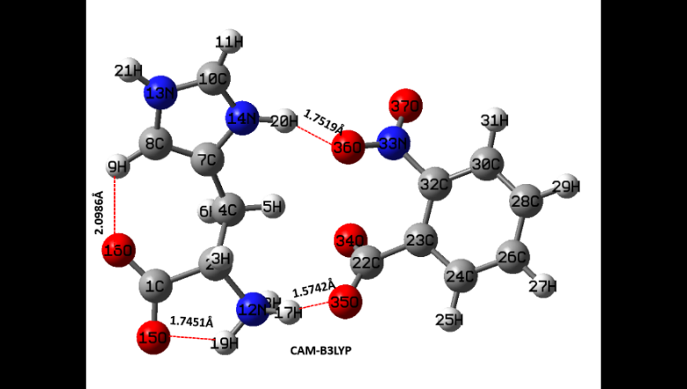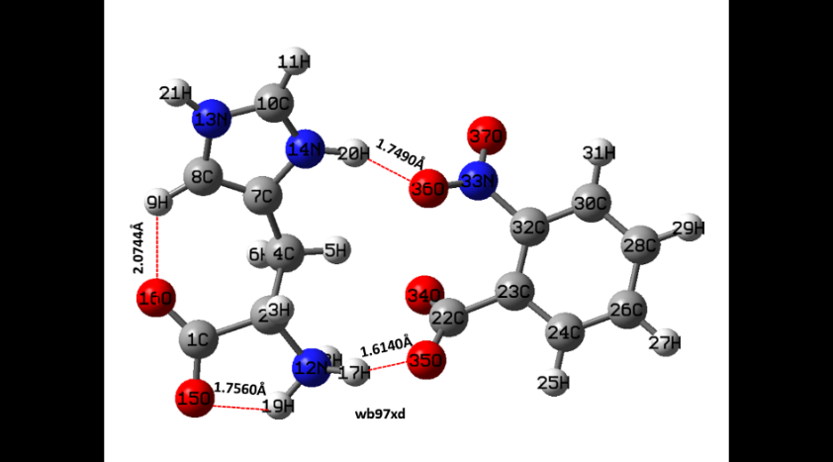

**Figure 1S** Optimized stable geometry of LH2NB by CAM-B3LYP and wb97xd levels of theory using 6-31G** basis set.

***Few results obtained from HF calculation are as follows and the results calculated from other level of theory like CAM/B3LYP and wb97xd are similar to B3LYP which is already explained in the article:***

***The explanation on all these results can be made accordingly as explained in the article paper for other level of theory***

***Figure 1S. UV-Vis spectrum at TD-HF/6-31G\*\****

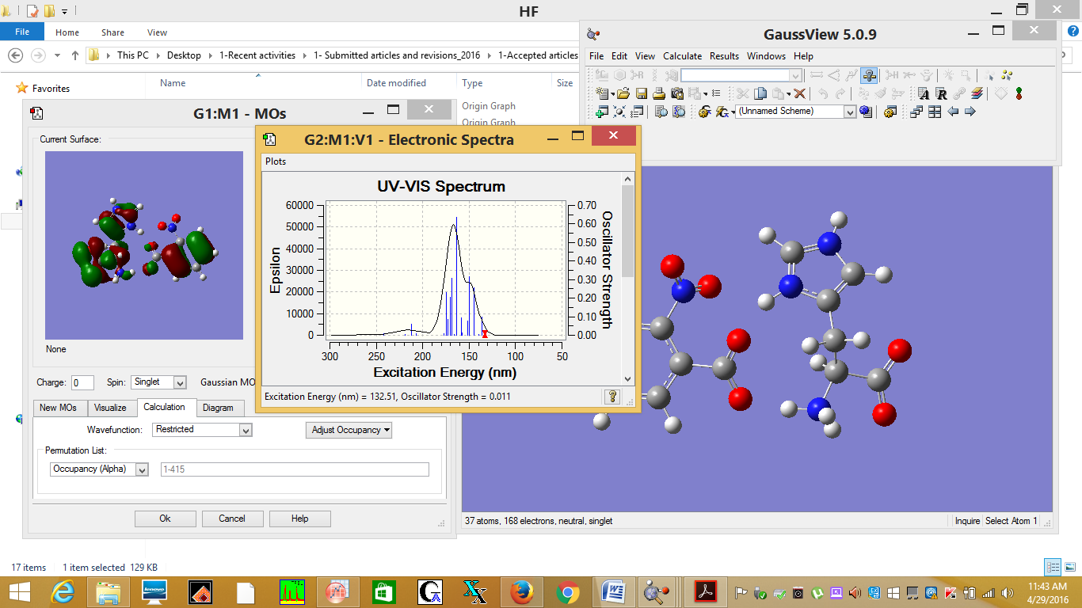

***Figure 2S. HOMO - LUMO 3-D plots obtained at HF/6-31G**.***

***LUMO= 0.077 a.u. HOMO= - 0.353 a.u.***

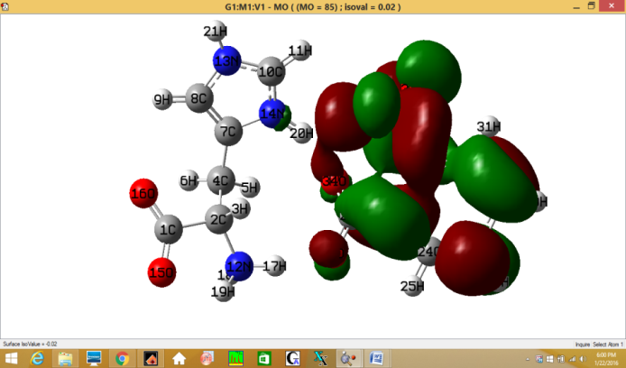 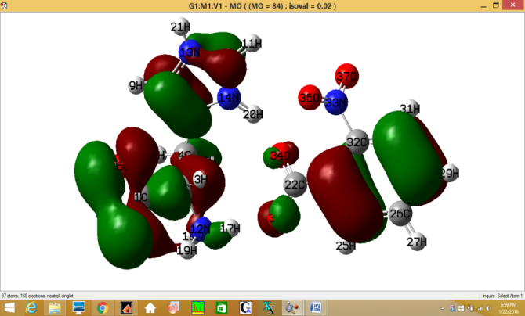

***Figure 3S MEP plot calculated at HF/6-31G** level of theory***

