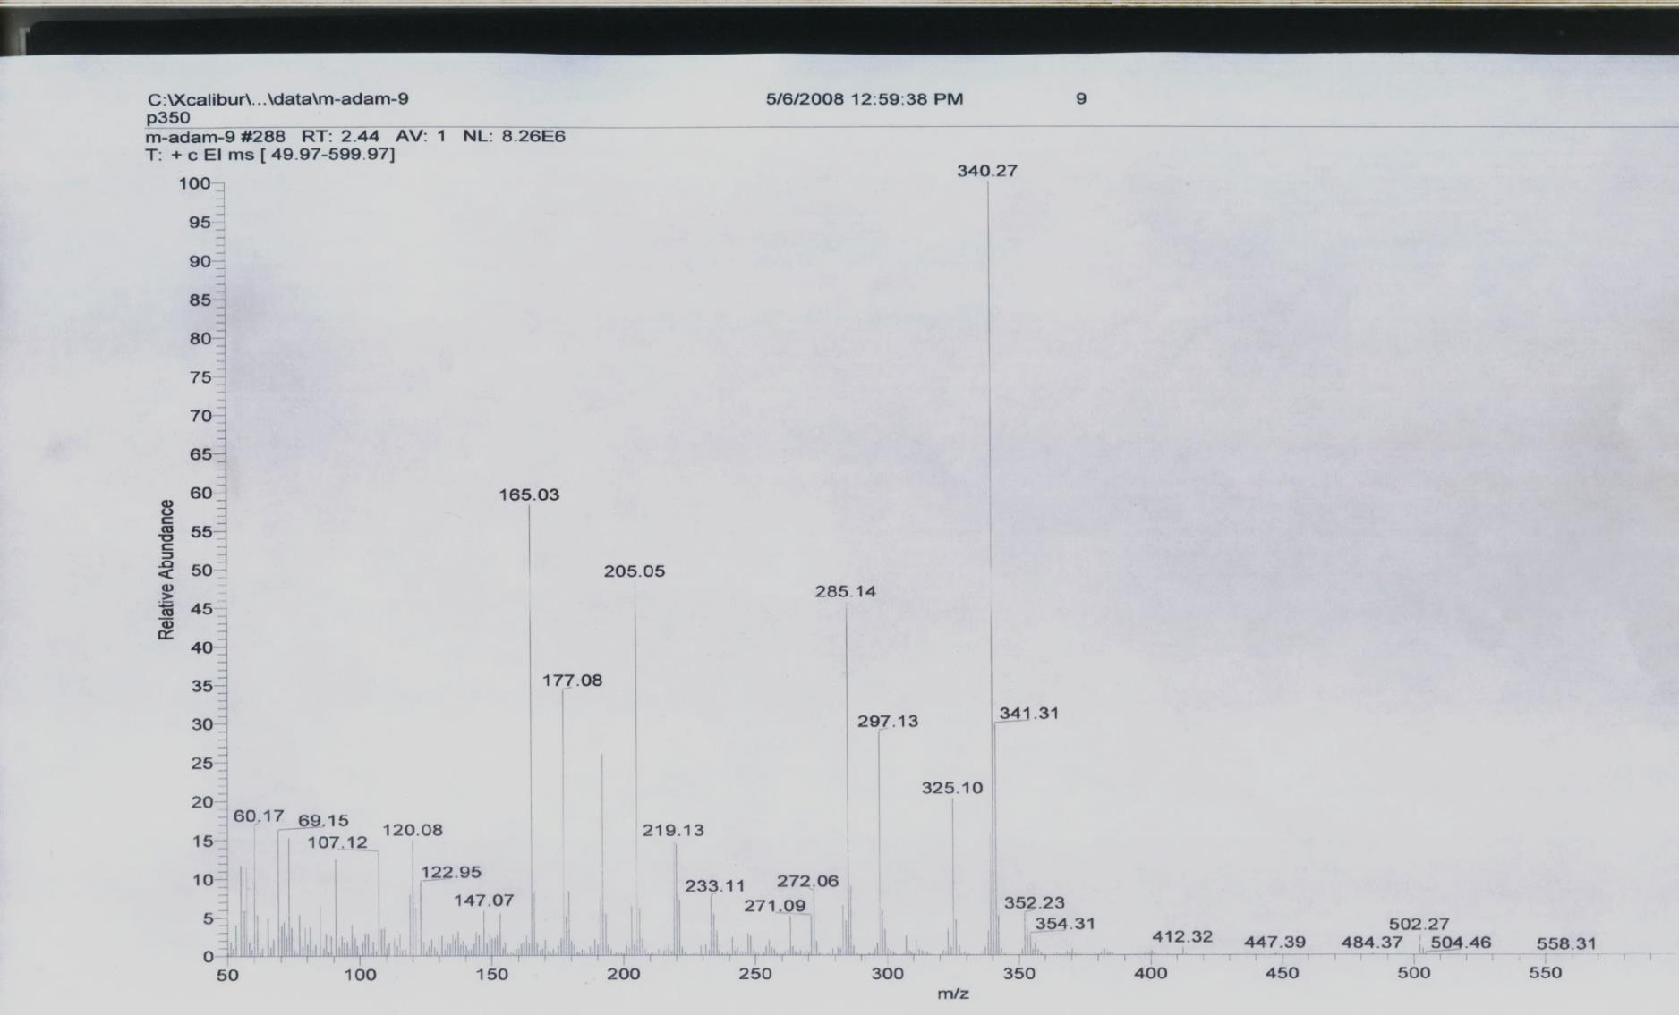
Appendix A. Spectra
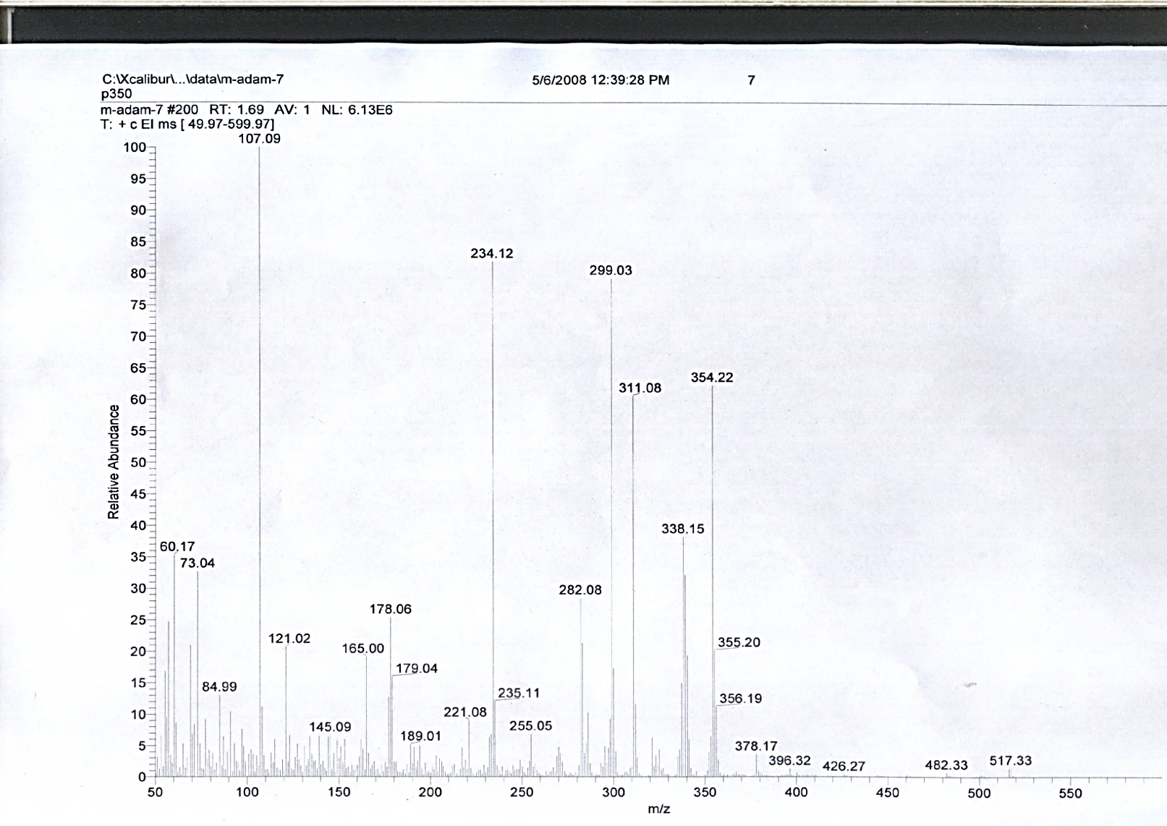
Fig. 4.27: LREIMS spectrum of compound 7.

LREIMS spectrum of compound 5. LREIMS spectrum of compound 6
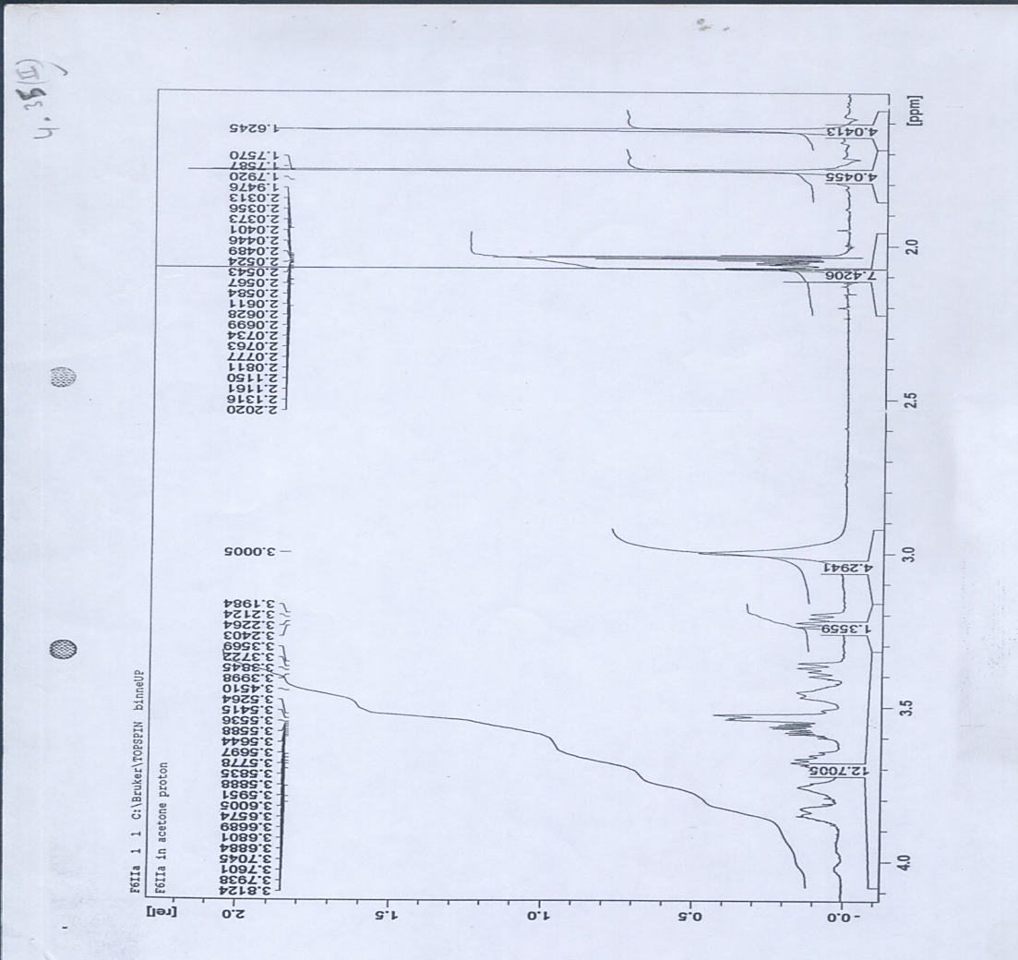
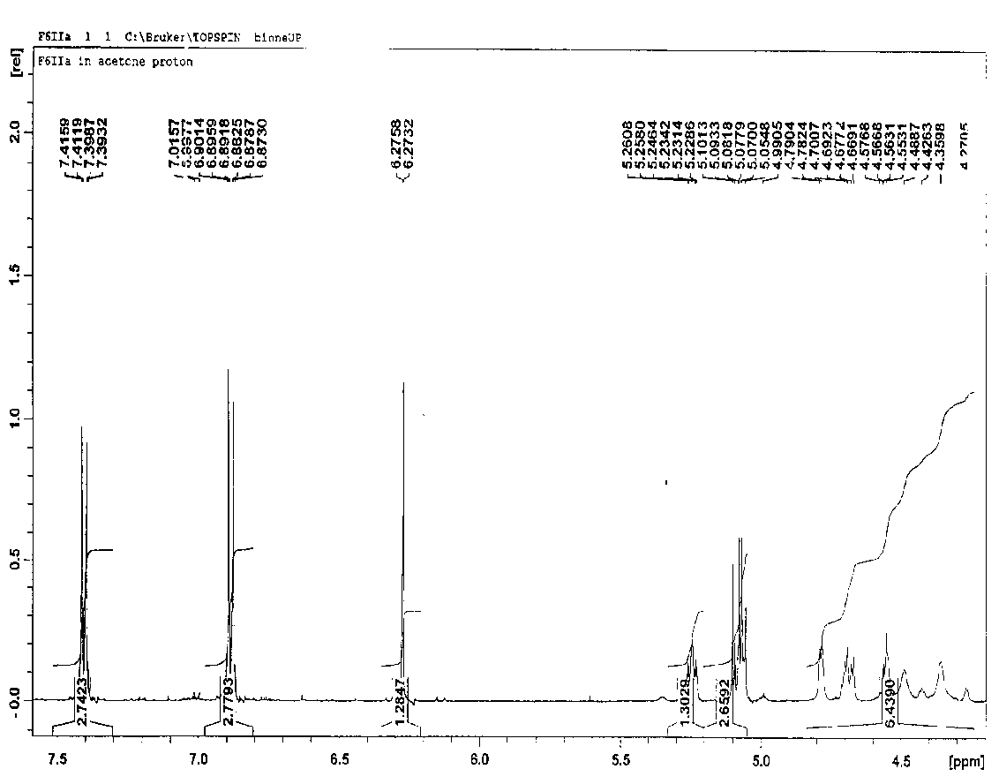

Fig. 4.25(II): ¹H-NMR (Acetone-d₆) spectrum of compound 7.

¹H-NMR (Acetone-d₆) spectrum of compound 5

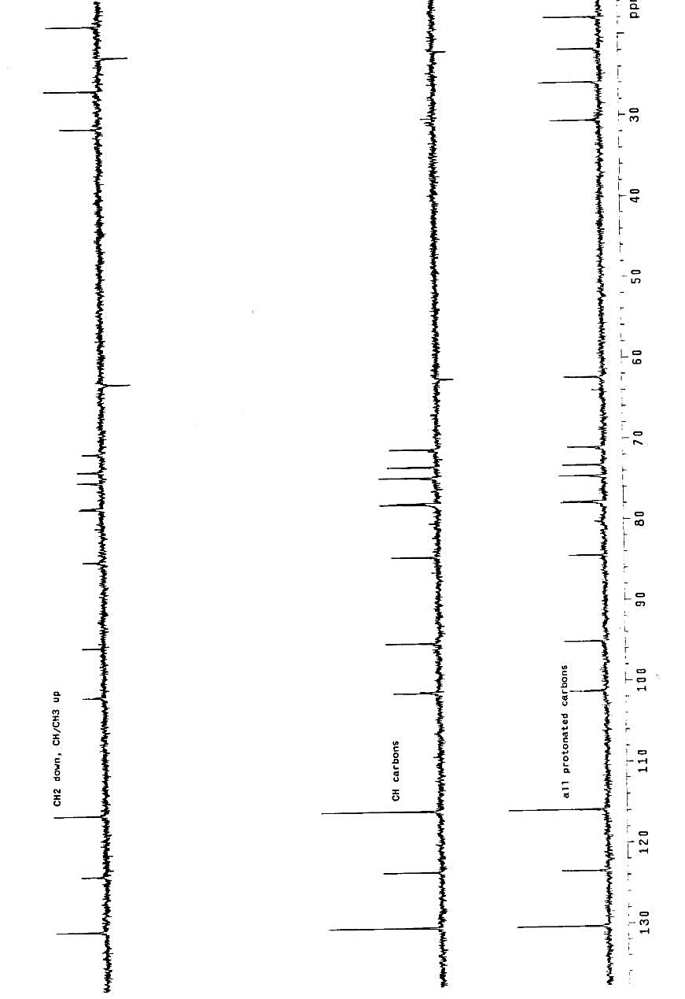

DEPT-135 of compound 5
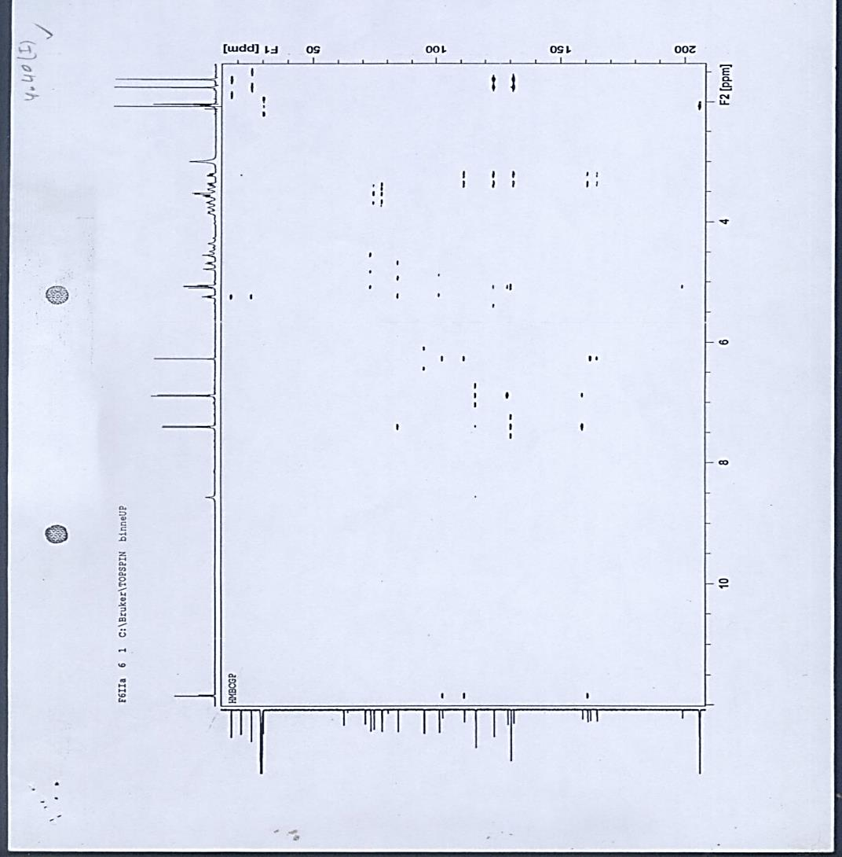
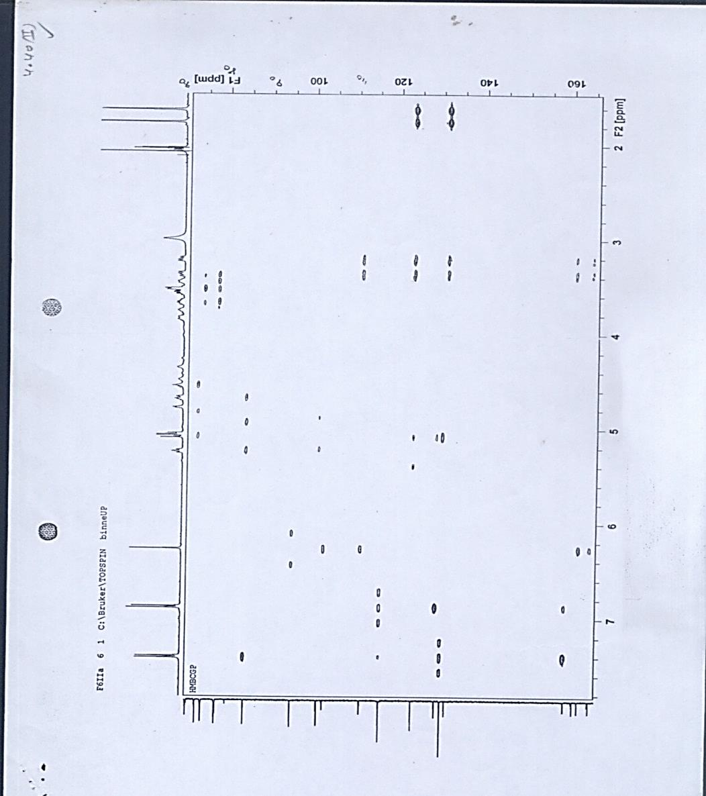

HMBC of compound 5

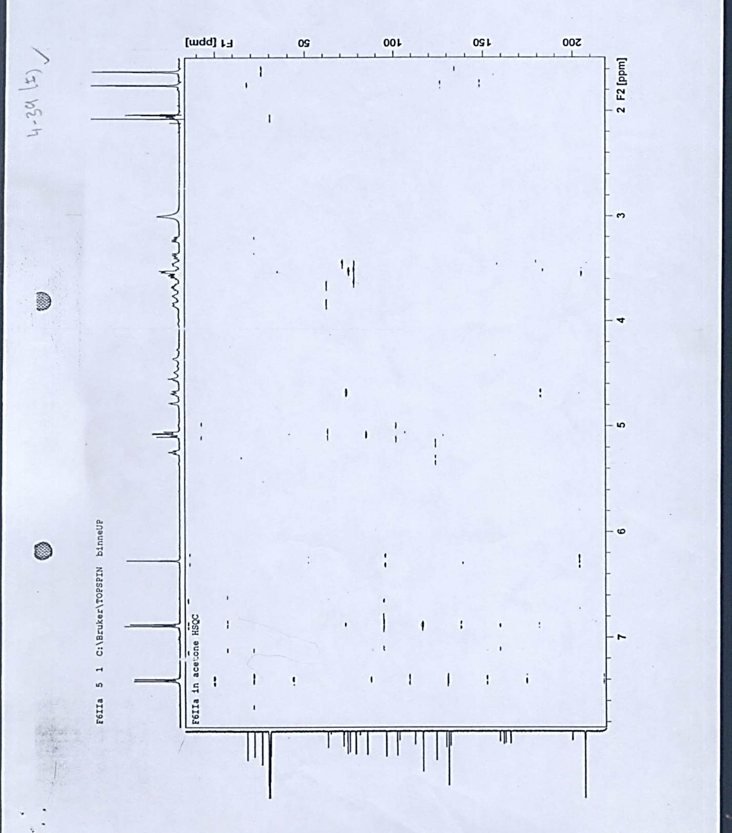

HSQC of compound 5
Fig. 4.37: LREIMS spectrum of compound 9 9.

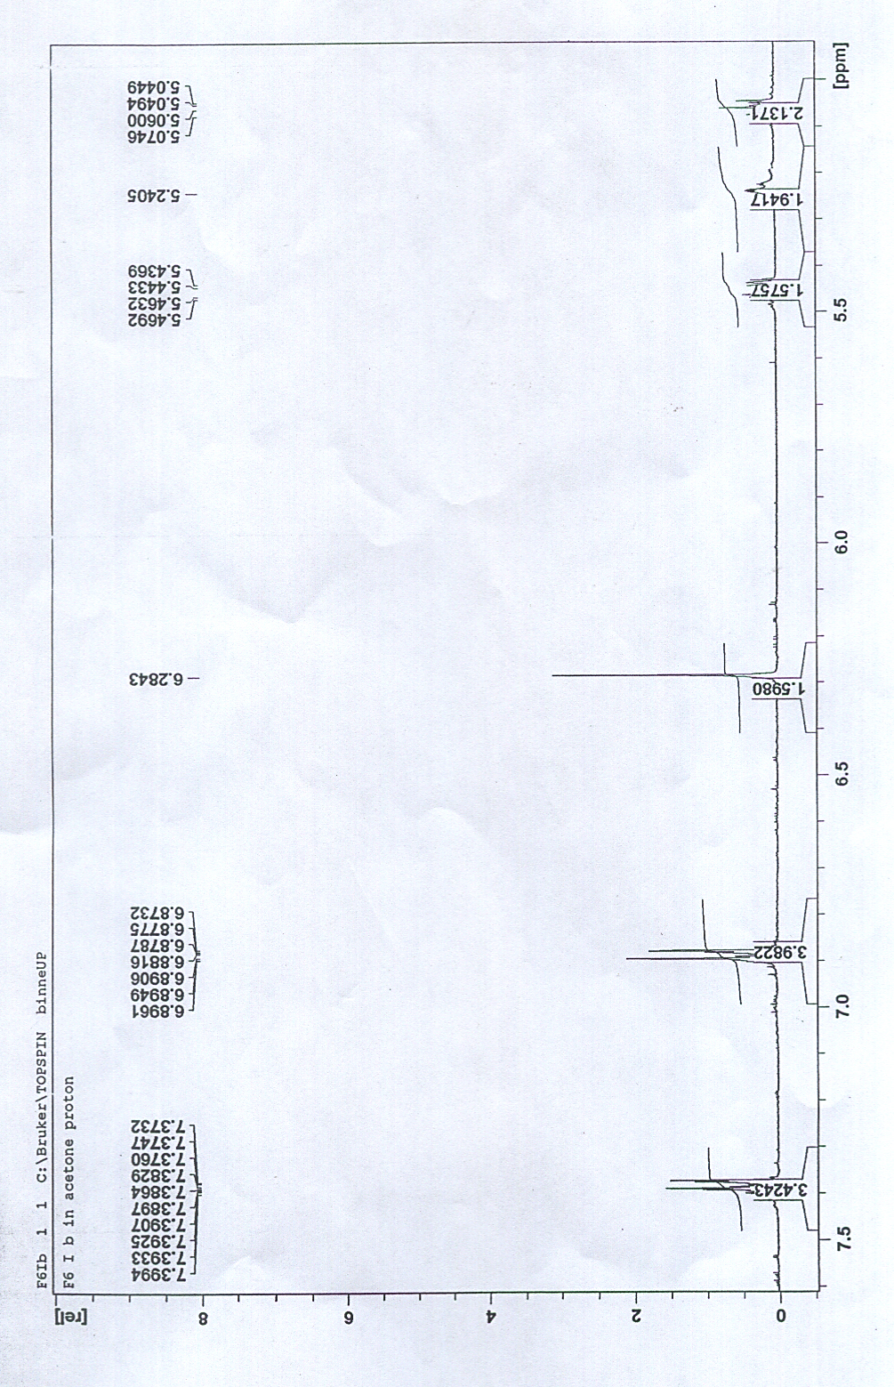
¹H-NMR (Acetone-d₆) spectrum of compound 6

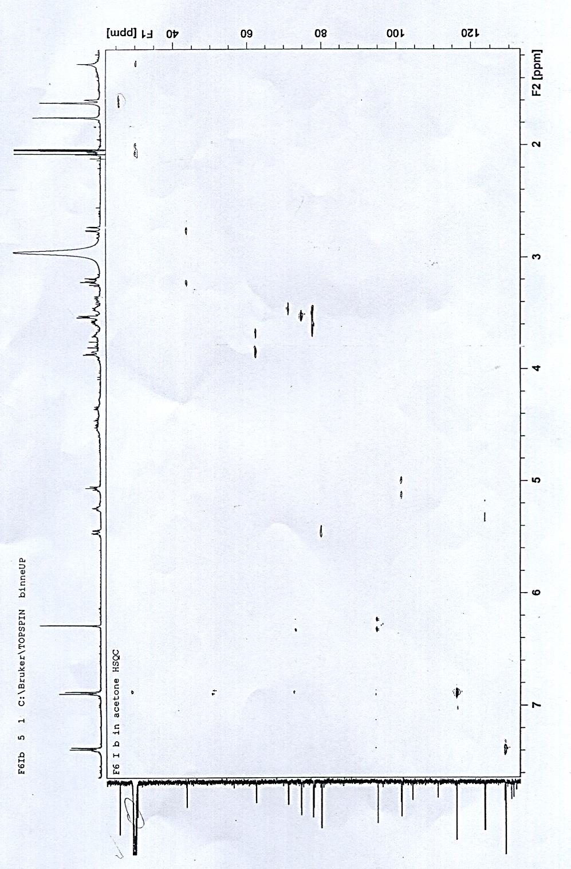
HSQC (Acetone-d₆) spectrum of compound 6

